Pacemaker Risk Following TAVR

Arthur M. Albuquerque and James Brophy MD PhD

November 07, 2021

## Introduction

Recently, a nationwide Swedish, population-based cohort study found no statistically significant difference for all-cause mortality (hazard ratio [HR] 1.03; 95% CI: 0.88 - 1.22; P = 0.692) in patients who underwent permanent pacemaker implantation after transcatheter aortic valve replacement (TAVR) between 2008 and 2018 (Glaser et al. 2021). Leading the authors to conclude that long-term survival between patients who did and did not undergo permanent pacemaker implantation after TAVR was not different. While the study included a large unselected sample of 3,420 TAVR patients, there are a number of reasons why it is of interest to query the strength of the evidence supporting their conclusion.

First, their central Kaplan-Meier curve shows survival curves crossing, raising the possibility of a time-varying HR such that the proportional hazards assumptions underlying their analysis may not be valid. Second given this is an elderly population (mean age > 81), the performed comparative lifetime analysis with some patients followed up to 10 years may not be the most informative and clinically relevant. As eventually, we all die and this analysis perhaps obscures some earlier clinically pertinent mortality differences among those receiving and not receiving pacemakers post-TAVR. Thirdly, the same nationwide databases have examined the mortality impact of pacemaker implantation in a contemporary population of aortic stenosis patients undergoing surgical aortic valve replacement (SAVR) (Ruck, Saleh, and Glaser 2021) and the inclusion of all or some of this additional evidence may be informative.

A Bayesian analysis (Gelman et al. 2014) directly estimates the probability of increased mortality post pacemaker insertion and which allows the incorporation of past knowledge may be helpful in furthering our understanding of this data by presenting actionable probabilities.

## Methods

### Data source

To gain approximate access to this dataset, we digitalized the reported Kaplan-Meier mortality curve in the propensity score-matched cohort (Glaser et al. 2021) using the R package IPDfromKM (Liu and Lee 2020) thereby allowing secondary Bayesian survival analyses to be performed. Further details about the extraction process can be found in our analysis protocol (REFERENCE TO OSF PROJECT).

### Outcome

This analysis is limited to the main outcome of total mortality as that is the only outcome for which we can estimate Kaplan-Meier-derived individual patient data (IPD). Given that the median follow-up is 2.7 years, that the KM slopes appear to change beyond 4 years and that assessing the impact of pacemaker implantation seems clinically most relevant in this shorter time window, we prespecified a maximum 4 year follow-up.

### Statistical analyses

Bayesian approaches to survival analysis can provide a number of benefits over the classical frequentist approach, including the ability to make direct probability statements about parameters of interest (the risk of pacemaker implantation), and to incorporate prior knowledge.

The mechanics of the Bayesian analyses were performed using the Stan programming language (Stan Development Team 2021) through the R package rstanarm (Brilleman et al. 2020). We fitted a proportional hazard regression model using cubic M-splines for the baseline hazard. Further details about the model can be found in our analysis protocol (REFERENCE TO OSF PROJECT). All analyses were conducted in R (R Environment version 4.0.4), and the statistical code can be found on [Github](https://github.com/brophyj/tavr_pace).

## Results

### Bayesian survival analysis

Using a vague prior the HR is 1.08 (95% credible interval [CrI] 0.86 - 1.36). While the CrI approximates the previously calculated CI, it can now be used to formulate direct probability statements. As shown in Figure 1, the use of a pacemaker is compatible with an 75% probability of increased mortality compared to those not receiving a pacemaker.

Previously research using the same Swedish databases have examined the risk of a pacemaker in patients undergoing SAVR (Glaser et al. 2021) and found an increased risk (HR 1.14; 95% CI, 1.01 - 1.29). Given the similarities in the populations, everyone with aortic stenosis undergoing treatment in the same hospitals in the same treatment windows, it seems reasonable to use this information, down weighted as described in the Methods, to represent our prior beliefs. With this informative prior, the HR for the no pacemaker group is 1.14, 95% credible interval (CrI 0.95 - 1.37). Using this informative prior, it can be appreciated that the probability of increased mortality following a pacemaker post TAVR is 94%.

## Discussion

In this reanalysis of a recent publication from the SWEDEHEART registry (Glaser et al. 2021), we were able to reliably extract the individual patient data concerning TAVR mortality as a function of receiving or not a permanent cardiac pacemaker. We analyzed the risk associated with a cardiac pacemaker using a 4-year window. This has the advantages of being a period when the hazard ratios appear constant as well as providing results in a more clinically pertinent risk window.

The Bayesian analysis with a vague prior revealed an 75% probability of increased mortality among TAVR patients requiring a pacemaker group compared those not requiring the same. The probability of increased mortality is augmented to 94% when informative prior knowledge about the risk of mortality with pacemakers in aortic stenosis patients undergoing SAVR is integrated into the decision calculus.

By concentrating on parameter estimation rather than on null hypothesis statistical testing and by incorporating relevant background knowledge, this Bayesian analysis arguably leads to a more insightful assessment of the risks of pacemakers following TAVR. Using aggregate data from previous clinical trials, multiple publications have demonstrated the additional advantages of Bayesian re-analyses (Goligher et al. 2018)(Brophy 2020). The current article suggests that similar benefits may be observed when this approach is applied to individual patient data in the context of an observational research design.

While the original publication concluded there was “no difference in long-term survival between patients who did and did not undergo permanent pacemaker implantation after TAVR,” this Bayesian reanalysis suggests a moderate to high probability that pacemaker implantation is associated with increased mortality in the first 4 years following TAVR.

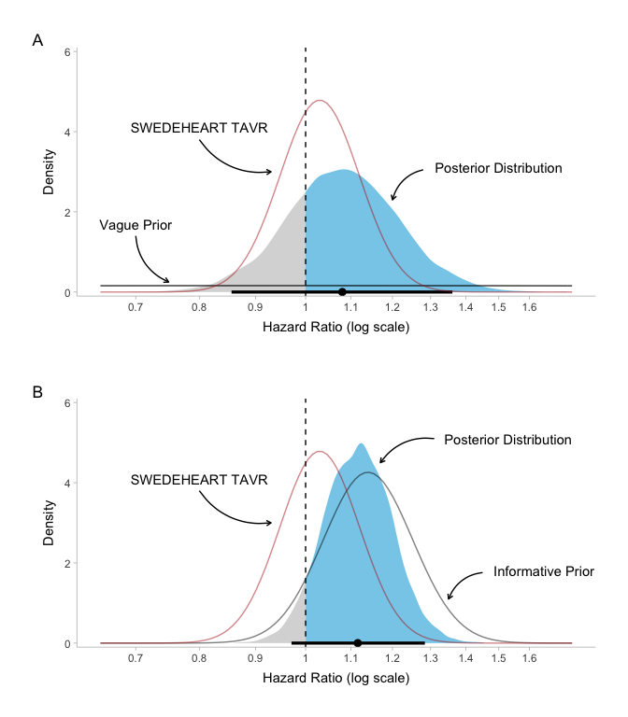

## References

Brilleman, Samuel L., Eren M. Elci, Jacqueline Buros Novik, and Rory Wolfe. 2020. “Bayesian Survival Analysis Using the Rstanarm r Package.” <https://arxiv.org/abs/2002.09633>.

Brophy, J. M. 2020. “Bayesian Interpretation of the EXCEL Trial and Other Randomized Clinical Trials of Left Main Coronary Artery Revascularization.” Journal Article. *JAMA Intern Med* 180 (7): 986–92. <https://doi.org/10.1001/jamainternmed.2020.1647>.

Gelman, A., JB. Carlin, HS. Stern, and DB. Rubin. 2014. *Bayesian Data Analysis*. Book. Third edition. Chapman & Hall/CRC Texts in Statistical Science. Boca Raton: CRC Press. <Cover image http://images.tandf.co.uk/common/jackets/websmall/978143984/9781439840955.jpg>.

Glaser, N., M. Persson, M. Dalen, and U. Sartipy. 2021. “Long-Term Outcomes Associated with Permanent Pacemaker Implantation After Surgical Aortic Valve Replacement.” Journal Article. *JAMA Netw Open* 4 (7): e2116564. <https://doi.org/10.1001/jamanetworkopen.2021.16564>.

Goligher, E. C., G. Tomlinson, D. Hajage, D. N. Wijeysundera, E. Fan, P. Juni, D. Brodie, A. S. Slutsky, and A. Combes. 2018. “Extracorporeal Membrane Oxygenation for Severe Acute Respiratory Distress Syndrome and Posterior Probability of Mortality Benefit in a Post Hoc Bayesian Analysis of a Randomized Clinical Trial.” Journal Article. *JAMA* 320 (21): 2251–59. <https://doi.org/10.1001/jama.2018.14276>.

Liu, Na, and J.Jack Lee. 2020. *IPDfromKM: Map Digitized Survival Curves Back to Individual Patient Data*. <https://CRAN.R-project.org/package=IPDfromKM>.

Ruck, A., N. Saleh, and N. Glaser. 2021. “Outcomes Following Permanent Pacemaker Implantation After Transcatheter Aortic Valve Replacement: SWEDEHEART Observational Study.” Journal Article. *JACC Cardiovasc Interv* 14 (19): 2173–81. <https://doi.org/10.1016/j.jcin.2021.07.043>.

Stan Development Team. 2021. “RStan: The R Interface to Stan.” <http://mc-stan.org/ 5>.