Pacemaker Risk Following TAVR

Arthur M. Albuquerque and James Brophy MD PhD

November 07, 2021

Table of Contents

## Introduction

Recently, a nationwide Swedish, population-based cohort study found no statistically significant difference for all-cause mortality (hazard ratio [HR] 1.03; 95% CI: 0.88 - 1.22; P = 0.692) in patients who underwent permanent pacemaker implantation after transcatheter aortic valve replacement (TAVR) between 2008 and 2018 (Glaser et al. 2021). Leading the authors to conclude that long-term survival between patients who did and did not undergo permanent pacemaker implantation after TAVR was not different. While the study included a large unselected sample of 3,420 TAVR patients, there are a number of reasons why it is of interest to query the strength of the evidence supporting their conclusion.

First, their central Kaplan Meier curve shows survival curves crossing, raising the possibility of a time-varying HR such that the proportional hazards assumptions underlying their analysis may not be valid. Second given this is an elderly population (mean age > 81), the performed comparative lifetime analysis with some patients followed up to 10 years may not be the most informative and clinically relevant. As eventually, we all die and this analysis perhaps obscures some earlier clinically pertinent mortality differences among those receiving and not receiving pacemakers post-TAVR. Thirdly, the same nationwide databases have examined the mortality impact of pacemaker implantation in a contemporary population of aortic stenosis patients undergoing surgical aortic valve replacement (SAVR) (Ruck, Saleh, and Glaser 2021) and the inclusion of all or some of this additional evidence may be informative.

A Bayesian analysis (Gelman et al. 2014) directly estimates the probability of increased mortality post pacemaker insertion and which allows the incorporation of past knowledge may be helpful in furthering our understanding of this data by presenting actionable probabilities.

## Methods

### Data source

To gain approximate access to this dataset, we digitalized the reported Kaplan-Meier mortality curve in the propensity score-matched cohort (Glaser et al. 2021). We extracted this data instead of from the full cohort since propensity score matching yields more balanced comparative groups than the crude data. This was operationalized by following the technique of Guyot (Guyot et al. 2012), utilizing [WebPlotDigitalizer](https://apps.automeris.io/wpd/) and the R programming language (R Core Team 2021). Specifically, this reconstruction of the individual patient data used the R package IPDfromKM (Liu and Lee 2020) thereby allowing secondary Bayesian survival analyses to be performed.

### Outcome

While the original publication examined several different outcomes, this analysis is limited to the main outcome of total mortality as that is the only outcome for which we can estimate Kaplan–Meier-derived individual patient data (IPD). Given that the median follow-up is 2.7 years, that the KM slopes appear to change beyond 4 years and that assessing the impact of pacemaker implantation seems clinically most relevant in this shorter time window, we prespecified a maximum 4 year follow-up.

### Statistical analyses

Bayesian approaches to survival analysis can provide a number of benefits over the classical frequentist approach, including the ability to make direct probability statements about parameters of interest (the risk of pacemaker implantation), and to incorporate prior knowledge. These probability statements arise from the posterior distribution according to the following equation;

$$Posterior probability=\frac{Likelihood*Prior probability}{Normalizing constant}$$

Therefore, in addition to the current data summarized by the likelihood one requires a prior probability distribution each parameter parameter. The robustness of the Bayesian approach is often assessed by sensitivity analyses that examine the variation in the posterior probability as a function of the choice of different prior distributions.

The mechanics of the Bayesian analyses were performed using the Stan programming language (Stan Development Team 2021) through the R package rstanarm (Goodrich et al. 2020) . We fitted a proportional hazard regression model using cubic M-splines for the baseline hazard. Bayesian analyses require a prior distribution for each parameter. In this model, parameters were the intercept, M-spline coefficients, and coefficient regarding pacemaker exposure. Because our focus in this article was on the latter, we used rstanarm’s default priors for the intercept and M-spline coefficients (Normal[0, 20] and Dirichlet[1, 1, 1, …], respectively) in all analyses. To calculate the posterior distribution of the the pacemaker exposure, we used two different priors. First we performed the analysis using the rstanarm built-in default vague, or weakly informative, normal prior (Normal [0, 2.5]). This prior avoids placing excessive unjustified prior weight on nonsensical parameter values and provides some regularization to avoid overfitting, while still allowing the data to dominate the analyses. Next we used an informative prior based on a previous study, using the same national databases, of pacemaker risk in a cohort undergoing surgical aortic valve replacement (SAVR) (Glaser et al. 2021). We downweighted the influence of this informative prior by 50%, because while the populations are similar (everyone has aortic stenosis), the aortic valve interventions were different and the long term evolutions of SAVR patients receiving pacemakers may not be identical to TAVR patients. All analyses were executed within the integrated development environment of RStudio and the statistical code can be found on [Github](https://github.com/brophyj/tavr_pace).

## Results

### Verifying individual data extraction

Quality assessment of our Kaplan–Meier-derived IPD data extraction was performed analytically by comparing our etracted overall hazard ratio and 95% CI with the published values, and graphically by checking the derived Kaplan–Meier curves (Figure 1) with the published propensity-matched KM curve (Original Supplemental Figure 2). Not only is the data extraction judged to be adequate graphically but also numerically with a calculated HR = 1.02, 95% CI 0.84 - 1.24 which compares favorably with the published value (HR: 0.99; 95% CI: 0.81 - 1.21).

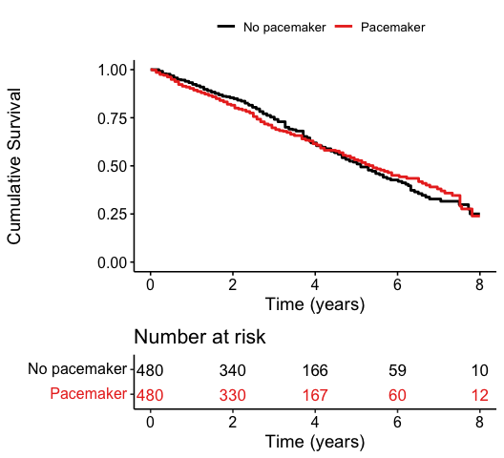

The difference in survival probabilities with the 95% CI is plotted in Figure 2. One of the concerns with the original analysis was the possibility of time-varying proportional hazards which are again suggested in this Figure. However, statistical tests suggested the proportional hazards assumption was not violated (p = 0.11), although it bears mentioning that the power to detect violations with this sample size is limited (Austin 2018).

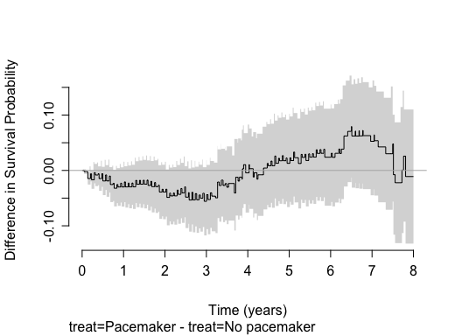

### Standard survival analysis to 4 years

Even if the proportional hazards assumptions are not violated, clinically it is indicated to investigate the risks over a more restricted time window. In accordance also with the varying risks, we elected a priori to concentrate on a 4-year time window. Using this time frame, we extracted the individual data as described in the Methods section above. The frequentist Cox proportional hazards model analysis for this more restricted data set results in a HR = 1.14, 95% CI 0.9 - 1.43, p = 0.27. While this remains statistically not significant, the point estimate has clearly moved towards a survival benefit in the no pacemaker group. Using this analysis to conclude that a pacemaker does not influence 4-year mortality risks makes the common error of confusing absence of evidence with evidence of absence. To further explore the data, we next performed a Bayesian survival analysis.

### Bayesian surival analysis

Bayesian approaches to survival analysis can provide a number of benefits over the classical frequentist approach, including the ability to make direct probability statements about parameters of interest (the risk of pacemaker implantation), and to incorporate prior knowledge. Using a vague prior the HR is 1.08, 95% credible interval (CrI 0.86 - 1.36). While the CrI approximates the previously calculated CI, it can now be used to formulate direct probability statements. As shown in Figure 3, the use of a pacemaker is compatible with an 75% probability of increased mortality compared to those not receiving a pacemaker.

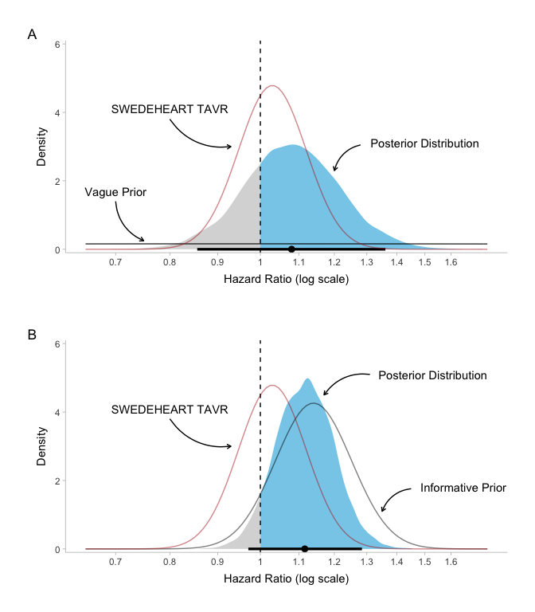

Previously research using the same Swedish databases have examined the risk of a pacemaker in patients undergoing SAVR (Glaser et al. 2021) and found an increased risk (HR 1.14; 95% CI, 1.01 - 1.29). Given the similarities in the populations, everyone with aortic stenosis undergoing treatment in the same hospitals in the same treatment windows, it seems reasonable to use this information, down weighted as described in the Methods, to represent our prior beliefs. With this informative prior, the HR for the no pacemaker group is 1.14, 95% credible interval (CrI 0.95 - 1.37). Given that this informative prior is consistent with the observed TAVR data, the slight rightward shift and narrowing of the 95% CrI of the posterior distribution compared to the posterior with a vaguely informative prior is to be expected (Figure 3). Using this informative prior, it can be appreciated that the probability of increased mortality following a pacemaker post TAVR is 94%.

## Discussion

In this reanalysis of a recent publication from the SWEDEHEART registry (Glaser et al. 2021), we were able to reliably extract the individual patient data concerning TAVR mortality as a function of receiving or not a permanent cardiac pacemaker. As the original analysis used a 10-year follow-up window and as the hazard ratios varied over time, we analyzed the risk associated with a cardiac pacemaker using a shorter 4-year window. This has the advantages of being a period when the hazard ratios appear constant as well as providing results in a more clinically pertinent risk window. Certainly, one could argue that examining relative risks at 10 years when the mean entry age is 81 is of limited value since most patients will be deceased by this time, independently of the presence or absence of a pacemaker following their TAVR. Our standard survival analysis using 4-year mortality as the outcome revealed an increased risk following pacemaker insertion (HR = 1.14, 95% CI 0.9 - 1.43) which not reach statistical significance (p = 0.27). However, the goal of this re-analysis was not to evaluate statistical significance but rather to estimate the probability of any increase in total mortality experienced by the pacemaker group. The estimation of this parameter requires a formal Bayesian survival analysis.

The Bayesian analysis with a vague prior revealed an 75% probability of increased mortality among TAVR patients requiring a pacemaker group compared those not requiring the same. The probability of increased mortality is augmented to an 94% probability when informative prior knowledge about the risk of mortality with pacemakers in aortic stenosis patients undergoing SAVR is integrated into the decision calculus.

By concentrating on parameter estimation rather than on null hypothesis statistical testing and by incorporating relevant background knowledge, this Bayesian analysis arguably leads to a more insightful assessment of the risks of pacemakers following TAVR. Using aggregate data from previous clinical trials, multiple publications have demonstrated the additional advantages of Bayesian re-analyses. The current article suggests that similar benefits may be observed when this approach is applied to individual patient data in the context of an observational research design.

While the original publication concluded there was “no difference in long-term survival between patients who did and did not undergo permanent pacemaker implantation after TAVR,” this Bayesian reanalysis suggests a moderate to high probability that pacemaker implantation is associated with increased mortality in the first 4 years following TAVR.

## References

Austin, Peter C. 2018. “Statistical Power to Detect Violation of the Proportional Hazards Assumption When Using the Cox Regression Model.” *Journal of Statistical Computation and Simulation* 88 (3): 533–52. <https://doi.org/10.1080/00949655.2017.1397151>.

Gelman, A., JB. Carlin, HS. Stern, and DB. Rubin. 2014. *Bayesian Data Analysis*. Book. Third edition. Chapman & Hall/CRC Texts in Statistical Science. Boca Raton: CRC Press. <Cover image http://images.tandf.co.uk/common/jackets/websmall/978143984/9781439840955.jpg>.

Glaser, N., M. Persson, M. Dalen, and U. Sartipy. 2021. “Long-Term Outcomes Associated with Permanent Pacemaker Implantation After Surgical Aortic Valve Replacement.” Journal Article. *JAMA Netw Open* 4 (7): e2116564. <https://doi.org/10.1001/jamanetworkopen.2021.16564>.

Goodrich, Ben, Jonah Gabry, Imad Ali, and Sam Brilleman. 2020. “Rstanarm: Bayesian Applied Regression Modeling via Stan.” <https://mc-stan.org/rstanarm>.

Guyot, P., A. E. Ades, M. J. Ouwens, and N. J. Welton. 2012. “Enhanced Secondary Analysis of Survival Data: Reconstructing the Data from Published Kaplan-Meier Survival Curves.” Journal Article. *BMC Med Res Methodol* 12: 9. <https://doi.org/10.1186/1471-2288-12-9>.

Liu, Na, and J.Jack Lee. 2020. *IPDfromKM: Map Digitized Survival Curves Back to Individual Patient Data*. <https://CRAN.R-project.org/package=IPDfromKM>.

R Core Team. 2021. *R: A Language and Environment for Statistical Computing*. Vienna, Austria: R Foundation for Statistical Computing. <https://www.R-project.org/>.

Ruck, A., N. Saleh, and N. Glaser. 2021. “Outcomes Following Permanent Pacemaker Implantation After Transcatheter Aortic Valve Replacement: SWEDEHEART Observational Study.” Journal Article. *JACC Cardiovasc Interv* 14 (19): 2173–81. <https://doi.org/10.1016/j.jcin.2021.07.043>.

Stan Development Team. 2021. “RStan: The R Interface to Stan.” <http://mc-stan.org/ 5>.