**ShopBridge API**

ShopBridge API provide the CRUD operation that can be consumed by the frontend application.

It provides below functionality.

1. Add a new item to the inventory.

2. Modify an item in the inventory.

3. Delete an item from the inventory.

4. Lists the items in the inventory.

**Tracking:**

1. Data store design: 20 Min

2. API and service logic: 90 Min

3. Unit Test Coverage:30 Min

**Deployment Path:**

Step To Run Application

1.Download the code from GitHub.

2.Execute the given script to create the database.

3.Change the connection string (ShopBridgeConnectionString) from appsetting.json file accordingly.

4.Need to change log file path from nlog.config file accordingly.

5.You can run the code from visual studio or to run the “dotnet run” CLI command in command prompt.

6. You can the test the api from swagger by url like <https://localhost:44303/swagger> or you can test the api from postmen by below url

GET : <https://localhost:44303/api/Product>

GET : <https://localhost:44303/api/Product/1>

POST : <https://localhost:44303/api/Product>

PUT : <https://localhost:44303/api/Product/7>

DELETE : <https://localhost:44303/api/Product/7>

NuGet Package:

Below are NuGet Packages Use.

1. For Entity Framework:

Microsoft.EntityFrameworkCore

Microsoft.EntityFrameworkCore.Design

Microsoft.EntityFrameworkCore.Sqlserver

2. For Automapper:

AutoMapper.Extensions.Microsoft.DependencyInjection

3.NLog

NLog.Web.AspNetCore

UT Documentation:

Swagger UI

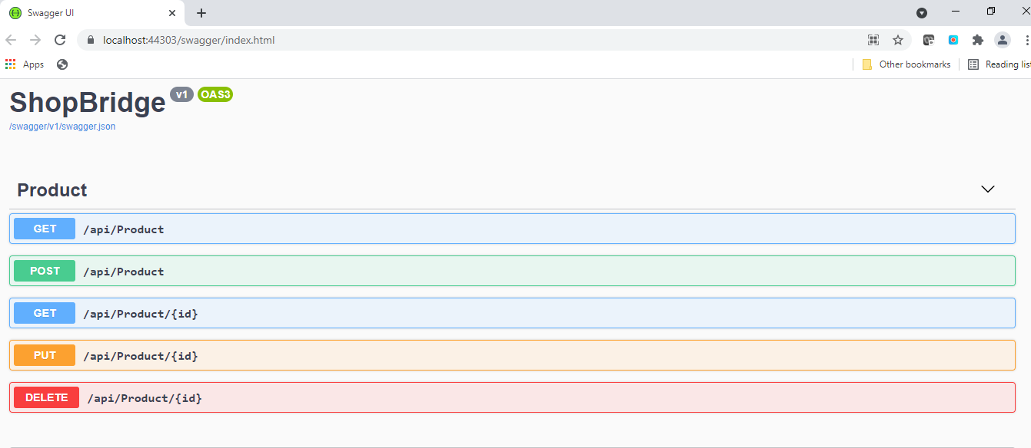

1. Lists the items in the inventory.

Get All Products

URL:

GET : <https://localhost:44303/api/Product>

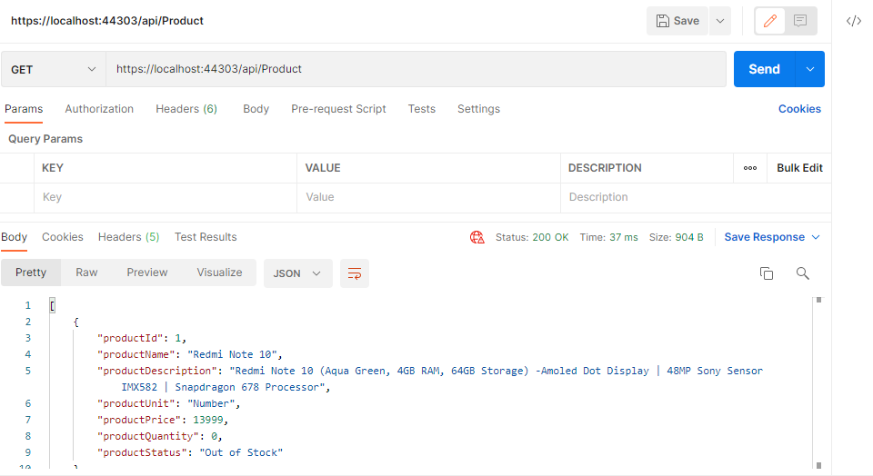

Get Product By Product Id

URL

GET: <https://localhost:44303/api/Product/1>

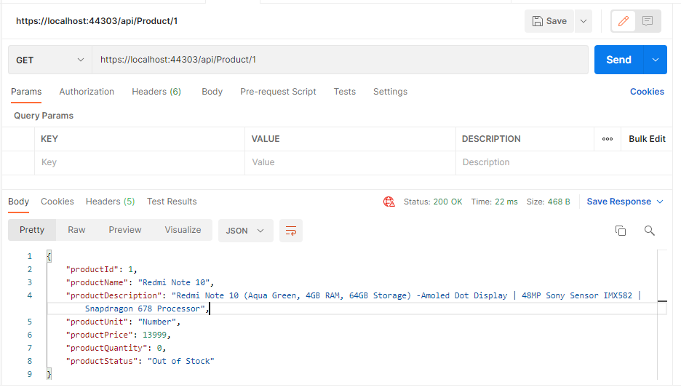

2. Add a new item to the inventory.

URL:

POST: <https://localhost:44303/api/Product>

Body Parameters:

JSON:

{

"productName": "Test product",

"productDescription": "Test ProductDescription",

"productUnit": "kg",

"productPrice": 100,

"productQuantity": 10

}

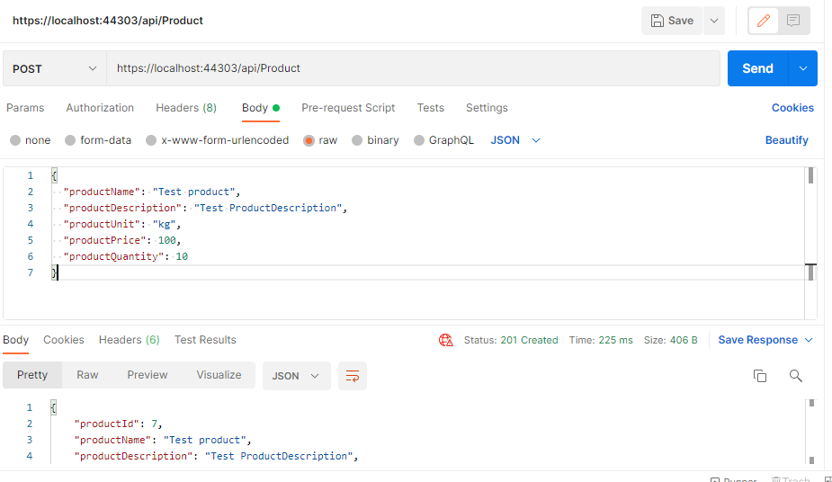

3. Modify an item in the inventory.

URL:

PUT: <https://localhost:44303/api/Product/7>

Body Parameters:

JSON:

{

"productName": "Test product",

"productDescription": "Test ProductDescription",

"productUnit": "kg",

"productPrice": 100,

"productQuantity": 0

}

4. Delete an item from the inventory.

URL:

DELETE: <https://localhost:44303/api/Product/7>

