Overview
This application is intended to help a car hire company to maintain their fleet and manage the rental business together with their customer details.

Screens
The application has three main screens:
The first page which is the point of entry allows the user to search for a customer an order or particular vehicle in the fleet.

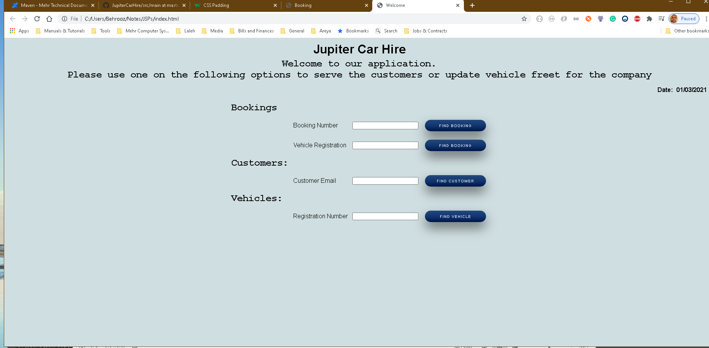

In case of an existing order being retrieved or in case of a new booking, the user will then be directed to the relevant page where they can create update or close and complete an existing booking.

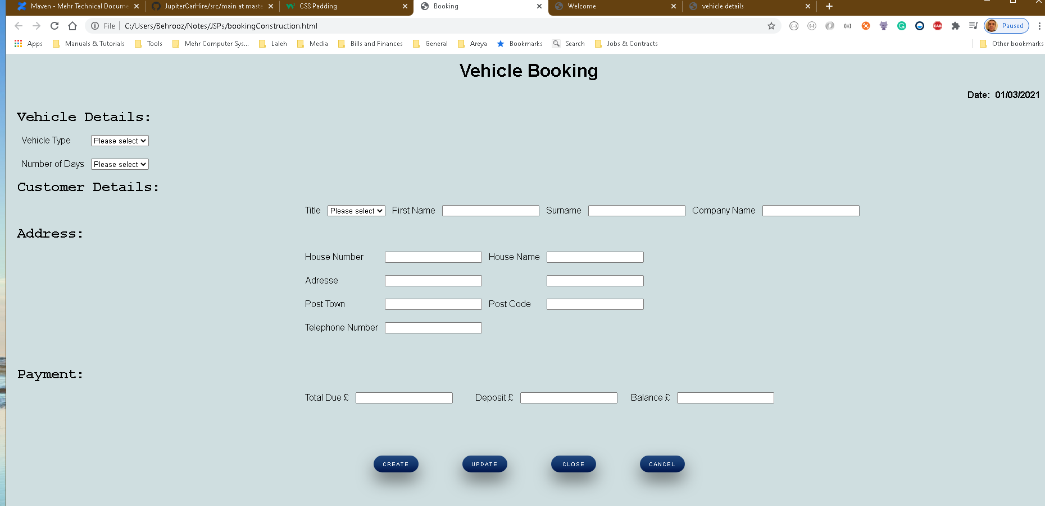

In case there needs to be any changes to the vehicles available In the fleet, the user would then be able to maintain a relevant data via the dedicated screens.

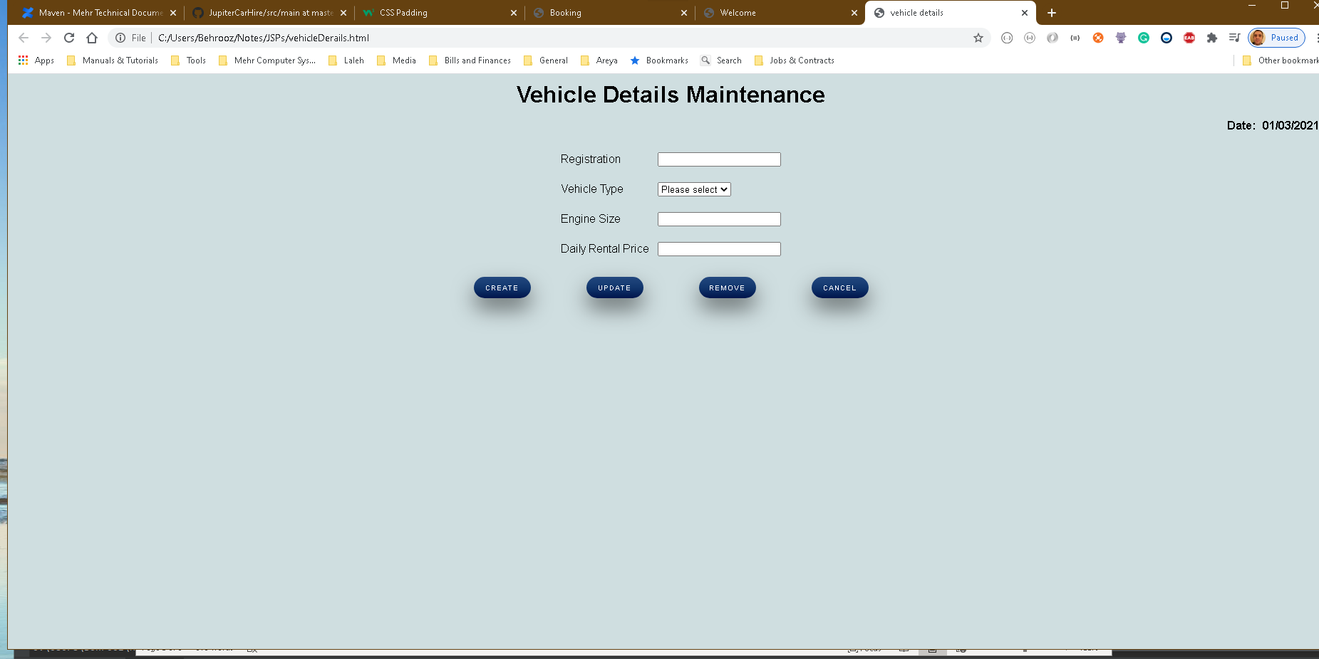

Implementation.
The application is constructed as a Spring web MVC app.
The front JSP files are connected to the backend controller by dispatcher servlet.
In order to communicate between classes spring annotation methodology has been used to optimise the resource use
The code has been organised into a standard hierarchy of relevant, Beans, Controllers, service and DAO classes.
In order to persist the data, it was decided to use local SQLite Database technology which will create an on-file Relation database on the go in case it is not present on the local machine or will create missing tables.
The database constructed to maintain the data for this application consists of Four main tables as
Follows
- Customer
- Vehicle
- Booking
- Address
The following Data Flow Diagram displays a brief overlook of these tables within the database and their relation to each other.
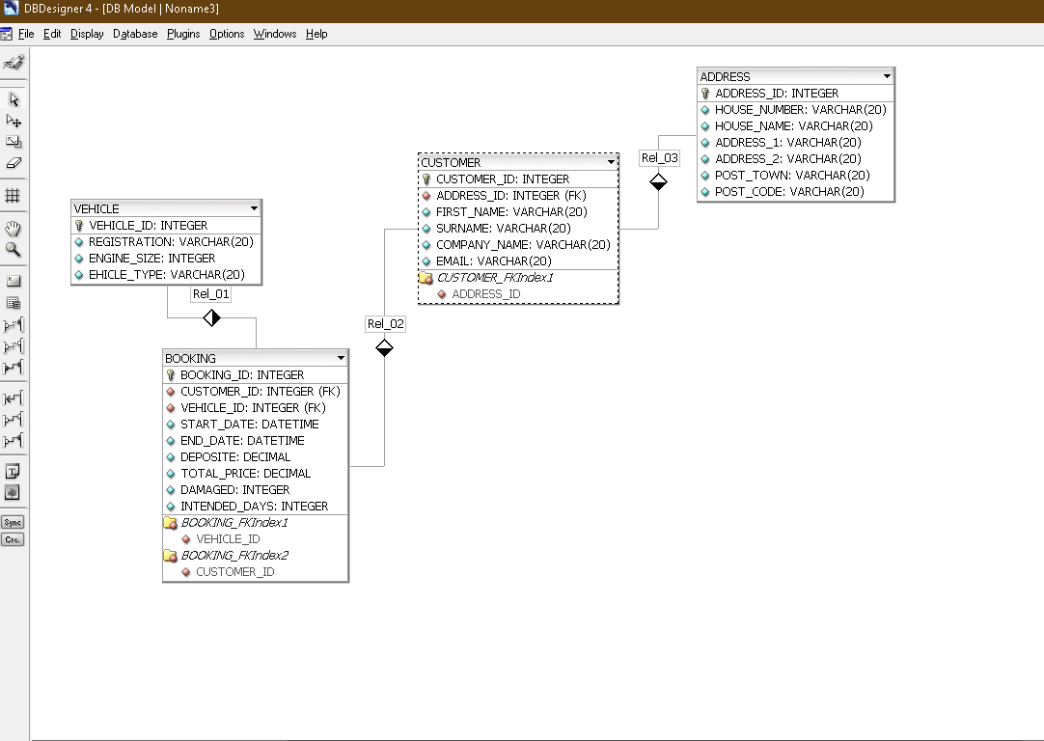

At the moment the new customer address should be entered manually by the staff using the application.

However, as you might have already noticed in my personal GIT repository, I have recently implemented a microservice that uses the following URL:
http://api.postcodes.io/
to retrieve the Addresses using their post code from the post office data inventory.
However due the shortage of time it was not possible to complete the task.
Also, an extra functionality was considered for the application to process and manage payments.
However, again due to shortage of time it was not possible to complete the functionality.
I case you are still interested in the extra functionalities to beaded please contact me ASAP.

