The study of gamification in the process of learning OOP

Radu Andrei, Popescu David, Alexandra Iordache, Raceanu Andrei, Mihnea Apostolescu, Badoi Bianca

**Abstract: Is the usage of user-friendly interfaces that follow the gamification method useful to the learning of OOP concepts? This paper thrives to prove or disprove if that is the case or not. The team designed an interface in which the user is given a scrabble-derived game with a set of letters in order to form words that match OOP key-words, and then presented said project as a game to learn OOP to a category of people who knew nothing about this paradigm before. Out of the 6 people who tried the platform, all of them improved their understandings in the concepts presented. As a result, we concluded that the usage of gamification in learning based platforms is to be looked upon and implemented as to improve the process of learning.**

1. Introduction

The process through which one is being able to learn a particular skill in all of its complexity should be designed in such a way as the learner to comprehend easily the concepts presented and to make the additional informations to be learned corelate with the knowledge taught beforehand. The same applies for learning Computer Science; as the method of gamification proved useful in other fields, it is necessary to find if it can be used for making CS-paradigms, such as OOP, more easily to study and understand.This paper will show if gamification can be used in the learning of OOP in order to make for a better understanding, and if this proves to be true, it can be widely implemented to lower the time required for learning. At the moment, the research shows that gamification is a useful tool in learning, as shown in these scientific journals <https://slejournal.springeropen.com/articles/10.1186/s40561-019-0098-x>, and,<https://educationaltechnologyjournal.springeropen.com/articles/10.1186/s41239-017-0042-5>.The purpose of this paper is to study if OOP learning can be enhaced with gamification and we draw to the conclusion that this is the case.

2. Materials and Methods

In order to study the effects of gamification in learning, our team devised a platform in which the user is to be choosing from letters made available for him and form different words on a scrabble-like table game, meaning that based on what letters the User has chosen and on what positions he considered more fitting, he/she will gain points. Based on the pshychology of punishment/reward, the player is rewarded for forming up Object Oriented Programming-related words, and is penalized if failing to do so, thus enticing the learner to make connections and improve upon the knowledge that he/she is already having in order to stop losing points, and to actually “win the game”. This kind of motivation is well known as it is generally a sensory type motivation, but when used to a purpose, rather than just losing energy , it stimulates actual decision making to the learner and entices to search for the topic he/she was penalized/rewarded for.

The platform this team developed is currently available at our GitHub repository, where it can be find at: <https://github.com/brospresident/Proiect-OOP-Scrabble-Gamification>, and cloned using: [git@github.com:brospresident/Proiect-OOP-Scrabble-Gamification.git](mailto:git@github.com:brospresident/Proiect-OOP-Scrabble-Gamification.git).

In order for a better understanding of our work it will be presented step by step how to achieve the same results of our project, together with an in depth explanation of our files.

In the upper-shown picture it can be seen that our projects is accompanied with

useful comments as per needed for a smooth understanding in each file. The source code of this file implements the game instance which itself calls upon the other methods

described in other files, but for now, that is important to understand is that the source code which is partly presented here actually run the platform using all the functionalities descrbied in other sources. The game instance holds one object of the table and timer classes. In the Board class there were implemented functionalities for the table rendering and the logic behind the interaction between itself and its elements. Timer is a type object which has the role to keep watch of the remaining time and to render it.

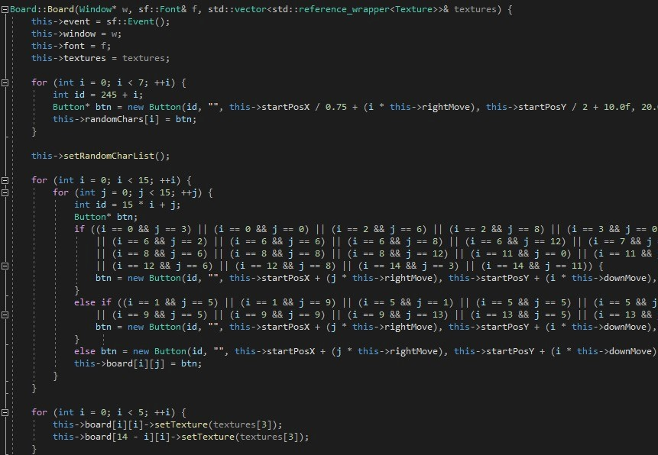

In the picture showed above, it is shown that the rendering of the table itself is done in the constructor method of the Board class. The first thing to be noticed is how firstly the 7 pseudo-random generated letters are rendered, these letters are the ones to be used by the player to form words in the game, and only after this is done the letters are actually generated and inserted in the box. Afterwards, the table is rendered using the special scrabble-type indices, which represent scpeial positions on the map, such as: double word, triple word, which denote how the player is extra rewarded for fulfilling a game related task.

In the image showed below, I inserted the code that continues the implementation of the table randering and the code of the reroll button, which has the main task of generating 7 random letters for the User.

In the photo presented below is pictured the method which implements the logic behind the buttons. Each button has a corresponding ID which is set in this particular way: from 0 to 244 are the buttons used for the scrabble-game, and from 245 to 245+7, the ID matches the ones used for the randomly generated letters. The reroll button from User Interface has the ID number 300. This method takes the button’s ID, if that is by default -1, it means that this particular button is to no use and is scrapped, else, we take a reference to said button and check its type: if it is the reroll button, the reroll method is called and we exit, but, if one of those 7 letters is pressed, we put the respective letter on the board.

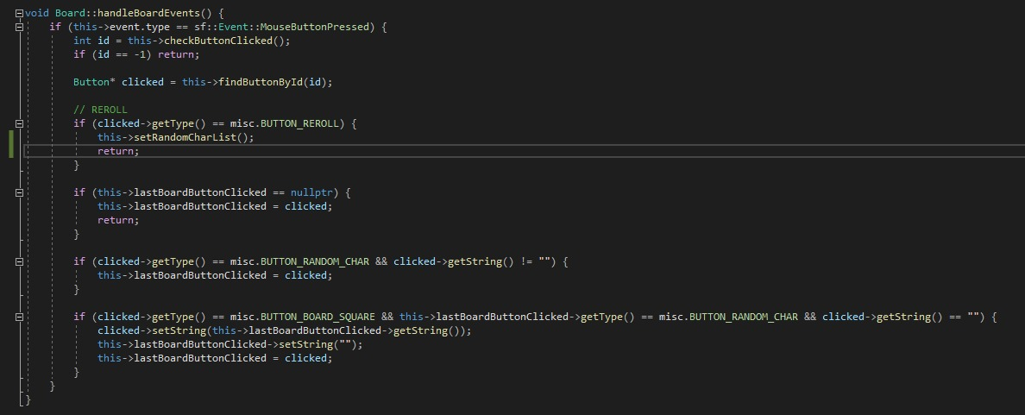

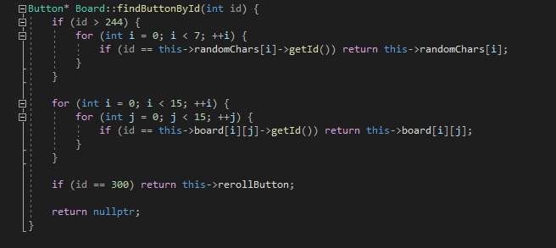

In the picture above is implemented the method to search a button after its ID.

In the photo above is represented the method which generates the 7 letters that are going to be used. The concept uses the seed paradigm to randomly generate the values in question. We chose to use 4 consonants and 3 vocals because in the Romanian language, the concepts of OOP are most of the time vocal-oriented words, which in other words means that the vocals surpass the consonants in a word. At each iteration the seed is changed for better diversity, each letter is associated with 2 numbers. In the end, the method returns a vector-type container of strings.

This is the main event handler: it verifies each event that happens and forwards it. There are many types of events, but the main thing to be noticed is that in this event handler out team registered the player.

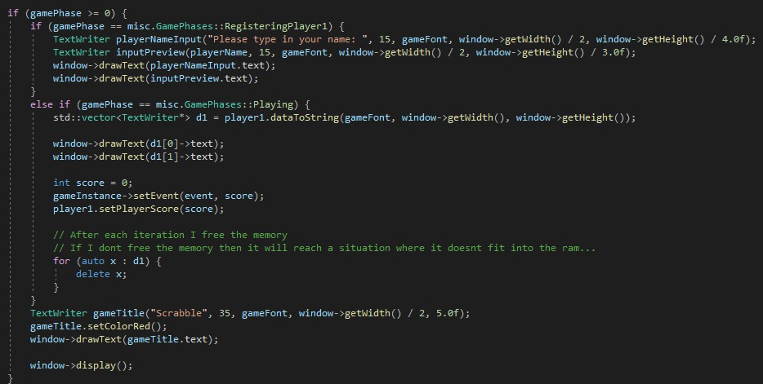

The “game” can have two main states: the first inserts the name of the player, and the second one initializes the platform and sets the current number of points at each iteration. Afterwards, the main title and the color are initialized and then rendered. One of the things to be noticed is how each element from d1 is deleted. Our team implemented that because otherwise it would have been generated a new pointer at each iteration, and in no time, the RAM would have been overflown.

The study was done by randomly choosing 6 people with ages in the range of 20-21 years old and asking three of them to play the “game” and express at the end how better did they understood the concepts of OOP, this was later verified with the number of points each participant managed to obtain, the other ones were introduced to the same concepts of OOP using traditional methods of learning, without interactive use of means.

The study concluded that all the participants who were subjected to the gamification had a better understanding of the concepts they were faced to learn because they were better motivated to learn and excel at what yhey were doing.

3. Results

In Table 1, pictured below, are presented the main findings of our study, where the personal knowledge assessment represents a percentage which describes how well the person in question understood the concepts of OOP, the lower the perentage, the worse the understanding, the greater the percentage, the better understansing. The number of points gained represent the final score of the 3 players, this serves as a checker of their assessment, the score is from 1 to 100 and is directly proportional to how good the players behaved in the game, if the score and the percentage are in the same margin, then their assessment is considered to be precise and their understanding good. If the subject considered their knowledge to be insufficient, there is no point in assessing their score, this was done in preparation for the ones who did not partake in the gamification group.

**Table 1.**

|  |  |  |
| --- | --- | --- |
| **Subject No.** | **Personal knowledge**  **assessment** | **Number of points gained** |
| 1.  2.  3.  4.  5.  6. | 79%  90%  85%  60%  55%  45% | 75  85  86 |
|  |  |  |

It can be observed from the table that the subjects with ID numbers from 1 to 3, those who were selected to “play the game” have always assessed their personal knowledge to be above 70%, which is verified to be true with their respective number of points gained in the platform, while those who were selected to the other group were not so confident in their knowledge. The experimental conclusions that can be drawn is that those who participated in the gamification-based platform were more confident in what they learned than their counterparts, their assessment verified to be true by the number of points gained in the interface.

5. Conclusions

The team found in the previously described study that the gamification method is sucessful in easining the process of learning in the people who meets the requirements from the test group. It can be stated that gamification is a useful concepet that can be used at a wide scale in order to teach as many subjects as possible in a short amount of time, without losing information, or attention on behalf of the learners.

**Supplementary Materials:** The following supporting information can be downloaded at:

1) https://journals.sagepub.com/doi/full/10.1177/2042753018818342

2) https://www.frontiersin.org/articles/10.3389/fpsyg.2021.648552/full

3) https://link.springer.com/article/10.1007/s10648-019-09498-w

**Funding:** Please add: “This research received no external funding”.

**Data Availability Statement:** Not applicable.

**Conflicts of Interest:** The authors declare no conflict of interest.