# QATERIE TAILORED MENÚ FORM

This documentation contains basic instructions about the implementation of the pastries multi step form for Qaterie.

## For designers

* All elements can be customized as much as needed, it won’t affect the script functionality.

**Note:** customizing means styling the CSS properties in Webflow’s Designer:

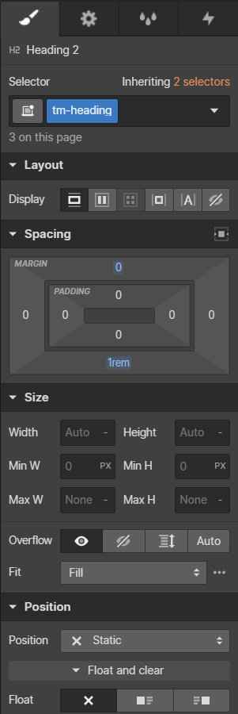

* All elements have classes applied to them, named with a *“tm-“* prefix to avoid class name collisions. Class names can be changed on all elements except the ones mentioned in the next bullet.
* All elements can be moved around **except** the following ones:
  + All elements inside the *“tm-pastry”* block.
  + All elements inside the *“tm-confirm-pastries”* block.

These ones should not be moved or deleted as the script generates them dynamically.

**Note**: they can be styled with no problems as the rest of the elements, as long as the class names aren’t changed.

## For developers

* GitHub repository: <https://github.com/brotame/qaterie>
* Code is written in Vanilla Javascript.
* As the code uses ES6 modules, it needs to be bundled. ParcelJS is used as a dev-pendency to bundle and compile (ParcelJS uses Babel).
* There are 4 modules:
  + Msf.js: controls the multi step functionality of the form.
  + Pastry.js: controls the pastries functionality (collecting data, adding, removing, toggling, printing).
  + Base.js: Contains the nodes that the code affects to and gets the available options of the pastries (read below).
  + Index.js: General controller.
* Pastry options are set through Webflow’s CMS. In order to make them available for the script to get them, a hidden collection is set on the page that prints out the values.

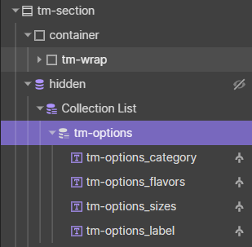

## For the client

* Pastry options can be created, edited or removed through Webflow’s CMS.
* The collection that contains all the options is the one called “TM Options”.

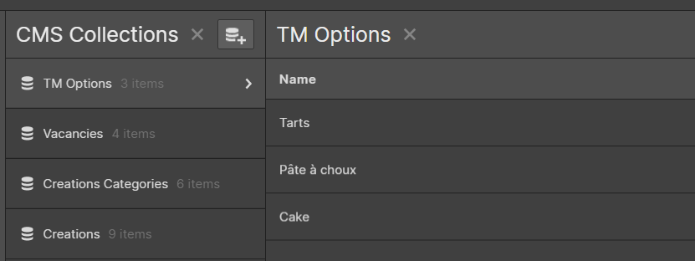

* Each collection item represents a Category. Inside the item, there are the following fields:
  + Name: Category Name
  + Slug: It’s not used, so no need to bother about it.
  + Flavors: Flavor options, separated with a comma and space “, “.
  + Sizes: Size options, separated with a comma and space “, “.
  + Quantity Label.

