Mario Maeder

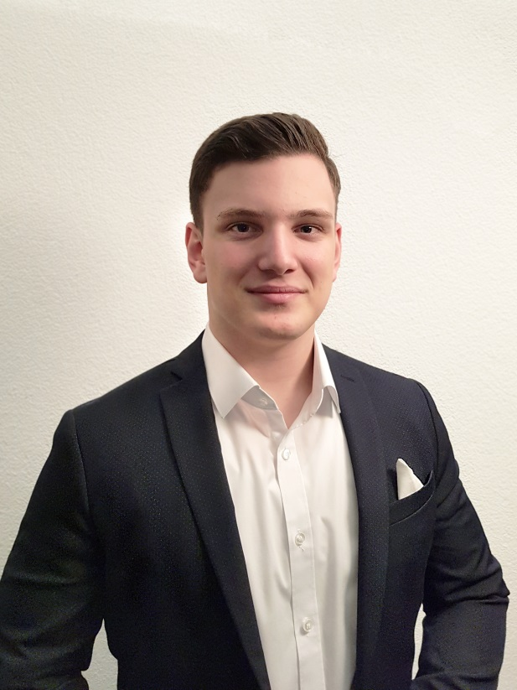

# Personal Data

Name: Mario Maeder  
Address: Sonnhaldenstrasse 6  
 8113 Boppelsen  
 + 41 79 710 15 71  
 + 41 44 844 20 41  
 <mailto:mario.maeder@ubs.com>  
 <mailto:brotasco@gmail.com>

Date of Birth: 16.11.1999  
Marital Status: single  
Citizenship: Swiss

apprenticeship

08/15 – 07/19 Application Developer  
 UBS Business Solution AG  
 8048 Altstetten

Graduation: Application Developer EFZ

# Education

08/15 – 07/19 Vocational   
 Bildungszentrum Zürichsee (BZZ)  
 8810 Horgen

08/12 – 07/15 Secondary school Level A  
 Sekundarschule unteres Furttal (SekUF)  
 8112 Otelfingen

08/06 – 07/12 Primary School  
 Primarschule Maiacher  
 8113 Boppelsen

# Knowledge And Hobbies

iU: intensive use

IT: Java - very good (4 years **iU**)  
 Hibernate - very good (3 years **iU**)  
 Spring(-boot) - very good (3 years **iU**)  
 JSF - good (2 years of experience)  
 Rest - very good (3 years **iU**)

JavaScript - very good (3 years **iU**)  
 React JS - very good (3 years **iU**)  
 Node JS - very good (3 years **iU**)

SQL - very good (4 years **iU**)  
 PLSQL - good (2 years **iU**)  
 Oracle - very good (3 years **iU**)

PHP - passable (1 year Practice)  
 C - passable (1/2 years Practice)

Github - very good (3 years **iU**)  
SVN - very good (2 years **iU**)

Languages: German (native language)  
English (advanced / Advanced Diploma)  
French (School knowledge / B2 / communication possible)

Hobbies: Sport (Tennis, Fitness, MMA)  
Music (Piano, Digital Keyboard, Synth.)

# Additional Information

References: On request I will gladly announce the references