**Objective**

Our task is to predict the winner of the 2017 GRAMMY Record of the Year award. Because our model can be easily applied to future GRAMMY seasons, these results will yield insights into subtle differences between popular expectations and actual winners, especially in upset years, and can help provide context for identifying shifts and trends in popular music. Our project output is a ranking of all songs that have made an appearance on the Billboard Top 100 in this year’s GRAMMY eligibility period by their likelihood of winning the Record of the Year award.

**Data**

Our data set consists of roughly 5400 songs from 1958-2015 that were on the year-end Billboard Top 100 list, giving us a set of popular and significant songs spread out over the time that the GRAMMYs have been contested. For each song, we collected information on 23 different attributes:

* General information (year of release, genre, and song duration)
* Measures of popularity (Spotify popularity; Last.fm followers of the artist, listeners to the song, and play count of the song)
* Characteristics of lyrics (word count, Flesch reading ease, and the positivity and subjectivity of the lyrics)
* Characteristics of music, as calculated by Spotify (key, major/minor modality, and time signature; danceability, energy, tempo, and loudness; speechiness, acousticness, instrumentalness, and liveness; and the positivity of the music)

**Model**

Our model makes rankings by predicting the numerical “winner score” (in our training data, a song’s score was 1 if the song won Record of the Year and was 0.2 if the song was nominated for the award) for each song in a given set using a multilayer perceptron model with two hidden layers. To reflect the greater predictive power of recent results, our training data was also weighted using a logistic function in the difference between each song’s year of release and the last year in our training set. Songs with higher predicted scores are predicted as more likely to win Record of the Year.

To test the performance of our model, we trained on songs from 1958-2010 and generated predictions for the scores of songs from 2011-2015. Using these scores, we created rankings of songs by their year of release and examined the ranked positions of the Record of the Year winners and nominees in each year to evaluate our model. The graph below displays our results. Our model correctly predicted the Record of the Year winner in 2011, 2012, and 2014, while ranking 2013’s winner 5th and 2015’s winner 21st.

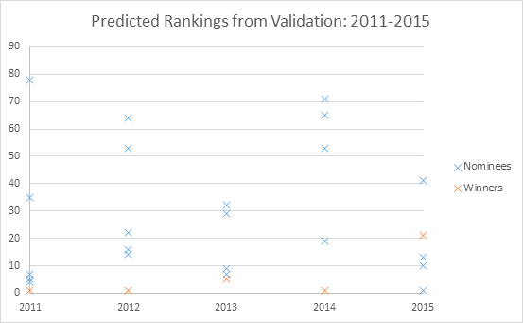

**Predictions**

After using our model to rank all songs that have appeared on the Billboard Top 100 list since October 1, 2015 (the cutoff for eligibility for the 2017 GRAMMYs), we predict that Ultralight Beam by Kanye West is the favorite for 2017’s Record of the Year award. Below is a list of our predicted top-30 songs.

*List of songs goes here*

**Teamwork**

*Teamwork section as before*