MANUAL

Client-Server Operation of QRap

Table of Contents
Table of Contents
1Introduction 3
2Backup 4
2.1Making a backup 4
2.2Restoring from backup 4
3Importing and Exporting 6
3.1Exporting to a file 6
3.2Importing from a file 6
4Updating to a Server 7
4.1Running the Server 7
4.2Registering an identifier 8
4.3Updating to a Server 8

Introduction
To open the import and export menu, click on the Import&Export button (as shown in figure ).
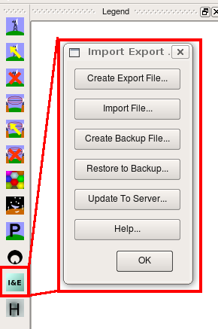

There are 7 options on this menu. These are
- Create Export File... This option creates a standalone export file. Note that sites will not be automatically deleted from a client if this option is used.
- Import File... This imports data from either an exported file (such as created by Create Export File or one that is created from an Excel file).
- Create Backup File... This creates a backup file from the database (Backups should preferably mad regularly). Backups should be made regularly. The backup functionality backs up the whole database.
- Restore Backup File... Restores the database from a backup file. Any data that was inserted to the database since the backup was last made will be lost.
- Run the Server... Executes the server in a separate process.
- Update to Server... This updates the current database to the server.
- Help... Shows this help file.

Backup
The backup functionality backs up most of the important tables to file. This functionality would most likely be used in the event of data loss.

Making a backup
Clicking on the Create Backup File button brings up the following window:

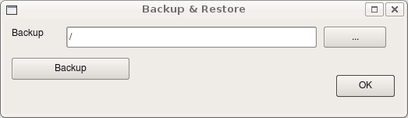

By clicking on the ... button the file to which the backup will be made can be selected. This looks as follows:

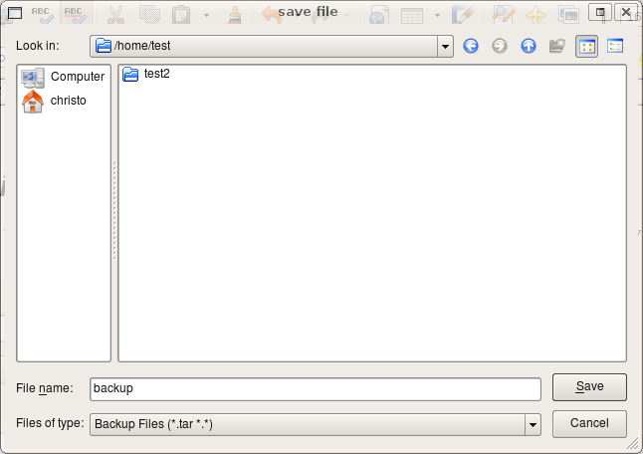

The file is selected by selecting the directory and naming the file and clicking on the Save button (this save file dialog will then close). Clicking on the Backup button in the Backup dialog will create the backup file.

N.B. Ensure that the database user has privileges to create and write the specified file (it is the database user that writes the file – not the user under which QGis was run).

Restoring from backup
The database can be restored from an earlier backup by clicking on the Restore from Backup button.

N.B.1 Ensure that the database user has privileges to read the specified file (it is the database user that reads the file – not the user under which QGis was run).

N.B. 2 Restoring the database from an earlier file will remove any changes that was made between when the backup was made and the restore done.

The Restore dialog is shown below.

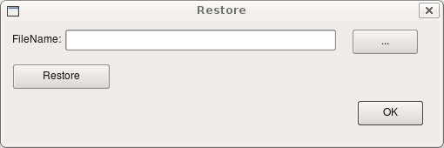

The filename from which the database will be restored is selected by clicking the ... button (the same as above). Clicking on the Restore button will restore the database to this file. The dialog is closed with the Ok button.

Importing and Exporting
QRap provides two methods to transfer updates – exporting and importing from file, and exporting and importing over a network. Updating of the server from a client should preferably be done using the Client-Server model over a network. The disadvantage of working with files are that sites will not automatically be deleted on client machines.

There is one case where importing and exporting with files is beneficial: data from an external source (e.g. previously generated data from an excel file).

Exporting to a file
The Create Update File menu is shown below.
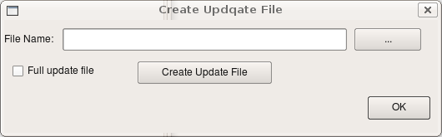

The file to which the update should be written is selected by clicking on the ... button. There are two options for the update file:
- Create a full update file
- Create an update file with only the entries added by this machine (checkbox not selected).
It is recommended that all the updates from the server to the clients are full update files. All the updates from the clients to the server should be an update file with only the entries created by this machine – this will prevent loading entries to the server that was already deleted on the server.

Importing from a file
The Import File dialog is given below
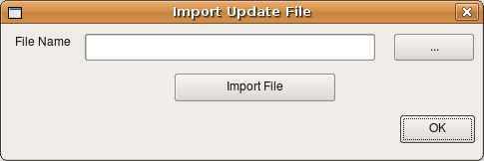

To import the file, click on the Import File button. To close the dialog, click the Ok button.

Creating a custom import file
A custom import file can be created to import data from other sources (such as legacy programs). The data should be stored in a flat file. The format of the flat file is given in the table below.
# | Column Name | Data Type
1 | sitelastmodified | TIMESTAMP
2 | sitemachineid | INT2
3 | sitesitename | TEXT
4 | sitestatus | VARCHAR (15)
5 | sitegroundheight | INT4
6 | sitecontactslastmodified | TIMESTAMP
7 | sitecontactsmachineid | INT2
8 | sitecontactsownername | VARCHAR (100)
9 | sitecontactsnaturalperson | BOOL
10 | sitecontactscontactname | VARCHAR (100)
11 | sitecontactspostaladdress | TEXT
12 | sitecontactstel | VARCHAR (20)
13 | sitecontactsidnumber | BPCHAR (13)
14 | sitecontactscontract | VARCHAR (30)
15 | sitecontactscontractstartdate | DATE
16 | sitecontactscontractenddate | DATE
17 | sitecontactsmonthlyrental | NUMERIC (983042)
18 | sitecontactselectricitysupplier | VARCHAR (30)
19 | sitecontactselectricityaccno | VARCHAR (20)
20 | sitecontactselectricitypoleno | VARCHAR (15)
21 | sitedescriptionlastmodified | TIMESTAMP
22 | sitedescriptionmachineid | INT2
23 | sitedescriptionphysicaladdress | TEXT
24 | sitedescriptionstructuretype | VARCHAR (20)
25 | sitedescriptionstructureheight | FLOAT4
26 | sitedescriptionstructurecapacity | FLOAT4
27 | sitedescriptionavailablecapacity | TEXT
28 | sitedescriptionpowersupply | VARCHAR (12)
29 | sitedescriptionfencing | VARCHAR (50)
30 | sitedescriptionaccess | TEXT
31 | sitedescriptioncontainertype | VARCHAR (15)
32 | sitedescriptionsitedocumentation | TEXT
33 | radioinstallationlastmodified | TIMESTAMP
34 | radioinstallationmachineid | INT2
35 | radioinstallationsector | INT4
36 | radioinstallationpermanent | BOOL
37 | radioinstallationtechkey | INT2
38 | radioinstallationeirp | FLOAT4
39 | radioinstallationdiversity | BOOL
40 | radioinstallationtxpower | FLOAT4
41 | radioinstallationtxlosses | FLOAT4
42 | radioinstallationtxantennaheight | FLOAT4
43 | radioinstallationtxantpatternkey | INT4
44 | radioinstallationtxbearing | FLOAT4
45 | radioinstallationtxmechtilt | FLOAT4
46 | radioinstallationrxsensitivity | FLOAT4
47 | radioinstallationrxlosses | FLOAT4
48 | radioinstallationrxantennaheight | FLOAT4
49 | radioinstallationrxantpatternkey | INT4
50 | radioinstallationrxbearing | FLOAT4
51 | radioinstallationrxmechtilt | FLOAT4
52 | radioinstallationbtlplot | INT4
53 | radioinstallationflaga | VARCHAR (50)
54 | radioinstallationflagb | VARCHAR (50)
55 | radioinstallationflagc | VARCHAR (50)
56 | celllastmodified | TIMESTAMP
57 | cellmachineid | INT2
58 | cellmastercell | INT4
59 | cellrisector | INT4
60 | cellpermanent | BOOL
61 | cellcstraffic | FLOAT4
62 | cellpstraffic | FLOAT4
63 | celltxpower | FLOAT4
64 | cellbeacon | INT4
65 | celllayerthreshold | INT4
66 | antennapatternpatternfile | VARCHAR (100)
67 | technologytechnologytype | VARCHAR (20)
68 | frequencyallocationlistlastmodified | TIMESTAMP
69 | frequencyallocationlistmachineid | INT2
70 | frequencyallocationlistci | INT4
71 | frequencyallocationlistcarrier | INT
72 | frequencyallocationlistchannel | INT
73 | locationtext | VARCHAR (100)

If there is no value for a specific column, it can be indicated with a \N sign.The separator between two columns is a tab space. The position should be indicated by a point (see example below).

2008-07-29 15:39:05.605496 2 Pretoria Experimental 200 2008-07-29 15:40:45.130152 2 Pietman van Niekerk t Pietman PO Box 1234 082 123456 7802235007098 Yes 2000-01-01 2020-01-01 200.00 Eskom 947343498 123455 2008-07-29 15:39:29.805776 2 Hatfield Guyed lattice 10 0 Wind Electric palicade Brick Yes 2008-07-29 15:42:46.801225 2 1 t \N 2 t 34.7712 3 3 \N 3 3 1 2 0 \N 0 0 \N \N FlagB FlagC \N \N \N \N \N \N \N \N \N \N \N \N POINT(28.4237 -25.7403)

Working with an import file in openoffice
Openoffce spreadsheet has the ability to work with CSV files if you prefer to work with the files manually. Rename the txd file to a CSV file. To open the file, run OpenOffice Spreadsheet. Open the csv file in OpenOffice. Open Office opens up the following window:

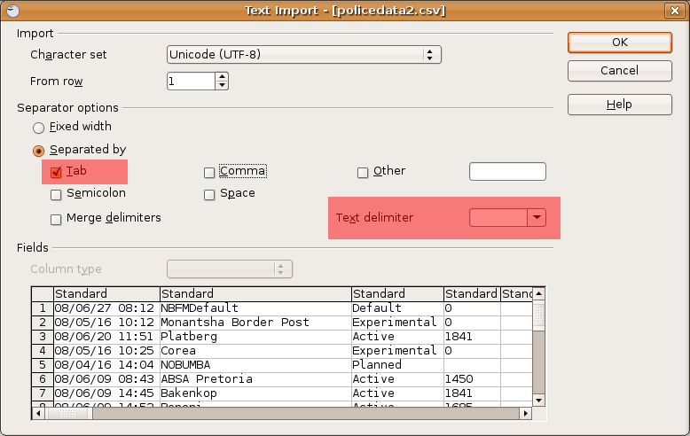
Ensure that you select a Tab Separator and that the text delimiter is not set. You can now edit the file as you would a normal Spreadsheet file. Notice that the \N sign shows a cell that does not have a value (you can write over them or replace them).
After you have saved the file, run fixtxd (fixtxd inputfilename outputfilename) to esure that the file is in the correct format. This file can then be imported and exported just as a normal exported file.

Updating to a Server

Running the Server
The server is run by clicking on the Run Server button. The server is run as a separate process. Alternatively, the server can be run by typing qrapserver in the command line.
The server's window is shown below.
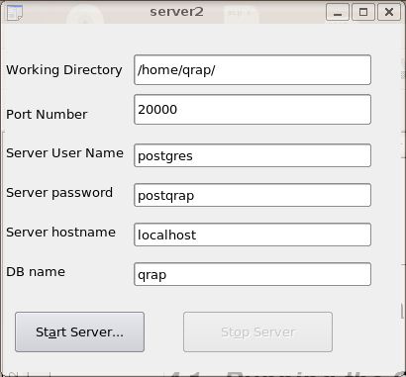
The working directory is the directory that the qrapserver will use to create its temporary files and serving files to the client. The port number is the port on which the server will listen on. Ensure that the user can open the specified ports.

The Server Username is the name that the server should use in the local database. The Server Password is the password for the database account. The Server hostname is the hostname of the database which will be accessed (usually localhost). The DB name is the name of the database that the server will use.
To start the server, press the Start Server button on the window.

Clicking on the Update To Server button in QGis produces the following window.
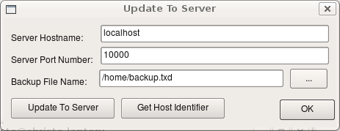

The Server Hostname is the hostname of the server. If the clients and the server are on a local area network, the server hostname can be obtained by executing ifconfig. As an example, consider the output of ifconfig below.
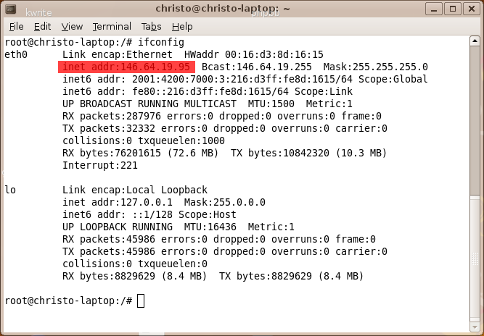

Registering an identifier
Before sites are added to a client, it should register a unique ID from the server. This can be done by clicking on the Get Host Identifier button, after the network settings is set correctly.

Updating to a Server
After the network settings are set correctly and the server is run, the client and server can be updated by clicking on the Update to Server button. This will send all the information created by the client to the server and download all the new information to the client.

