ResumeMatch AI — Technical Test Report
Project | ResumeMatch AI (CVisionnaires AI) — CV / job-offer matching platform
Version tested | main @ 4c99d1f (+ test tooling)
Test date | 11 October 2026
Environment | Windows 11 · Python 3.14.3 · Django 5.2.18 · DRF 3.18.3 · Node 24.14.1 · React 19 · Vite 8 · SQLite · AI engine in demo (mock) mode
Tools | Django test runner + Coverage.py · Vitest · Playwright · Locust · Lighthouse
Design | UML class, use case and activity diagrams (PlantUML) — section 3
Prompts | Development prompts given to the Cursor agent and LLM prompts embedded in the app — section 4

1. Executive summary
The full application (Django REST API + React SPA) was tested with five complementary tools, each covering a different level of the test pyramid: backend unit/integration tests, frontend unit tests, browser end-to-end tests, load testing and a quality audit.
Indicator | Result
Automated functional tests executed | 86 (52 backend + 19 frontend + 15 end-to-end)
Functional tests passed | 86 / 86 (100 %)
Backend code coverage | 83 % of statements (2 169 statements, 369 missed)
Frontend unit coverage | 90 % of src/lib business logic — 4.4 % of the whole src tree
API under normal load (20 users) | 975 requests, 0 errors, median 7 ms, p95 23 ms
API under stress (100 users) | 4 517 requests, median 10 ms, p95 97 ms; the only errors (3.4 %) are intentional 429 quota responses
Lighthouse (desktop) | Performance 89–98, Accessibility 100, Best practices 100, SEO 82–83
Lighthouse (mobile landing page) | Performance 65 (LCP 7.1 s)

Verdict: the application is functionally stable — every user journey works end to end, the API is fast and did not produce a single server error under load, and accessibility/best-practice audits are perfect. The main improvement areas are mobile loading performance of the landing page, SEO metadata, unit tests for React components, and the cost of login under concurrent load.

2. System under test
Browser (React 19 SPA, Vite) ──/api──► Django 5 + DRF (JWT auth) ──► SQLite
│
├── AI service (Anthropic/OpenAI/Gemini, or deterministic mock)
└── Job feeds (Remotive, Arbeitnow, Jobicy, Adzuna, France Travail)
Module | Backend app | Main frontend pages
Authentication | accounts | Landing, Login, Register, Profile
CV management | cvs, pdf_service, ats_service | Analysis wizard (upload step)
Analysis engine | analyses, ai_service, scoring | Wizard, Results, History, Compare, Dashboard
Job search | job_search_service, job_import_service | Job search, Application board
Administration | adminpanel | Admin console

Test data: the database was seeded with the built-in seed_demo command (1 admin, 3 candidates — Sarah, Karim, Léa — with CVs, analyses and cover letters). The developer database was backed up before testing and restored afterwards.
AI mode: no LLM API key is configured, so the AI engine ran in its deterministic demo mode. Response times therefore measure the application itself, not a third-party AI provider.

3. Software design — UML diagrams
The application was modelled with PlantUML from its actual code (Django models, API views, services and React pages). Diagram labels are in French, the project's working language. Sources are in docs/conception/diagrammes/; PNG and SVG renderings are in docs/conception/images/.
Diagram | UML type | What it shows
Domain model | Class | Entities, attributes, enumerations, multiplicities and service dependencies
Visitor and Candidate | Use case | 21 use cases with include / extend relations and two external systems
Administration | Use case | Admin console features, all requiring an is_staff account
Run a CV / job analysis | Activity | Upload, quota check, asynchronous job and progress polling
AI job search | Activity | Search plan, 5 job sources in parallel, filtering and AI ranking
Registration, login and JWT session | Activity | Sign-up, login, automatic token refresh and logout

3.1 Class diagram
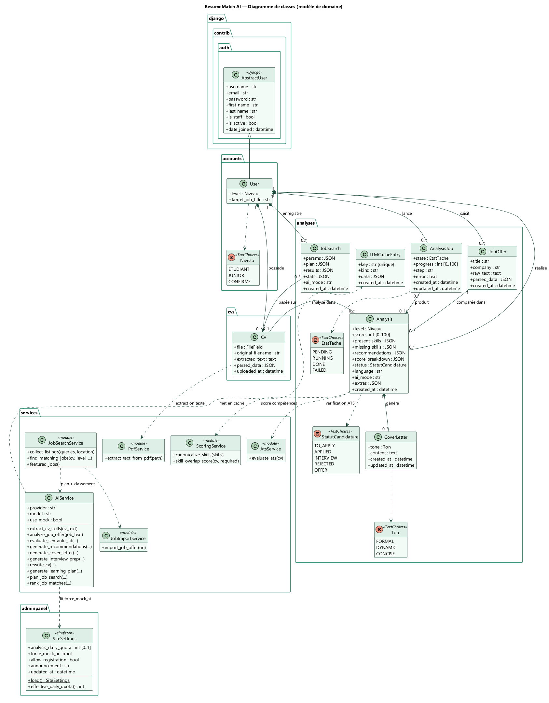
Figure — Class diagram — domain model
Class | Role
User | Extends Django's AbstractUser with a level (student / junior / senior) and a target job title
CV | Uploaded PDF, extracted text and structured skills (parsed_data)
JobOffer | Job offer pasted or imported from a URL, with its structured analysis
Analysis | Matches one CV with one offer: score 0–100, present / missing skills, recommendations, application status (Kanban) and career-toolkit results (extras)
CoverLetter | Cover letter generated for an analysis in a given tone
AnalysisJob | Asynchronous analysis task (pending → running → done / failed) with progress
JobSearch | AI job search: parameters, plan and ranked results (last 10 kept per user)
LLMCacheEntry | Cache of LLM answers, keyed by a hash of the prompt
SiteSettings | Configuration singleton: daily quota, forced demo mode, registrations, announcement
AIService | Provider-agnostic AI service with Pydantic validation and mock fallback

A user owns (composition, on_delete=CASCADE) their CVs, offers, analyses, jobs and searches. An analysis links exactly one CV and one offer, while a CV or an offer can be reused in many analyses. An AnalysisJob produces at most one analysis, and a JobSearch is based on at most one CV (both SET_NULL).

3.2 Use case diagrams
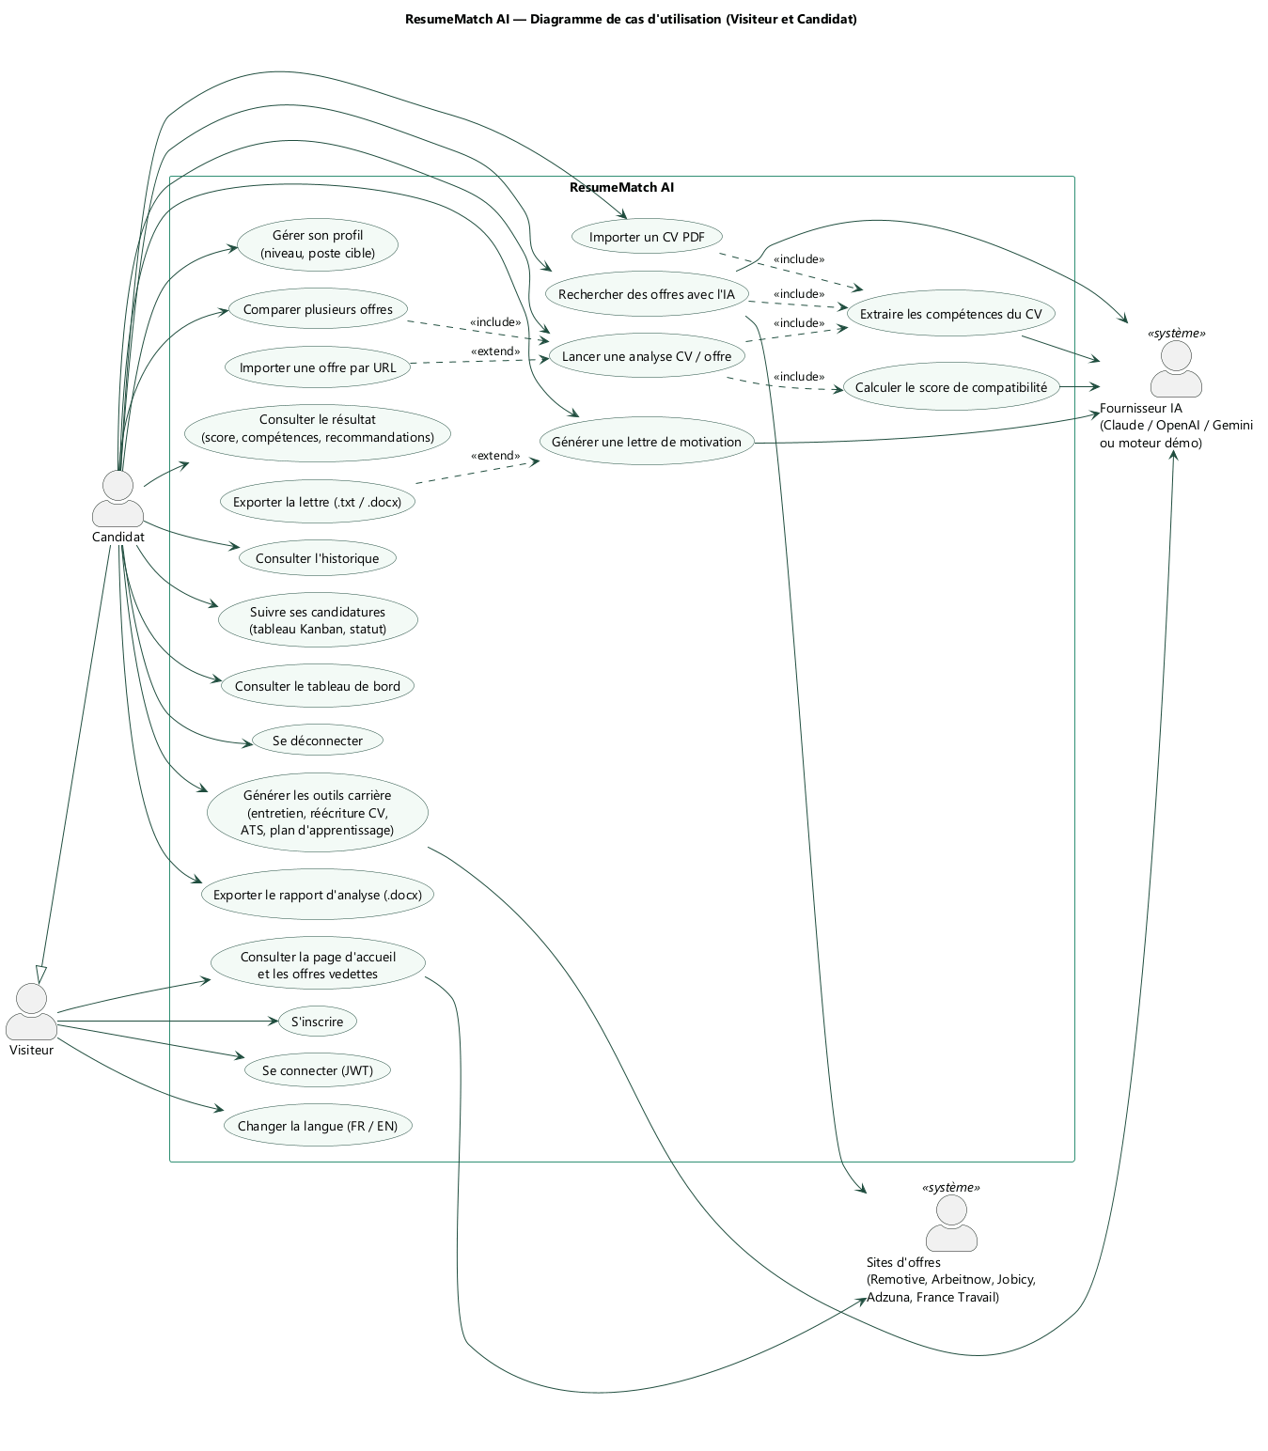
Figure — Use cases — Visitor and Candidate
The Visitor can browse the landing page, register, log in and switch language. The Candidate inherits these and uses every analysis feature. Run an analysis includes skill extraction and score calculation; import an offer from a URL extends it; export the cover letter extends cover-letter generation. The AI provider (Claude, OpenAI, Gemini or the demo engine) and the job sites (Remotive, Arbeitnow, Jobicy, Adzuna, France Travail) are external system actors.
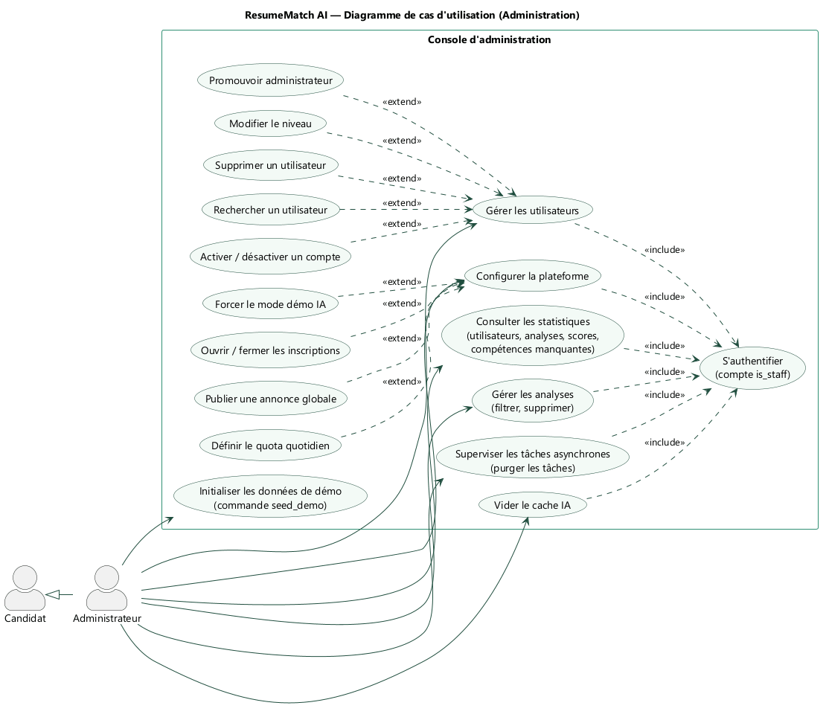
Figure — Use cases — Administration
The Administrator inherits from the Candidate. Every administration use case includes authentication with an is_staff account. User management (search, activate, promote, change level, delete) and platform configuration (quota, demo mode, registrations, announcement) are modelled as extensions.

3.3 Activity diagrams
Swimlanes show who performs each action: the candidate, the React interface, the Django API or the AI service.
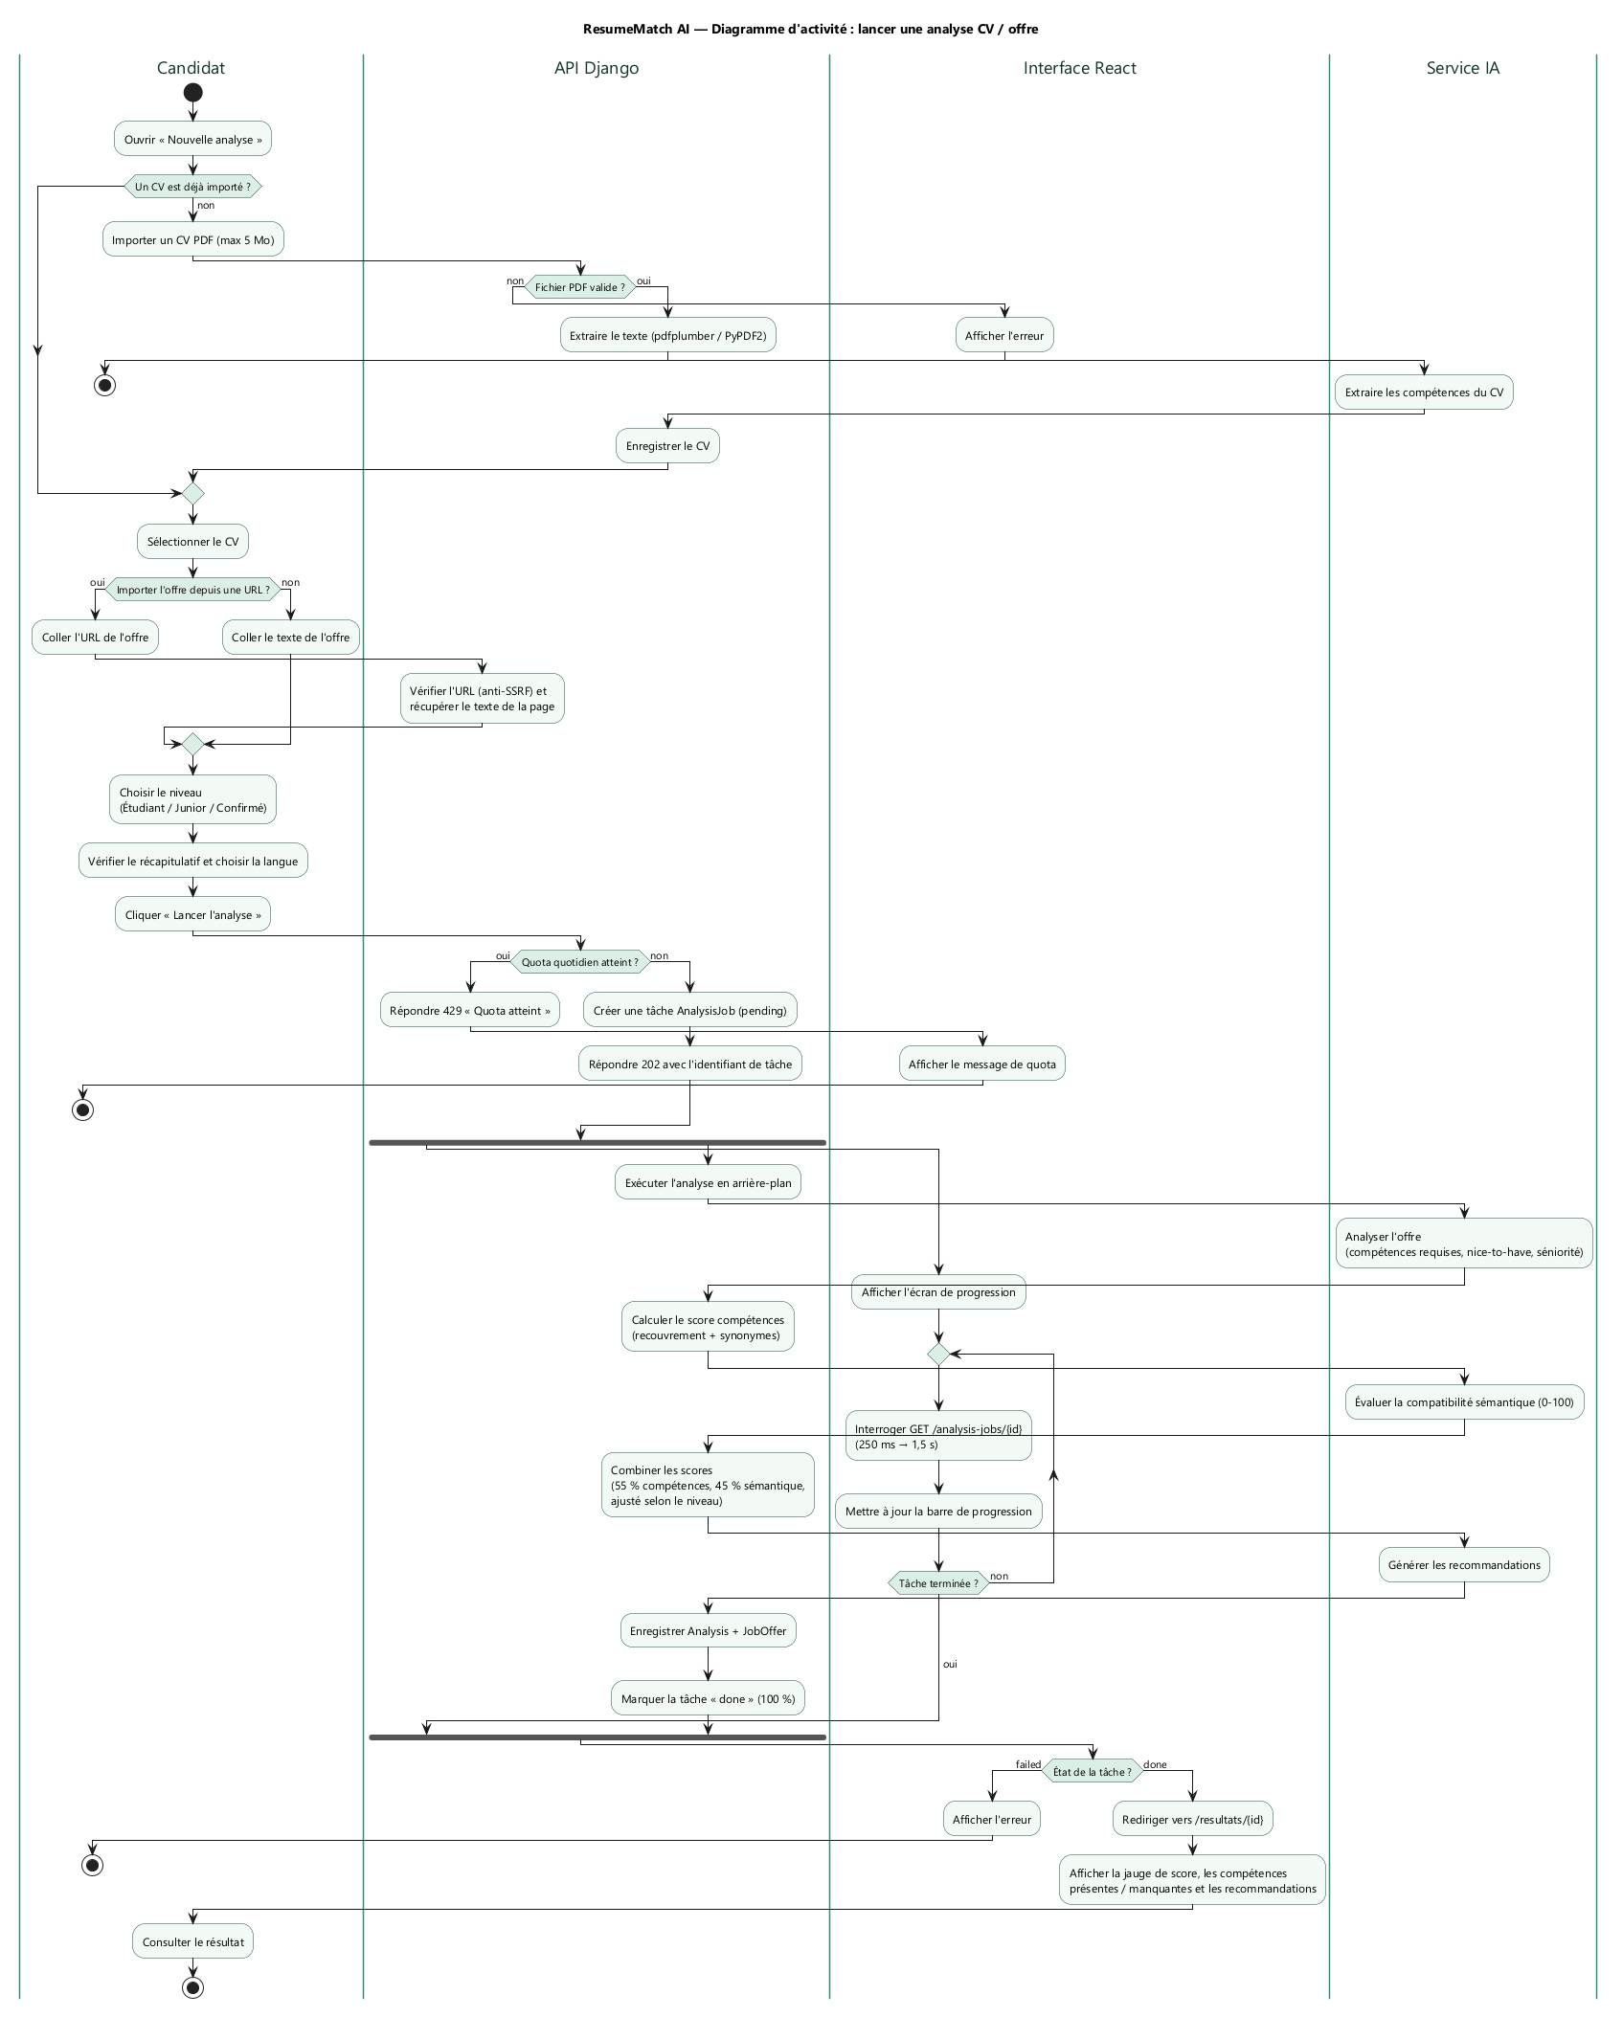
Figure — Activity — run a CV / job analysis
The CV is validated (PDF, 5 MB maximum) and its skills extracted; the offer is pasted or imported from a URL (SSRF-protected). If the daily quota is reached the API answers 429; otherwise it creates an AnalysisJob and answers 202 immediately. The analysis then runs in the background (offer analysis, skill score, semantic score, 55 % / 45 % weighting adjusted to the level, recommendations) in parallel with the interface polling the job (250 ms growing to 1.5 s), before redirecting to the results.
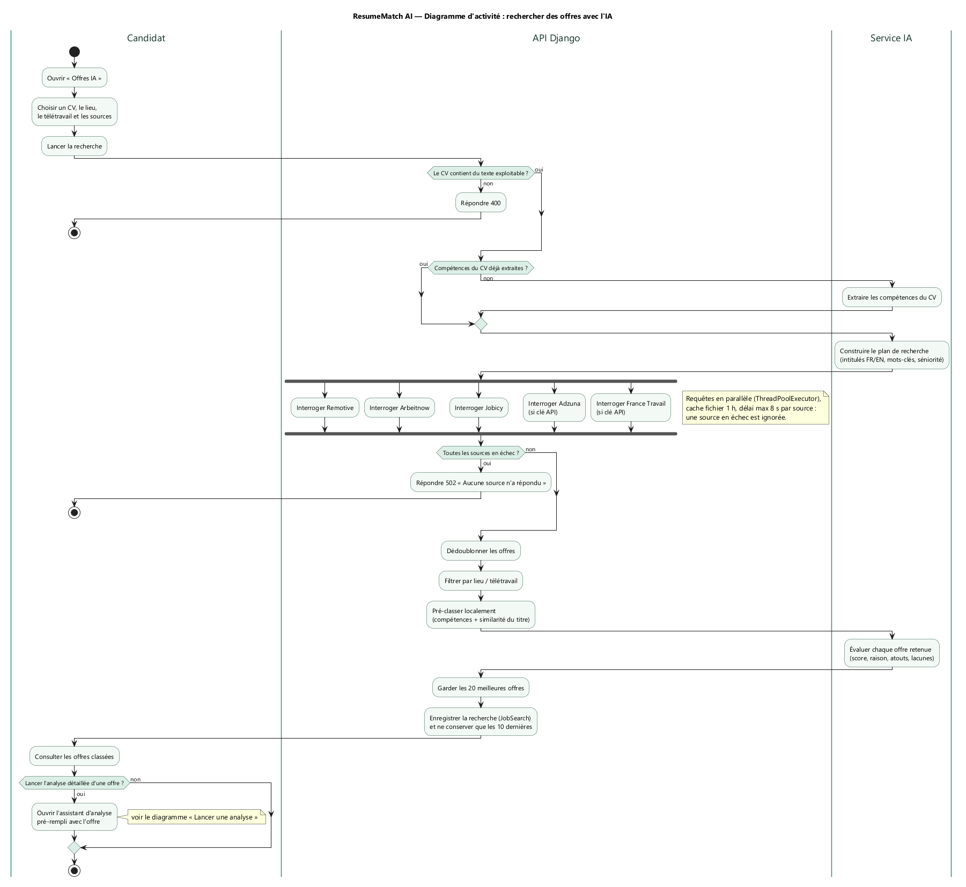
Figure — Activity — AI job search
The API rejects a CV without usable text (400), reuses already-extracted skills, asks the AI for a search plan (French and English titles, keywords, seniority), then queries the 5 sources in parallel (1-hour cache, 8 s maximum per source, a failing source is skipped; 502 if all fail). Offers are deduplicated, filtered by location / remote, pre-ranked locally and ranked by the AI; the top 20 are kept and the search is saved.
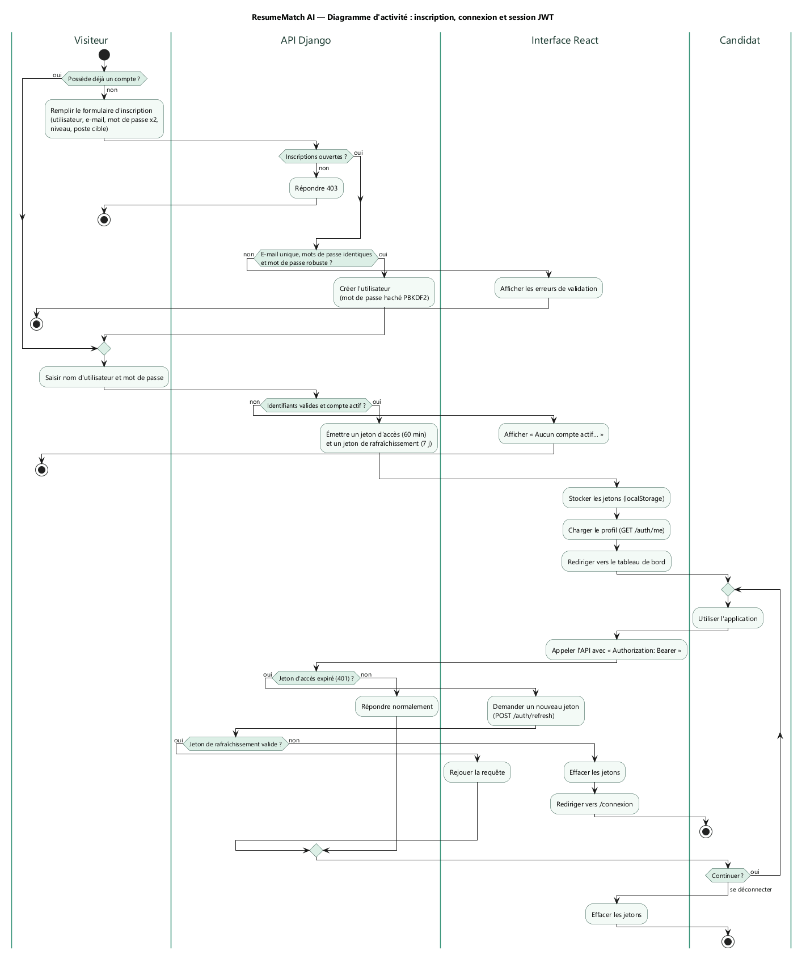
Figure — Activity — registration, login and JWT session
Registration checks that sign-ups are open (403 otherwise) and validates the form (unique e-mail, matching and strong passwords; PBKDF2 hashing). Login issues an access token (60 min) and a refresh token (7 days). When an API call returns 401, the interface requests a new token and replays the request, or clears the session and redirects to the login page if the refresh token is invalid.

4. Prompts used to build the application
ResumeMatch AI was built with the Cursor AI agent. Two kinds of prompts are documented here: the instructions given to the agent during development, and the prompts the application itself sends to the LLM. The full French version, with every prompt text, is in docs/conception/PROMPTS.md.

4.1 Project timeline
Date | Commit | Author | Step
05/10/2026 | 47f5c5f | azouzi marwen | Repository initialised
05/10/2026 | 58adf16 | Cursor Agent | Full MVP: Django API + React interface
05/10/2026 | 34bf48f | Cursor Agent | History search filter fix
05/10/2026 | 1ad595b | Cursor Agent | Scoring unit tests (synonyms, overlap)
05/10/2026 | fbc695e, d6d6a07 | Cursor Agent | Forest / teal colour palette and favicon
05/10/2026 | c10ac4a | Cursor Agent | start-local.sh one-command launcher
05/10/2026 | 13a2769 | Mahdibouazizi + Cursor | AI job search, admin console, demo data, career toolkit, async analyses, FR / EN
11/10/2026 | 4c99d1f | brouri12 + Cursor | Interface responsiveness optimisation
11/10/2026 | — | Cursor Agent | 5 module branches, test campaign, this report, UML design

4.2 Creation phase — 5 October 2026 (reconstructed prompts)
The conversations of this phase were held with a Cursor agent on another account (commits signed Cursor Agent, co-author marwenazouzi44), so their original text is not available locally. The prompts below are reconstructed from the exact content of each commit; they describe faithfully what was requested and delivered, but are not word-for-word.
# | Commit | Reconstructed prompt (summary)
C1 | 58adf16 | Build the full-stack « ResumeMatch AI » app (Django 5 + DRF + JWT, React + Vite + Tailwind): JWT accounts with level, PDF CV upload and text extraction, LLM skill extraction, job-offer analysis, hybrid 0–100 score (55 % skills / 45 % semantic, adjusted by level), recommendations, cover letters in 3 tones with export, history; provider-agnostic AI with an offline mock when no API key is set
C2 | 34bf48f | Fix the history page search filter
C3 | 1ad595b | Add unit tests for scoring: skill synonyms and overlap score
C4 | fbc695e, d6d6a07 | Replace the cream / terracotta palette with forest / teal tones and align the favicon
C5 | c10ac4a | Add start-local.sh: venv, migrations, Django on :8765 and Vite on :43124 in one command
C6 | 13a2769 | Add AI job search over real job feeds, live offers on the landing page, admin console, seed_demo, interview prep, CV rewrite, ATS check, learning plan, .docx report, async analyses, URL import, multi-offer comparison, Kanban board, score timeline, FR / EN interface, LLM cache, throttling and quotas

4.3 Evolution and quality phase — 11 October 2026 (original prompts)
Exact prompts typed in Cursor, in order (automatic environment notifications excluded):
# | Original prompt (verbatim) | Result
P1 | https://github.com/brouri12/resumematch-ai pull the project and run it in ide cursor | Project cloned and running locally
P2 | i want you to split this progect to 5 modules and the you push each module in that repo git in braches that has the name of each module ok | Branches auth, cv-management, analysis, job-search, admin-panel
P3 | now i want you to solve the prolems in the app because it take alot of time to respense for any action | Slowness traced to page animations (API was fast); navigation ≈ 0.35 s instead of over 1 s — commit 4c99d1f
P4 | YES | Fix pushed to main and the 5 module branches
P5 | I WANT YOU TO use 5 tools of test to test the full app and the collect the resultes and make a comparation table and dont forget to take screenshots to add it tho the technical raport that you gonna make it ok | Test campaign and this report (sections 5 to 13)
P6 | AJOUTER LES PROMPT utilisuer durant touts la creation de app et creerer les diagramme de classe et usecase et activiter | Sections 3 and 4 of this report, docs/conception/
P7 | ajouter le travail demander au rapport technique | Design and prompts integrated into this report

4.4 Prompts embedded in the application
The application sends its own prompts to the LLM (backend/services/ai_service.py). Each prompt demands an answer « UNIQUEMENT en JSON strict », includes the expected JSON schema (generated from a Pydantic model), and is validated with up to 3 attempts before falling back to the mock engine. Three reusable fragments personalise them:
Fragment | Values | Example of injected text
Level | etudiant, junior, confirme | « Le candidat est JUNIOR. Mets en avant les réalisations concrètes, outils maîtrisés et le travail en équipe. »
Tone | formal, dynamic, concise | « Ton concis, direct, sans fioritures (max 250 mots). »
Language | fr, en | « Write all textual content in English. »

Method | Feature | Prompt instruction (beginning)
extract_cv_skills | CV parsing | « Extrais du CV les informations suivantes en JSON strict. »
analyze_job_offer | Offer analysis | « Analyse cette offre d'emploi et extrais les compétences et infos en JSON strict. »
evaluate_semantic_fit | Semantic score | « Évalue la compatibilité sémantique entre le CV et l'offre (0-100). »
generate_recommendations | Recommendations | « Propose des recommandations d'amélioration du CV pour cette offre. »
generate_cover_letter | Cover letter | « Rédige une lettre de motivation personnalisée. »
generate_interview_prep | Interview prep | « Prépare le candidat à l'entretien pour cette offre. Génère 8 à 10 questions probables… »
rewrite_cv | CV rewrite | « Sélectionne 4 à 8 phrases/puces du CV qui gagneraient à être réécrites… sans inventer de faits »
generate_learning_plan | Learning plan | « Construis un plan d'apprentissage pour combler ces compétences manquantes… URLs réelles uniquement »
plan_job_search | Job search plan | « Tu prépares une recherche d'offres d'emploi pour ce candidat. Déduis du CV : target_titles… »
rank_job_matches | Offer ranking | « Évalue l'adéquation entre le CV et CHAQUE offre… Sois exigeant : une offre hors métier du candidat doit être sous 30. »

Prompt-engineering practices applied: structured output with schema + Pydantic validation; tolerant JSON extraction and retries; anti-hallucination constraints (« texte EXACT du CV », « sans inventer de faits », « URLs réelles uniquement »); cost control through text truncation (4 000–12 000 characters), the LLMCacheEntry cache, quotas and throttling.

5. Test strategy
Level | Question answered | Tool
Unit + integration (backend) | Do models, services, API endpoints and permissions behave correctly? How much code is exercised? | Django test runner + Coverage.py
Unit (frontend) | Is the client-side business logic (scoring display, i18n, helpers) correct? | Vitest (+ V8 coverage)
End-to-end (system) | Can a real user complete every journey in a real browser? | Playwright
Performance / load | How does the API behave with many simultaneous users? | Locust
Quality audit | Is the UI fast to load, accessible, secure and SEO-friendly? | Lighthouse

6. Tool 1 — Django test runner + Coverage.py (backend)
Purpose: unit and integration tests of the REST API, business services and permissions, measured with statement coverage.
Command
cd backend
python -m coverage run --source=accounts,cvs,analyses,adminpanel,services `
--omit="*/migrations/*,*/tests*.py" manage.py test -v 2
python -m coverage report --sort=cover
python -m coverage html -d ../docs/test-report/coverage-backend-html
Results
Metric | Value
Tests run | 52
Passed / failed / errors | 52 / 0 / 0
Duration | 12.9 s
Statement coverage | 83 % (1 800 / 2 169)

Least-covered modules | Coverage
cvs/views.py | 45 %
services/pdf_service.py | 53 %
cvs/serializers.py | 59 %
accounts/serializers.py | 63 %
analyses/views.py | 65 %

Best-covered: scoring.py 95 %, ats_service.py 95 %, analyses/models.py 94 %, adminpanel/views.py 90 %, all serializers of analyses and adminpanel 100 %.
Covered behaviours include: JWT registration/login, admin-only endpoints (non_staff_is_forbidden), daily analysis quota, async analysis jobs, DOCX report export, LLM JSON-retry fallback, ATS layout detection, SSRF protection on URL import (private_addresses_are_rejected), job-feed caching and failure isolation.
The red lines in the console capture are expected log messages produced by tests that deliberately simulate failures (an unreachable job source, an invalid LLM response); the tests themselves pass.
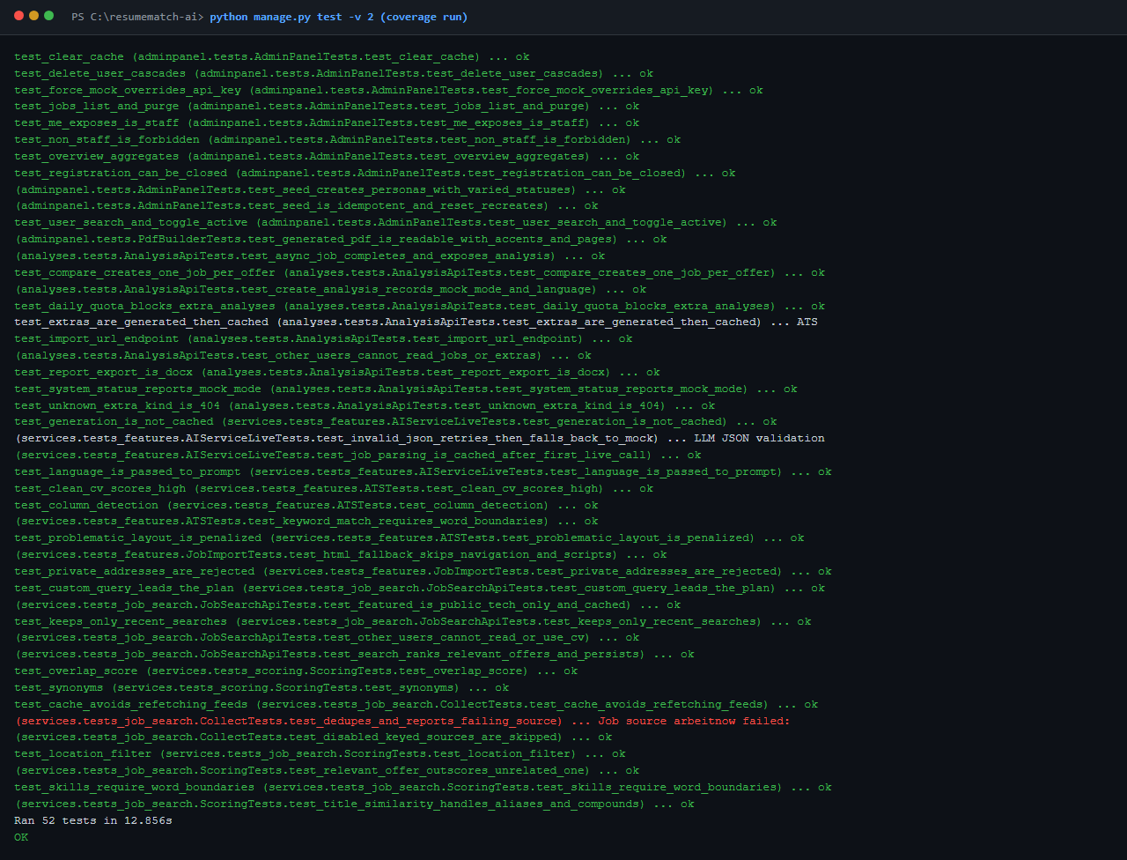
Figure — Django test run
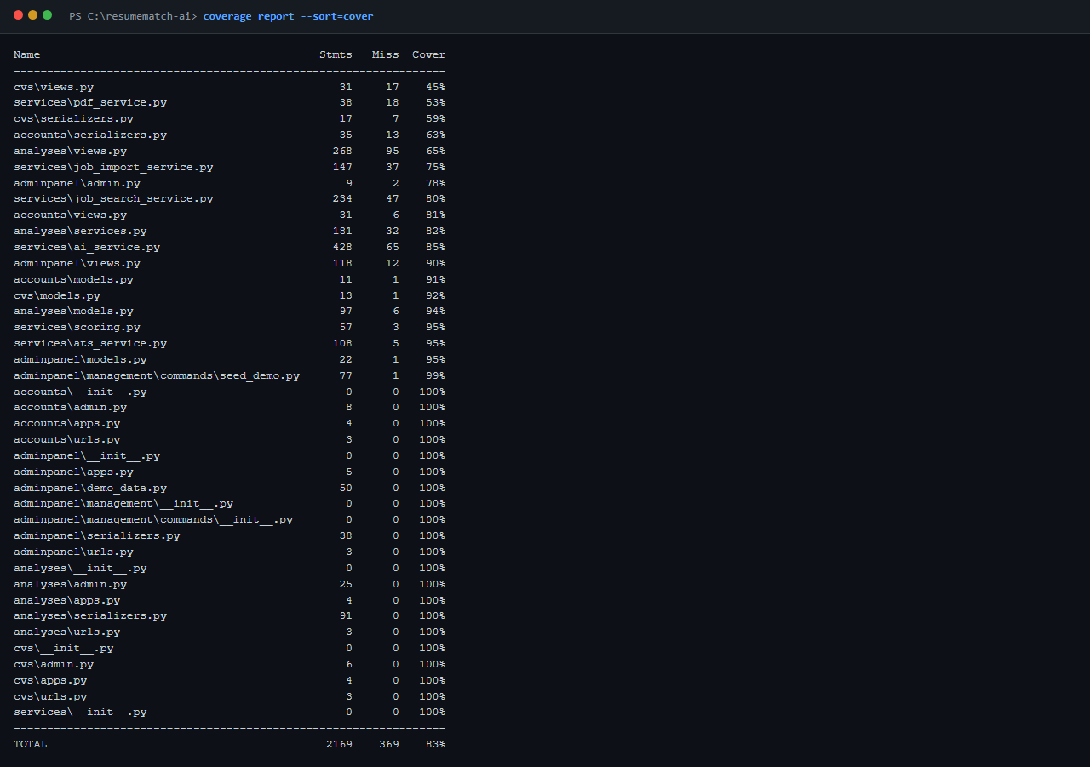
Figure — Coverage.py console report
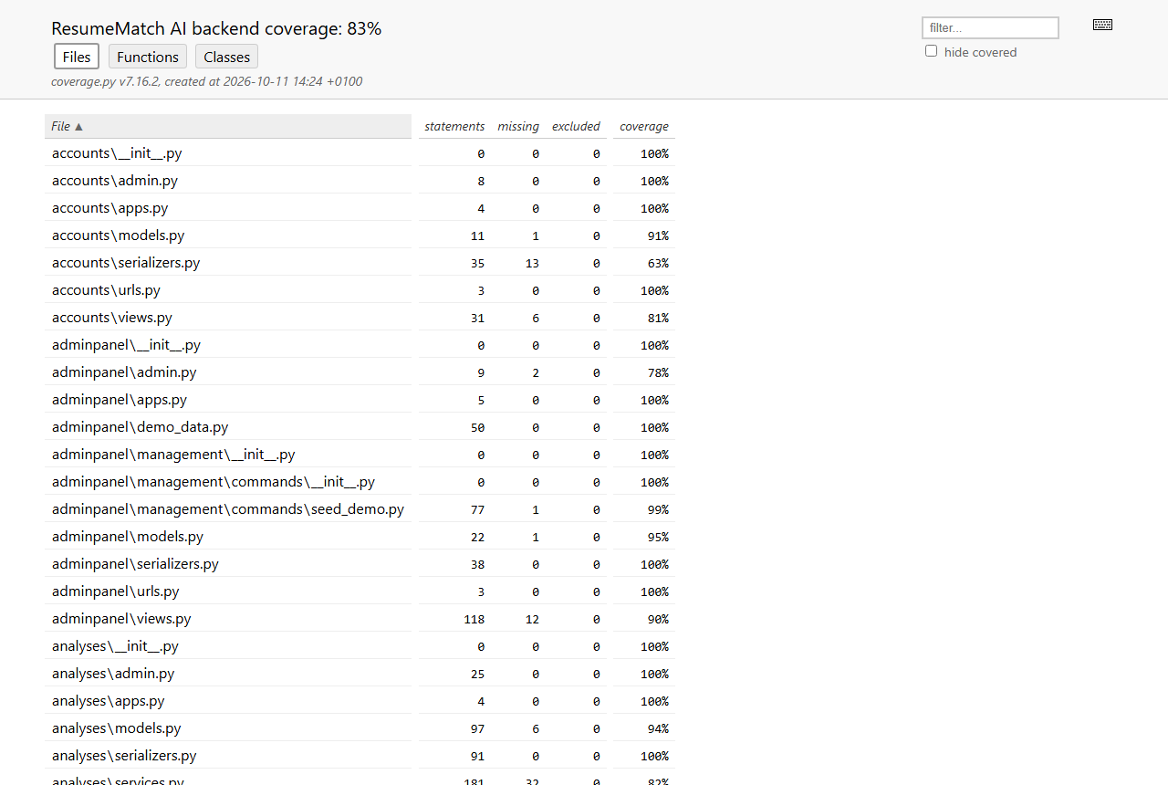
Figure — Coverage.py HTML report

7. Tool 2 — Vitest (frontend unit tests)
Purpose: fast unit tests of the React application's pure logic (helpers, translations), with V8 coverage.
Command
cd frontend
npm run test:coverage
Results
Metric | Value
Test files / tests | 2 / 19
Passed / failed | 19 / 0
Duration | 0.65 s
Coverage of src/lib (business logic) | 90 % statements · 84.6 % branches · 90 % functions
Coverage of whole src (incl. pages/components) | 4.4 % statements

Tested: score buckets, job-offer text builder, Kanban grouping by status, SVG score-chart geometry and trend, job ranking, URL validation, translation lookup/fallback/interpolation, and parity of keys and placeholders between French and English.
Finding: React pages, components and contexts have no unit tests (0 %). They are exercised only by the Playwright end-to-end suite (Tool 3).
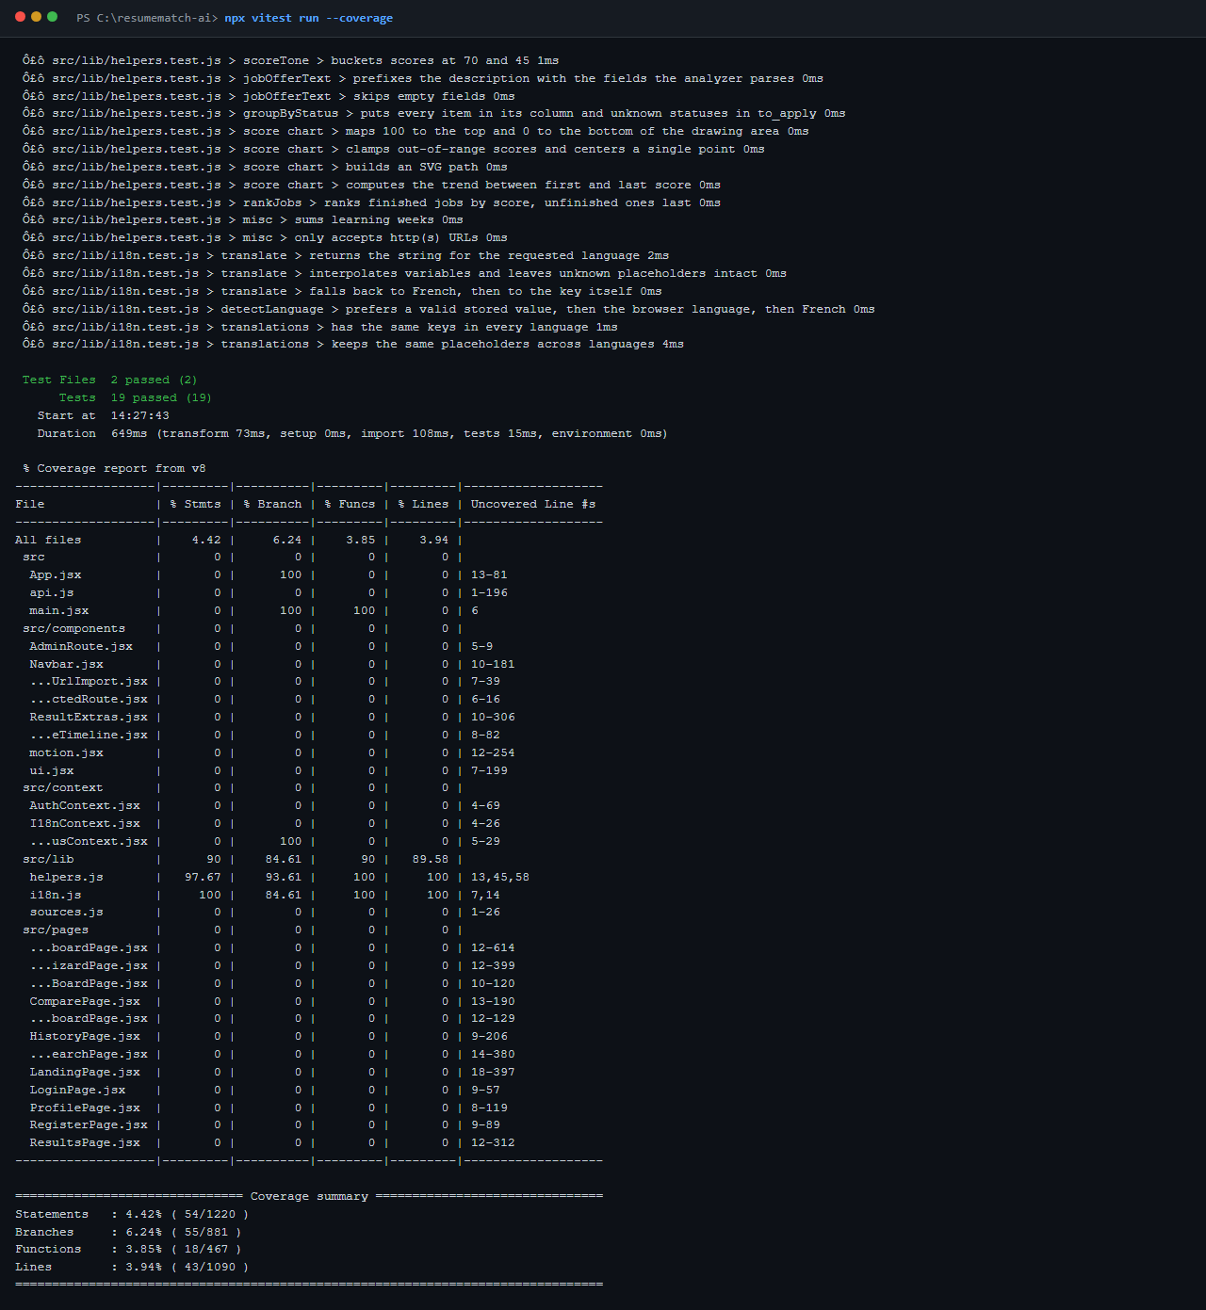
Figure — Vitest console output
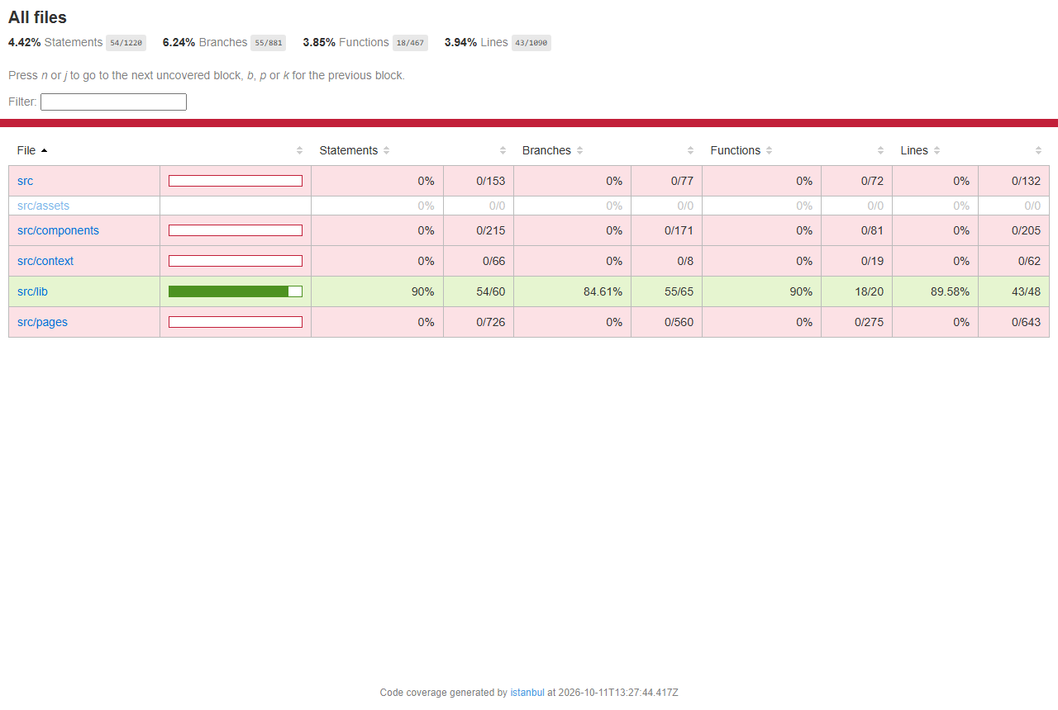
Figure — Vitest coverage report

8. Tool 3 — Playwright (end-to-end browser tests)
Purpose: drive a real Chromium browser through complete user journeys against the running frontend + backend, and capture screenshots.
Files: frontend/playwright.config.js, frontend/e2e/app.spec.js
Command
cd frontend
npm run test:e2e
Results — 15 / 15 passed in 75 s (Chromium 1280×800, locale fr-FR)
ID | Scenario | Result
E2E-01 | Landing page renders hero and call-to-action | ✅ Pass
E2E-02 | Protected route redirects anonymous users to login | ✅ Pass
E2E-03 | Login with a wrong password shows an error | ✅ Pass
E2E-04 | Registration creates an account and opens the dashboard | ✅ Pass
E2E-05 | Dashboard shows statistics and score timeline | ✅ Pass
E2E-06 | Upload a PDF CV in the analysis wizard | ✅ Pass
E2E-07 | Full CV / job-offer analysis (4-step wizard → results) | ✅ Pass — analysis completed in 148 ms
E2E-08 | History lists previous analyses | ✅ Pass
E2E-09 | Application board shows status columns | ✅ Pass
E2E-10 | Compare page and job-search page load | ✅ Pass
E2E-11 | Profile page shows the user's information | ✅ Pass
E2E-12 | Non-admin users cannot open the admin console | ✅ Pass
E2E-13 | Language switch translates the interface (FR → EN) | ✅ Pass
E2E-14 | Admin console shows the platform overview | ✅ Pass
E2E-15 | Mobile layout (390×844 viewport) | ✅ Pass

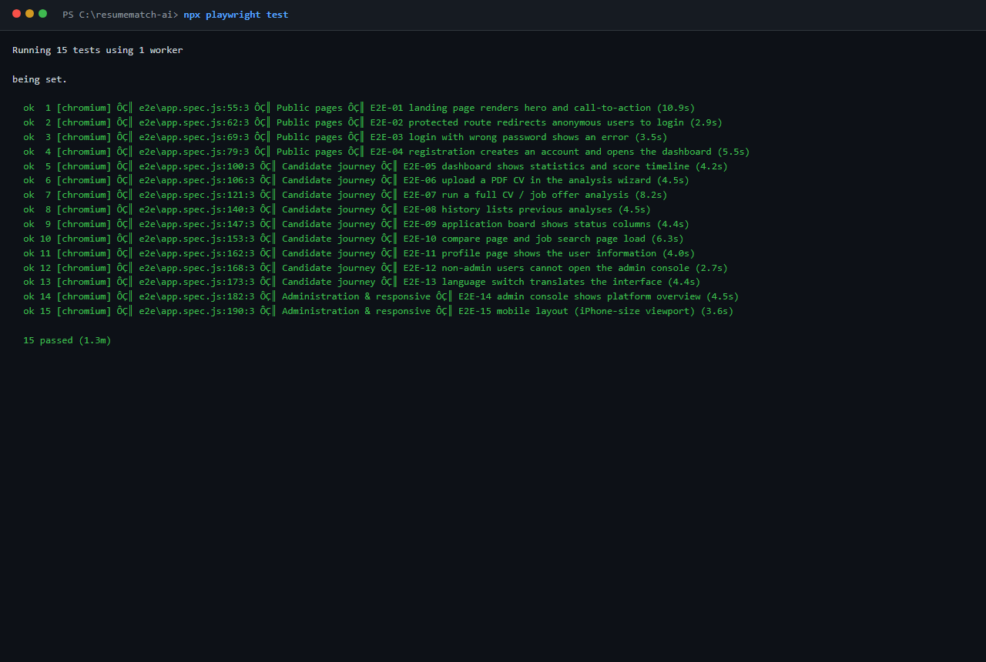
Figure — Playwright console
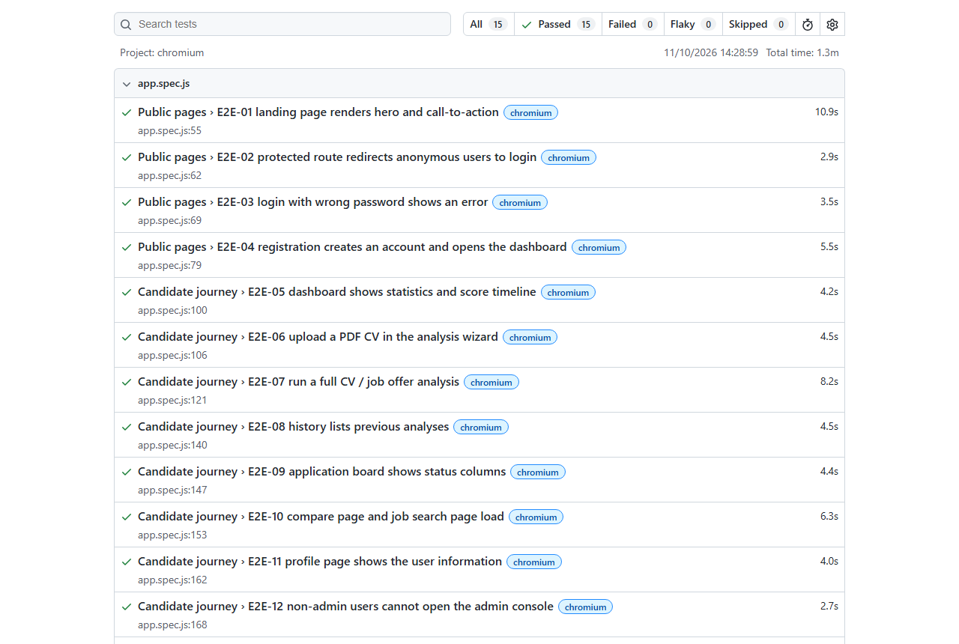
Figure — Playwright HTML report

8.1 Screenshots captured during the end-to-end run
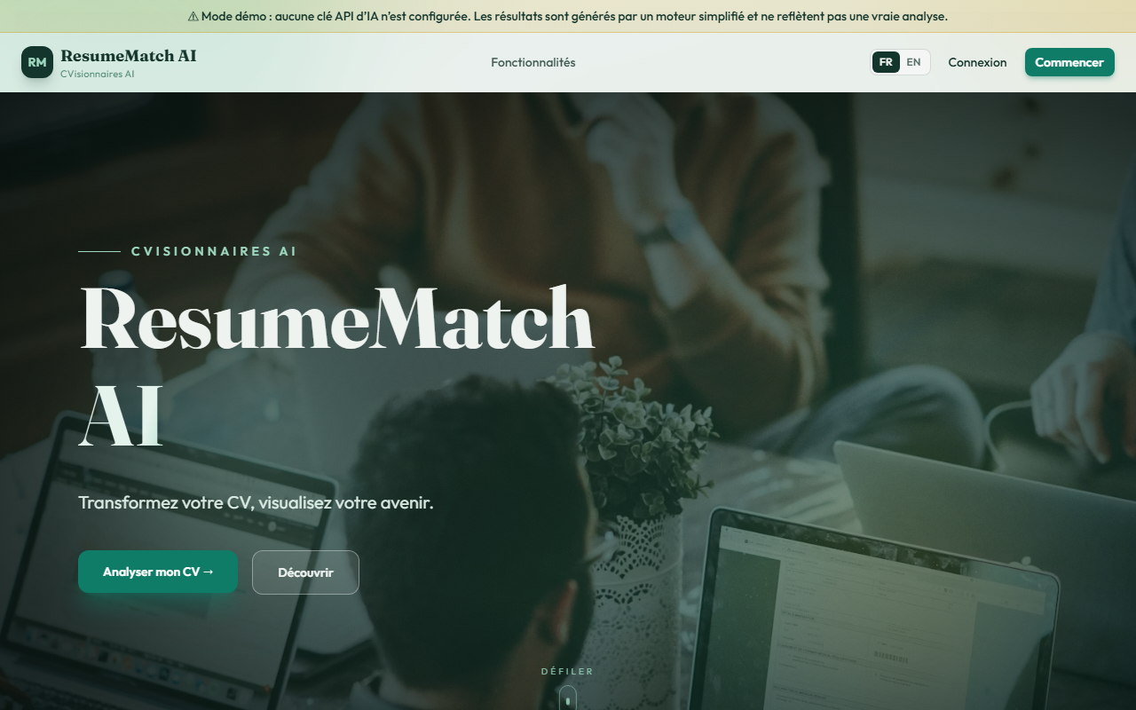  E2E-01 Landing page | 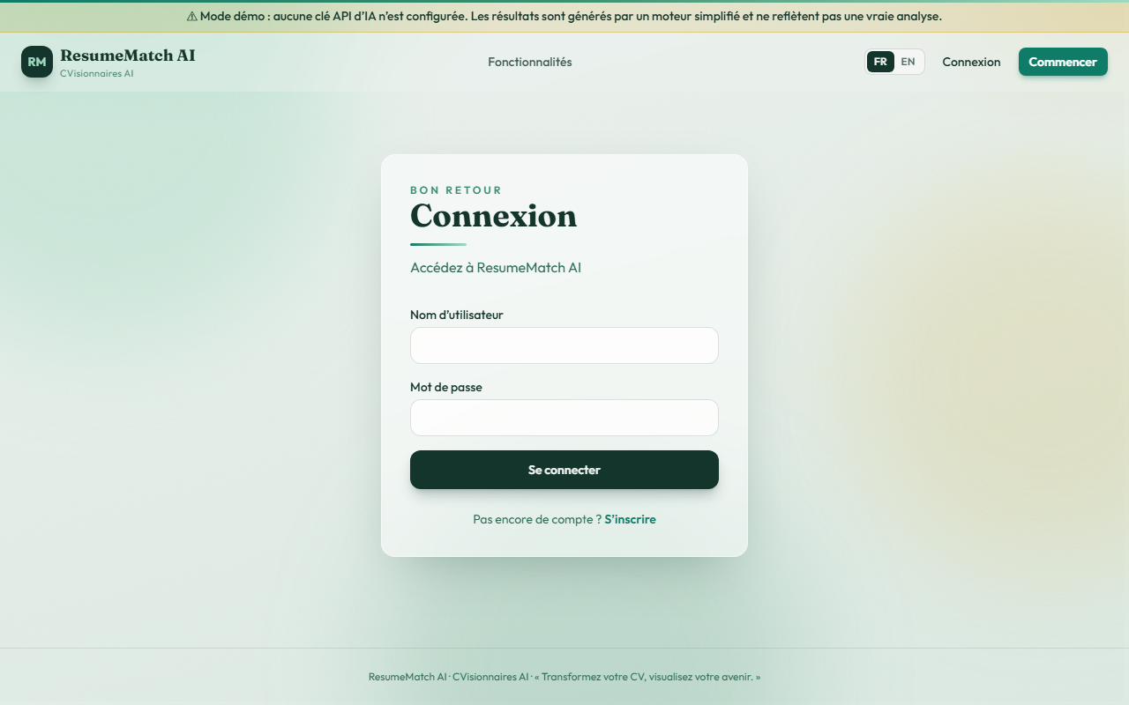  E2E-02 Redirect to login
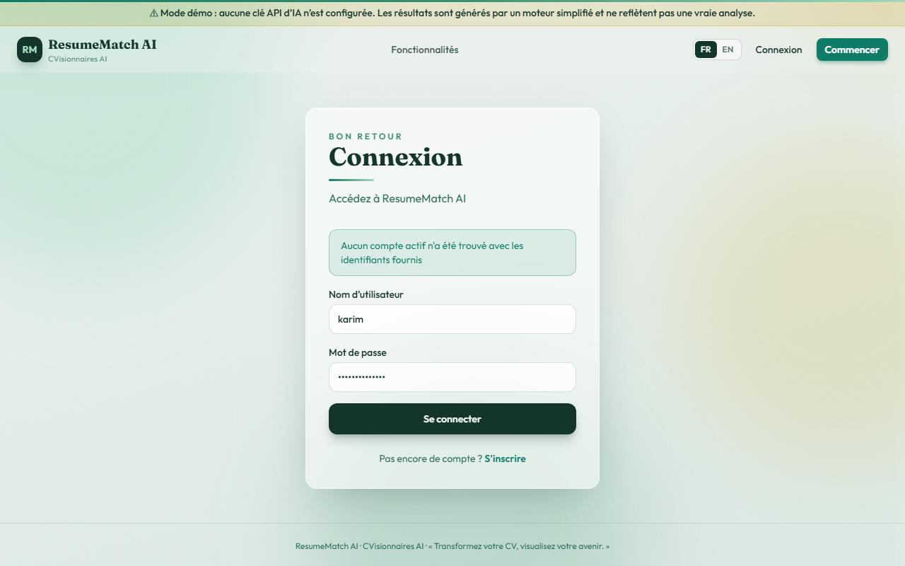  E2E-03 Wrong password | 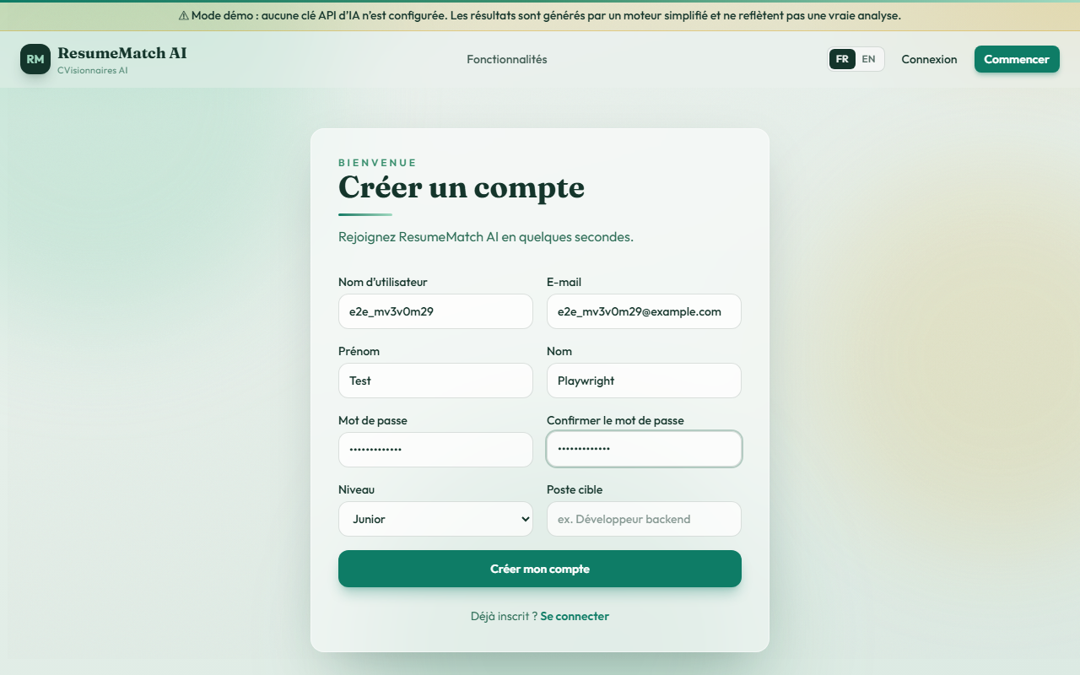  E2E-04 Registration form
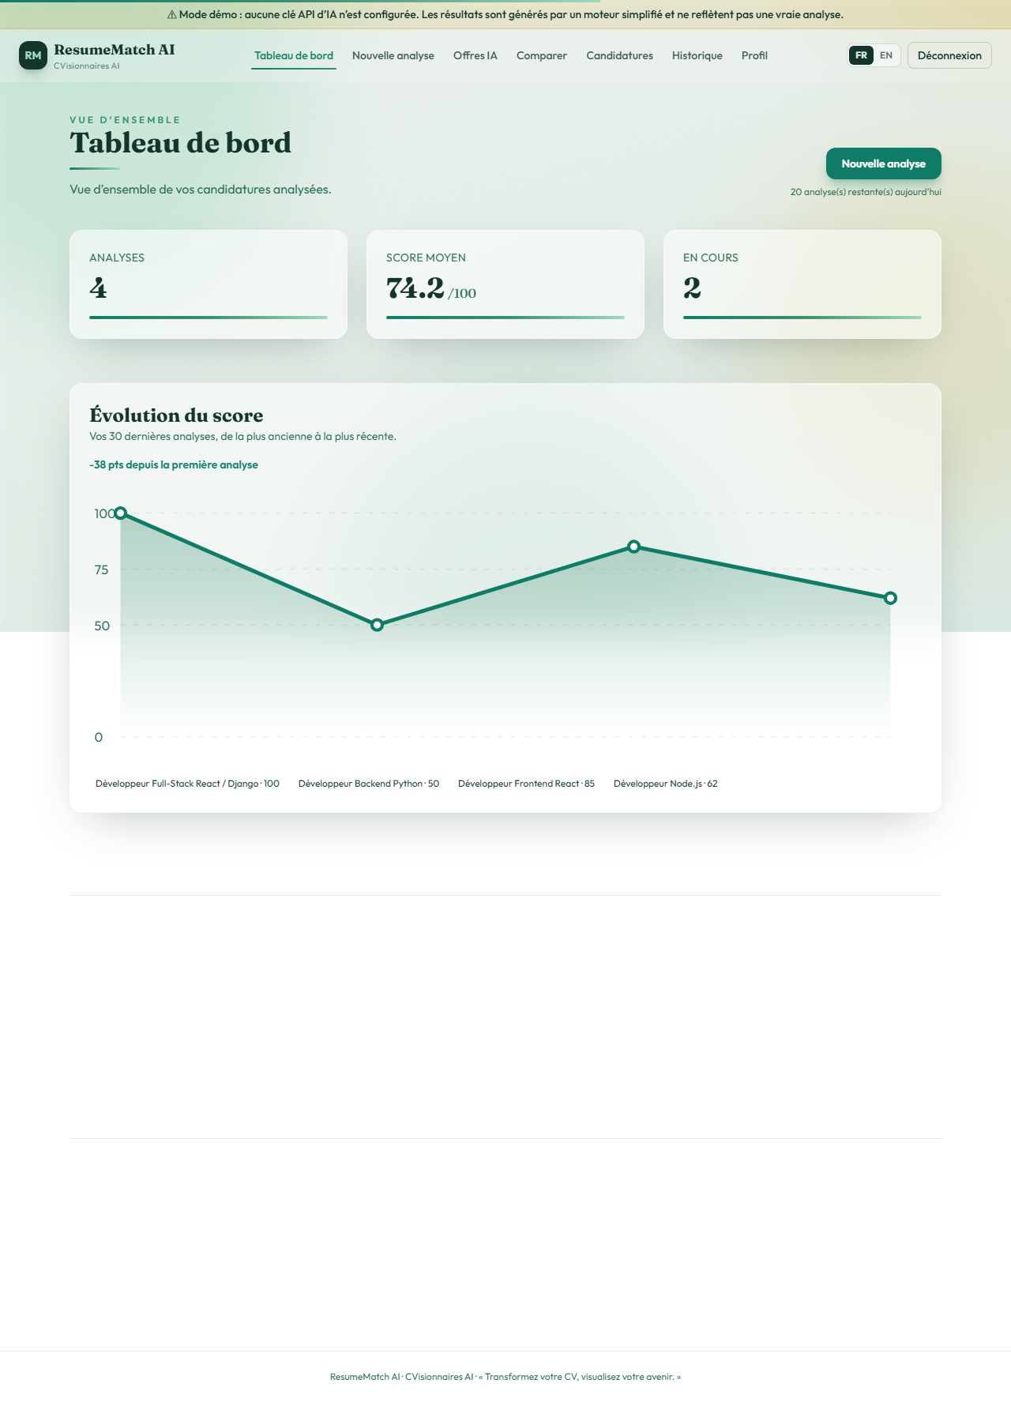  E2E-05 Dashboard | 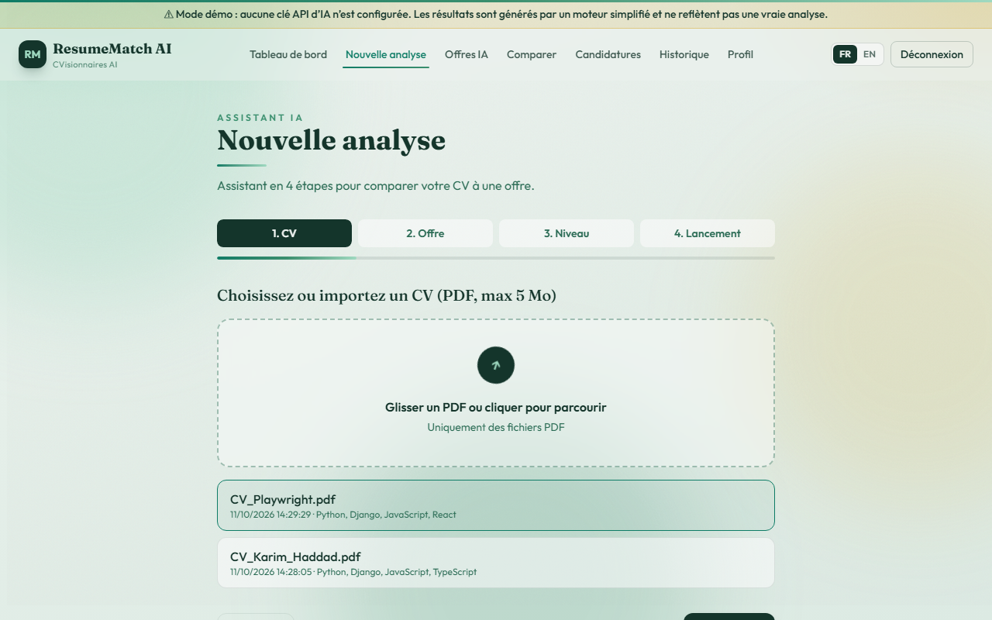  E2E-06 CV upload
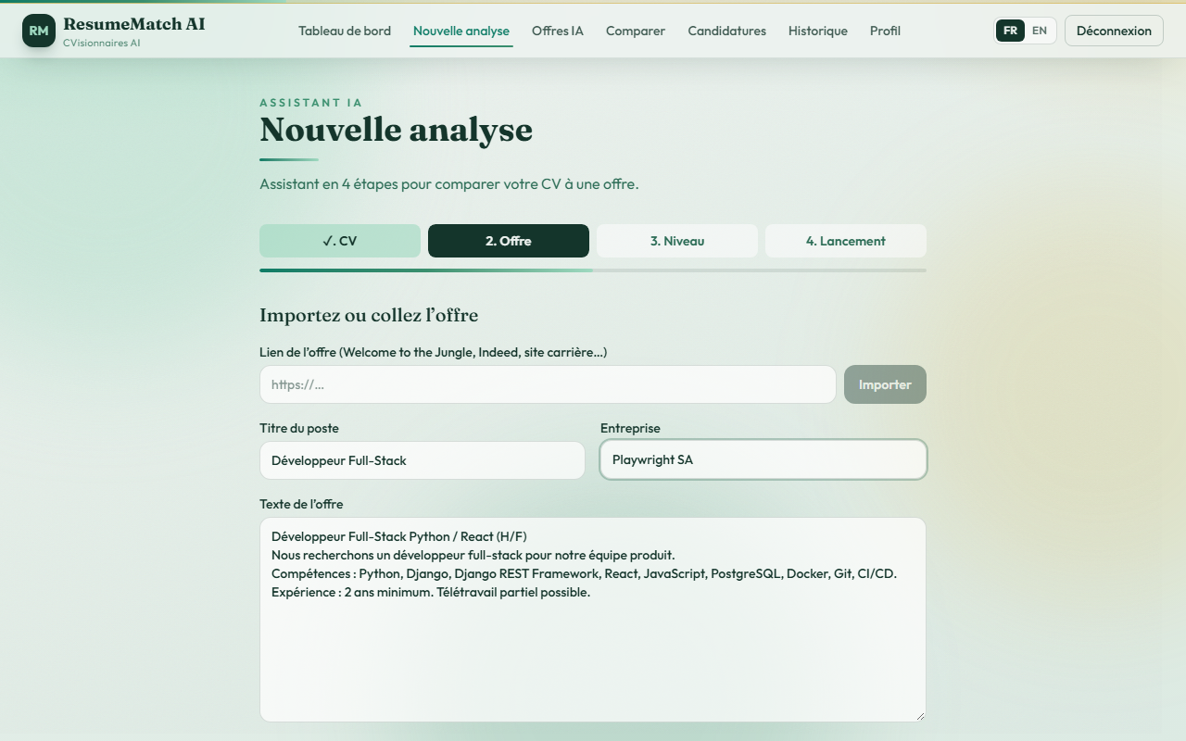  E2E-07 Wizard — job offer | 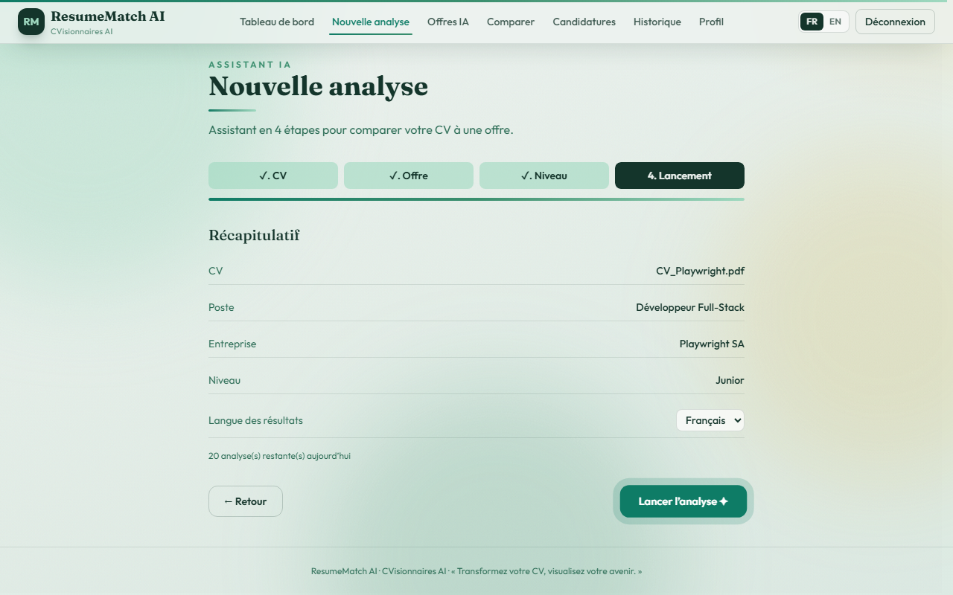  E2E-07 Wizard — summary
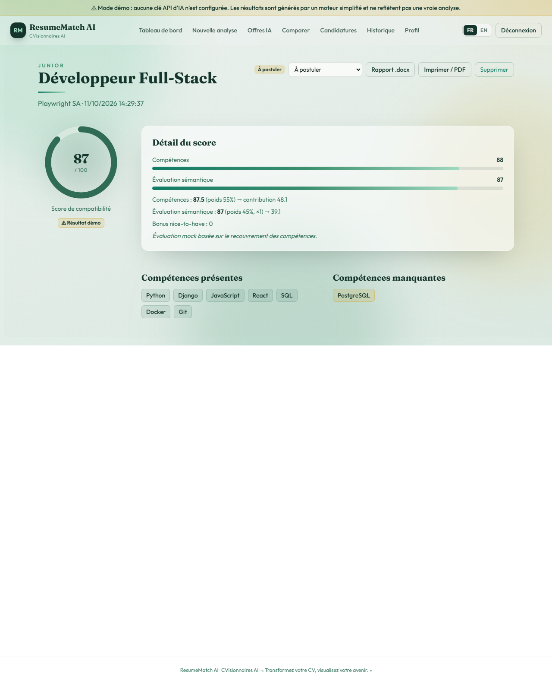  E2E-07 Analysis result (score 87/100) | 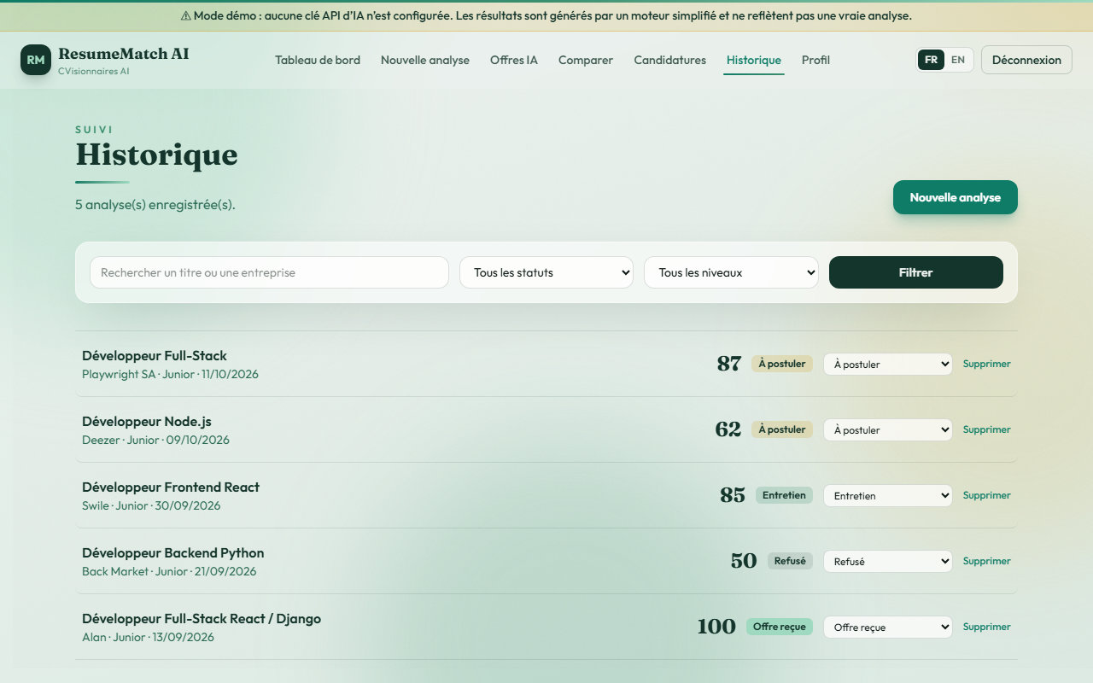  E2E-08 History
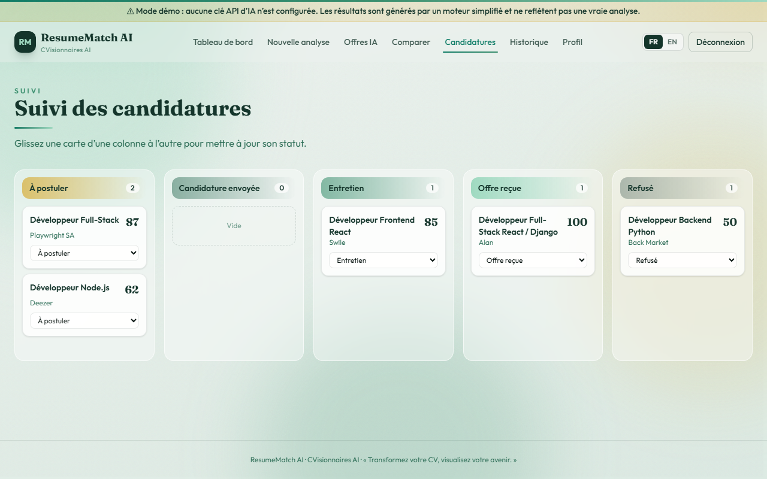  E2E-09 Application board | 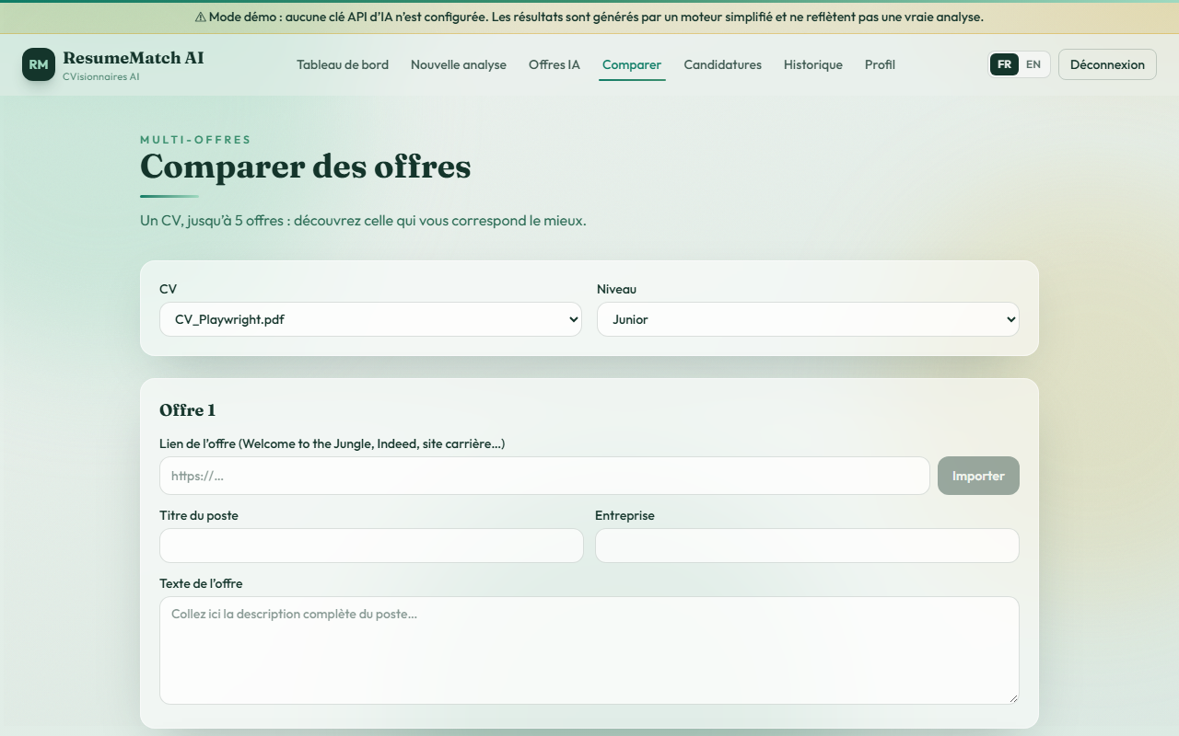  E2E-10 Compare offers
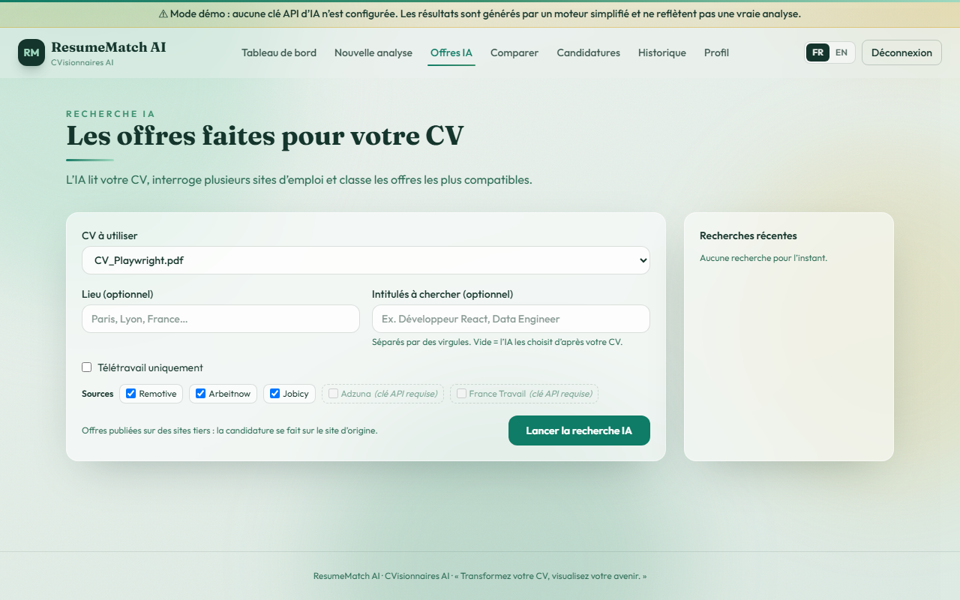  E2E-10 AI job search | 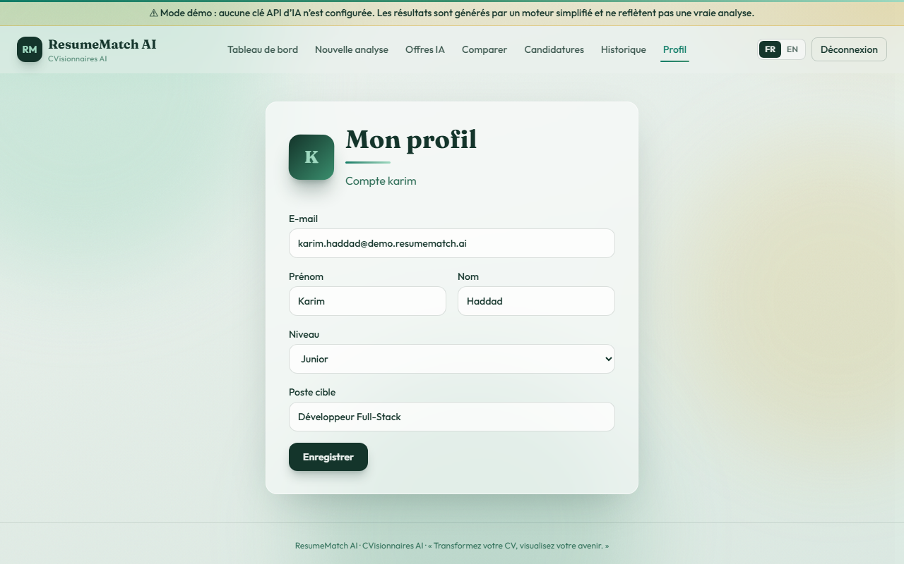  E2E-11 Profile
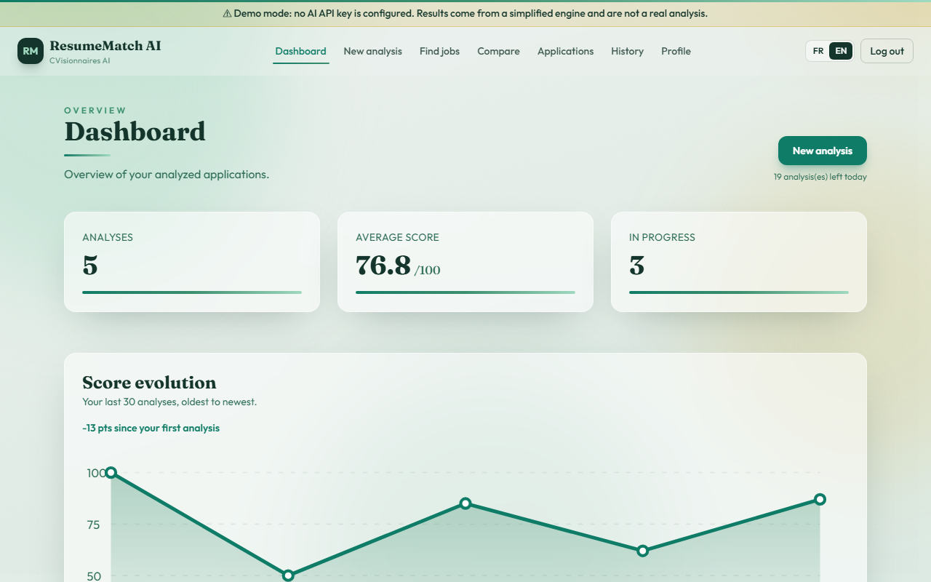  E2E-13 English interface | 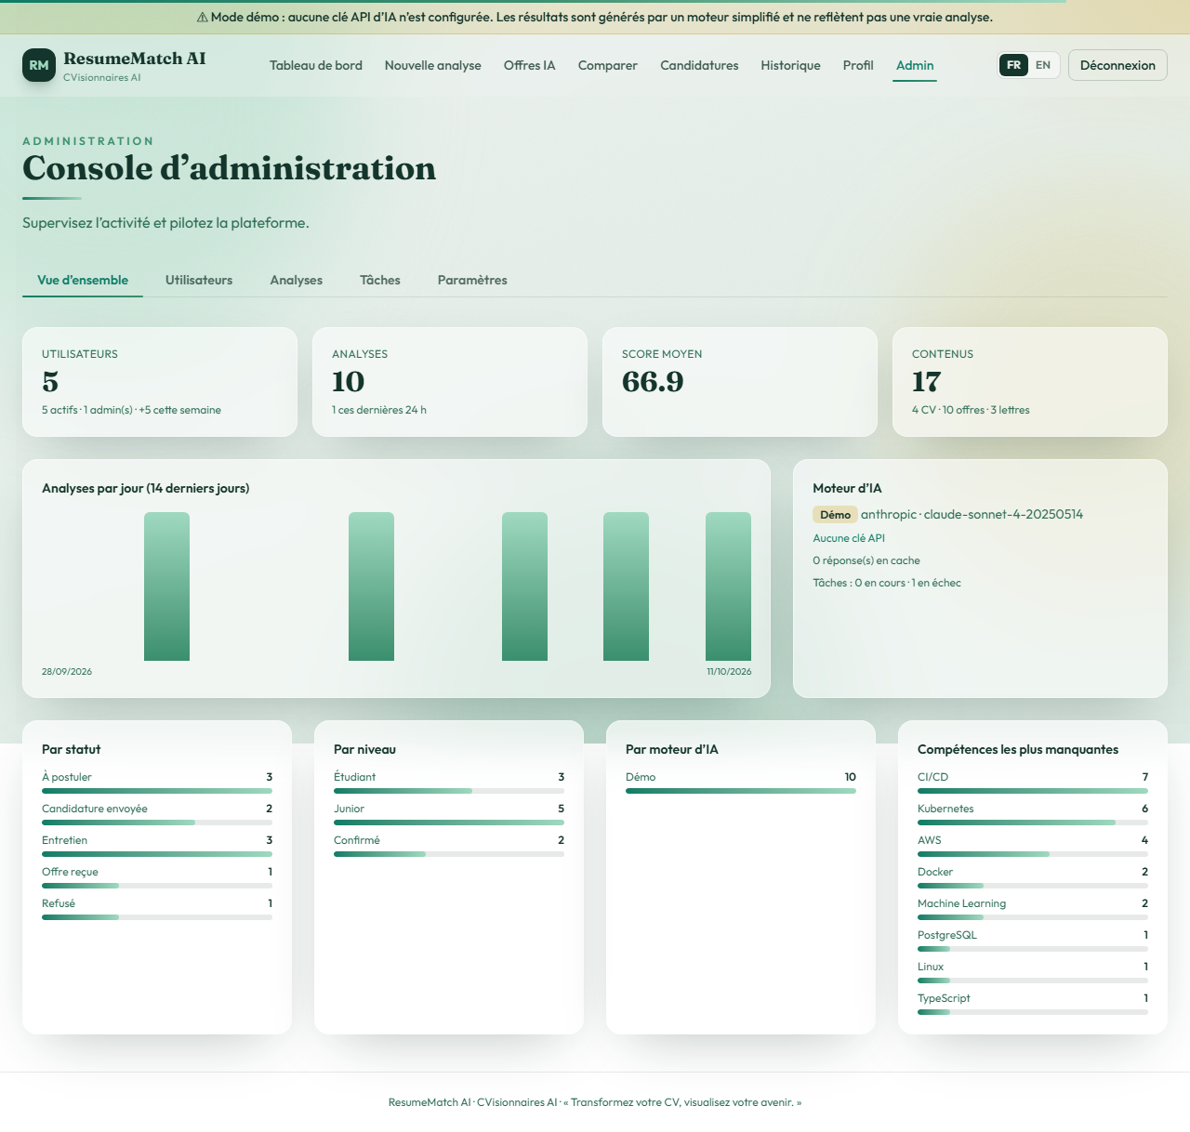  E2E-14 Admin console
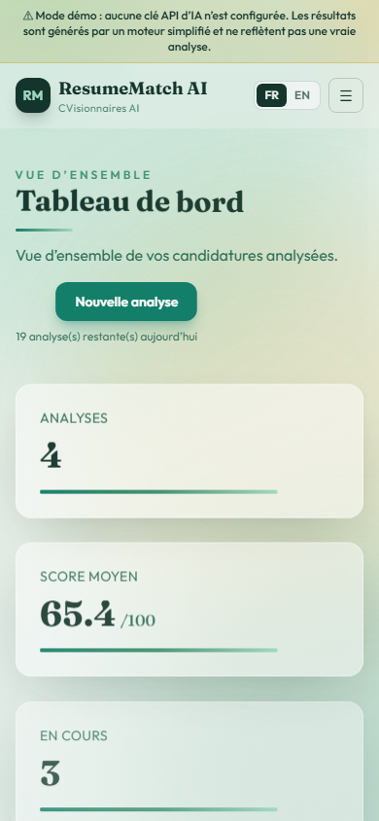
E2E-15 Mobile dashboard

Observation (UX): on E2E-03 the error message is displayed in the brand teal colour. Since the palette change, the coral colour token used by Alert type="error" is teal, so errors are not visually distinguishable from informational messages.

9. Tool 4 — Locust (load and stress testing)
Purpose: simulate many concurrent candidates using the REST API and measure throughput, latency percentiles and error rate.
File: backend/loadtests/locustfile.py — each virtual user logs in (JWT) and then randomly, with weights, opens the dashboard (5), lists analyses (4), opens an analysis (3), reads the profile (3), checks system status (2), lists job sources (2), runs a new analysis (1) and calls the health check (1), waiting 0.5–2 s between actions.
Commands
cd backend
locust -f loadtests/locustfile.py --host http://127.0.0.1:8765 --headless -u 20 -r 5 -t 60s --html ../docs/test-report/locust-report.html
locust -f loadtests/locustfile.py --host http://127.0.0.1:8765 --headless -u 100 -r 10 -t 60s --html ../docs/test-report/locust-stress-report.html

9.1 Normal load — 20 concurrent users, 60 s
Endpoint | Requests | Failures | Median (ms) | Avg (ms) | p95 (ms) | Max (ms)
GET /api/dashboard/stats/ | 238 | 0 | 10 | 11.7 | 20 | 68
GET /api/analyses/ | 199 | 0 | 7 | 8.2 | 13 | 23
GET /api/analyses/:id/ | 129 | 0 | 5 | 6.1 | 10 | 32
GET /api/auth/me | 130 | 0 | 4 | 4.9 | 9 | 19
GET /api/job-search/sources | 97 | 0 | 4 | 4.1 | 7 | 9
GET /api/system/status/ | 71 | 0 | 6 | 6.9 | 12 | 13
GET /api/health/ | 40 | 0 | 2 | 2.5 | 5 | 17
GET /api/cvs/ | 20 | 0 | 7 | 7.1 | 14 | 14
POST /api/analyses/ | 31 | 0 | 23 | 23.4 | 30 | 31
POST /api/auth/login | 20 | 0 | 770 | 788 | 950 | 953
Total | 975 | 0 (0 %) | 7 | 24 | 23 | 953

Throughput: 16.7 requests/s (limited by the simulated think time, not by the server).

9.2 Stress — 100 concurrent users, 60 s
Metric | Value
Requests | 4 517
Throughput | 76.2 requests/s
Median / p95 / p99 | 10 ms / 97 ms / 1 800 ms
Login median under stress | 1 800 ms (max 2.6 s)
Failures | 153 (3.4 %) — all `429 Too Many Requests` on `POST /api/analyses/`
Server errors (5xx) / timeouts | 0

Interpretation of the 429 responses: the 100 virtual users share the 3 demo accounts, so each account quickly exceeded the business rule "20 analyses per user per 24 h" (ANALYSIS_DAILY_QUOTA) and the AI rate limit (30/hour). The API correctly refused the extra analyses with HTTP 429 and a clear message, which is the expected behaviour. Read-only endpoints served every request.
Finding: login is the slowest operation (≈0.8 s alone, 1.8 s under stress). This is caused by the deliberately expensive password hashing (PBKDF2) running on a single development server process; it is a security feature, but it limits how many logins per second one process can handle.
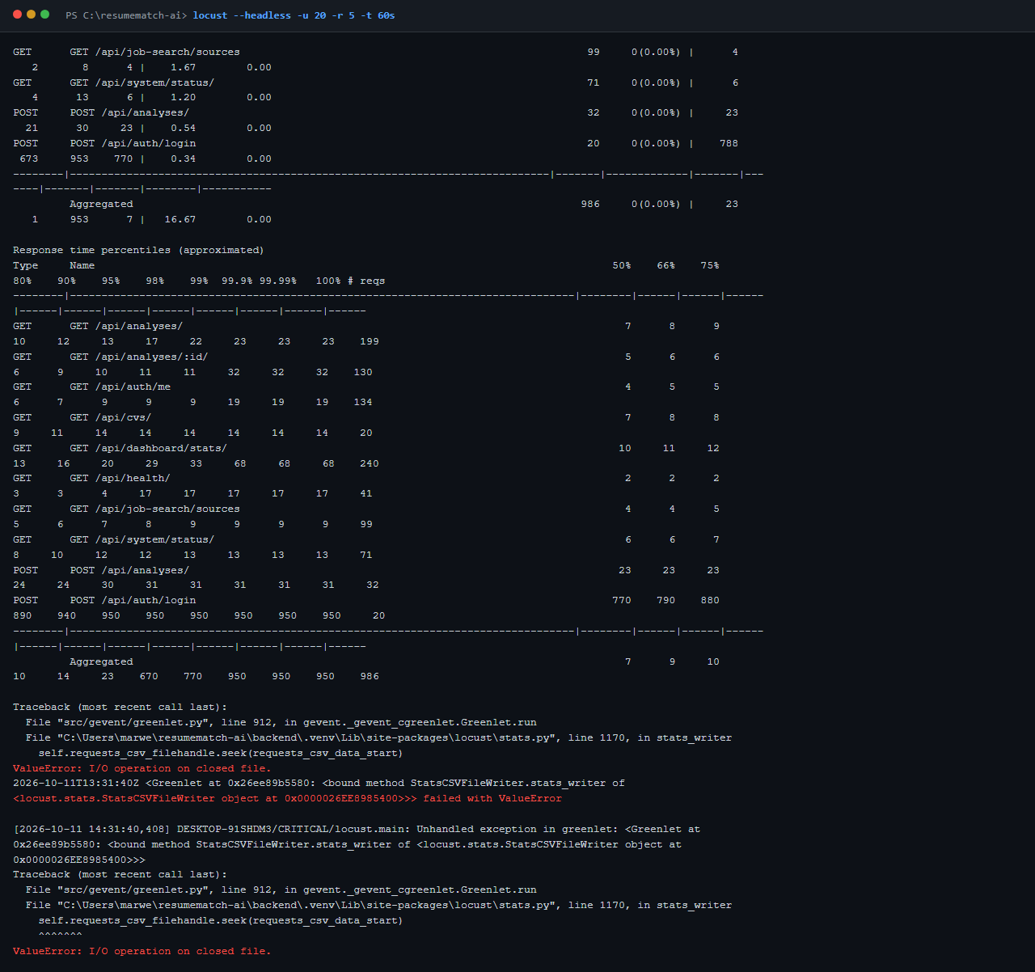
Figure — Locust console summary
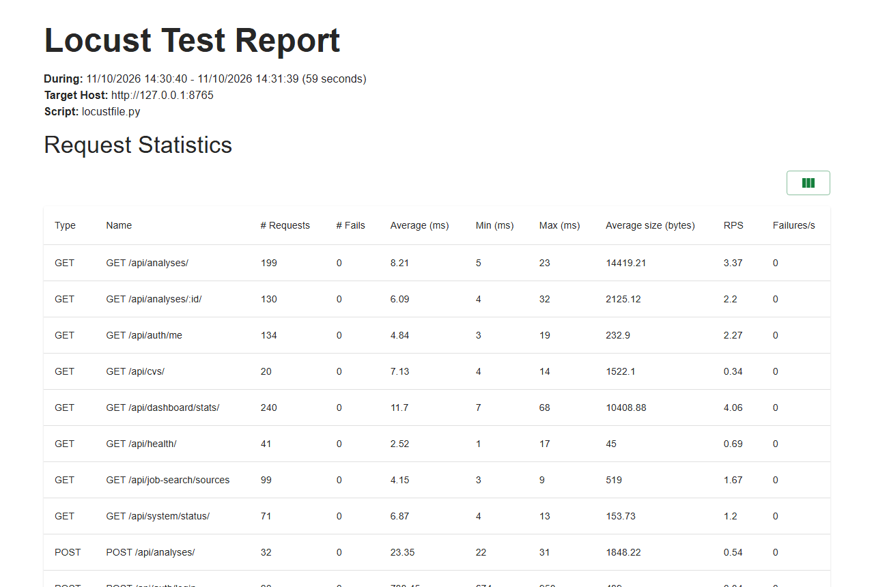
Figure — Locust HTML report — statistics
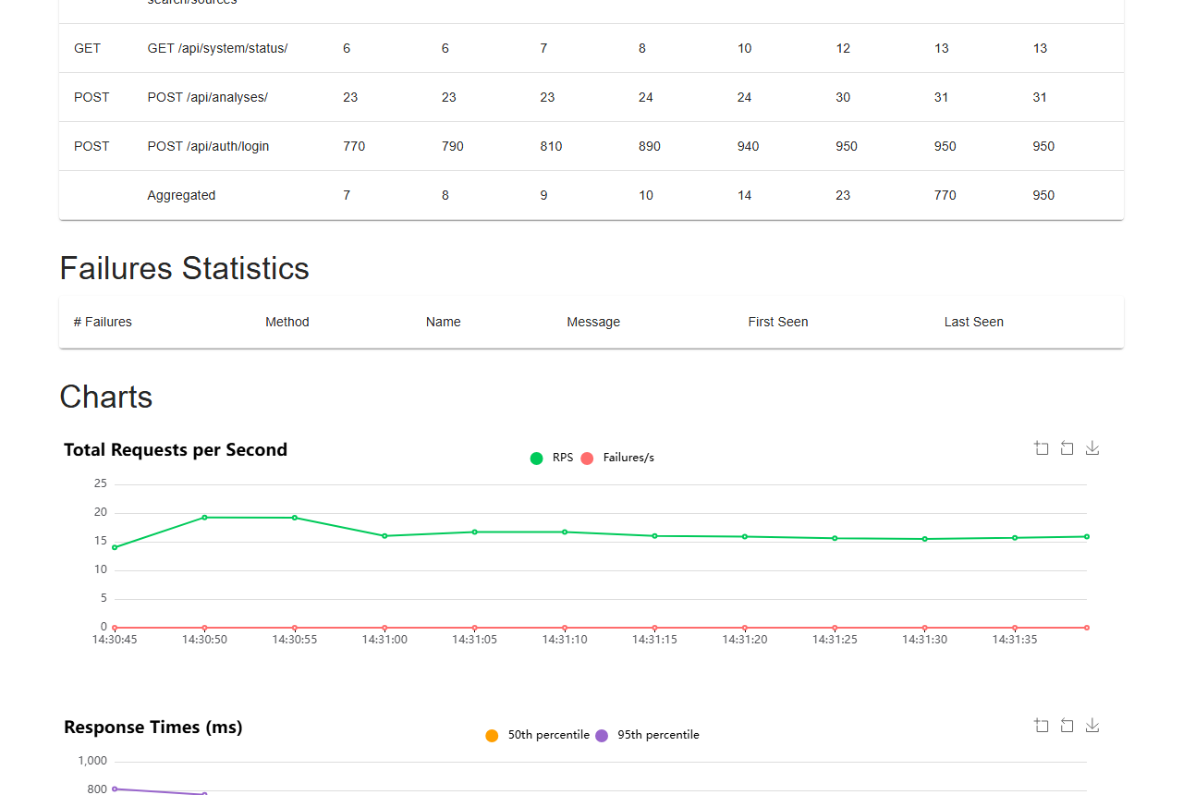
Figure — Locust HTML report — charts
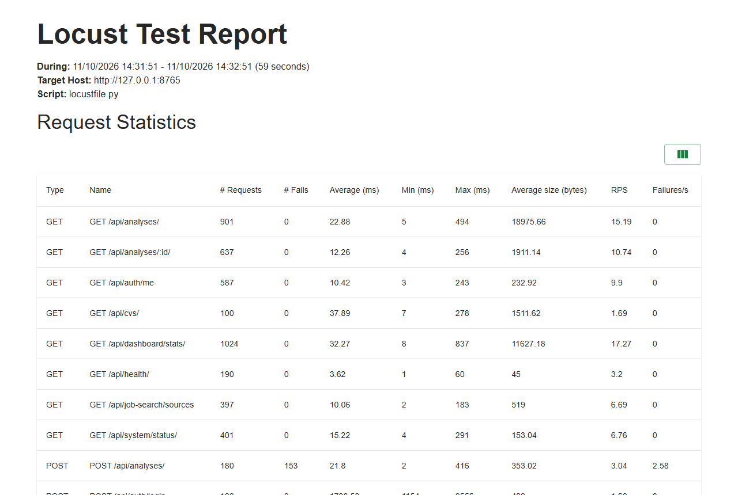
Figure — Locust stress report

10. Tool 5 — Lighthouse (performance, accessibility, best practices, SEO)
Purpose: audit the production build (vite build + vite preview) of the public pages with Google Lighthouse 12.8.2 (headless Chromium).
Command (example)
npx lighthouse http://127.0.0.1:43131/ --preset=desktop --output=html --output=json `
--output-path=docs/test-report/lighthouse/landing-desktop `
--only-categories=performance,accessibility,best-practices,seo
Results
Page | Device | Performance | Accessibility | Best practices | SEO | FCP | LCP | TBT | CLS | Speed Index
Landing / | Desktop | 89 | 100 | 100 | 83 | 0.6 s | 1.5 s | 0 ms | 0.039 | 2.5 s
Landing / | Mobile | 65 | 100 | 100 | 83 | 3.3 s | 7.1 s | 170 ms | 0.034 | 5.0 s
Login /connexion | Desktop | 95 | 100 | 100 | 82 | 0.9 s | 1.3 s | 0 ms | 0.023 | 1.1 s
Register /inscription | Desktop | 98 | 100 | 100 | 82 | 0.6 s | 1.1 s | 0 ms | 0.023 | 0.9 s

Findings
- Mobile LCP 7.1 s: the largest element is the full-screen hero background, a 1920 px image loaded from images.unsplash.com (external host, not optimised for mobile).
- Main-thread work 2.2 s and 62 KiB of unused JavaScript on mobile (animation library + shared bundle).
- SEO: the page has no <meta name="description">, and /robots.txt is missing (the SPA returns index.html instead).
- Accessibility 100 / Best practices 100 on every page: correct contrast, labels, roles, HTTPS-ready headers, no console errors.
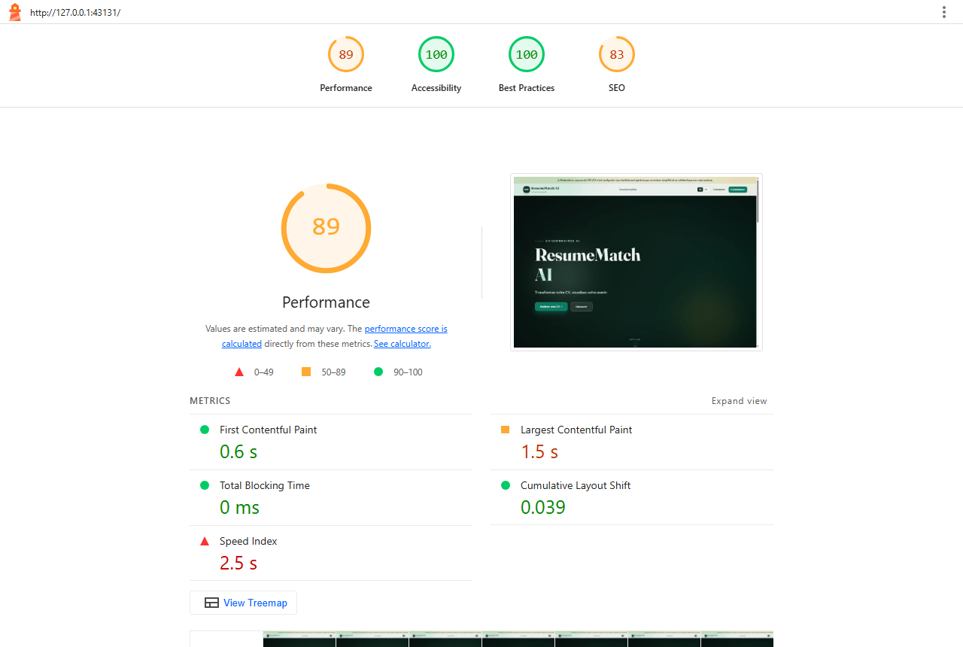
Figure — Lighthouse — landing desktop
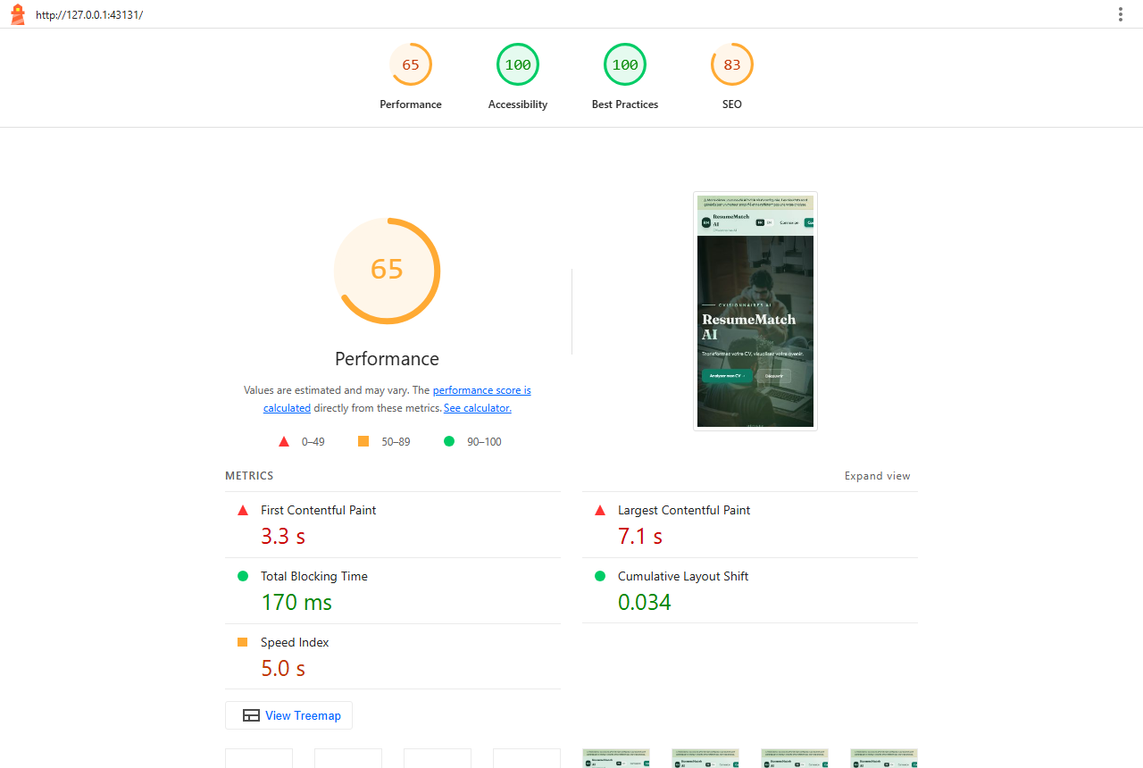
Figure — Lighthouse — landing mobile
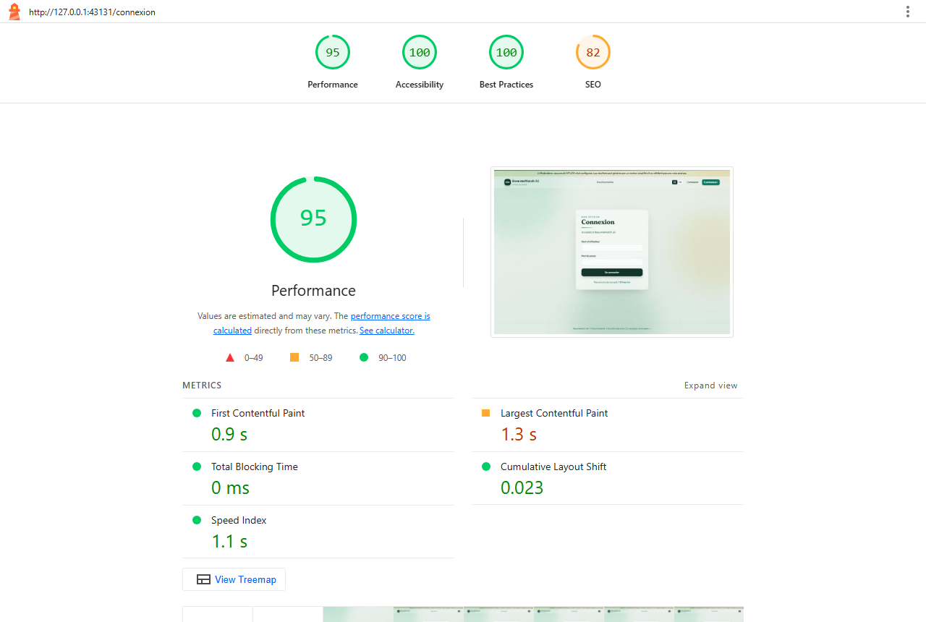
Figure — Lighthouse — login desktop

11. Comparison of the five tools

11.1 Tool characteristics
Criterion | Django test + Coverage.py | Vitest | Playwright | Locust | Lighthouse
Test type | Unit + integration | Unit | End-to-end (system) | Load / stress | Quality audit
Layer tested | Backend (API, models, services) | Frontend logic | Whole stack via the browser | Backend API | Frontend (rendered pages)
Language | Python | JavaScript | JavaScript | Python | CLI (no code)
Main metric | Pass/fail + % statements covered | Pass/fail + % coverage | Pass/fail + screenshots | Latency percentiles, RPS, error rate | 0–100 scores + Web Vitals
Speed | 12.9 s | 0.65 s | 75 s | 60 s per scenario | ≈20 s per page
Needs running servers | No (test DB) | No | Yes (frontend + backend) | Yes (backend) | Yes (built frontend)
Detects | Logic bugs, permission and validation errors, regressions | Logic bugs in helpers / i18n | Broken journeys, routing, UI integration, visual issues | Bottlenecks, slow endpoints, errors under load | Slow loading, a11y, SEO, bad practices
Does not detect | UI problems, performance | UI rendering, API issues | Performance limits, untested branches | Functional correctness of UI | Functional bugs
Effort to write tests | Medium | Low | Medium–high | Low–medium | None
Report produced | Console + HTML coverage | Console + HTML coverage | HTML report + JSON + screenshots | HTML report + CSV | HTML + JSON
Best use in CI | Every commit | Every commit | Before merge / release | Before release | Before release

11.2 Results obtained
Tool | Tests / scenarios | Passed | Key result | Rating
Django test + Coverage.py | 52 tests | 52 (100 %) | 83 % backend coverage | ✅ Very good
Vitest | 19 tests | 19 (100 %) | 90 % of src/lib, 4.4 % of all frontend code | ⚠️ Good logic coverage, no component tests
Playwright | 15 journeys | 15 (100 %) | All user journeys work; analysis in 148 ms | ✅ Very good
Locust | 2 scenarios (20 and 100 users) | 0 server errors | Median 7–10 ms, 76 RPS at 100 users; login 0.8–1.8 s | ✅ Good (login is the bottleneck)
Lighthouse | 4 audits | — | A11y 100, BP 100, Desktop perf 89–98, Mobile perf 65, SEO 82–83 | ⚠️ Good on desktop, mobile to improve

12. Defects and recommendations
# | Severity | Finding | Source tool | Recommendation
1 | Medium | Mobile landing page LCP 7.1 s (performance 65) | Lighthouse | Self-host the hero image in WebP/AVIF with responsive srcset (≈800 px for mobile) and fetchpriority="high"; preload it
2 | Medium | React pages/components have 0 % unit coverage | Vitest | Add component tests with @testing-library/react (login form, wizard steps, results page)
3 | Medium | Login takes 0.8 s alone and 1.8 s under 100 users | Locust | Run Django with several workers in production (gunicorn/uvicorn); keep refresh tokens so users rarely log in again
4 | Low | No meta description, missing robots.txt (SEO 82–83) | Lighthouse | Add <meta name="description"> in index.html and public/robots.txt
5 | Low | 62 KiB unused JS, 2.2 s main-thread work on mobile | Lighthouse | Keep route-level code splitting; lazy-load the landing-page animations
6 | Low | Error alerts use the brand teal colour | Playwright (screenshot E2E-03) | Give Alert type="error" a dedicated red/orange token
7 | Low | cvs/views.py (45 %) and pdf_service.py (53 %) weakly covered | Coverage.py | Add tests for CV upload errors (non-PDF, oversize, empty text) and PDF extraction fallbacks
8 | Info | Daily quota correctly returned HTTP 429 under stress | Locust | No action — expected behaviour; document it for load tests

13. Conclusion
Across 86 automated functional tests and 4 517 load-test requests, ResumeMatch AI showed no functional failure and no server error. The backend is well covered (83 %) and very fast (median 7–10 ms per API call), every user journey works in a real browser on desktop and mobile, and the UI scores 100 in accessibility and best practices.
The five tools turned out to be complementary: Coverage.py and Vitest guarantee correctness of the code, Playwright proves that the integrated product works for a user, Locust shows how it behaves at scale, and Lighthouse evaluates the experience perceived in the browser. No single tool would have found all eight findings in section 12.
Priority next steps: optimise the mobile hero image, add React component tests, and deploy the API with multiple worker processes.

Appendix A — How to reproduce
# Backend tools
cd backend
pip install -r requirements-dev.txt
python -m coverage run --source=accounts,cvs,analyses,adminpanel,services --omit="*/migrations/*,*/tests*.py" manage.py test
python -m coverage report
# Frontend unit tests
cd ../frontend
npm install
npm run test:coverage
# Start the application with demo data (two terminals)
cd ../backend; python manage.py seed_demo --reset; python manage.py runserver 127.0.0.1:8765
cd ../frontend; npx vite --port 43130 --strictPort
# End-to-end
npx playwright install chromium
npm run test:e2e
# Load test
cd ../backend
locust -f loadtests/locustfile.py --host http://127.0.0.1:8765 --headless -u 20 -r 5 -t 60s
# Lighthouse (on the production build)
cd ../frontend; npm run build; npx vite preview --port 43131
npx lighthouse http://127.0.0.1:43131/ --preset=desktop --view

Appendix B — Deliverables in docs/test-report/
Path | Content
TECHNICAL_REPORT.md / TECHNICAL_REPORT.docx | This report
screenshots/ | 32 screenshots (18 from the end-to-end run, 14 of tool reports)
coverage-backend-html/ | Coverage.py HTML report
coverage-frontend-html/ | Vitest V8 coverage HTML report
playwright-html/ | Playwright HTML report
locust-report.html, locust-stress-report.html | Locust reports
lighthouse/ | Lighthouse HTML + JSON reports (4 audits)
raw/ | Raw console logs, Locust CSV, Playwright JSON
console/, tools/ | Console captures and the scripts that render them and build the .docx / .html / .pdf reports
../conception/diagrammes/, ../conception/images/ | PlantUML sources and PNG / SVG renderings of the 6 UML diagrams (section 3)
../conception/PROMPTS.md, ../conception/CONCEPTION.md | Full French versions of the prompts and design documents (also as .docx / .pdf)

