Name:______________________________

ENS 495 Fall 2017 Homework 10

**Question 7)** A model using temp and ozone was fit to the data in question 6 data using the lm() function in R. The following output was produced using the summary() command.

Estimate Std. Error t value Pr(>|t|)

Intercept -146.9955 18.2872 -8.038 9.37e-13 ***

Temp 2.4287 0.2331 10.418 < 2e-16 ***

**7a)** Write the full **mathematical equation** described by this output.

**7b)** In the output above there are 2 p-values listed. One is more interesting than the other. What is the most relevant **p-value**? Write it below.

P = __________________

Why is this the most relevant of the 2 p-values?

**7c)** How do you interpret this **p-value**?

1. Significant
2. Non-significant
3. Marginally significant
4. Not enough information
5. p-values are dumb

**Move the decimal place of this p-value so that a different conclusion would be reach.**

New p-value: _________________ New conclusion (circle): Sig / Non-sig / Marg. Sig

**Question 12:** The standard error (SE) of the slope of a regression line represents:

1. Variation in the slope due to non-random sampling
2. Error due to non-normal residuals
3. Uncertainty about the true slope of the line
4. Variation in the intercept
5. All of the above
6. None of the above

**Question 22) Logistic regression** is used to model

1. Binomial predictors
2. Categorical response w/2+ levels (red, blue, green)
3. Numeric responses
4. Binomial responses (eg alive/dead)
5. Numeric predictors

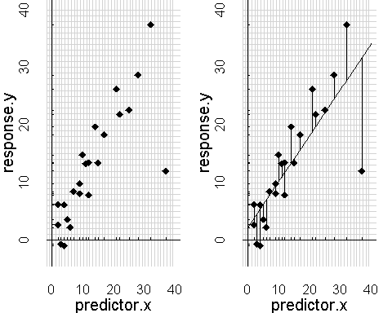**Question 9)** In the figure to the left, the left-hand side of the plot shows a scatter plot of the data. The right hand side shows a regression line through the data.

What are the **vertical lines** drawn from the sloping regression line up or down to each data point?

1. Residuals
2. Intercepts
3. Slopes
4. Least squares
5. Mean square errors (MSE)

**What is the approximate intercept for the line shown in the right-hand panel?**

**_______________**

**Is the slope of the line positive or negative?**

Positive / Negative / Not relevant

**Question 13:** The value of R2 from a regression tells us:

1. How well the model fits the data
2. If the line is significantly different from zero
3. If the p-value is small
4. If the slope is positive or negative
5. None of the above
6. All of the above

**Question 20)** For the following questions consider this scatter plot of variable y plotted against variable x.

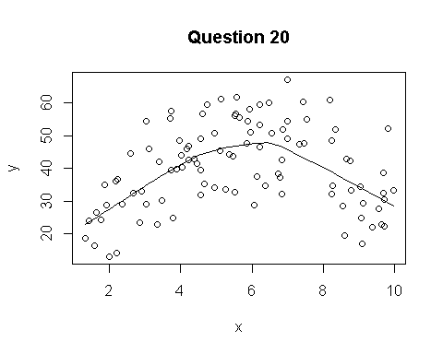**20a)** The line through the data was not draw using regression but instead using a technique use to help visualize curvey data. What is the name of this type of line? (1/2 point)

1. A curvey line
2. Logistic model
3. 2-way ANOVA (aka 2 x 2 ANOVA)
4. A smoother
5. None of the above
6. All of the above.

**Question XX**: Draw on the graph where the line has a **positive slope** and where on the graph it has a **negative slope**.