Table 2. Mist-net capture rates, richness, and diversity of birds in regenerating dry forest and mature dry forest in the Sierra de Bahoruco.
 | La Cueva | La Caoba | Morelia | El Corral | Aceitillar
 | 2-yr | 5-yr | 10-yr | 20-yr | mature
Elevation | 395 m | 410 m | 400 m | 400 m | 340 m
Mist net hours | 7612 | 7293 | 7553 | 6946 | 11319
Capture rate¹ | 231.5 | 235.8 | 152.4 | 132.9 | 155.4
Migrant capture rate¹ | 60.8 | 88.7 | 55.9 | 43.2 | 34.5
Resident capture rate¹ | 170.7 | 147.1 | 96.5 | 89.7 | 120.8
Species richness (indivs) | 45 (1762) | 42 (1720) | 40 (1151) | 29 (923) | 37 (1759)
Shannon diversity Index | 2.97 | 2.97 | 2.96 | 2.77 | 2.66
Effective number of species | 19.5 | 19.5 | 19.3 | 16.0 | 14.3
Chao 1 Estimator (SD) | 65.2 (12.6) | 45 (2.7) | 43.6 (3.2) | 41.5 (11.6) | 41.2 (4.0)
Chao 1 confidence interval | 40.4 - 90.0 | 39.6 - 50.4 | 37.2 - 50.0 | 18.8 - 64.2 | 33.3 - 49.0
Evenness | 0.78 | 0.79 | 0.80 | 0.82 | 0.74
Resident spp (indivs) | 33 (1299) | 25 (1073) | 28 (729) | 21 (623) | 24 (1368)
% resident individuals | 73.7% | 62.4% | 63.3% | 67.5% | 77.8%
Endemic spp (indivs) | 11 (269) | 9 (277) | 10 (234) | 7 (267) | 9 (421)
% endemic individuals | 15.3% | 16.1% | 20.3% | 28.9% | 23.9%
Migrant spp (indivs) | 12 (463) | 17 (647) | 12 (422) | 8 (300) | 13 (391)
% migrant individuals | 26.3% | 37.6% | 36.7% | 32.5% | 22.2%
¹ birds captured/1000 mnh
Table 3: Dominance of 5 most abundant species in regenerating dry forest and mature dry forest. Scientific names of species are found in Table 2.

Species | La Cueva | La Caoba | Morelia | El Corral | Aceitillar
 | 2-yr | 5-yr | 10-yr | 20-yr | mature
Common Ground-Dove | 2 (13.0) | 3 (9.7) | 2 (8.8) | 3 (10.6)
Broad-billed Tody |  |  | 4 (8.1) | 2 (11.0)
Ovenbird |  |  | 1 (16.1) | 1 (15.6) | 4 (7.6)
Common Yellowthroat |  | 4 (8.7)
Cape May Warbler | 5 (6.4) | 1 (10.8)
Black-throated Blue Warbler |  |  | 5 (7.6)
Green-tailed Ground-Tanager |  |  |  |  | 5 (7.0)
Bananaquit | 4 (7.7) |  |  |  | 2 (16.5)
Black-crowned Palm-Tanager |  |  |  | 4 (9.0) | 3 (8.0)
Yellow-faced Grassquit | 1 (15.1) | 2 (10.2)
Greater Antillean Bullfinch | 3 (8.1) | 5 (8.5) | 3 (8.5) | 5 (6.7) | 1 (22.0)

Table 4. Similarity indices of birds captured in 5 habitats based on species presence/absence (Jaccard Similarity; unshaded portion), and proportional abundances of individuals mistnetted (Sorenson Index; shaded portion). Values are parentheses are bootstrapped 95% confidence intervals.

 | Cueva | Caoba | Morelia | Corral | Aceitillar
Cueva | -- | 0.81 | 0.69 | 0.59 | 0.57
Caoba | 0.63 | -- | 0.68 | 0.58 | 0.54
Morelia | 0.70 | 0.71 | -- | 0.80 | 0.55
Corral | 0.61 | 0.58 | 0.57 | -- | 0.54
Aceitillar | 0.64 | 0.61 | 0.57 | 0.69 | --

Table 6. Percentage of captured individuals (n) of ten resident species that were site persistent in regenerating pastures and mature dry forest in the Sierra de Bahoruco, Dominican Republic. Scientific names of species are found in Table 2.
 |  | La Cueva | La Caoba | Morelia | El Corral | Aceitillar
Species | Bands¹ | 2-yr | 5-yr | 10-yr | 20-yr | mature | P
Hispaniolan Lizard-Cuckoo |  | 50.0 (10) | 40.0 (10) | 15.4 (13) | 20.0 (20) | 11.1 (10) | 0.253
Stolid Flycatcher | CB | 55.6 (18) | 66.7 (10) | 38.1 (21) | 43.8 (16) | 35.0 (40) | 0.982
Red-legged Thrush |  | 21.4 (42) | 9.7 (41) | 16.7 (18) | 13.3 (15) | 8.3 (60) | 0.358
Northern Mockingbird | CB | 33.3 (24) | 41.9 (31) | 11.1 (18) | 6.3 (16) |  | 0.02
Green-tailed Ground-Tanager | CB | 64.3 (28) | 67.6 (37) | 69.2 (13) | 80.0 (30) | 58.4 (77) | 0.325
Bananaquit |  | 12.4 (113) | 7.8 (77) | 8.3 (48) | 13.6 (22) | 7.2 (97) | 0.653
Black-crowned Palm-Tanager | CB | 57.4 (54) | 47.4 (38) | 56.8 (44) | 70.2 (47) | 33.9 (121) | <0.001
Yellow-faced Grassquit |  | 27.3 (150) | 21.6 (97) | 3.5 (57) | 11.5 (52) |  | <0.001
Black-faced Grassquit |  | 8.3 (24) | 21.2 (33) | 0.0 (13) |  |  | 0.11
Greater Antillean Bullfinch |  | 43.2 (74) | 37.8 (82) | 33.3 (67) | 18.6 (43) | 14.4 (332) | <0.001

¹ Site persistence determined by mist net recaptures, and resighting of those specuies which were uniquely color-banded (CB).
FIGURE CAPTIONS
Figure 1. Estimated species richness in regenerating dry forest with plots representing 2-yr old growth at La Cueva, 5-yr old growth at La Caoba, 10-yr old growth at Morelia, 20-yr old growth at El Corral, and mature dry forest. Analyses of Chao 1 indicators of diversity indicate no significant difference in richness among the sites.
Figure 2. Trends in species richness, Simpson’s diversity, and Pielou’s evenness across pasture ages. Regression lines calculated using only pasture data and site means calculated using a 1-way ANOVA type model that included the mature forest site (Aceitillar). Site means for the two youngest sites were calculated only using ages that did not overlap (La Cueva: 2 to 4 years post abandonment; La Caoba 7 to 9 years post-abandonment). Error bars are 95% confidence intervals.
Figure 3: Trends in abundance for individual migrant and resident species as pastures age. A trend of 1.0 indicates no net change. Thick error bars are standard errors (SE) and thin error bars are approximate 95% confidence intervals (1.96*SE).
Figure 4: Trends in body condition for individual migrant and resident species as pastures age. A trend of 0 indicates no net change. Thick error bars are standard errors (SE) and thin error bars are approximate 95% confidence intervals (1.96*SE).

Figure 2. Proportions of individuals captured in mist nets categorized by (a) diet, and (b) preferred habitat type. Captures took place in dry forest regenerating after agricultural clearance with plots representing 2-yr old growth at La Cueva (1,762 birds), 5-yr old growth at La Caoba (1,720 birds), 10-yr old growth at Morelia (1,151 birds), 20-yr old growth at El Corral (923 birds), and mature dry forest (1,759 birds).
Figure 3. Proportions of insect groups (with sample size) captured or observed in (a) sticky traps, and (b) leaf litter samples in dry forest regenerating after agricultural clearance with plots representing 2-yr old growth at La Cueva, 5-yr old growth at La Caoba, 10-yr old growth at Morelia, 20-yr old growth at El Corral, and mature dry forest.
Figure 4. Body condition index (bird mass/wing chord [x100]) of birds (with sample size) captured in dry forest regenerating after agricultural clearance with plots representing 2-yr old growth at La Cueva, 5-yr old growth at La Caoba, 10-yr old growth at Morelia, 20-yr old growth at El Corral, and mature dry forest.
Figure 1.

Figure 2:
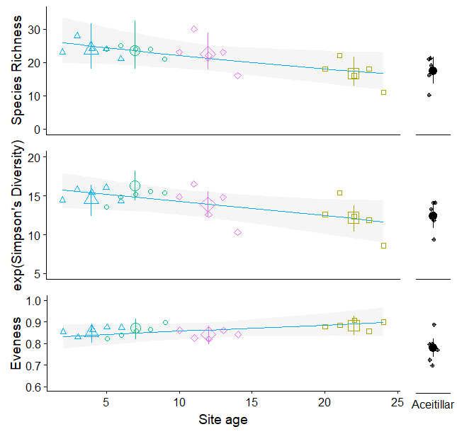
Figure 3:
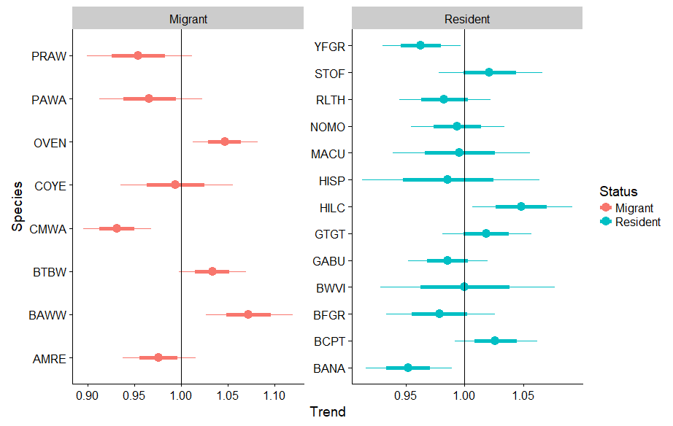

Figure 4.
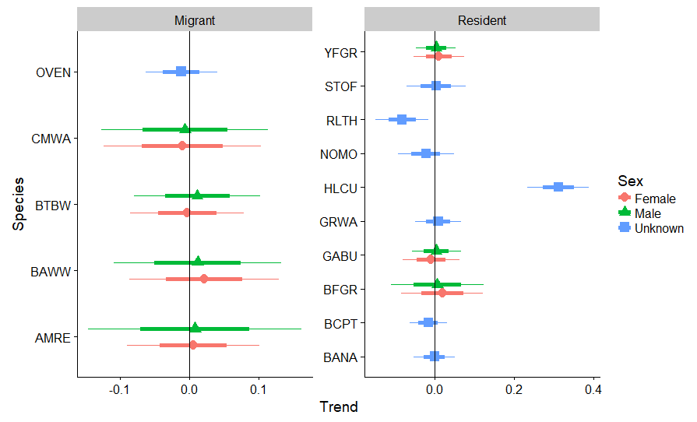

Figure 2.

(a)
La Cueva La Caoba Morelia El Corral Aceitillar

(b)
La Cueva La Caoba Morelia El Corral Aceitillar

Figure 3.

(a)
(323) (348) (599) (399) (749)
La Cueva La Caoba Morelia El Corral Aceitillar

(b)
(210) (227) (213) (294) (112)

La Cueva La Caoba Morelia El Corral Aceitillar

Figure 4.
- Bananaquit
(47)
(110)
(75)
(22)
(71)

- Black-crowned Palm-Tanager
(110)
(37)
(51)
(40)
(45)
- Greater Antillean Bullfinch (male)
(21)
(25)
(43)
(32)
(96)
- Greater Antillean Bullfinch (female)
(22)
(25)
(17)
(15)
(90)
- Green-tailed Ground-Tanager
(28)
(36)
(13)
(28)
(77)

