**Mist net**

Banding PNC Access Database

Banding Sheet.csv Original data from Boris (extracted from Access Database)

Banding Sheet 2.csv Updated data from Boris (extracted from Access Database)

Banding Sheet 2 MMDD_YYYY Banding sheet 2 after data prep (see 1_Ecuador_mn_data_prep.Rmd)

**Point count**

Point_Counts Original data from Boris (extracted from Access Database)

Point_Counts_MMDD_YYYY Point_counts after data prep (see 1_Ecuador_pc_data_prep.Rmd)

Working datasets:

ecuador_1_MMDD_YYYY.csv

* Most inclusive dataset
* Nothing excluded

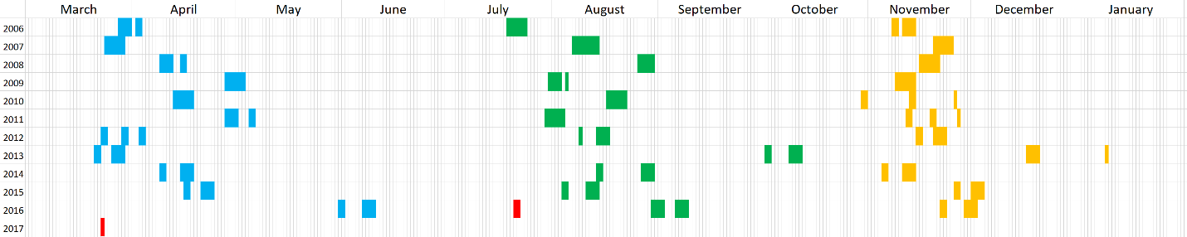

ecuador_2_MMDD_YYYY.csv

* Second most inclusive dataset
* Excludes SANA



ecuador_3_MMDD_YYYY.csv **(This is what I’m using)**

* Third most inclusive dataset
* Excludes SANA
* Excludes segunda 13, January tercera 13 (retains December tercera 13), primera 16, Jan 2017 data

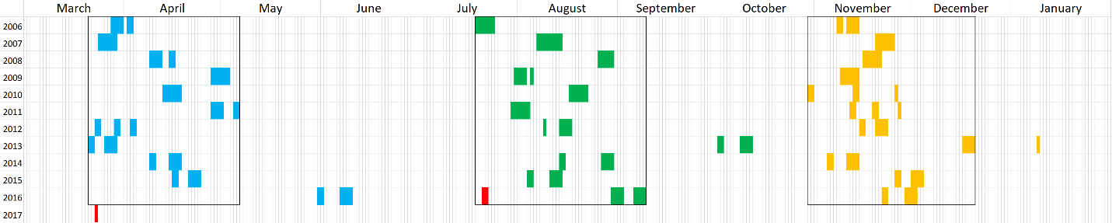

ecuador_4_MMDD_YYYY.csv

* Least inclusive dataset
* Excludes SANA
* Excludes segunda 13, tercera 13, primera 16, Jan 2017 data

