Electronic Supplementary Material for
“Genetic and ‘cultural’ similarity in wild chimpanzees”
Langergraber et al.
Assessing the robustness of the relationship between overall behavioural dissimilarity and genetic dissimilarity to coding errors in the behavioural data

METHODS
In our first analysis we systematically introduced varying amounts of error into the behavioural codes and then re-examined the size and statistical significance of the correlation between overall between-group behavioural dissimilarity and genetic dissimilarity. Reasoning that the vast majority of uncertainty in the original behavioural coding system lies in the reliability and validity of distinguishing between adjacent (e.g., ‘customary’ versus ‘habitual’) rather than more distant (e.g., ‘customary’ versus ‘absent’) codes, behavioural variants were free to vary in the following way: ‘customary’ could become ‘habitual’, ‘habitual’ could become ‘customary’ or ‘present’, ‘present’ could become ‘habitual’ or ‘absent’, and ‘ecological explanation’ and ‘unknown’ could not vary. Each behavioural variant could change from its original state to its alternative state(s) with a certain probability, which we varied from 0.01 to 1.00. Behavioural variants which had two alternative states could change to either with equal probability. For each of the 100 different error levels we performed 1000 randomizations of changes from original to alternative states, and recalculated overall between-group behavioural dissimilarity (using Euclidean distance) and its Pearson correlation matrix permutation with genetic dissimilarity for each of these 1000 iterations. We then examined, for each of the 100 different error levels, the mean and standard deviation of the sizes and P values of the 1000 iterations of the Pearson correlation matrix permutation.
In our second analysis we recoded the behavioural data binarily so that the measure of overall behavioural dissimilarity measure was insensitive to the specific levels chosen for the behavioural traits. Here we lumped ‘customary’ and ‘habitual’ into one category, and ‘present’ and ‘absent’ into another. We then calculated overall behavioural dissimilarity for each pair of chimpanzee groups as the number of behavioural variants that were different between the pair divided by the number of behavioural variants for which they were compared (i.e., up to 38, ‘ecological explanation’ and ‘unknown’ were treated as missing values and excluded pairwise). We then examined the relationship between overall behavioural dissimilarity and genetic dissimilarity using a Spearman rank correlation, with statistical significance obtained by 10,000 Mantel matrix permutations.

RESULTS
In our first analysis we found that the strong and statistically significant positive correlation between overall between -group behavioural dissimilarity and genetic dissimilarity was robust to even large amounts of introduced error. Even when each behavioural variant in every group was changed (i.e., error probability of 1), the Pearson correlation was still moderately strong at 0.34 (Supplementary Figure 1). The mean P value of the Pearson correlation was less than 0.05 with an error probability of up to 0.61 (Supplementary Figure 2).
Our second analysis showed that overall behavioural dissimilarity and genetic dissimilarity were significantly correlated even when behavioural variants are coded as binary variables (Spearman r_{s} = 0.34, P = 0.044).

Figure 1. Mean (and standard deviation) of size of Pearson correlations between overall behavioural and genetic dissimilarity with varying amounts of error introduced into codes for behavioural variants. For clarity of presentation, only results for 20 of the 100 tested error probabilities are shown.
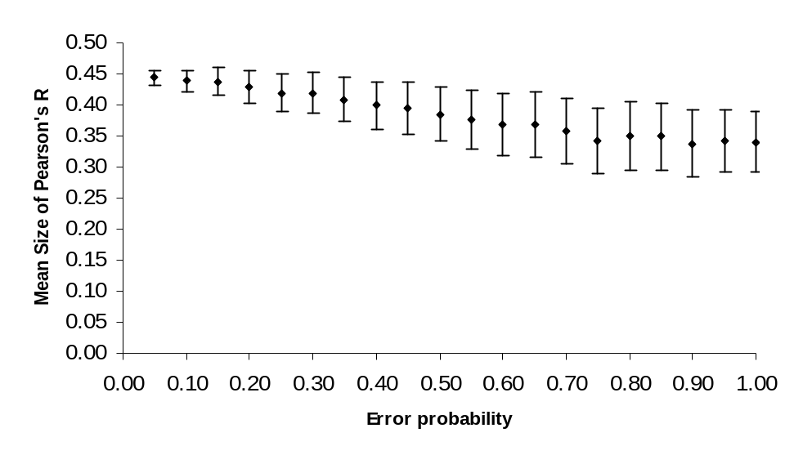

Figure 2. Mean (and standard deviation) of P values of matrix permutations for Pearson correlations between overall behavioural and genetic dissimilarity with varying amounts of error introduced into codes for behavioural variants. For clarity of presentation, only results for 20 of the 100 tested error probabilities are shown.

