# Matching Statistics to Experimental Design

## Introduction (this is all true):

Heat [shock proteins (Hsps)](https://en.wikipedia.org/wiki/Heat_shock_protein) are part of plants' adaptive response to thermal stress. Zhang et al. summarize the importance of Hsp:

"Heat causes protein denaturation, disrupting normal protein function. The Hsps act as molecular chaperons to prevent protein aggregation, repair protein damage and maintain cellular homeostasis. Hsps stabilize protein form and prevent aggregation. The Hsps together recover or protect normal cellular function provided that the heat stress is not too extreme."

[Zhang et al. (2015)](https://academic.oup.com/aobpla/article/doi/10.1093/aobpla/plv101/1801891/Natural-populations-of-Arabidopsis-thaliana-differ) studied how expression of Hsps in *Arabidopsis thaliana* seedlings was impacted by exposure to high temperatures. In particular, they wanted to study "acquired thermotolerance" by testing whether acclimation at a moderately high temperature (38 degrees C; 100 F) resulted in higher production of Hsp when plants were subsequently exposed to an extreme temperature (45 degrees C; 113 F). **Control plants** received no acclimation but were subjected directly to 45 C for 3 hours. **Aclimization Treatment** plants experienced 3 hours of acclimization at 38 degrees C, 3 hours of recovery at a lower temperature, then 3 hours of 45 C. At the end of the experiment leaf tissue was collected from plants and Hsp production was quantified using western blots. Zhang has also done transcriptomic work [(Zhang et al pre-print)](http://www.biorxiv.org/content/early/2016/03/18/044446) to see what genes are upregulated and therefore might be related to Hsp production. The following experiments are based on this general design.

# Hypothetical Context (none of this is true):

Let's imagine that when Zhang began her work on Hsp she ran a number of pilot studies to work out the experimental conditions. In particular, she had to work on the apparatus she used to bring the plants up to 45 C (113 F). She initially started with a small apparatus that fit on her lab benches that housed a single plant, and later acquired grant money to buy bigger environmental chambers. Let's also imagine that her transcriptomic work identified an interesting gene, *hsp1*, linked to Hsp expression. We'll consider several variations on these experiments.

# References

Zhang et al 2015. Natural populations of Arabidopsis thaliana differ in seedling responses to high-temperature stress. AoB Plant.

## EXPERIMENT 1: Impact of heat stress on Hsp, trial 1

### Experimental Design:

In her 1st experiment, Zhang used 3 plants were used as controls and 3 plants were given an acclimatization treatment. Each plant was subject to the high temperature conditions using special bench-top environmental chambers that house a single plant. A single tissue sample was taken from each plant and Hsp production quantified using western blots. There are therefore 6 total samples (3 controls + 3 acclimatized).

### Experiment 1 Data

|  |  |
| --- | --- |
| Hsp.express | treatment |
| 0.8911 | control |
| 1.461 | control |
| 2.478 | control |
| 2.329 | acclim |
| 1.664 | acclim |
| 2.93 | acclim |

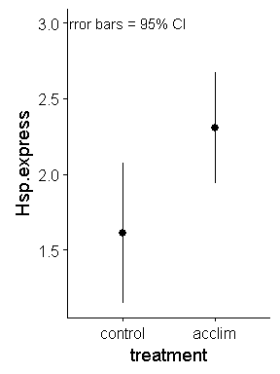

## EXPERIMENT 2: Impact of heat stress on Hsp, trial 2

In this experiment, Zhang took multiple samples from each plant, instead of just 1. As in EXPERIEMNT 1, 3 plants were used as controls and 3 plants were acclimatized at 38 degrees C. Each plant was subject to the high temperature conditions using special bench-top environmental chambers that house a single plant. After exposure to heat stress at 45 degrees C, 3 samples were taken from each plant. (18 samples total; 3 * 3 = 9 controls, 3 * 3 = 9 acclimatized)

### Experiment 2 Data

|  |  |  |
| --- | --- | --- |
| Hsp.express | treatment | plant.ID |
| 0.9233 | control | 1 |
| 0.1172 | control | 1 |
| 1.03 | control | 1 |
| 0 | control | 2 |
| 0.5534 | control | 2 |
| 2.682 | control | 2 |
| 1.052 | control | 3 |
| 0.7991 | control | 3 |
| 1.037 | control | 3 |
| 3.236 | acclim | 4 |
| 2.495 | acclim | 4 |
| 4.158 | acclim | 4 |
| 1.724 | acclim | 5 |
| 0.4235 | acclim | 5 |
| 3.271 | acclim | 5 |
| 2.581 | acclim | 6 |
| 2.215 | acclim | 6 |
| 3.838 | acclim | 6 |

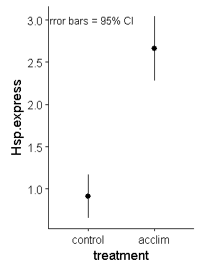

EXPERIMENT 3: Impact of heat stress on Hsp, trial 3

Zhang wants to run more samples and modified her bench-top environmental chamber to house 2 plants at a time. She therefore put one control plant (no acclimatization) and one acclimatized plant into each of her new chambers. One plant from each treatment is therefore in each chamber. She has 6 chambers and so has 6 x 2 = 12 total plants (6 control plants, 6 acclimatized).

|  |  |  |
| --- | --- | --- |
| Hsp.express | treatment | chamber.ID |
| 1.672 | control | 1 |
| 0.7749 | control | 2 |
| 0 | control | 3 |
| 0 | control | 4 |
| 0 | control | 5 |
| 2.19 | control | 6 |
| 3.318 | acclim | 1 |
| 1.505 | acclim | 2 |
| 1.895 | acclim | 3 |
| 3.953 | acclim | 4 |
| 0.9104 | acclim | 5 |
| 3.478 | acclim | 6 |

EXPERIMENT 4: HSP as temperature changes

One of Zhang's committee members tells her that she should know what happens at other stressful temperatures besides 45 degrees. She therefore runs an experiment with 9 control and 9 acclimatized plants. She determines Hsp expression at 25, 35, and 45 C. 3 plants of each treatment are exposed to each temperature. Each plant is in its own separate environmental chamber. EXPERIMENT 5: Impact of heat stress on the gene "hsp1"

Let's imagine that Zhang identified a gene linked to Hsp production called hsp1. To study the gene hsp1's upregulation Zhang conducted an experiment with 9 plants. First, she sampled leaf tissue from plants growing at 22 degrees C (72 F). Then she exposed these sample plants to 45 C. Each plant was subject to the high temperature conditions using special bench-top environmental chambers that house a single plant. From both the 22 C and 45 C samples she quantified hsp1 gene expression.

## EXPERIMENT 5. Scaled up experiment on Stress and Hsp, trial 1.

Let's say Zhang just got a big NSF grant and can buy 6 big, refrigerator-sized environmental chambers that can go up to 45 C. Each chamber can hold 60 plants, but she starts off with just 30. In 3 of these chambers she puts non-acclimated plants and in the other 3 she puts acclimatized plants. The total number of plants is 6 x 30 = 180 plants; 90 controls, 90 acclimatized).

EXPERIMENT 6: Scaled up experiment on stress and Hsp, trial 2.

Let's say Zhang just got a big NSF grant and can buy 6 big, refrigerator-sized environmental chambers that can go up to 45 C. Each chamber can hold 60 plants. In each chamber she puts 30 control plants and 30 acclimatized plants. She has a total of 360 plants.