Electronic supplementary material

Step-by-step guide to calculating the HC0 estimator

To demonstrate exactly how the HCSE estimators introduced in our work, here we provide a worked numerical example using a simulated dataset. The dataset consists of four measurements of two variables, the response Y and the predictor X (Table A1). We chose to use only four data points in order to keep the examples simple. The model considered here is a simple linear regression of the form:
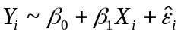 (A1)
where Y_{i} is the response variable, X_{i} is the predictor variable, parameters β₀ and β₁ are the intercept and slope of the model respectively, and 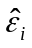 represents the model residuals.

Table A1 The simulated data used in the example. Both Y and X were randomly generated from a normal distribution with mean=0 and SD=1
Y (Response) | X (Predictor)
1.37 | −1.07
−0.17 | −0.92
1.25 | 0.07
−0.24 | −0.51

The variance–covariance matrix was calculated for this regression using the HC0 estimator introduced in the main article. To refresh, the equation for the HC0 estimator is:

HC0 = ( diag X ( (A2)
The HC0 estimator is a type of sandwich estimator, and the equation above can be split into two distinct parts; the ‘bread’, (X^{T}X)⁻¹, and the ‘filling’, 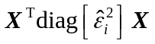. We show how to estimate both parts separately, and then combine them to calculate the variance–covariance matrix that we will use.

To begin with, we define X as a matrix with p+1 columns, with p being the number of predictors included in the model. The first column of X is a column of 1’s representing the regression constant, and the remaining columns are the values for each predictor variable. Thus, in the current example:
X = 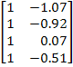
(A3)
To create the bread matrix, we first multiply the transpose of matrix X with X.
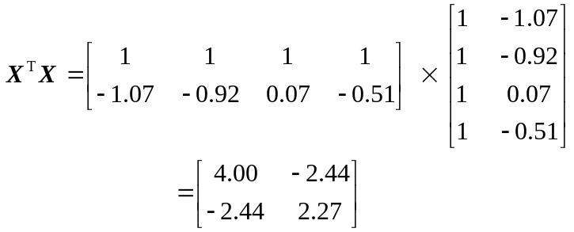 (4)
We then take the inverse of the resulting X^{T}X matrix in order to calculate the bread matrix that we will use.
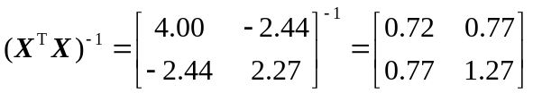 (A5)
Now that we have the ‘bread’ for our sandwich, we can switch our focus to the all-important ‘filling’. In the case of the HC0 estimator, we have 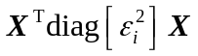, which includes a matrix with the squared residuals from the regression on the diagonal.
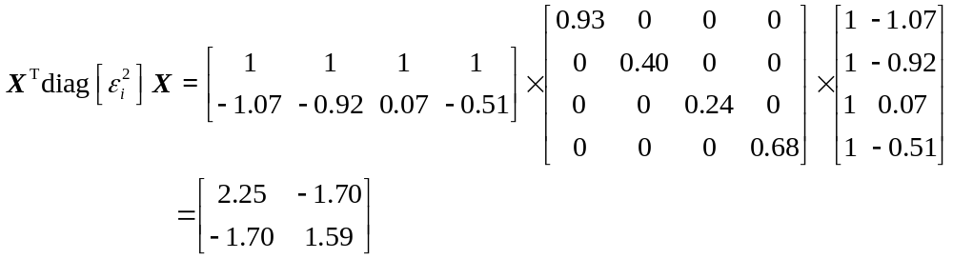 (A6)
Finally, we can combine the ‘bread’ and the ‘filling’ matrices we have created to estimate the standard errors for the regression model.

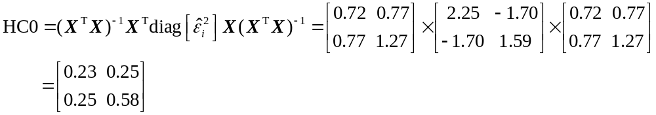(A7)
The standard errors are then calculated as the square root of the diagonal elements in the above matrix (e.g., 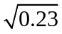=0.48; 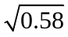=0.76; see Table A2).

Table A2 Model results when using a HC0 estimator
 | Estimate | Standard Error | t Value | p Value
β₀ | 0.74 | 0.48 | 1.52 | 0.50
β₁ | 0.30 | 0.76 | 0.39 | 0.82

