### ­ADDENDUM:

### Model w/ 2 continous covariates

# Fit the model  
m.age.condition <- lm(telo.length ~ 1 + age + condition,   
 data = bad)  
  
  
# Summary

summary(m.age.condition)

##   
## Call:  
## lm(formula = telo.length ~ 1 + age + condition, data = bad)  
##   
## Residuals:  
## Min 1Q Median 3Q Max   
## -3.4614 -1.0776 -0.0319 1.1146 4.3883   
##   
## Coefficients:  
## Estimate Std. Error t value Pr(>|t|)   
## (Intercept) 10.18030 0.12999 78.314 < 2e-16 ***  
## age -0.13003 0.03882 -3.350 0.000895 ***  
## condition 0.16529 0.09689 1.706 0.088892 .   
## ---  
## Signif. codes: 0 '***' 0.001 '**' 0.01 '*' 0.05 '.' 0.1 ' ' 1  
##   
## Residual standard error: 1.629 on 358 degrees of freedom  
## Multiple R-squared: 0.03371, Adjusted R-squared: 0.02831   
## F-statistic: 6.245 on 2 and 358 DF, p-value: 0.002158

**Model has**

* an intercept
* a slope for "age"
* a slope for "condition"
* These slopes are often called "partial regression coefficients"
* Have to think carefully how to plot them

### Plotting multiple regression w/2 continous predicors

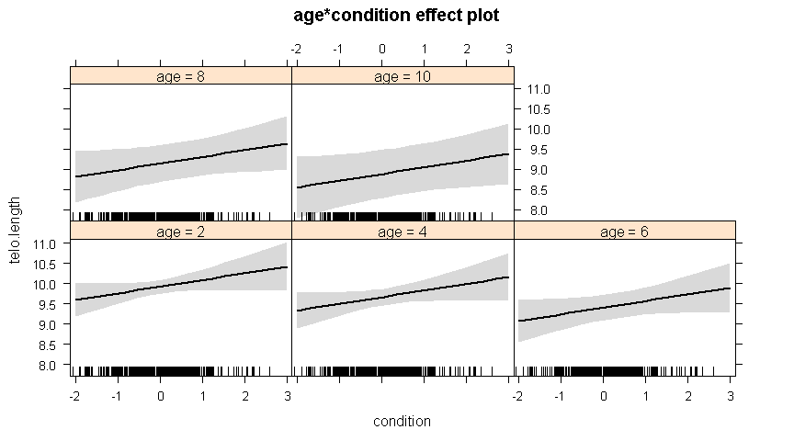

* Vary 1st continous predictor accross its range on x axis
* Hold 2nd continous predictor constant at different levels
  + Often done with mean

### 3D Plot: 2 continuous predictors

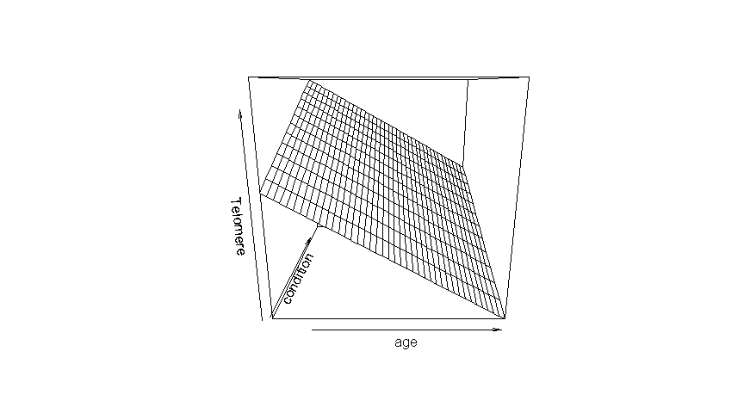

* x axis is age
* y axis is condition (partially hidden, under the surface)
* z axis is telomere length

### Model w/ continous*continous "interaction""

# Fit the model  
m.age.x.condition <- lm(telo.length ~ 1 + age*condition,   
 data = bad)

# Summary  
  
summary(m.age.x.condition)

##   
## Call:  
## lm(formula = telo.length ~ 1 + age * condition, data = bad)  
##   
## Residuals:  
## Min 1Q Median 3Q Max   
## -3.5232 -1.0849 -0.0421 1.1215 4.3641   
##   
## Coefficients:  
## Estimate Std. Error t value Pr(>|t|)   
## (Intercept) 10.17862 0.13016 78.201 < 2e-16 ***  
## age -0.12648 0.03942 -3.209 0.00145 **   
## condition 0.22890 0.15313 1.495 0.13586   
## age:condition -0.02017 0.03758 -0.537 0.59176   
## ---  
## Signif. codes: 0 '***' 0.001 '**' 0.01 '*' 0.05 '.' 0.1 ' ' 1  
##   
## Residual standard error: 1.63 on 357 degrees of freedom  
## Multiple R-squared: 0.03449, Adjusted R-squared: 0.02638   
## F-statistic: 4.251 on 3 and 357 DF, p-value: 0.005722

### 3D Plot

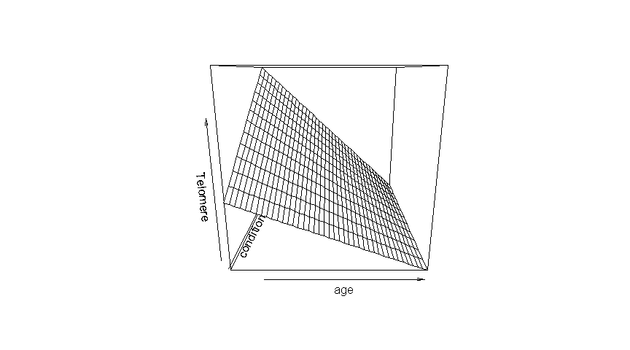

* x axis is age
* y axis is condition (partially hidden)
* z axis is telomere length
* Note the slight curvature to the surface.
* The positive effect of condition declines as age increases