How populations change over time: a gentle guide to the math behind exponential and logistic population growth

A major question in ecology is how populations change over time. In particular, if there is a certain number of organisms now how many will there be at some time point later, say next year.? We can write equations to describe such changes, called the number of organisms now $N_{now}$ and next year $N_{next year}$.
Populations change due to processes such as the deaths of current members of the population and the birth of offspring. We can represent these changes mathematically like this:
$N_{next year}= N_{now}$*(proportion of adults surviving)
+ $N_{now}$*(number of offspring per adult) (1)
Which can be thought of as
$N_{next year}= N_{surviving adults}$ + $N_{kids}$ (2)
To make our equation more compact we’ll take “proportion of adults surviving” and represent it as S, the survival rate, and “number of offspring per adult as F. Also, “now” will just be “t” and “next year” as “t+1”
So, we can write a shorter equation
$N_{t+1}= N_{t}$*S + $N_{t}$*F (3)
Population ecologists are frequently interested in both the absolute number of organisms (${eg N}_{t}$, $N_{t+1}$) and also the rate of population change over time, usually referred to as the population growth rate. Usually the Greek letter “L” called “lambda” (λ) is used to represent population growth rate.
If you have been following a population over time you can calculate lambda (λ) directly using the size of the population at one time point and at a previous time point.
$\frac{N_{t+1}}{N_{t}}=λ$ (4)
Lambda (λ) is therefore the ratio between two population sizes.
If we have a value for lambda (perhaps from a past study) and the current size of the population from a field survey, we can calculate the future size of the population by doing a little algebra. We can multiple both sides of equation (4) by $N_{t}$ to cancel out the ratio like this:
$$N_{t}*\frac{N_{t+1}}{N_{t}}=λ*N_{t}$$
This gives us
$N_{t+1}=λ*N_{t}$ (5)
Calculating lambda from demographic rates
Survival and fecundity are often generally referred to as demographic rates or vital rates. You can also calculate lambda from the survival (S) and fecundity (F) rates collected from field data or from past studies. We can start with our equation (3) from above
$N_{t+1}= N_{t}$*S + $N_{t}$*F
and then do a little algebra and extract and factor out the common element $N_{t}$ from both the $N_{t}$*S and $N_{t}$*F parts on the right side of the equation. This results in
$N_{t+1}= N_{t}$(S + F) (7)
Since $N_{t+1}=λ*N_{t}$ and also $N_{t+1}= N_{t}$(S + F) , we can see that $λ=$(S + F). $λ$ therefore represents a combination of both survival (S) of adults for one year to the next plus how many offspring they produce (F).

Project population growth a single year
Let’s say you want to know about how a population of deer will change over time. If you start with 10 deer and you know that lambda for this population is 1.2 you can start with equation (5)
$N_{t+1}=λ*N_{t}$
then plug in the values lambda = 1.2 and N = 10
$$N_{t+1}=1.2*10$$
and get the project population the following year
$$N_{t+1}=12$$

Exponential population growth
If you take the population size of 12 deer from our last calculation and plug it back into the population growth equation like this
$$N_{t+1}=1.2*12$$
the estimated population the following year will be 14.4 deer.
$$N_{t+1}=14.4$$
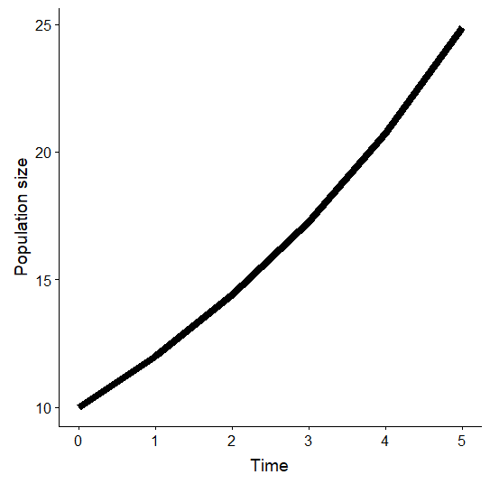
If you repeat this 5 time times (for 5 years of population change) you will see a graph like this. Note the curvature to the line.
When you plug the output of an equation back into itself repeatedly this is called recursion. The equation $N_{t+1}=λ*N_{t}$ is therefore sometimes referred to as a recursion equation. (Similar terms are iterate and iteratively.)
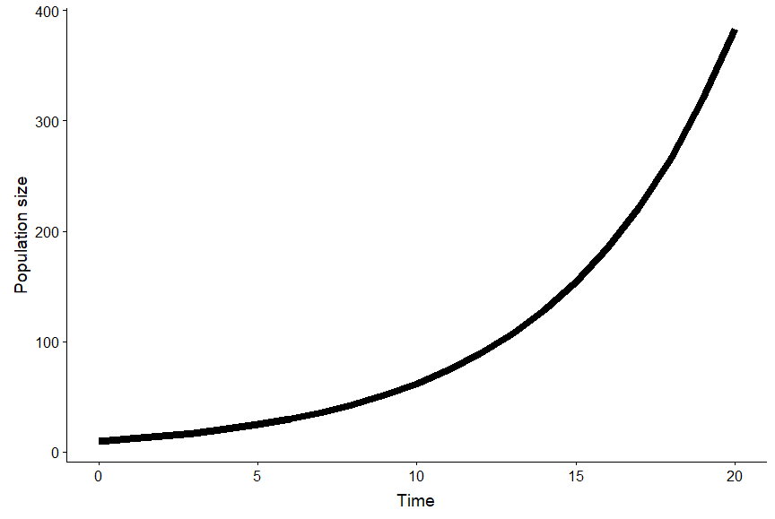
If you repeat this recursion process 20 times you see a graph like this.
This type of upward-curving, accelerating change is known as exponential population growth. (We won’t do it right now, but we can re-write our equations in terms of an exponential term).

Expressing exponential population growth in terms of $r_{d}$
There are multiple related ways of writing out equations to express population growth. The form we use will depend on exactly what our goals are and how we want to think about the biology. For example, if we want, we can take our equation (5) with lambda
$N_{t+1}={λ*N}_{t}$ (8)
And re-write it in terms of a new parameter, $r_{d}$
$$N_{t+1}={\left(1+r_{d}\right)*N}_{t}$$
That is, ${λ=1+r_{d}}_{}$
$r_{d}$ is called the discrete growth factor. The “discrete” part has to do with the fact that we are thinking about our population in terms of discrete time steps: the passage of one year. We are therefore setting up our model in terms of discrete time. This is a good way to think about organisms that have a single breeding season each year, such as deer and birds. In contrast, other organisms such as humans don’t have defined breeding seasons and so can reproduce continuously throughout the year. Model of humans are therefore set up in terms of continuous time using a slightly different framework than what we are doing here. If we wanted to, we could model human populations using a discrete time model, but this would be a simplification of human life history. Make simplifications, though is a key part of modeling!
[what is the “Growth factor” part of it…]
Returning to the equation$N_{t+1}={\left(1+r_{d}\right)*N}_{t}$, we can multiple our population size $N_{t}$ through the $\left(1+r_{d}\right)$term and arrive at a slightly different version of the equation:
$N_{t+1}=N_{t}+ N_{t}*r_{d}$ (9)
One reason why we switch around how the equation is framed is to set up an extension of the exponential growth model that incorporates an important concept in ecology: a population’s carrying capacity, which is typically represented with the letter K.
Focusing on the rate of population change
Frequently we want to focus our attention just on the how much a population changes over a single time step. Starting with equation (9)
$$N_{t+1}=N_{t}+ N_{t}*r_{d}$$
We redefine the $N_{t}*r_{d}$ part as $ΔN$. That is
$ΔN= N_{t}*r_{d}$,
The symbol $Δ$ is the Greek letter Delta, which is used across the sciences to represent change. We can therefore substitute $ΔN$ for $N_{t}*r_{d}$ and re-write equation (9) as
$$N_{t+1}=N_{t}+ ΔN$$
That is, the population at the next time step ($N_{t+1}$) equals the population now ($N_{t}$) plus how much the population is going to change over the course of time ($ΔN$).
As I said initially, we often just want to think how much change is happening, so we focus on this equation
$ΔN= N_{t}*r_{d}$ (10)
As mentioned above, we are setting up our models here on the basis of discrete time. Therefore “$ΔN"$ means how much the population (N) change ($Δ)$ over a discrete time step; in particular, over one year.
Because $ΔN$is the difference between two population sizes it is referred to as a difference equation (similar but not exactly the same as a differential equation).
Many books focus not on discrete-time models but continuous-time models. Instead of $ΔN= N_{t}*r_{d}$ they frequently present a very similar equation as their focus:
$\frac{dN}{dt}=N_{t}*r_{}$ (11)
The part on the left $\frac{dN}{dt}$ comes from calculus and, similar to $ΔN$ indicates that we are interested in change. Also note that the subscript “d” has been dropped and we just have “r”.

Logistic population growth
The equations presented above involve many assumptions. For example, we they only consider survival/death and reproduction, completely ignoring migration (movement or settling into a population) and immigration (leaving a population). More subtly, these equations above assume that the population has access to an infinite amount of resources. That is, no matter how large the population size is, they can always produce more offspring.
Resources are always limiting. This means that as populations increase in size, their growth rate, whether expressed as lambda or $r_{d}$ declines. Ecologists frequently refer to this as density dependent population growth. That is, the population growth rate at any given time is not a constant $r_{d}$, but rather depends on the current size or density of the population. (To be more specific, the situation when an increase in density decreases the growth is rate is called negative density dependence. There are situations when increasing density can increase growth rates, which is known as positive density dependence).
Logistic populating growth in terms of $α$
Density dependent population growth is frequently represented by adding a penalty term to the exponential population growth rate equation $N_{t+1}={N_{t}+ r_{d}N}_{t}$. This penalty term sets up the equation so that as population size increases, $r_{d}$begins to decrease. This penalty term is often called $α$ and results in an equation like this:
$N_{t+1}={N_{t}+ r_{d}(1-{α*N}_{t})N}_{t}$ (11)
What $α$ represents is the negative impact an organism has on the survival and reproduction of other members of its population. This negative effect could be caused by things increased difficulty finding food, more frequently disease transmission due to crowding, or decreased time spent foraging because more time must be spending defending territories and mates.
Logistic population growth in terms of carrying capacity K
An equivalent way of represent logistic population growth is in terms of the carrying capacity, represented with K. The term $(1-{α*N}_{t})$ in equation 11 gets swapped out with a different for of the penalty term $\left[1-\frac{N_{t}}{K}\right]$, resulting in this equation
$N_{t+1}={N_{t}+ r_{d}\left[1-\frac{N_{t}}{K}\right]N}_{t}$ (12)

Different versions of the logistic population equation
There’s a completely equivalent version of the logistic population growth equation that is frequently used:
$N_{t+1}={N_{t}+ r_{d}\left[\frac{{K-N}_{t}}{K}\right]N}_{t}$ (13)
This is equation is derived from equation 12 using a little bit of algebra.
First, start with equation 12:
$N_{t+1}={N_{t}+ r_{d}\left[1-\frac{N_{t}}{K}\right]N}_{t}$
Then, since any number divided by itself equals one, we can swap out the 1 in the brackets of equation 12 with the term K/K, like this
$$N_{t+1}={N_{t}+ r_{d}\left[\frac{K}{K}-\frac{N_{t}}{K}\right]N}_{t}$$
We can then try to remember how to do subtraction with fractions to simplifying $\frac{K}{K}-\frac{N_{t}}{K}$ . Since both K/K and N/K have K as the denominator, this simplifies to $\frac{{K-N}_{t}}{K}$. So, we have the new equation
$N_{t+1}={N_{t}+ r_{d}\left[\frac{{K-N}_{t}}{K}\right]N}_{t}$ (14)

As for exponential population growth, we often focus not on calculating population in the future ($N_{t+1})$ but just how much the poualtion changes ($ΔN)$. We therefore focus on the difference equation
$ΔN={ r_{d}\left[\frac{{K-N}_{t}}{K}\right]N}_{t}$ (15)
Again, things have been framed here in terms of discrete time. Many books work in continuous time, so they use this equation:
$\frac{dN}{dt}={ r_{d}\left[\frac{{K-N}_{t}}{K}\right]N}_{t}$ (16)

