Lecture 28: Multiple regression w/Lion data

[brouwern@gmail.com](mailto:brouwern@gmail.com)

December 5, 2016

setwd("C:/Users/lisanjie2/Desktop/TEACHING/1_STATS_CalU/1_STAT_CalU_2016_by_NLB/Lecture/Unit3_regression/last_week")

# Multiple linear regression

* Also known as "multiple regression"

## Lion data: predicting age from nose coloration

### Preliminaries

Load the data

lions <- read.csv("lion_age_by_pop.csv" )

There are 2 populations, The main Serengeti population and the Ngorogoro crater (sub?) population

summary(lions)

## portion.black age.years population  
## Min. :0.1000 Min. : 1.100 Ngorogoro:10   
## 1st Qu.:0.1475 1st Qu.: 2.175 Serengeti:22   
## Median :0.2650 Median : 3.500   
## Mean :0.3197 Mean : 4.309   
## 3rd Qu.:0.4325 3rd Qu.: 5.850   
## Max. :0.7900 Max. :13.100

In the book they consider *all* of the data combined and ignore the two seperate populations (which are sperate geographically and genetically)

Does the relationship between age and nose-blackness work the same for both populations?

### Plot lion data w/ both populations combined

We will "pool" the data from both populations (that is, ignore population differences)

#### Run regression

#build regression model  
m.pooled <- lm(age.years ~ portion.black, data = lions)

#### Look at summary of regression

summary(m.pooled)

##   
## Call:  
## lm(formula = age.years ~ portion.black, data = lions)  
##   
## Residuals:  
## Min 1Q Median 3Q Max   
## -2.5457 -1.1457 -0.3384 0.9245 4.3426   
##   
## Coefficients:  
## Estimate Std. Error t value Pr(>|t|)   
## (Intercept) 0.9262 0.5591 1.657 0.108   
## portion.black 10.5827 1.4884 7.110 6.59e-08 ***  
## ---  
## Signif. codes: 0 '***' 0.001 '**' 0.01 '*' 0.05 '.' 0.1 ' ' 1  
##   
## Residual standard error: 1.66 on 30 degrees of freedom  
## Multiple R-squared: 0.6276, Adjusted R-squared: 0.6152   
## F-statistic: 50.55 on 1 and 30 DF, p-value: 6.59e-08

#### Plot pooled data

#plot  
plot(age.years ~ portion.black, data = lions,   
 cex = 2, lwd = 2,  
 xlim = c(0.0, 0.9),  
 ylim = c(0,14))  
abline(m.pooled, lwd = 3, col = 2)

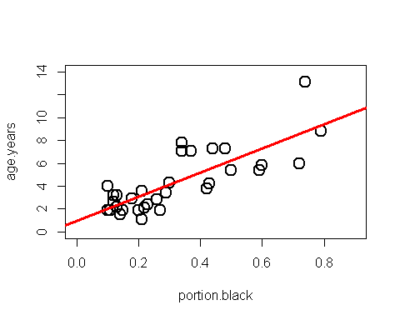

#To Do: add equations for line

### Plot lion data seperated by population

i.Serengeti <- which(lions$population == "Serengeti")  
i.Ngorogoro <- which(lions$population == "Ngorogoro")  
  
#plot Serengeti  
plot(age.years ~ portion.black,   
 data = lions,  
 subset = i.Serengeti,   
 cex = 2, lwd = 2,col = 2,  
 xlim = c(0.0, 0.9),  
 ylim = c(0,14))  
  
  
#plot Serengeti  
points(age.years ~ portion.black,   
 data = lions,  
 subset = i.Ngorogoro,   
 cex = 2, lwd = 2,  
 col = 3,pch = 2,  
 xlim = c(0.0, 0.9),  
 ylim = c(0,14))  
  
#add legend  
legend("topleft",  
 legend = c("Serengeti","Ngorogoro"),  
 col = c(2,3),pch = c(1,2),cex = 1.2,  
 )

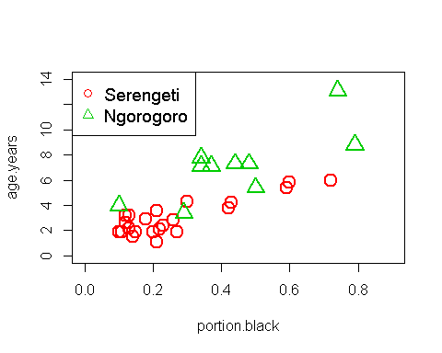

#### What model best describes the data: 1 line or 2?

##### Hypothesis 0: there is no relationship

THe null hypothesis Ho is that there is no relationship between how black the nose is and age. We can seee that there is a relationshop and will skip this Ho.

##### Hypothesis 1: the populations are the same

The data can be modeled with a single regression line. Any differene between the popuatliosn due to random noise.

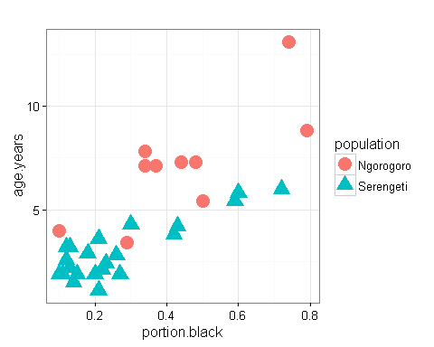

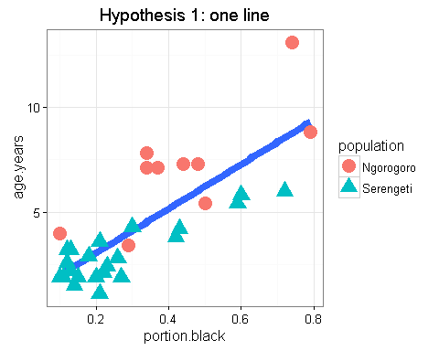

##### Hypothesis 2: the populations are different

*The populations have different biological/ecological processes going on that make the relationship between age and nose blackness depend on the population* We say there is an **INTERACTION** between population and portion.black *stated another way: The relationship between nose blackness and age is different between the two populations* Therefore, the slope of the lines are different *(THis include the possiblity that there is no relationship in one population (slope = 0) and is a relationship in the other (slope >0) )

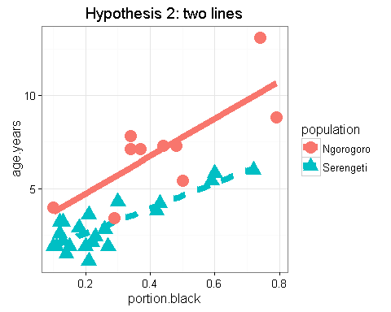

#### Run multiple regression model

*We indicate in* ***interaction*** *in R using the multiple symbol "*"

Look at multiple regression output

summary(m.by.pop)

##   
## Call:  
## lm(formula = age.years ~ portion.black * population, data = lions)  
##   
## Residuals:  
## Min 1Q Median 3Q Max   
## -2.3453 -0.4460 0.0258 0.5827 2.9336   
##   
## Coefficients:  
## Estimate Std. Error t value Pr(>|t|)   
## (Intercept) 2.7015 0.9032 2.991 0.00574 **   
## portion.black 10.0877 1.8801 5.365 1.02e-05 ***  
## populationSerengeti -1.4667 1.0106 -1.451 0.15781   
## portion.black:populationSerengeti -3.3352 2.3630 -1.411 0.16914   
## ---  
## Signif. codes: 0 '***' 0.001 '**' 0.01 '*' 0.05 '.' 0.1 ' ' 1  
##   
## Residual standard error: 1.16 on 28 degrees of freedom  
## Multiple R-squared: 0.8303, Adjusted R-squared: 0.8122   
## F-statistic: 45.68 on 3 and 28 DF, p-value: 6.508e-11

#### Test models

Compare the model w/1 line vs. the model w/ 2 lines

anova(m.pooled, # data combined (aka "pooled")  
 m.by.pop) # data seperated by population

## Analysis of Variance Table  
##   
## Model 1: age.years ~ portion.black  
## Model 2: age.years ~ portion.black * population  
## Res.Df RSS Df Sum of Sq F Pr(>F)   
## 1 30 82.712   
## 2 28 37.679 2 45.034 16.733 1.657e-05 ***  
## ---  
## Signif. codes: 0 '***' 0.001 '**' 0.01 '*' 0.05 '.' 0.1 ' ' 1

#### MOre stuff

#no relationship  
m.null <- lm(age.years ~ 1,data = lions)  
  
#relationship is the same for both populations  
m.pooled <- lm(age.years ~ portion.black,data = lions)  
  
  
#slope is the same but intercepts are different  
m.by.pop.add <- lm(age.years ~ portion.black + population,data = lions)  
  
  
#slopes AND intercepts are different  
m.by.pop.intnx <- lm(age.years ~ portion.black*population,data = lions)

#relationship is the same for both populations  
summary(m.pooled)

##   
## Call:  
## lm(formula = age.years ~ portion.black, data = lions)  
##   
## Residuals:  
## Min 1Q Median 3Q Max   
## -2.5457 -1.1457 -0.3384 0.9245 4.3426   
##   
## Coefficients:  
## Estimate Std. Error t value Pr(>|t|)   
## (Intercept) 0.9262 0.5591 1.657 0.108   
## portion.black 10.5827 1.4884 7.110 6.59e-08 ***  
## ---  
## Signif. codes: 0 '***' 0.001 '**' 0.01 '*' 0.05 '.' 0.1 ' ' 1  
##   
## Residual standard error: 1.66 on 30 degrees of freedom  
## Multiple R-squared: 0.6276, Adjusted R-squared: 0.6152   
## F-statistic: 50.55 on 1 and 30 DF, p-value: 6.59e-08

#slope is the same but intercepts are different  
summary(m.by.pop.add)

##   
## Call:  
## lm(formula = age.years ~ portion.black + population, data = lions)  
##   
## Residuals:  
## Min 1Q Median 3Q Max   
## -2.5415 -0.5361 -0.1484 0.5990 3.5691   
##   
## Coefficients:  
## Estimate Std. Error t value Pr(>|t|)   
## (Intercept) 3.6283 0.6306 5.753 3.14e-06 ***  
## portion.black 7.9764 1.1582 6.887 1.45e-07 ***  
## populationSerengeti -2.7185 0.4928 -5.517 6.04e-06 ***  
## ---  
## Signif. codes: 0 '***' 0.001 '**' 0.01 '*' 0.05 '.' 0.1 ' ' 1  
##   
## Residual standard error: 1.18 on 29 degrees of freedom  
## Multiple R-squared: 0.8183, Adjusted R-squared: 0.8057   
## F-statistic: 65.29 on 2 and 29 DF, p-value: 1.827e-11

#slopes AND intercepts are different  
summary(m.by.pop.intnx)

##   
## Call:  
## lm(formula = age.years ~ portion.black * population, data = lions)  
##   
## Residuals:  
## Min 1Q Median 3Q Max   
## -2.3453 -0.4460 0.0258 0.5827 2.9336   
##   
## Coefficients:  
## Estimate Std. Error t value Pr(>|t|)   
## (Intercept) 2.7015 0.9032 2.991 0.00574 **   
## portion.black 10.0877 1.8801 5.365 1.02e-05 ***  
## populationSerengeti -1.4667 1.0106 -1.451 0.15781   
## portion.black:populationSerengeti -3.3352 2.3630 -1.411 0.16914   
## ---  
## Signif. codes: 0 '***' 0.001 '**' 0.01 '*' 0.05 '.' 0.1 ' ' 1  
##   
## Residual standard error: 1.16 on 28 degrees of freedom  
## Multiple R-squared: 0.8303, Adjusted R-squared: 0.8122   
## F-statistic: 45.68 on 3 and 28 DF, p-value: 6.508e-11