Lions as two-way ANOVA

[brouwern@gmail.com](mailto:brouwern@gmail.com)

December 9, 2016

# Lion data set as 2-way ANOVA

#The following sets up the data fro the analysis  
#Set working directory  
  
setwd("C:/Users/lisanjie2/Desktop/TEACHING/1_STATS_CalU/1_STAT_CalU_2016_by_NLB/Lecture/Unit3_regression/last_week")

Load data

dat <- read.csv("lion_age_by_pop_and_sex.csv")

## Lion data

plot(age.years ~ portion.black, data = dat,  
 main = "Lion pigment data split into 3 groups",  
 ylim = c(0,19))

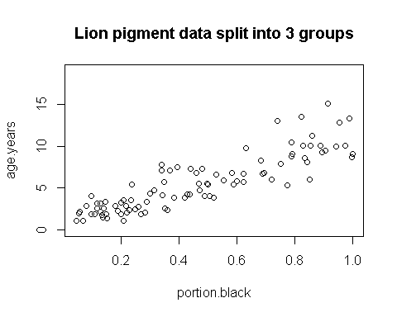

## Split lion data by groups

par(mfrow = c(1,1))  
pigment.mean <- mean(dat$portion.black)  
  
plot(age.years ~ portion.black, data = dat,  
 main = "Lion pigment data split into 3 groups",  
 ylim = c(0,19))  
abline(v = pigment.mean, col = 2, lwd = 3)  
  
text(x = 0.125, y = 17, "Low\npigment", cex =1.1)  
  
text(x = 0.895, y = 17, "High\npigment", cex = 1.1)

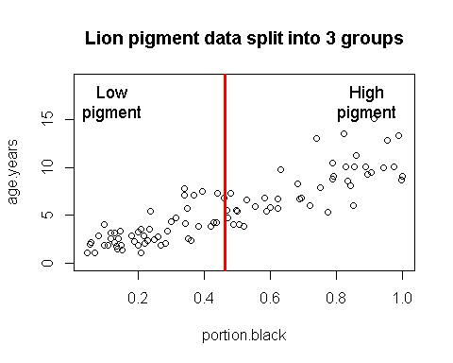

## Create Two pigment groups

pigment.mean <- mean(dat$portion.black)  
  
dat$pigment.groups.2 <- "high.pigment"  
  
dat$pigment.groups.2[which(dat$portion.black <= pigment.mean)] <- "low.pigment"  
  
  
  
dat$pigment.groups.2 <- factor(dat$pigment.groups.2)  
summary(dat)

## age.years portion.black population sex   
## Min. : 1.056 Min. :0.04609 Ngorogoro:10 female:61   
## 1st Qu.: 2.800 1st Qu.:0.21000 Serengeti:83 male :32   
## Median : 5.378 Median :0.43000   
## Mean : 5.589 Mean :0.46446   
## 3rd Qu.: 7.800 3rd Qu.:0.72000   
## Max. :15.178 Max. :1.00000   
## pigment.groups.2  
## high.pigment:43   
## low.pigment :50   
##   
##   
##   
##

dat$pigment.groups.2 <- factor(dat$pigment.groups.2,  
 levels =c("low.pigment",  
 "high.pigment"))  
  
  
table(dat$pigment.groups.2, dat$population)

##   
## Ngorogoro Serengeti  
## low.pigment 6 44  
## high.pigment 4 39

table(dat$pigment.groups.2, dat$sex)

##   
## female male  
## low.pigment 25 25  
## high.pigment 36 7

**NOTE:** Splitting up a continous variable like this into a categorical variable and doing an ANOVA is generally a BAD idead. Regression is the proper way to analyze the raw data. I am making these groups for illustration purposes only!

## Plot raw data by pigmentation group

par(mfrow = c(1,1))  
plot(age.years ~ pigment.groups.2,data = dat,  
 xlab = "Pigmentation group",  
 ylab = "Known Lion Age")

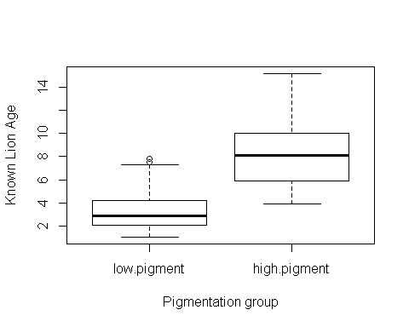

**Figure 1a:** Boxplots of lion ages in two pigmentation groups from the Serengeti and Ngorogoro Crater, Tanzania, east Africa.

## Plot raw data by pigmentation group

par(mfrow = c(1,1))  
plot(age.years ~ population,data = dat,  
 xlab = "Pigmentation group",  
 ylab = "Known Lion Age")

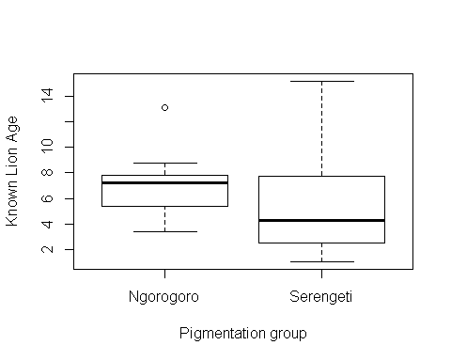

**Figure 1b:** Boxplots of lion ages in two populations the Serengeti and Ngorogoro Crater, Tanzania, east Africa.

## Plot means

library(sciplot)  
  
  
ci.fun. <- function(x) c(mean(x)-2*se(x), mean(x)+3*se(x))  
lineplot.CI(x.factor = pigment.groups.2,  
 response = age.years,  
 data = dat,  
 ci.fun = ci.fun.  
 )

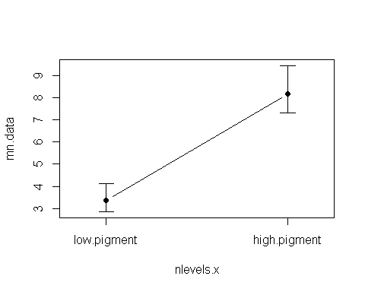

**Figure 2a:** Mean age of lions in two pigmentation groups from the Serengeti and Ngorogoro crater, Tanzania, east Africa. Error bars are approximate 95% confidence intervals.

lineplot.CI(x.factor = population,  
 response = age.years,  
 data = dat,  
 ci.fun = ci.fun.  
 )

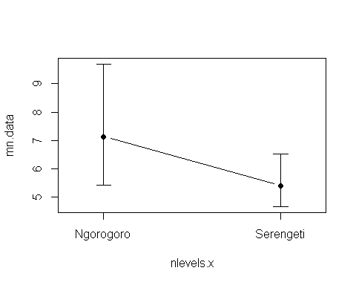 **Figure 2b:** Mean age of lions in two population groups, the Serengeti and Ngorogoro crater, Tanzania, east Africa. Error bars are approximate 95% confidence intervals.

## Calcualte the means of each of the FOUR groups

source("plot_means.R")  
#combine group names  
dat$all.four.groups <- paste(dat$population,  
 dat$pigment.groups.2)  
  
means <- tapply(dat$age.years,  
 dat$all.four.groups,  
 mean)  
  
sds <- tapply(dat$age.years,  
 dat$all.four.groups,  
 sd)  
  
ns <- tapply(dat$age.years,  
 dat$all.four.groups,  
 length)  
  
summary(factor(dat$all.four.groups))

## Ngorogoro high.pigment Ngorogoro low.pigment Serengeti high.pigment   
## 4 6 39   
## Serengeti low.pigment   
## 44

groups <- c("Ngorogoro high",  
 "Ngorogoro low",  
 "Serengeti high",  
 "Serengeti low")  
ses <- sds/sqrt(ns)  
plot.means(means = means,  
 SEs = ses,  
 categories = groups,y.axis.label = "Lion Age")

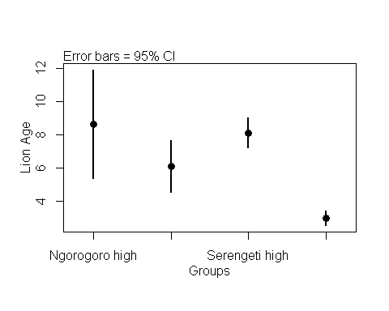

## Two-way ANOVA

(again, don't do an analysis like this - use the original data and do an ANOVA!)

### Null model: age.years ~ 1

Age does not vary with pigmentation OR pigmentation

m.null <- lm(age.years ~ 1 ,data = dat)

### Alternative model 1: age.years ~ pigment.groups.2

Hypoth:Age *does* vary with pigmentation

m.alt.1.pigment <- lm(age.years ~ pigment.groups.2,data = dat)

### Alternative model 2: age.years ~ population

Hypoth:Age varies with population

m.alt.2.pop <- lm(age.years ~ population,data = dat)

### Alternative model 3: age.years ~ pigmentation + population

Hypoth:Age varies with population AND pigmentation

m.alt.3.both <- lm(age.years ~ population +pigment.groups.2,data = dat)

### Alternative model 4: age.years ~ pigmentation *population (FUll model)

Hypoth:Age varies with population

m.alt.4.intxn <- lm(age.years ~ population*pigment.groups.2,data = dat)  
  
m.alt.4.mean <- lm(age.years ~ -1+ population:pigment.groups.2,data = dat)

### THe hard way: Omnibus ANOVA F-test on EACH set of models

Null vs. alt.1 (pigmentation groups)

anova(m.null, m.alt.1.pigment)

## Analysis of Variance Table  
##   
## Model 1: age.years ~ 1  
## Model 2: age.years ~ pigment.groups.2  
## Res.Df RSS Df Sum of Sq F Pr(>F)   
## 1 92 1025.42   
## 2 91 489.14 1 536.28 99.77 2.697e-16 ***  
## ---  
## Signif. codes: 0 '***' 0.001 '**' 0.01 '*' 0.05 '.' 0.1 ' ' 1

Null vs. alt.3 (populations)

anova(m.alt.1.pigment, m.alt.2.pop)

## Analysis of Variance Table  
##   
## Model 1: age.years ~ pigment.groups.2  
## Model 2: age.years ~ population  
## Res.Df RSS Df Sum of Sq F Pr(>F)  
## 1 91 489.14   
## 2 91 998.83 0 -509.69

Null vs. alt.3 (pigmentation + population)

anova(m.alt.1.pigment, m.alt.3.both)

## Analysis of Variance Table  
##   
## Model 1: age.years ~ pigment.groups.2  
## Model 2: age.years ~ population + pigment.groups.2  
## Res.Df RSS Df Sum of Sq F Pr(>F)   
## 1 91 489.14   
## 2 90 451.09 1 38.048 7.5912 0.007098 **  
## ---  
## Signif. codes: 0 '***' 0.001 '**' 0.01 '*' 0.05 '.' 0.1 ' ' 1

Null vs. alt.4 (pigmentation*population inteaction)

anova(m.alt.3.both, m.alt.4.intxn)

## Analysis of Variance Table  
##   
## Model 1: age.years ~ population + pigment.groups.2  
## Model 2: age.years ~ population * pigment.groups.2  
## Res.Df RSS Df Sum of Sq F Pr(>F)   
## 1 90 451.09   
## 2 89 436.44 1 14.652 2.9878 0.08736 .  
## ---  
## Signif. codes: 0 '***' 0.001 '**' 0.01 '*' 0.05 '.' 0.1 ' ' 1

### The easy way

anova() on "interaction" model

anova(m.alt.4.intxn)

## Analysis of Variance Table  
##   
## Response: age.years  
## Df Sum Sq Mean Sq F value Pr(>F)   
## population 1 26.60 26.60 5.4234 0.02213 *   
## pigment.groups.2 1 547.74 547.74 111.6958 < 2e-16 ***  
## population:pigment.groups.2 1 14.65 14.65 2.9878 0.08736 .   
## Residuals 89 436.44 4.90   
## ---  
## Signif. codes: 0 '***' 0.001 '**' 0.01 '*' 0.05 '.' 0.1 ' ' 1

### Writing up result of Omnibus F-test

*Summarize reulst of ANOVA in a single sentence:* "There was a significant difference in the mean ageas of the three diffrent pigmentation groups (F = 106.67, p < 0.00001, DF = 92,90)"

## Comparisons using Tukey-HSD

### Refit m.alt w/ aov()

dat$pigment.groups.2.rename <- gsub("pigment","",dat$pigment.groups.2)  
  
m.alt.4.inxtn.aov <- aov(age.years ~ pigment.groups.2.rename*population,data = dat)

### Pairwise comparison w/TukeyHSD()

Run TukeyHSD()

my.tukey.intxn <- TukeyHSD(m.alt.4.inxtn.aov)