Lions as 1-way ANOVA

[brouwern@gmail.com](mailto:brouwern@gmail.com)

December 9, 2016

# Lion data set as 1-way ANOVA

plot(age.years ~ portion.black, data = dat,  
 main = "Lion pigment data split into 3 groups",  
 ylim = c(0,19))

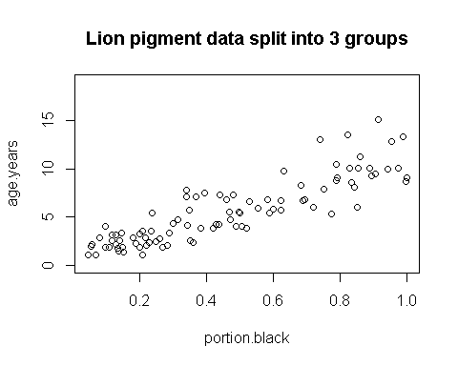

## 

## Split lion data by groups

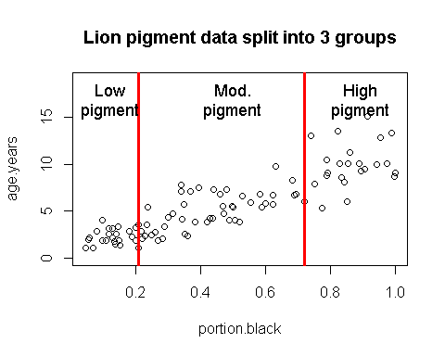

## Create 3 pigment groups

summary(dat)

## pigment.groups.3  
## high.pigment:23   
## low.pigment :24   
## mod.pigment :46   
##   
  
table(dat$pigment.groups.3, dat$population)

##   
## Ngorogoro Serengeti  
## low.pigment 1 23  
## mod.pigment 7 39  
## high.pigment 2 21

table(dat$pigment.groups.3, dat$sex)

##   
## female male  
## low.pigment 11 13  
## mod.pigment 29 17  
## high.pigment 21 2

**NOTE:** Splitting up a continous variable like this into a categorical variable and doing an ANOVA is generally a BAD idead. Regression is the proper way to analyze the raw data. I am making these groups for illustration purposes only!

## 

## Plot raw data by group

p

plot(age.years ~ pigment.groups.3,data = dat,  
 xlab = "Pigmentation group",  
 ylab = "Known Lion Age")

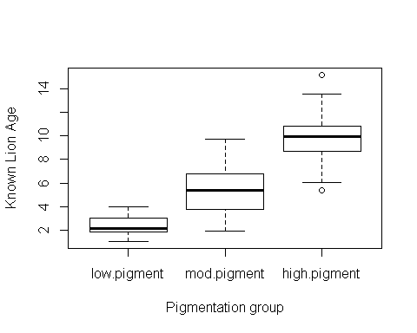

**Figure 1:** Boxplots of lion ages in three pigmentation groups from the Serengeti and Ngorogoro Crater, Tanzania, east Africa.

## Plot means

**Figure 2:** Mean age of lions in three pigmentation groups from the Serengeti and Ngorogoro crater, Tanzania, east Africa. Error bars are approximate 95% confidence intervals.

## 1-way ANOVA

(again, don't do an analysis like this - use the original data and do an ANOVA!)

### Null model: age.years ~ 1

Age does not vary with pigmentation

m.null <- lm(age.years ~ 1 ,data = dat)

### Alternative model: age.years ~ pigment.groups.3

Age *does* vary with pigmentation

m.alt <- lm(age.years ~ pigment.groups.3,data = dat)

### Omnibus ANOVA F-test

anova(m.null, m.alt)

## Analysis of Variance Table  
##   
## Model 1: age.years ~ 1  
## Model 2: age.years ~ pigment.groups.3  
## Res.Df RSS Df Sum of Sq F Pr(>F)   
## 1 92 1025.42   
## 2 90 304.24 2 721.18 106.67 < 2.2e-16

### Writing up result of Omnibus F-test

*Summarize reulst of ANOVA in a single sentence:*

"There was a significant difference in the mean ageas of the three diffrent pigmentation groups (F = 106.67, p < 0.00001, DF = 92,90)"

## Comparisons using Tukey-HSD

### Refit m.alt w/ aov()

dat$pigment.groups.3.rename <- gsub("pigment","",dat$pigment.groups.3)  
  
m.alt.aov <- aov(age.years ~ pigment.groups.3.rename,data = dat)

### Pairwise comparison w/TukeyHSD()

my.tukey <- TukeyHSD(m.alt.aov)

### Look at Tukey output

This lists the effect sizes (differences), their p-values and confidence intervals.

my.tukey

## Tukey multiple comparisons of means  
## 95% family-wise confidence level  
##   
## Fit: aov(formula = age.years ~ pigment.groups.3.rename, data = dat)  
##   
## $pigment.groups.3.rename  
## diff lwr upr p adj  
## low.-high. -7.707850 -8.986380 -6.429321 0e+00  
## mod.-high. -4.939613 -6.058570 -3.820657 0e+00  
## mod.-low. 2.768237 1.664931 3.871542 1e-07

### 

### Plot Tukey HSD

Plot the effect sizes calcautled by Tukey

source("plot_tukey_HSD_code.R")  
  
plotTukeysHSD(my.tukey,x.axis.label = "")  
abline(h =0, col =2)

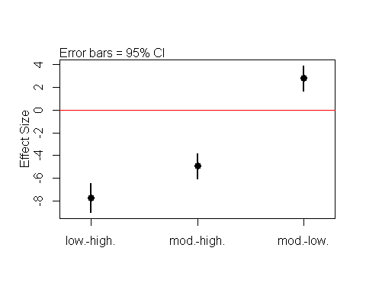

**Plot 3:** Difference between mean lion ages (effect sizes) for three pigmentation groups calculated using Tukey's HSD.

### Compare Means of raw data to plot of Tukey

par(mfrow = c(1,2))

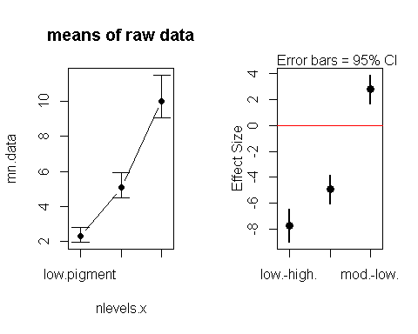

## Write results from Tukey

my.tukey

## Tukey multiple comparisons of means  
## 95% family-wise confidence level  
##   
## Fit: aov(formula = age.years ~ pigment.groups.3.rename, data = dat)  
##   
## $pigment.groups.3.rename  
## diff lwr upr p adj  
## low.-high. -7.707850 -8.986380 -6.429321 0e+00  
## mod.-high. -4.939613 -6.058570 -3.820657 0e+00  
## mod.-low. 2.768237 1.664931 3.871542 1e-07

The results could be written out like this:

"Tukey's HSD indicated that all means were different from each other. The difference between the low and moderate pigment groups was 2.7 years (p < 0.0001), the difference between the moderate and high groups was 4.9 years (p< 0.0001), and the difference between teh low and high groups was 7.7 years (p < 0.0001)"

Note 1: The difference between the low and high group would normally be left out, since if low vs mod and mod vs high are differnet, then low vs high would alos be different.

Note 2: For real publication I'd probalby include the confidence intervals around each differene, but you guys have enough to worry about already.

Note 3: Again do an analysis like this where you take a continuous variable (pigmentation) and split it up into a categorical variable!