Lions as 1-way ANOVA

[brouwern@gmail.com](mailto:brouwern@gmail.com)

December 9, 2016

# Lion data set as 1-way ANOVA

#The following sets up the data fro the analysis  
#Set working directory  
  
setwd("C:/Users/lisanjie2/Desktop/TEACHING/1_STATS_CalU/1_STAT_CalU_2016_by_NLB/Lecture/Unit3_regression/last_week")

Load data

dat <- read.csv("lion_age_by_pop_and_sex.csv")

## Lion data

pigment.fivenum <- fivenum(dat$portion.black)  
  
plot(age.years ~ portion.black, data = dat,  
 main = "Lion pigment data split into 3 groups",  
 ylim = c(0,19))

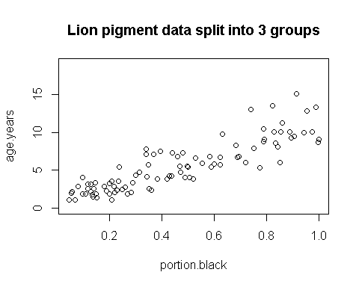

## Split lion data by groups

pigment.fivenum <- fivenum(dat$portion.black)  
plot(age.years ~ portion.black, data = dat,  
 main = "Lion pigment data split into 3 groups",  
 ylim = c(0,19))  
abline(v = pigment.fivenum[2], col = 2, lwd = 3)  
abline(v = pigment.fivenum[4], col = 2, lwd = 3)  
text(x = 0.125, y = 17, "Low\npigment", cex =1.1)  
text(x = 0.5, y = 17, "Mod.\npigment", cex = 1.1)  
text(x = 0.895, y = 17, "High\npigment", cex = 1.1)

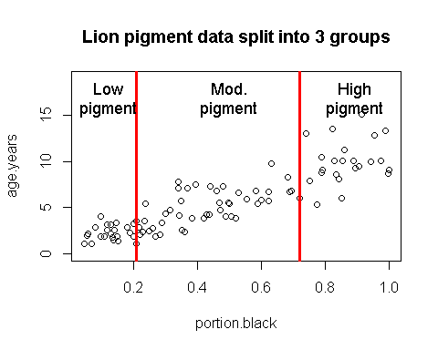

## Create 3 pigment groups

pigment.fivenum <- fivenum(dat$portion.black)  
  
dat$pigment.groups.3 <- "mod.pigment"  
  
dat$pigment.groups.3[which(dat$portion.black <= pigment.fivenum[[2]])] <- "low.pigment"  
  
dat$pigment.groups.3[which(dat$portion.black > pigment.fivenum[[4]])] <- "high.pigment"  
  
  
dat$pigment.groups.3 <- factor(dat$pigment.groups.3)  
summary(dat)

## age.years portion.black population sex   
## Min. : 1.056 Min. :0.04609 Ngorogoro:10 female:61   
## 1st Qu.: 2.800 1st Qu.:0.21000 Serengeti:83 male :32   
## Median : 5.378 Median :0.43000   
## Mean : 5.589 Mean :0.46446   
## 3rd Qu.: 7.800 3rd Qu.:0.72000   
## Max. :15.178 Max. :1.00000   
## pigment.groups.3  
## high.pigment:23   
## low.pigment :24   
## mod.pigment :46   
##   
##   
##

dat$pigment.groups.3 <- factor(dat$pigment.groups.3,  
 levels =c("low.pigment",  
 "mod.pigment",  
 "high.pigment"))  
  
  
table(dat$pigment.groups.3, dat$population)

##   
## Ngorogoro Serengeti  
## low.pigment 1 23  
## mod.pigment 7 39  
## high.pigment 2 21

table(dat$pigment.groups.3, dat$sex)

##   
## female male  
## low.pigment 11 13  
## mod.pigment 29 17  
## high.pigment 21 2

**NOTE:** Splitting up a continous variable like this into a categorical variable and doing an ANOVA is generally a BAD idead. Regression is the proper way to analyze the raw data. I am making these groups for illustration purposes only!

## Plot raw data by group

par(mfromc = c(1,1))

## Warning in par(mfromc = c(1, 1)): "mfromc" is not a graphical parameter

plot(age.years ~ pigment.groups.3,data = dat,  
 xlab = "Pigmentation group",  
 ylab = "Known Lion Age")

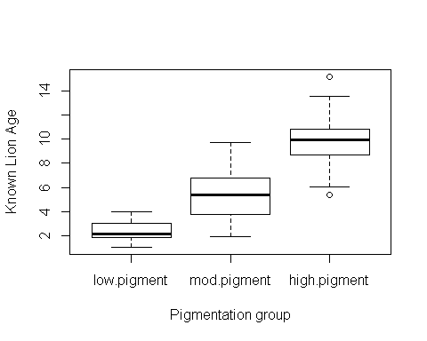

**Figure 1:** Boxplots of lion ages in three pigmentation groups from the Serengeti and Ngorogoro Crater, Tanzania, east Africa.

## Plot means

library(sciplot)  
  
  
ci.fun. <- function(x) c(mean(x)-2*se(x), mean(x)+3*se(x))  
lineplot.CI(x.factor = pigment.groups.3,  
 response = age.years,  
 data = dat,  
 ci.fun = ci.fun.  
 )

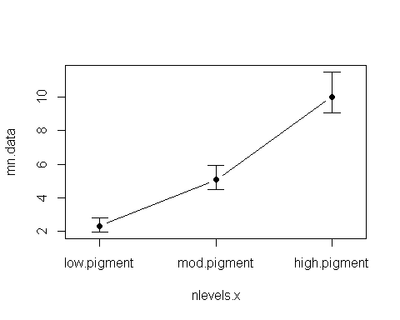

**Figure 2:** Mean age of lions in three pigmentation groups from the Serengeti and Ngorogoro crater, Tanzania, east Africa. Error bars are approximate 95% confidence intervals.

## 1-way ANOVA

(again, don't do an analysis like this - use the original data and do an ANOVA!)

### Null model: age.years ~ 1

Age does not vary with pigmentation

m.null <- lm(age.years ~ 1 ,data = dat)

### Alternative model: age.years ~ pigment.groups.3

Age *does* vary with pigmentation

m.alt <- lm(age.years ~ pigment.groups.3,data = dat)

### Omnibus ANOVA F-test

anova(m.null, m.alt)

## Analysis of Variance Table  
##   
## Model 1: age.years ~ 1  
## Model 2: age.years ~ pigment.groups.3  
## Res.Df RSS Df Sum of Sq F Pr(>F)   
## 1 92 1025.42   
## 2 90 304.24 2 721.18 106.67 < 2.2e-16 ***  
## ---  
## Signif. codes: 0 '***' 0.001 '**' 0.01 '*' 0.05 '.' 0.1 ' ' 1

### Writing up result of Omnibus F-test

*Summarize reulst of ANOVA in a single sentence:* "There was a significant difference in the mean ageas of the three diffrent pigmentation groups (F = 106.67, p < 0.00001, DF = 92,90)"

## Comparisons using Tukey-HSD

### Refit m.alt w/ aov()

dat$pigment.groups.3.rename <- gsub("pigment","",dat$pigment.groups.3)  
  
m.alt.aov <- aov(age.years ~ pigment.groups.3.rename,data = dat)

### Pairwise comparison w/TukeyHSD()

Run TukeyHSD()

my.tukey <- TukeyHSD(m.alt.aov)

### Look at Tukey output

This lists the effect sizes (differences), their p-values and confidence intervals.

my.tukey

## Tukey multiple comparisons of means  
## 95% family-wise confidence level  
##   
## Fit: aov(formula = age.years ~ pigment.groups.3.rename, data = dat)  
##   
## $pigment.groups.3.rename  
## diff lwr upr p adj  
## low.-high. -7.707850 -8.986380 -6.429321 0e+00  
## mod.-high. -4.939613 -6.058570 -3.820657 0e+00  
## mod.-low. 2.768237 1.664931 3.871542 1e-07

### Plot Tukey HSD

Plot the effect sizes calcautled by Tukey

source("plot_tukey_HSD_code.R")  
  
plotTukeysHSD(my.tukey,x.axis.label = "")  
abline(h =0, col =2)

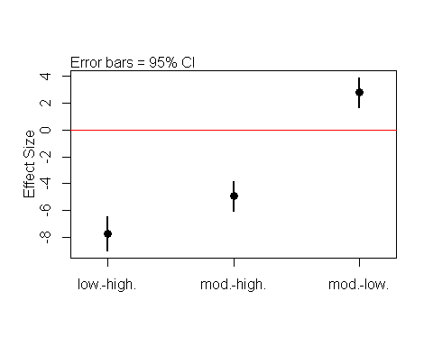

**Plot 3:** Difference between mean lion ages (effect sizes) for three pigmentation groups calculated using Tukey's HSD.

### Compare Means of raw data to plot of Tukey

par(mfrow = c(1,2))  
  
lineplot.CI(x.factor = pigment.groups.3,  
 response = age.years,  
 data = dat,  
 ci.fun = ci.fun.,  
 main = "means of raw data")  
  
plotTukeysHSD(my.tukey,x.axis.label = "")  
abline(h = 0, col =2)

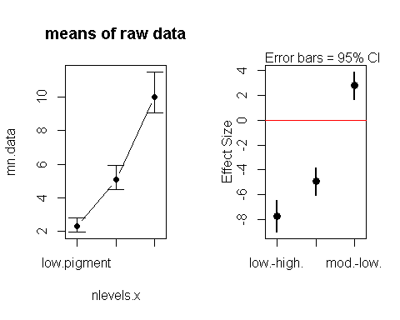

## WRite results from Tukey

my.tukey

## Tukey multiple comparisons of means  
## 95% family-wise confidence level  
##   
## Fit: aov(formula = age.years ~ pigment.groups.3.rename, data = dat)  
##   
## $pigment.groups.3.rename  
## diff lwr upr p adj  
## low.-high. -7.707850 -8.986380 -6.429321 0e+00  
## mod.-high. -4.939613 -6.058570 -3.820657 0e+00  
## mod.-low. 2.768237 1.664931 3.871542 1e-07

The results could be written out like this: "Tukey's HSD indicated that all means were different from each other. The difference between the low and moderate pigment groups was 2.7 years (p < 0.0001), the difference between the moderate and high groups was 4.9 years (p< 0.0001), and the difference between teh low and high groups was 7.7 years (p < 0.0001)"

Note 1: Th difference between the low and high group would normally be left out, since if low vs mod and mod vs high are differnet, then low vs high would alos be different.

Note 2: For a eal publication I'd probalby include the confidence intervals around each differene, but you guys have enough to worry about already.