ENS 495 Fall 2017 Independent Data Analysis: ANOVA Example Paper

## Loading required package: lattice

## Loading required package: survival

## Loading required package: Formula

## Loading required package: ggplot2

##   
## Attaching package: 'Hmisc'

## The following objects are masked from 'package:base':  
##   
## format.pval, round.POSIXt, trunc.POSIXt, units

## Loading required package: magrittr

##   
## Attaching package: 'cowplot'

## The following object is masked from 'package:ggpubr':  
##   
## get_legend

## The following object is masked from 'package:ggplot2':  
##   
## ggsave

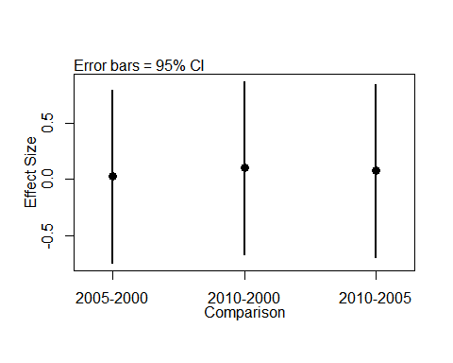

## TITLE: … Pileated Woodpecker (Dryocopus pileatus) …

## ABSTRACT

## INTRODUCTION

[your paper does not need an introduction]

## METHODS

[your paper does not need to have any field methods]

### STATISTICAL METHODS

## RESULTS

## DISCUSSION

[your paper does not need a discussion]

## AKNOWLEDGEMENT

[skip]

## FIGURES

### Figure 1

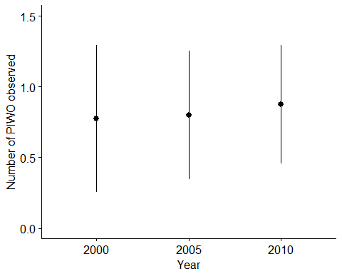

### Figure 1 caption

## APPENDICES

### Appendix 1: Data dictionary

[Paste your data dictionary as a table into your paper]

### Appendix 2: Exploratory graphs

#### Exploratory graphs: boxplots

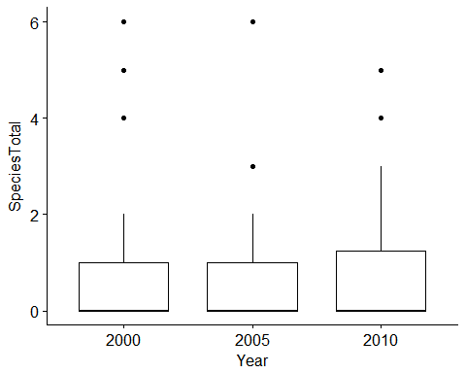

caption

#### Exploratory graphs: histograms

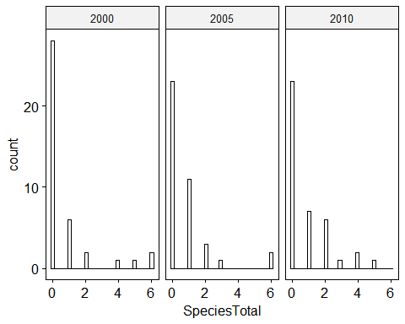

caption

## SUPLEMENTAL FILES

### Supplemental File 1: Raw data file:

Raw data is contained in Brouwer_NL_PIWO_vs_forest_cover.csv

### Supplemental file 2: Data analysis script

All code to reproduce these analyses is in the script file BROUWER_NL_analysis_script_PIWO_vs_forest_cover.R