Assignment 1: Using screen reader for accessibility testing

Screen readers are crucial assistive technologies that convert digital text into speech or Braille output, benefiting users with visual impairments (primary users), users with reading disorders, and cognitive disabilities. In this assignment, you will gain hands-on experience with screen readers, understand the challenges users may face when navigating inaccessible web pages and discover how code improvements can enhance web page accessibility.

# Assignment submission

on Brightspace, submit **ONE** Microsoft word file or PDF and include the following:

* Your name and student number in the file name,
* Your name and student number at the top of the document,
* The name and version of the screen reader used,
* The answers table and screenshot in two distinct sections.

# Grading

Check Brightspace for the rubric and total points

# Instructions

## Step 1: Begin by familiarizing yourself with the screen reader

* Practice the screen reader. You can find resources in Appendix A to help you with this.
* Make sure to take note of the keyboard command to turn off the screen reader to avoid frustration during the assignment.
* Consider using the basic commands and navigating through the entire assignment web pages from top to bottom using the screen reader & keyboard alone (detach the mouse).

## Step 2: Compare the screen reader experience between the accessible and inaccessible pages

* Open Assignment1_InaccessiblePage.html and Assignment1_AccessiblePage.html

in two separate browser tabs.

* Using the screen reader and the keyboard alone, read and interact with elements on both pages.
* Carefully listen to the differences in the screen reader announcement between the inaccessible and accessible pages.
* There are **12 unique defects** in the inaccessible page that were improved in the accessible page (unique means should not be repetitions of the same problem i.e., two broken links of <a> tag in a page are one unique functional defect)
* For each issue you encounter while using the screen reader on the inaccessible page, explain how the same issue was improved on the accessible page.
* Use the answer table and the [Screenshot](#_Screenshot_(inaccessible_page)) section to document your findings

# Answers table

Andrew Brown 040818088

The highlighted & underlined entry is an example to use for practice.

**Screen reader name and version number:** NVDA 2023.2

| **ID** | **Element name** | **Issue - Inaccessible page** | **The improved experience  - Accessible page** |
| --- | --- | --- | --- |
|  | Title of the page | NVDA announced “Untitled” which is not a descriptive title. | NVDA announcement “The Office TV series - Jat Gazette movies & shows reviews” is more descriptive for the purpose of the page |
| **1** | Headings | No next heading or previous heading | Uses proper heading hierarchy and allows navigation between them. |
| **2** | Jat Gazeet Logo | Alt text says just “The Logo” | Says “Jat Gazette Logo” |
| **3** | Original British Series link | Does not mention that it will open the link in a new window | Does let you know that it will open the link in a new window |
| **4** | Character List | Does not tell you how many items are in the list | Tells you that there are 5 items in the list when you tab into it |
| **5** | Le Bureau | Uses a French word in a English sentence without using a French language attribute | Used a language attribute to show language change. |
| **6** | Members tab | Only says Members which could be misleading. | Members was changed to members area to provide more context. |
| **7** | I Button | I Button uses mouse over for information popout | Was switched to a on click event which is more accessible |
| **8** | Email | Does not tell you to enter email which leaves you not sure what is to go in the blank area. | Tells you to enter your email once you tab into the area. |
| **9** | Subscribe | Does not tell you what you are subscribing to | Informs you that you are subscribing to the new letter after your email is inputted |
| **10** | Twitter link | Does not have name for accessible page | Tells you to connect on their Twitter page |
| **11** | Wikipedia Logo link | Does not specify what “logo link” it is pointing to | Tells the user that it is a landmark link for the information not the one at the top of the page. |
| **12** | Use of Aria naming convention for area of the website youre in | Does not specify what landmark that is in. | Mentions it while entering new portion of content. |
|  |  |  |  |

# 

# Screenshot (inaccessible page)

**1**

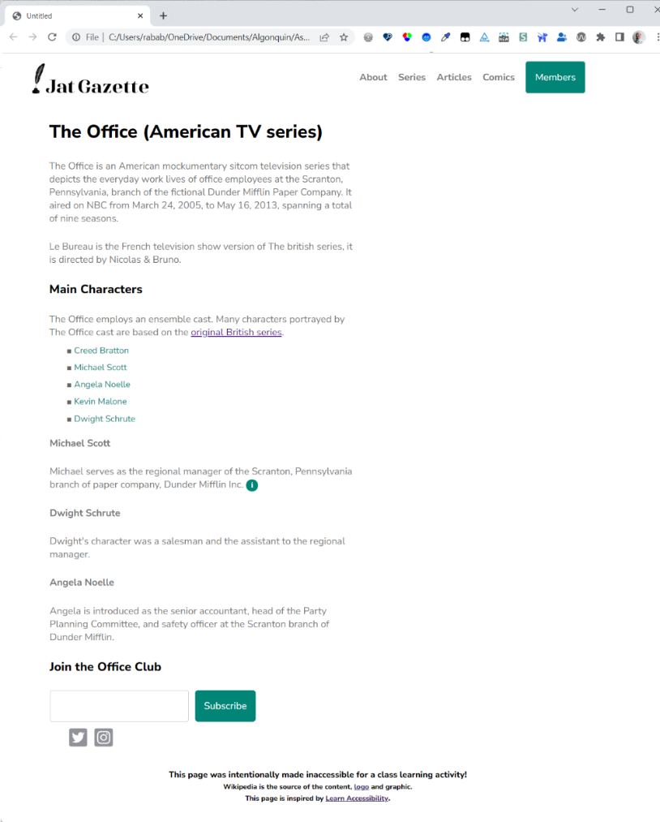

# Appendix A – Resources on the use of screen readers

**For Windows users:**

* Watch [NVDA: Screen Reader Basics](https://youtu.be/Jao3s_CwdRU) to learn NVDA basics and setup configurations.
* Review the  [NVDA keyboard commands (The basics section)](https://dequeuniversity.com/screenreaders/nvda-keyboard-shortcuts#nvda-the_basics) and consider having them printed for easy access.
* Download NVDA for windows, install it, and adjust the settings to your preference.

**For Macintosh users:**

* Watch [VoiceOver: Screen Reader Basics](https://youtu.be/5R-6WvAihms) to learn how to open and use VoiceOver.
* Review the [VoiceOver keyboard commands (The basics section)](https://dequeuniversity.com/screenreaders/voiceover-keyboard-shortcuts#vo-mac-basics) and consider having them printed for easy access.

You can also practice with assistance from lab technicians at [the Assistive Technology lab](https://www.algonquincollege.com/cal/accessible-learning-services/assistive-technology-lab/#assistants).