Ben Brown -> HW9

Logfile:

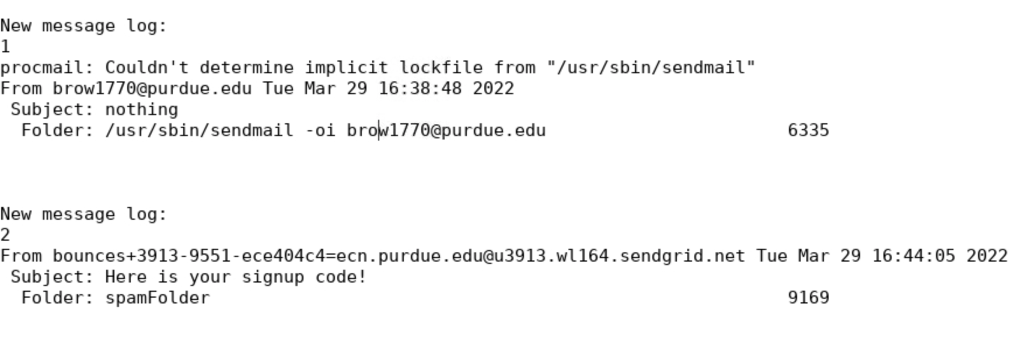

Tcpdump on next page ->

