### Gold-backed Digital Currency White Paper (Rev 3)

### In regards to Texas HB4903 and SB2334

CC:

Arkansas HB1718 / Act 595

Representative Robin Lundstrum

Senator Jonathan Dismang

Mississippi SB100

Senator Bill Eigel

Representative Joe Read

Maine LD 734

Sen. Eric Brakey

Kentucky HB360

Representative Jason Petrie

Representative Brandon Reed

Representative David Osborne

Wyoming SF0101

Senator Ide

Senator French

Senator Hicks

Senator Lynn Hutchings

Senator Dan Laursen

Senator Troy McKeown

### Gold-backed Digital Currency White Paper (Rev 2)

CC:

Texas HB4903:

State Rep. Mark Dorazio

State Rep. Giovanni Capriglione

State Rep. Richard Peña Raymond

State Rep. Cody Harris

State Rep. Lynn Stucky

State Rep. Todd Hunter

State Rep. Ana Hernandez

Texas SB2334:

Sen. Bryan Hughes

Sen. Joan Huffman

Sen. Juan "Chuy" Hinojosa

Texas Bullion Depository

Macy Douglas

Tennessee Bullion Depository Act. SB 150

Sen. Frank Niceley

Rep. Bud Hulsey

Wyoming Bullion Depository HB0198

Sen. Bo Biteman

Sen. Bouchard

Sen. Steinmetz

Idaho HO180 - bullion depository.

Senator Tammy Nichols

Senator Scott Herndon

Senator Brian Lenney

Senator Carl Bjerke

Senator Daniel Foreman

Senator Cindy Carlson

Representative Vito Barbieri

Mississippi SB2966

Senator Melanie Sojourner

Missouri HB718

Representative Dirk Deaton

Representative Michael Davis

Representative Justin Sparks

North Carolina h721 State Depository Study

Representative Mark Brody

Representative Harry Warren

Representative Donnie Loftis

Representative Neal Jackson

Oklahoma Senate Bill 816

Senator Nathan Dahm

Representative Thomas Marti

# Gold-backed Digital Currency White Paper - 2023 Ver 3

Broward Horne, [browardhorne@gmail.com](mailto:browardhorne@gmail.com)  
https://broward.ghost.io/

I'm a software developer with 30+ years of experience. There may soon be demand from State governments for R&D, prototyping and development of gold-backed digital currencies as described in [Texas bills S.B. No. 2334 and H.B. No. 4903](https://www.usgoldbureau.com/news/texas-proposes-gold-backed-digital-currency).

### **Abstract**:

This white paper is an overview of a **GOLD**-backed **DIG**ital currency (**GOLDDIGR**) using blockchain technology and backed by a State precious metals depository. It outlines economic forces, existing State legislation, proposes a multi-State commission to guide design, describes features and technical issues.

* Economic Forces (<https://broward.ghost.io/golddigr/forces/>)
* Legislation (<https://broward.ghost.io/golddigr/legal/>)
* Considerations (<https://broward.ghost.io/golddigr/consider/>)
* Proposal (<https://broward.ghost.io/golddigr/proposal/>)
* Strategic Design (<https://broward.ghost.io/golddigr/strategy/>)
* Tactical Design (<https://broward.ghost.io/golddigr/tactical/>)
* Conclusion (<https://broward.ghost.io/golddigr/finis/>)
* Author (<https://broward.ghost.io/golddigr/author/>)

### **Key Issues**

#### **Low Energy Use**:

GOLDDIGR should consume the same energy as sending an email or editing a document. Most crypto-currencies refer to "mining", "Proof of work", etc, which are energy-intensive features to create artificial scarity. GOLDDIGR's scarity is the gold depository.

#### **Low Complexity**:

GOLDDIGR should be less complex than other crypto-currencies. It won't require complex schemes to generate scarcity, validation, etc.

#### **Cost**

In 2018, I wrote a similar crypto platform using Ethereum. I believe a production system could be ready within a year by a team of five people for under $2 million.

#### **Biggest Variable**

In my opinion, the biggest technical variable will be revisions to the inventory system at the Texas Bullion Depository. Addressed later in the paper.

### Economic Forces **Overview**

The fiat US Dollar is already older than all fiats of the past several hundred years and contrary forces are building against it. Russia and China have planned for its end since 2009, it's aging as the world reserve currency, and the current Federal debt is unsustainable.

#### **Gold Standard**

The longest period in modern history without a gold standard is now; from 1971 to 2023. The last gold standard was the Bretton Woods which operated from 1944 to 1971. The United States has abandoned its gold standard in unusual situations (Civil war, World War 1) but only for a few years.

#### **Russian Gold Reserves**

Since 2009, Russia's central bank has steadily increased gold reserves to diversify away from the US dollar and foreign currencies. Russia's gold reserves more than tripled from 600 metric tons in 2009 to over 2,300 metric tons in early 2021.

#### **Chinese Gold Reserves**

China has consistently increased gold reserves since 2009 to diversify away from US dollars and foreign currencies, like Russia. Gold reserves grew from 1,054 metric tons to over 1,948 metric tons in 2021.

#### **Hegemony**

Western hegemonic empires have had an average lifespan of 95 years and the United States is at 103 years.

#### **Interest Payments**

The current rate of increase in [Federal debt interest payments](https://fredblog.stlouisfed.org/2018/03/the-cost-of-owing) is unsustainable.

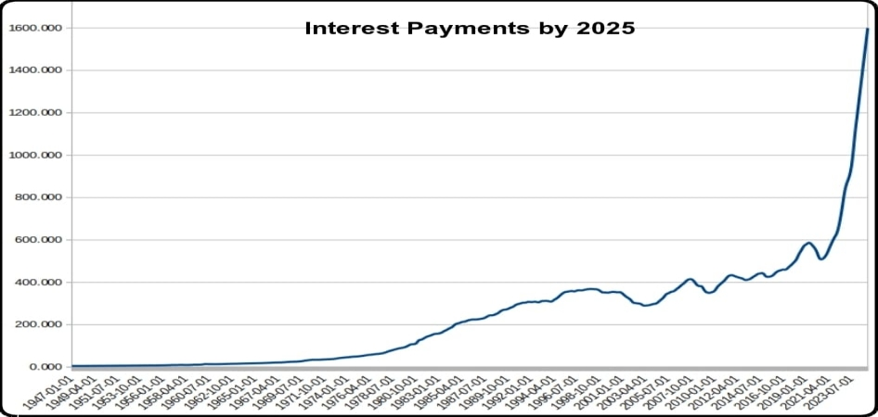

#### **Interest Rates**

As debt increases, rates must fall to maintain equilbrium. Interest rates during the credit upcycle (1980 to 2020) have fallen as far as investors will tolerate. Rising rates will be disastrous for the current debt.

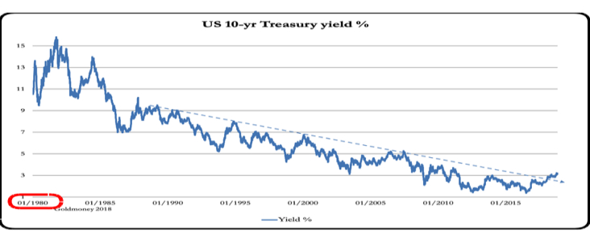

#### **BRICS Strategy**

De-dollarization. The BRICS financial system will use its oligopoly power to control commodity prices and bypass the US Dollar. BRIC countries control 1/2 of the world's food supply, 70% of the microchip supply (if China invades Taiwan) and enough energy to control pricing with a partner like Saudi Arabia.

#### **Central Bank Digital Currencies (CBDC)**

Interest and development in CBDCs accelerated in the past year. CBDCs centralize power and could lead to abuses and political interference in financial transactions.

#### **The Debt Ceiling**

The Federal debt ceiling was created in 1917. Its recent suspension is a huge warning sign. The interest payments on the debt are exploding.

### USA Legislation

The **Sound Money Movement** is a [political and economic movement](https://www.soundmoneydefense.org/) which opposes central bank manipulation of currencies and believes that a gold or silver-based currency has greater stability. The movement supports precious metal legislation in the United States.

#### **Three-Step Legislative Strategy**

1. Establish gold and silver as legal tender
2. Create a State precious metals depository
3. Add a digital currency backed by depository

States where gold and silver are legal tender

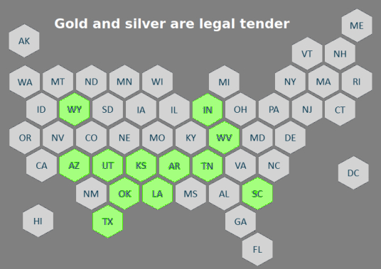

States with pending legislation in 2023

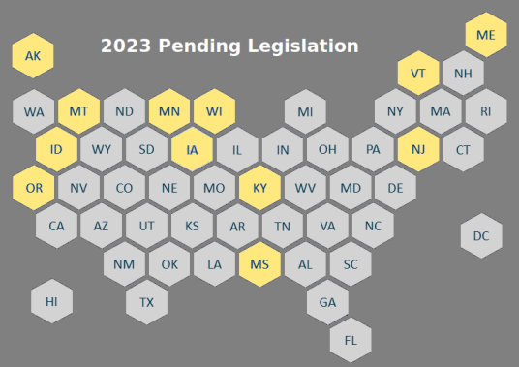

#### **Previous Depository Legislation**

[**Texas Bullion Depository Bill**](https://comptroller.texas.gov/economy/fiscal-notes/2017/september/bullion-depository.php) - signed into law in 2015 to create a state bullion depository.

[**2023: Tennessee Bullion Depository Act**](https://wapp.capitol.tn.gov/apps/BillInfo/default.aspx?BillNumber=SB0150&amp;GA=113) - SB 150 to establish a precious metals depository.

[**2023: Mississippi SB2966**](https://www.billtrack50.com/billdetail/1569891) - establish the Mississippi bullion depository

[**2023: Missouri HB718**](https://legiscan.com/MO/bill/HB718/2023) - create the “Missouri Bullion Depository.”

[**2023: North Carolina H721**](https://www.ncleg.gov/BillLookUp/2023/H721) - State Precious Metals Depository Study

[**2023: Idaho H0180**](https://legiscan.com/ID/rollcall/H0180/id/1267687) - invest in precious metals held in a secure depository

[**2023: Oklahoma SB 816**](https://legiscan.com/OK/bill/SB816/2023) - Establish a State Treasury Depository

[**2023: Montana HB0884**](https://leg.mt.gov/bills/2023/billhtml/HB0884.htm) - Department of Revenue authorizes a media of exchange using gold

#### **Impedence-Matched Currency**

The Euro is like harnessing a horse, a mule, a dog and a turtle to pull a wagon. A "one size fits all" strategy creates stresses because regions (States) have different histories, resources, skill levels, goals. Most economic transactions are within a local sphere and a State currency would be controlled regionally.

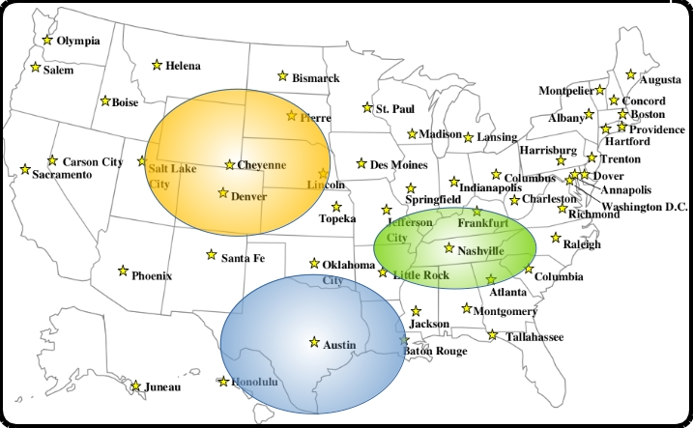

### Proposal

[Recent legislation](https://broward.ghost.io/golddigr/legal/) shows significant State interest in Texas-style precious metal depositories. This proposal is for a Technical Working Group (TWG) of interested parties to fund joint development of regional depositories with common procedures, protocols and digital currency platform. Here's an example.

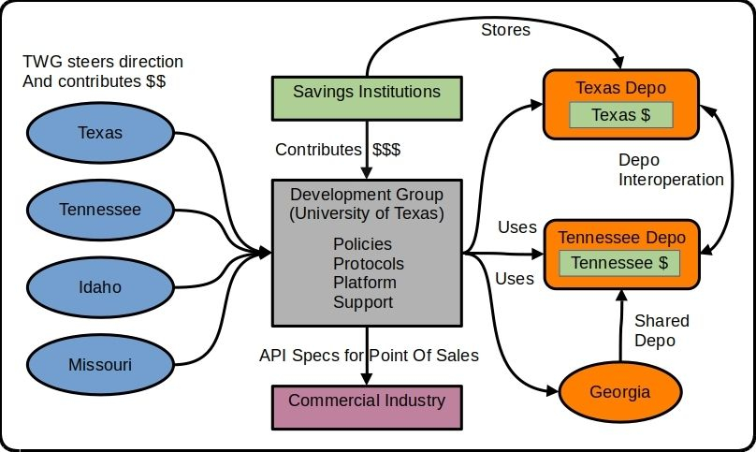

We used this model at Federal Highway in 1994-1996 to develop ASPEN, CDLIS and ISS software with a permanent staff of five. Ten States contributed 1-2 members each quarter for a three-day design and feedback meeting (about 500 manhours annually).

#### **5 Major Components**

**1) Development Group** - Independent organization which combines input to produce policies, protocols and platform for State depositories.

**2) Technical Working Group** (TWG) - a steering committee of States which contribute funding, feedback and policies from part-time advisors in each State.

**3) Regional Depositories** - State depositories which support digital currencies and interoperate with other depositories.

**4) Savings Institutions** - contribute funding to use the State depositories and currencies as a mechanism of investment and wealth preservation.

**5) Commercial Industry** - retail vendors, 3rd party developers to support digital currencies.

#### **Digital Currency Platform**

In 2018, I wrote a successful crypto-currency platform on Amazon AWS, [Sila stablecoin](https://docs.silamoney.com/docs). Our goal was to help hundreds of 3rd party developers add crypto capabilities into their phone apps. This is an improved design from 2020 which replaces Ethereum with a blockchain and Depository Inventory System.

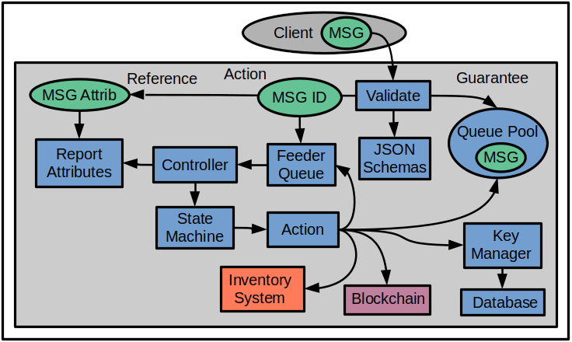

### Strategic Design

This is an example of how a gold-backed digital currency would work. A detailed design is at https://broward.ghost.io/golddigr/tactical

**Depository**: stores gold deposits.  
**Inventory System**: manages gold deposits  
**Currency**: manages cash transactions  
**Blockchain**: equivalent to accounting ledger  
**Key Manager**: equivalent to safety deposit box keys  
**Client**: Customer with gold in depository

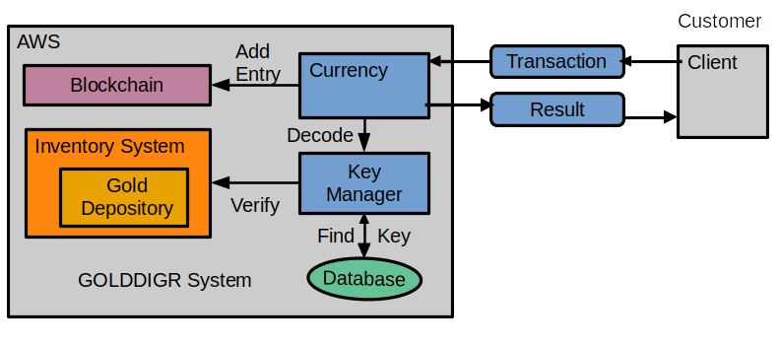

Assumptions: The depository inventory management system synchronizes with the blockchain.

**Here's a simple use case of transferring money:**

1. Client sends a transaction message to Currency API

Example message:

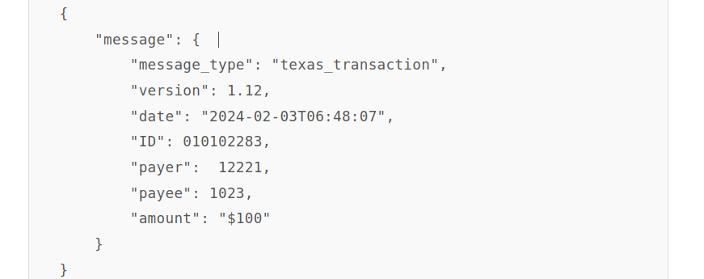

1. Currency forwards message to Key Manager.
2. Key Manager verifies the payer, payee and payer's balance.
3. Currency creates blockchain entry.
4. Currency sends result to client.

### Tactical Design



Three internal domains defined - **Guarantee**, **Action**, **Reference**.

Incoming message is validated by ECDSA decryption of signer ID. JSON schemas enforce a language-agnostic definitions for 90 to 95% of validation rules. Code functions can validate the remainder.

**Guarantee** uses AWS SQS queues to guarantee state and execution. Stores the ECDSA message in its own queue named Msg_ID. This is the only place the original message exists until it is archived.

The **Action** Lambda function accepts Msg_ID and adds it to the feeder queue. The controller pulls queue entries, retrieves and passes the current state into State Machine which executes the next action.

The action pulls the original message, executes, then updates Msg_State. The Msg_ID is re-submitted to the feeder queue for the next iteration until End_State is reached.

The **Reference** Lambda receives a subset of message attributes for reporting/tracking purposes, such as creation_date, client_id, etc. The original message is immutable except for Msg_State.

Complexity is mostly isolated in the State Machine/Rule Engine, so most future changes are there. The rest of the system should be stable, needing few changes except the addition of new actions.

My original design should have had an entry API to issue a unique Msg_ID. This is the initial client call and the client adds it to the transaction message before it's signed, as part of the immutable message.

Other peripheral areas are covered in my AWS primer:

[AWS Cloud Formation Infrastructure](https://broward.ghost.io/aws_app_1/) (https://broward.ghost.io/aws_app_1/)  
[Messaging Strateg](https://broward.ghost.io/aws_app_2/)y (https://broward.ghost.io/aws_app_2/)  
[Security considerations](https://broward.ghost.io/aws_app_9/) (https://broward.ghost.io/aws_app_9/)

### Considerations

#### **Design Issues**

The most complex and controversial areas are

* integration of blockchain with inventory system
* cash equivalency, yes or no? (KYC validation)
* key management (like safety deposit box keys)
* appropriate blockchain

#### **State Depositories**

In 2009, there were 50 State governments and a handful of crypto-currencies. In 2023, there are 23,000 crypto-currencies but still only 50 State governments. State depositories can be a significant option for **non-inflationary wealth preservation** of high-worth organizations and people.

#### **Private Gold-Back Currencies**

Many private gold-backed cryptocoins were released since 2018, most based on Ethereum. Several public blockchains were released since then but a private blockchain is probably better.

**Ethereum is probably adequate but not optimal.**

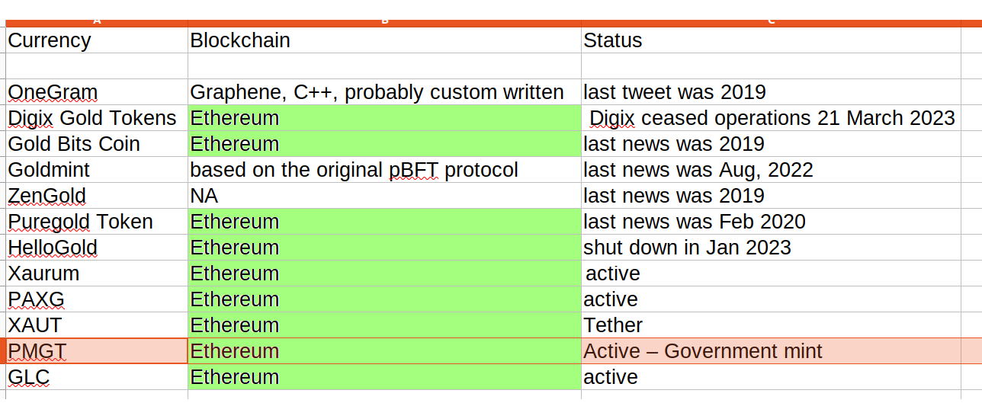

#### **Perth Mint Gold Tokens**

[Perth Mint Gold Tokens](https://pmgt.io/faq/" \l "what-is-pmgt) are the closest equivalent to our proposed gold-backed digital currency. Perth Mint was government-owned and Ethereum-based until their [blockchain host discontinued support](https://blockworks.co/news/gold-backed-crypto-perth-mint-australia) for legal reasons. This currency should be a primary research item.

#### **Existing Depository**

My educated guesses about an existing depository inventory system:

* traditional client-server app
* standard RDBMS for deposit entries
* no external API for remote entries
* no external API for verification of accounts

Integration with a digital currency would require modification of the inventory app. Probably significant work in security areas.

### Conclusion

A set of co-operative State depositories can provide a parallel financial system as a safeguard against the systemic failure or political abuse of the Federal Reserve. A State-based currency could allow a State or region to continue trading global goods in the case of a US dollar failure.

#### **Action Items**

Research the depository inventory software and determine effort to add API integration with a blockchain.

Research [Perth Mint Gold Tokens](https://pmgt.io/) (PMGT) as they are the closest political fit to this project. PMGT is being shut down so there may be lessons to be learned.

Private gold-backed currencies demonstrated that **Ethereum is an adequate choice but probably not optimal**. Private currencies used Ethereum to establish credibility but a State depository is already credible and most clients probably prefer private transactions. Research into private blockchains is an action item.

Research into multi-signature security for administrative access to the blockchain.

Identify strategic goals.

* Do we want cash equivalency?
* Should it support a Region vs a State?
* Estimate peak users and transactions
* Estimate market - ($100-$10K transactions?)

Estimate project timeline. I'm pretty sure a prototype can be built in four months by a team of five professionals and be production ready in a year.

### Author - Broward Horne

#### **Overview**:

Thirty-four years of eclectic software development. Hands-on experience in 30+ projects, seven startups, staff at a major university, several USDOT grants and corporate consulting. Three DEFCON presentations on predictive analytics.

#### **State governments**

From 1991-1996, I was the original architect for several Federal Highway Administration grants developing the [first handheld and wireless systems (ASPEN, CDLIS, ISS)](https://www.ugpti.org/research/details.php?id=93) for motor carrier inspections. I led a quarterly design conference with representatives from ten States to define features and we achieved adoption by 40 States..

I was [Boise State University employee of the year](https://raw.githubusercontent.com/broward/images/master/Me/nampa_article.jpg) in 1994 and received a commendation from the US Secretary of Transportation in 1996.

#### **Digital Currencies**

Hands-on work on three currencies - the Digital Money Trust (1994), Jing, an IoT token prototype (2014) and [Sila stablecoin](https://docs.silamoney.com/docs) (2018). I developed a minimum viable product for Sila in 100 days which was used in 50 funding demonstrations. I designed and wrote 75% of the original beta release which led to $21 million in venture capital funding.

#### **Contracting**

Projects at Boeing (call center), Avnet (e-commerce), Aetna (insurance), DLVR.com (video analytics), Verizon (ring tone sales), Staples (e-commerce). Many with million+ transactions per day and requirements for integrations, legacy limitations, etc.

#### **DEFCON**

I was one of the first [Internet data miners (1993)](https://broward.ghost.io/2014/05/19/realmeme-com/) which led to three [DEFCON convention presentations](https://broward.ghost.io/2014/01/09/defcon/) in 2005-2007 on predictive analytics and memetic manipulations such as election hacking. And I may be part of the composite character of "Zero Cool" in the "Hackers" movie (1996), as I [hacked the planet in 1988.](https://broward.ghost.io/2018/06/02/hacking-the-planet/)

### **Related Materal By Me**

GOLDDIGR White Paper, 2023 (<https://broward.ghost.io/golddigr/>)

How Bitcoin Will Fail, 2022 (<https://broward.ghost.io/golddigr/bitcoin_fail>)  
Texas Depository, 2023 (<https://broward.ghost.io/texas_depo>)  
Stablecoin Hack, 2022 (<https://broward.ghost.io/stablecoin_hack>)  
Bitcoin Miner Bankruptcy, 2022 (<https://broward.ghost.io/miner_bankruptcy>)  
Polymorphic API, 2022 (<https://broward.ghost.io/polymorphic_api/>)  
Bitcoin Death, 2022 (<https://broward.ghost.io/bitcoin_death>)  
Crypto Platform, 2020 (<https://broward.ghost.io/crypto_platform>)  
Pandemic and Gold, 2020 (<https://broward.ghost.io/pandemic_and_gold>)  
Bitcoin Scalability, 2015 (<https://broward.ghost.io/bitcoin_scalability>)  
Digital Money Trust, 2015 (<https://broward.ghost.io/digital_money_trust>)