### State Depository Tokens (SDT)

### GOLD DIGR White Paper – 2024, Ver 5

## Broward Horne, Tallahassee, FL

## browardhorne@gmail.com

## [https://broward.ghost.io/tag/gold-token/](https://broward.ghost.io/tag/gold-currency/)

PDF download of this paper at <https://broward.ghost.io/current-gold-paper>

I'm a software developer with 35 years of experience. I believe there may soon be demand from State governments for R&D, prototyping and development of gold-backed SDTs as described in [Texas bills S.B. No. 2334 and H.B. No. 4903](https://www.usgoldbureau.com/news/texas-proposes-gold-backed-digital-currency).

### **Abstract**:

This paper contains three complementary proposals to create a **State Depository Token (SDT)** backed by a State-regulated depository like the [Texas Bullion Depository](https://www.texasbulliondepository.gov/). The first proposal is the token itself including history, justification and legislation‚ the second is a development strategy‚ the third adds flexible exchange rates between participating States.

1) [**GOLD DIGR**](https://broward.ghost.io/2023/04/25/go-dig-strategic-design/) is an overview of a SDT necessitated by historical and political forces‚ current legislation and strategic design.

2) [**TWG** proposes a multi-State committee](https://broward.ghost.io/2023/05/26/technical-working-group/) to develop a standard token framework adaptable to multiple States and external partners.

3) [**SXS** is an interstate token exchange system](https://broward.ghost.io/tag/brics/) similar to the BRICS attempt to displace the Federal Reserve’s centralized system.

My goal with these mailings is to make this into a real system via State funding‚ grants‚ consulting contracts, corporate sponsorship. etc. I’ve had an ongoing interest in this since 1994, I believe in it and have the skill and knowledge to make happen. [My background is eclectic](https://broward.ghost.io/2014/03/09/about/) and spans startups‚ corporations‚ State and Federal systems for 35 years.

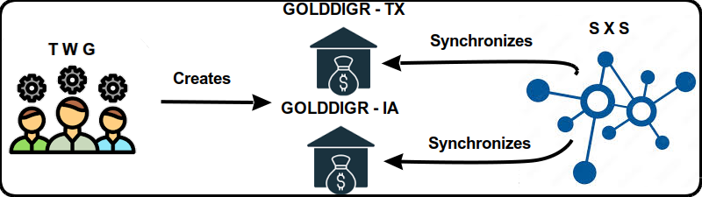

### Historical Background

This current period of fiat currency has already lasted longer than previous fiats of the past several hundred years and contrary forces are aligning against it. Russia and China have planned to end the fiat dollar for fifteen years, the US dollar is ripe for replacement as the world reserve currency, and the current Federal debt is unsustainable.

### **Gold Standard**

The longest period in modern history without a gold standard is now; from 1971 to 2024 or 53 years. The last major gold standard system was the Bretton Woods system, which operated from 1944 to 1971. The United States has abandoned its gold standard in unusual situations (Civil war, World War 1, etc) but only briefly.

### **Russian Gold Reserves**

Russia's central bank has steadily increased gold reserves since 2009 to diversify from the dollar and foreign tokens. Russia's gold reserves tripled from 600 metric tons in 2009 to over 2,300 metric tons in early 2021.

### **Chinese Gold Reserves**

China has consistently increased gold reserves since 2009 to diversify away from dollars and foreign tokens, and China's gold reserves grew from 1,054 metric tons in 2009 to over 1,948 metric tons in early 2021.

### **Hegemony**

Western hegemonic empires since 1400 A.D. had an average lifespan of 95 years and the United States has already exceeded that. The world reserve token is usually a function of the current hegemony.

### **Interest Payments**

The current rate of increase in [Federal debt interest payments](https://fred.stlouisfed.org/series/A091RC1Q027SBEA) is unsustainable.

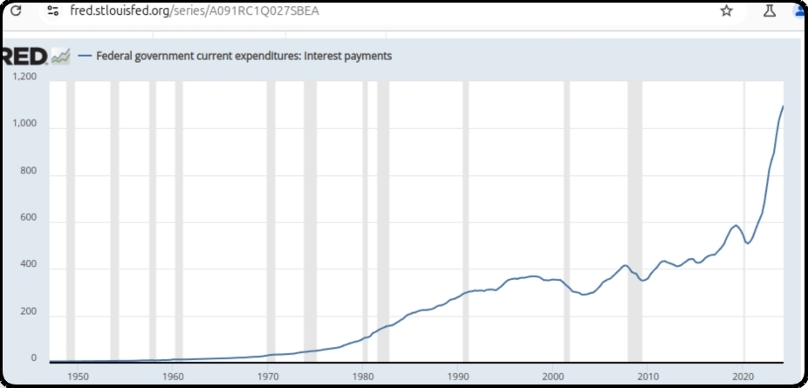

### **Interest Rates**

As debt increases, rates must fall to maintain equilibrium. Interest rates during the credit upcycle (1980 to 2020) have fallen as far as investors will tolerate. A trend reversal to higher rates will be disastrous for the current debt.

### **BRICS Strategy**

De-dollarization. The BRICS separate financial system aims to use their oligopoly power to control commodity prices and bypass the US Dollar. BRICS countries control 50% of the world's food supply, 70% of the microchip supply (China + Taiwan) and enough energy to control pricing in concert with a partner like Saudi Arabia or Venezuela.

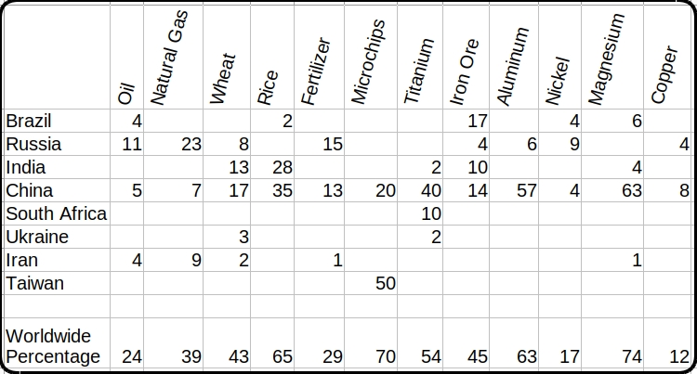

### USA Legislation

The **Sound Money Movement** is a [political and economic movement](https://www.soundmoneydefense.org/) that advocates for a stable, reliable currency and believes central banks should not manipulate currency for political gain and that a gold or silver standard would provide greater stability. The movement supports precious metal legislation across the United States.

### **Three-Step Legislative Strategy**

1. Pass legislation to legalize gold and silver
2. Create a State-controlled precious metals depository
3. Create a SDT token backed by the depository

1) States where gold and silver are legal tender

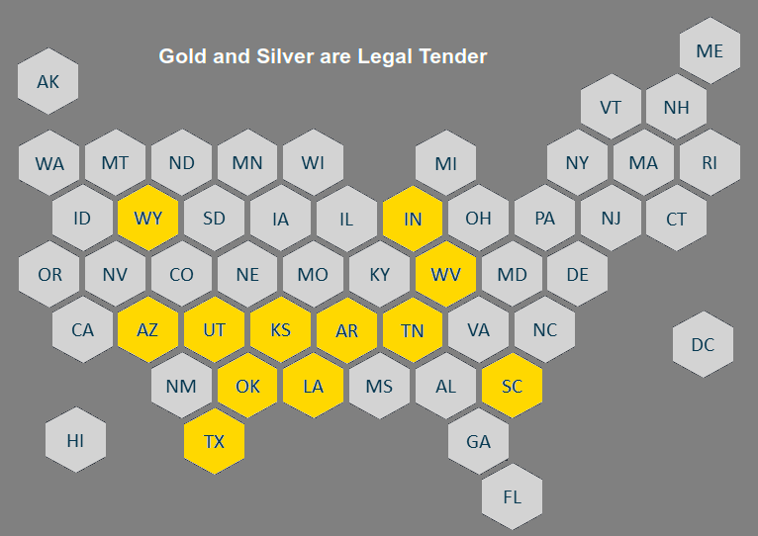

2) Previous States plus States with pending legislation

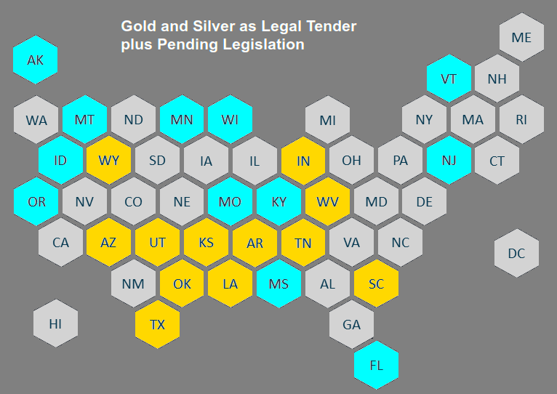

### **3) Previous Depository Legislation**

[**Texas Bullion Depository Bill**](https://comptroller.texas.gov/economy/fiscal-notes/2017/september/bullion-depository.php) - Signed into law in 2015 to create a State bullion depository.

[**2023: Tennessee Bullion Depository Act**](https://wapp.capitol.tn.gov/apps/BillInfo/default.aspx?BillNumber=SB0150&amp;GA=113) **SB150** - Establish a precious metals depository.

[**2023: Mississippi SB2966**](https://www.billtrack50.com/billdetail/1569891) - Establish the Mississippi bullion depository

[**2023: Missouri HB718**](https://legiscan.com/MO/bill/HB718/2023) - Create the “Missouri Bullion Depository.”

[**2023: North Carolina H721**](https://www.ncleg.gov/BillLookUp/2023/H721) - State Precious Metals Depository Study

[**2023: Idaho H0180**](https://legiscan.com/ID/rollcall/H0180/id/1267687) - Invest in precious metals held in a secure depository

[**2023: Oklahoma SB 816**](https://legiscan.com/OK/bill/SB816/2023) - Establish a State Treasury Depository

[**2023: Montana HB0884**](https://leg.mt.gov/bills/2023/billhtml/HB0884.htm) - Department of Revenue authorizes a media of exchange using gold

[**2024: Florida H697**](https://www.flsenate.gov/Session/Bill/2024/697) - State Legal Tender and Bullion Depository

[**2024: Louisiana SB485**](https://www.billtrack50.com/billdetail/1728658)- Management of the Louisiana Gold and Silver token Platform

[**2024: West Virginia SB749**](https://www.wvlegislature.gov/Bill_Status/bills_text.cfm?billdoc=sb749%20intr.htm&yr=2024&sesstype=RS&i=749) - Establish the West Virginia Bullion Depository

[**2024: Arizona SB1633**](https://blog.tenthamendmentcenter.com/2024/02/arizona-senate-committee-passes-bill-to-establish-bullion-depository-and-transactional-gold-backed-currency/?ref=broward.ghost.io) - Establish Bullion Depository and Gold-Backed token

[**2024: Kansas HB2729**](https://kslegislature.org/li/b2023_24/measures/documents/hb2729_00_0000.pdf) - Enacting the Kansas bullion depository act;

[**2024: Iowa HF2228**](https://www.legis.iowa.gov/docs/publications/LGI/90/HF2228.pdf)- Establishment of a token based on gold and held in a bullion depository

[**2024: New Hampshire H 1674**](https://fastdemocracy.com/bill-search/nh/2024/bills/NHB00011738/) - Establishes a state depository

#### **Impedance-Matched token**

Creating the Euro was somewhat like harnessing a horse, a mule, a dog and a turtle to pull a wagon. A "one size fits all" strategy creates stresses because regions (States) have different resources, skill levels, goals. Most economic transactions are local and a State token would be controlled regionally.

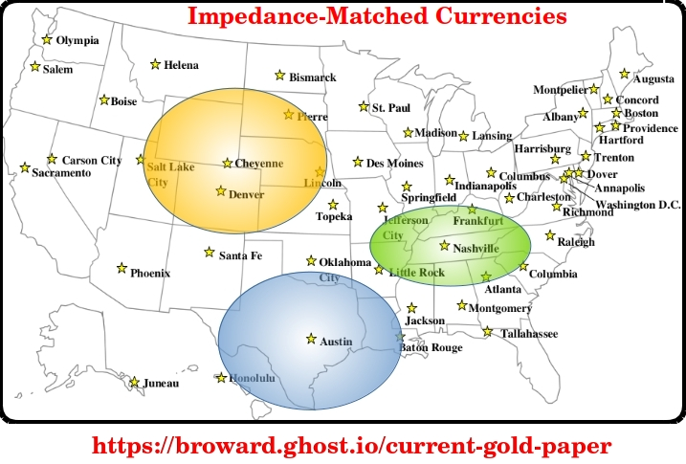

#### GOLD DIGR Proposal

This is an abstract high-level diagram of how a gold-backed SDT would work.

A more detailed design is at https://broward.ghost.io/golddigr/tactical

**Depository**: stores gold deposits.  
**Inventory System**: manages gold deposits  
**token**: manages cash transactions  
**Blockchain**: equivalent to accounting ledger  
**Key Manager**: equivalent to safety deposit box keys  
**Client**: Customer with gold in depository

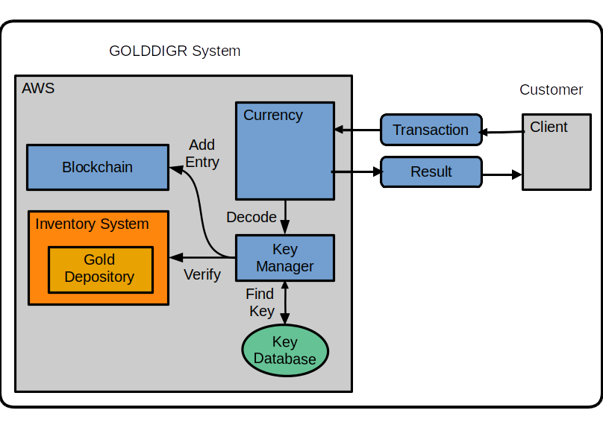

Assumptions: An existing depository has an existing inventory management system. That system needs to synchronize with the blockchain entries.

#### **Low Energy Use**:

GOLD DIGR won’t require enormous energy. It should consume the same energy as sending an email or editing a document. Most crypto-tokens refer to "mining” which uses energy-intensive functions to create artificial scarcity. GOLD DIGR's scarcity is the gold depository itself

#### **Low Complexity**:

GOLD DIGR is less complex than crypto-tokens. It doesn't require "proof" schemes to generate scarcity, validation and consensus mechanisms, etc.

### Sending A Transaction

1. Client sends a transaction to token API

Example message:

{

"message": {

"message_type": "texas_transaction",

"version": 1.12,

"date": "2024-02-03T06:48:07",

"ID": 010102283,

"payer": 12221,

"payee": 1023,

"amount": "$100"

}

}

2. token forwards message to Key Manager.

3. Key Manager verifies the payer, payee and payer’s balance.

4. Key Manager creates blockchain entry and sends result to token.

5. token sends result to client.

A much more detailed design is at <https://broward.ghost.io/golddigr/tactical>  
More information on [AWS implementation](https://broward.ghost.io/%20/aws_app_1)

#### TWG Proposal (Technical Working Group)

[Recent legislation](https://broward.ghost.io/golddigr/legal/) shows significant interest in Texas-style precious metal depositories. This proposal is for a Technical Working Group (TWG) of interested parties to fund joint development of regional depositories with common procedures and a SDT platform. Here's an example.

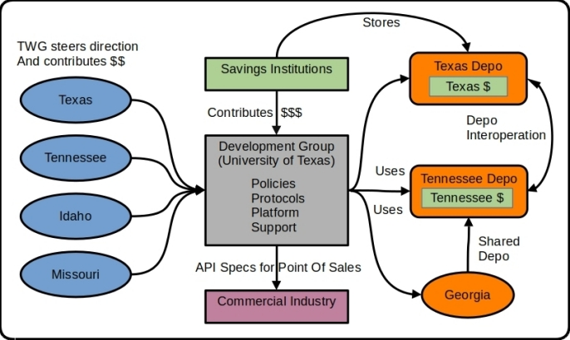

We used this model at Federal Highway from 1994 to 1996 to develop [ASPEN, CDLIS and ISS software](https://broward.ghost.io/2014/05/19/early-mobile-system/) with a permanent staff of five. Ten States contributed 1-2 members each quarter for a three-day design and feedback meeting (about 500 man hours annually).

#### ****5 Major Components****

**1) Development Group** - Independent organization which combines input to produce policies, protocols and platform for State depositories.

**2) Technical Working Group** (TWG) - a steering committee of States which contribute funding, feedback and policies from part-time advisors in each State.

**3) Regional Depositories** - State depositories which support SDTs and interoperate with other depositories.

**4) Savings Institutions** - contribute funding to use the State depositories and tokens as a mechanism of investment and wealth preservation.

**5) Commercial Industry** - retail vendors, 3rd party developers to support SDTs and arbitraging by potential investors.

#### SXS Proposal (State Exchange System)

The SXS platform has three functions.

* Manage financial transactions between platform members
* Collect information to calculate real-time exchange rates
* Adjust foreign reserves pools between platform members

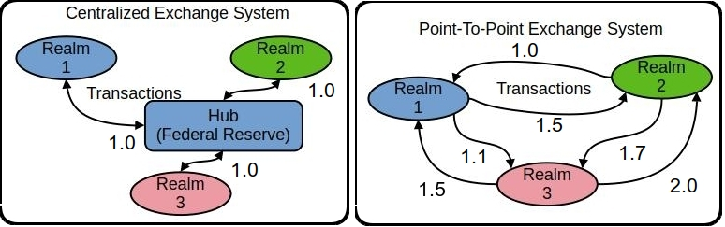

**CENTRALIZED**   
This is the design of the Federal Reserve and the realms represent countries and States. It’s inflexible but efficient and scalable with a single point of control and authority (hub). Over 100 countries use it.

**POINT-TO-POINT (PTP)**  
The BRICS countries are creating a point-to-point system which is less efficient but has more flexibility and freedom. Different rates are possible between Realm1 to Realm2 and Realm1 to Realm3, etc.

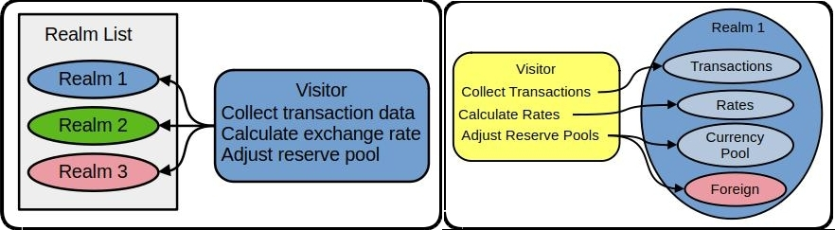

In the PTP system, a visitor regularly converses with all realms and executes a common set of functions. Within each realm are pending transactions, current exchange rates, foreign reserve pools. The visitor executes transactions, recalculates exchange rates and balances foreign reserve pools. Exchange rates are determined by the relationship between two realms instead of a central authority and each country (State) has some control in the exchange rate for each trading partner.

Here is a [small working software model of SXS](https://github.com/broward/BRICS) (<https://github.com/broward/BRICS>)

[More detailed model](https://broward.ghost.io/2023/09/01/brics-currency-platform/)  (https://broward.ghost.io/BRICS)

### Author

Thirty-five years of eclectic software development, including 7 startups, IT staff at a major university, several USDOT grants and 15 years of corporate consulting. [Three DEFCON presentations](https://broward.ghost.io/2014/01/09/defcon/) on predictive analytics.

#### **State governments**

From 1991-1996, I was the original architect of five Federal Highway Administration grants developing the [first handheld & wireless systems (ASPEN, CDLIS, ISS) for State-level motor carrier inspections](https://www.ugpti.org/research/details.php?id=93&ref=broward.ghost.io). I led a quarterly design conference with many State representatives, achieved a 40-State adoption and received a commendation from the US Secretary of Transportation. I was named [Boise State University employee of the year](https://broward.ghost.io/content/images/2022/01/nampa_article-1.jpg) in 1994.

#### **Startups**

* [Federal Highway 1992-96](https://broward.ghost.io/2014/05/19/early-mobile-system/) - R&D on early mobile systems
* [Saleslogix 1998-2000](https://broward.ghost.io/2021/03/01/saleslogix/) - CRM startup, SDK and Salesforce competitor
* [Sunhill Software 2004](https://broward.ghost.io/2023/11/14/sunhill-software/) - supply chain logistics and KPI
* [Gloo 2013](https://broward.ghost.io/2014/05/20/node-postgres-and-highcharts-app/) - health & wellness analytics
* [DLVR 2016-17](https://dlvr.com/how-it-works/video-multi-cdn-optimization/?ref=broward.ghost.io) - video analytics
* [Sila 2018](https://broward.ghost.io/2020/08/14/revision-2/) - stablecoin SDK and toolkit
* [Ensomata 2022](https://broward.ghost.io/2023/04/02/sonoma/) - health care analytics

#### **SDTs**

Hands-on work with three tokens – the [Digital Money Trust in 1994](https://broward.ghost.io/2015/09/26/bitcoin-blockchains-and-banking-busts/) (a precursor to Bitcoin), an [IoT token prototype in 2014](https://broward.ghost.io/2021/03/01/digital-currency-on-iot/) and [Sila stablecoin in 2018](https://docs.silamoney.com/docs?ref=broward.ghost.io) which received $21 million in venture capital. I developed the MVP (minimum viable product) in 100 days and we used it in 50 demonstrations for funding. I designed and wrote about 75% of the original beta release code, API, security.

#### **Contracting**

Significant projects at [Boeing](https://broward.ghost.io/2022/11/18/boeing-revisited/) (call center), [Avnet](https://broward.ghost.io/2021/02/28/e-commerce-systems/) (e-commerce), [Aetna](https://broward.ghost.io/aetna)) (case management), [Amdocs](https://broward.ghost.io/2015/05/17/simple-kafka-monitor-using-opendmk-jmx-2-0/) (payment system), [DLVR.com](https://raw.githubusercontent.com/broward/images/master/Architecture/CrossSignFlow.jpg?ref=broward.ghost.io) (video analytics), Verizon (ring tone sales), [Staples](https://broward.ghost.io/2023/01/13/skittles-autopsy/) (e-commerce).

#### **DEFCON**

[Three DEFCON convention presentations in 2005-2007](https://broward.ghost.io/2014/01/09/defcon/) on predictive analytics and memetic manipulations.

### **Related Materal By Me**

[Texas Depository, 2023](https://broward.ghost.io/texas_depo)

[BRICS Currency System 2023](https://broward.ghost.io/BRICS)

[AWS App Design, 2023](https://broward.ghost.io/aws_app_1)

[Stablecoin Hack, 2022](https://broward.ghost.io/stablecoin_hack)

[Miner Bankruptcy, 2022](https://broward.ghost.io/miner_bankruptcy)

[Polymorphic API, 2022](https://broward.ghost.io/polymorphic_api/)

[Crypto Platform, 2020](https://broward.ghost.io/crypto_platform)

[Payment System, 2015](https://broward.ghost.io/payment_system)

[Bitcoin Scalability, 2015](https://broward.ghost.io/bitcoin_scalability)

[Digital Money Trust, 2015](https://broward.ghost.io/digital_money_trust)

[Jing Currency on IoT, 2014](https://broward.ghost.io/digital_on_IoT)

[Aetna Migration, 2011](https://broward.ghost.io/aetna)

[Avnet E-commerce, 2000](https://broward.ghost.io/avnet)

[Multi-Tenant Systems, 1996-2018](https://broward.ghost.io/multi-tenant)

[Federal Highway System, 1992-1996](https://broward.ghost.io/FHWA/)

[Hacking the Planet, 1988](https://broward.ghost.io/hack_the_planet)