### GOLD DIGR White Paper – 2024, Ver 5

## Broward Horne, Tallahassee, FL

## browardhorne@gmail.com

## <https://broward.ghost.io/tag/gold-currency/>

I'm a software developer with 35 years of experience. I believe there may soon be demand from State governments for R&D, prototyping and development of gold-backed digital currencies as described in [Texas bills S.B. No. 2334 and H.B. No. 4903](https://www.usgoldbureau.com/news/texas-proposes-gold-backed-digital-currency).

### **Abstract**:

This paper contains three complementary proposals to create a digital currency backed by a State-regulated metal depository similar to the [Texas Bullion Depository](https://www.texasbulliondepository.gov/) established in 2015. The first part is the currency itself including its justification‚ the second is a development strategy‚ the third adds flexible interoperability between participating States.

1) [**GOLD DIGR**](https://broward.ghost.io/2023/04/25/go-dig-strategic-design/) is an overview of a State-regulated digital currency driven by historical and political forces‚ current legislation and strategic design.

2) [**TWG** proposes a multi-State committee](https://broward.ghost.io/2023/05/26/technical-working-group/) to develop a standard currency framework adaptable to multiple States and external partners.

3) [**SXS** is an interstate currency exchange system](https://broward.ghost.io/tag/brics/) similar to the BRICS attempt to compete with the Federal Reserve’s centralized system.

My goal with these mailings is to make this into a real system via State funding‚ grants‚ corporate sponsorship. etc. I’ve had an ongoing interest in this since 1994, I believe in it and have the skill and knowledge to make happen. My background is quite eclectic and spans startups‚ corporations‚ State and Federal systems for 35 years.

### Relevant History

This current period of fiat currency has already lasted longer than previous fiats of the past several hundred years and contrary forces are aligning to end it. Russia and China have planned for the end of the fiat dollar for the past fifteen years, the US dollar is ripe, age-wise, for replacement as the world reserve currency, and the current Federal debt is unsustainable.

### **Gold Standard**

The longest period in modern history without a gold standard is now; from 1971 to 2024 or 53 years. The last major gold standard system was the Bretton Woods system, which operated from 1944 to 1971. The United States has abandoned its gold standard in unusual situations (Civil war, World War 1, etc) but only briefly.

### **Russian Gold Reserves**

Since 2009, Russia's central bank has steadily increased gold reserves to diversify away from the US dollar and foreign currencies. According to the World Gold Council, Russia's gold reserves more than tripled from 600 metric tons in 2009 to over 2,300 metric tons in early 2021.

### **Chinese Gold Reserves**

China has consistently increased gold reserves since 2009 to diversify away from US dollars and foreign currencies, according to data from the People's Bank of China (PBOC). China's gold reserves grew from 1,054 metric tons in 2009 to over 1,948 metric tons in early 2021.

### **Hegemony**

Western hegemonic empires since 1400 A.D. had an average lifespan of 95 years and the United States has already exceeded that. The world reserve currency is usually a function of the current hegemony. No hegemony, no reserve currency.

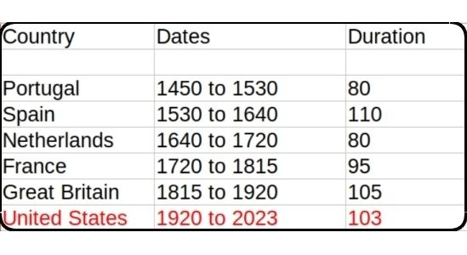

### **Interest Payments**

The current rate of increase in [Federal debt interest payments](https://fredblog.stlouisfed.org/2018/03/the-cost-of-owing) is unsustainable.

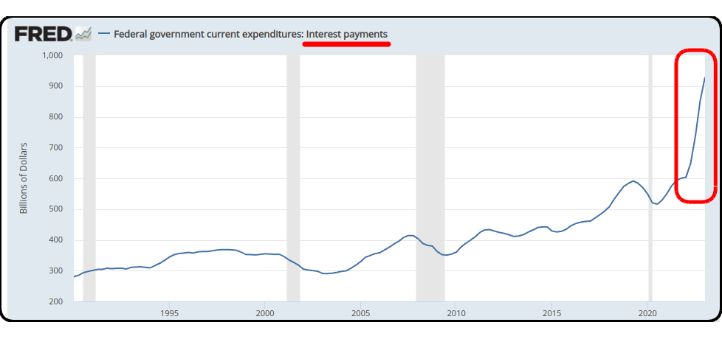

Federal Interest Payments

### **Interest Rates**

As debt increases, rates must fall to maintain equilibrium. Interest rates during the credit upcycle (1980 to 2020) have fallen as far as investors will tolerate. The inevitable return of higher rates will be disastrous for the current debt.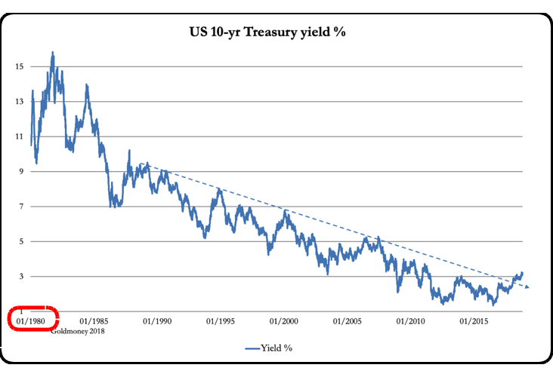

### **BRICS Strategy**

De-dollarization. The BRICS separate financial system aims to use their oligopoly power to control commodity prices and bypass the US Dollar. BRICS countries control 50% of the world's food supply, 70% of the microchip supply (China + Taiwan) and enough energy to control pricing in concert with a partner like Saudi Arabia or Venezuela.

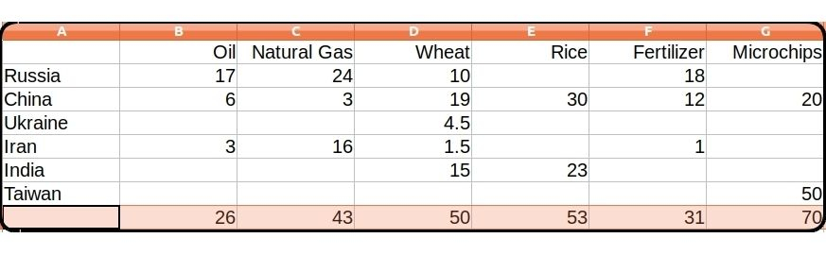

### USA Legislation

The **Sound Money Movement** is a [political and economic movement](https://www.soundmoneydefense.org/) that advocates for a stable, reliable currency and believes central banks should not manipulate currencies for political gain and that a gold or silver-based currency would provide greater stability. The movement supports precious metal legislation across the United States.

### **Three-Step Legislative Strategy**

1. Pass legislation to legalize gold and silver
2. Create a State-controlled precious metals repository
3. Create a digital token currency backed by the repository

1) States where gold and silver are legal tender

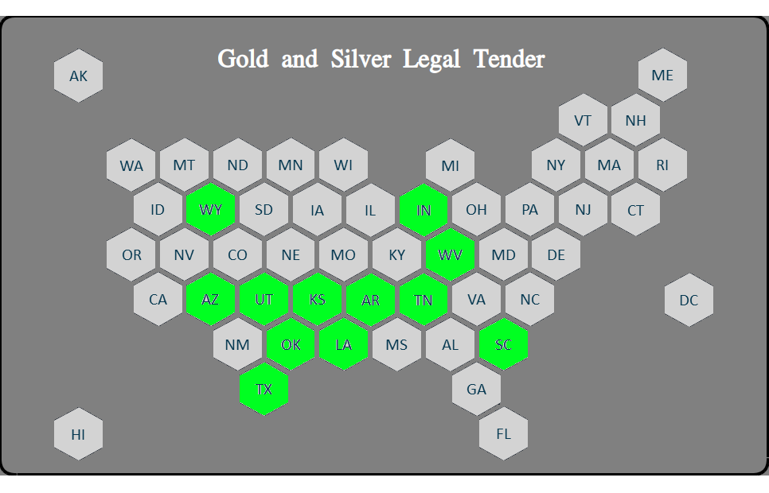

2) Plus States with pending legislation in 2023

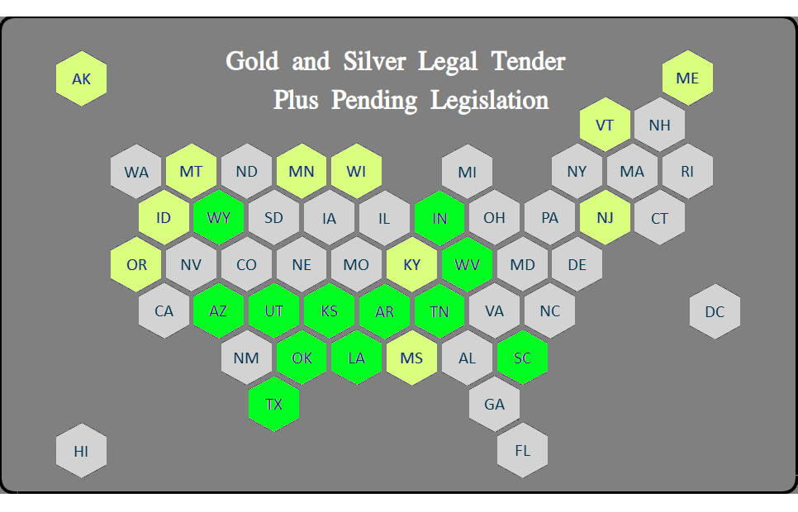

### **Previous Depository Legislation**

**Texas Bullion Depository Bill** - signed into law in 2015 and authorized the creation of a state bullion depository.

**Tennessee Bullion Depository Act** - In **2023**, SB 150 would establish a precious metals depository.

**Arizona Gold Bonds Act** - introduced in **2021** to create a state-run gold depository

**Utah Sound Money Amendments** - introduced in **2021** that would authorize the creation of a state bullion depository.

**Kentucky Precious Metals Depository Act** - introduced in **2021** to authorize the creation of a state-run precious metals depository.

**Wyoming bullion depository, 2020** - provided for the creation and administration of the Wyoming bullion depository

#### **Impedance-Matched Currency**

Creating the Euro was somewhat like harnessing a horse, a mule, a dog and a turtle to pull a wagon. A "one size fits all" strategy creates stresses because regions (States) have different resources, skill levels, goals. Most economic transactions are local and a regional currency would be controlled regionally.

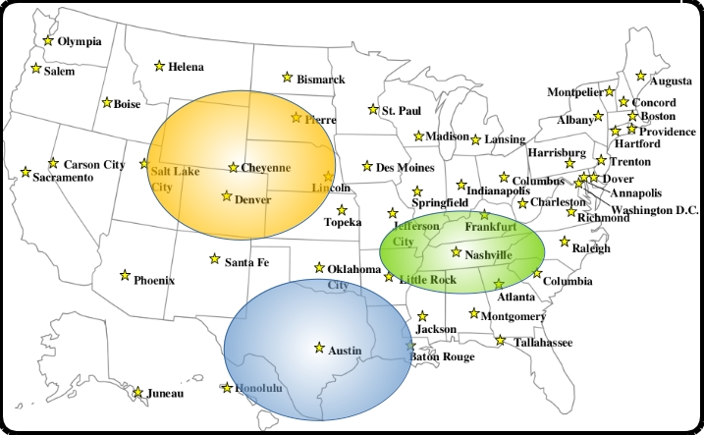

### GOLD DIGR Proposal

This is an abstract high-level diagram of how a gold-backed digital currency would work.

A more detailed design is at https://broward.ghost.io/golddigr/tactical

**Depository**: stores gold deposits.  
**Inventory System**: manages gold deposits  
**Currency**: manages cash transactions  
**Blockchain**: equivalent to accounting ledger  
**Key Manager**: equivalent to safety deposit box keys  
**Client**: Customer with gold in depository

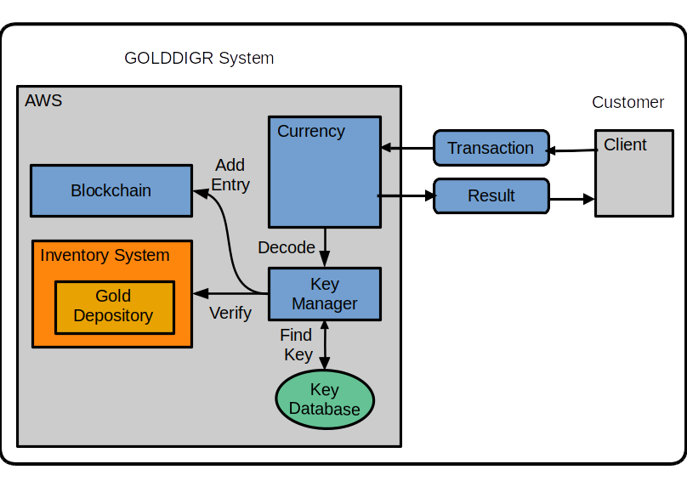

Assumptions: An existing depository has an existing inventory management system. That system needs to synchronize with the blockchain entries.

#### **Low Energy Use**:

GOLD DIGR won’t require enormous energy. It should consume the same energy as sending an email or editing a document. Most crypto-currencies refer to "mining” which uses energy-intensive functions to create artificial scarcity. GOLD DIGR's scarcity is the gold depository itself

#### **Low Complexity**:

GOLD DIGR is less complex than crypto-currencies. It doesn't require "proof" schemes to generate scarcity, validation and consensus mechanisms, etc.

### Sending A Transaction

1. Client sends a transaction to Currency API

Example message:

{

"message": {

"message\_type": "texas\_transaction",

"version": 1.12,

"date": "2024-02-03T06:48:07",

"ID": 010102283,

"payer": 12221,

"payee": 1023,

"amount": "$100"

}

}

2. Currency forwards message to Key Manager.

3. Key Manager verifies the payer, payee and payer’s balance.

4. Key Manager creates blockchain entry and sends result to Currency.

5. Currency sends result to client.

More information on [technical details](https://broward.ghost.io/golddigr/tactical/)  
More information on [AWS implementation](https://broward.ghost.io/ /aws_app_1)

### TWG Proposal (Technical Working Group)

[Recent legislation](https://broward.ghost.io/golddigr/legal/) shows significant interest in Texas-style precious metal depositories. This proposal is for a Technical Working Group (TWG) of interested parties to fund joint development of regional depositories with common procedures and a digital currency platform. Here's an example.

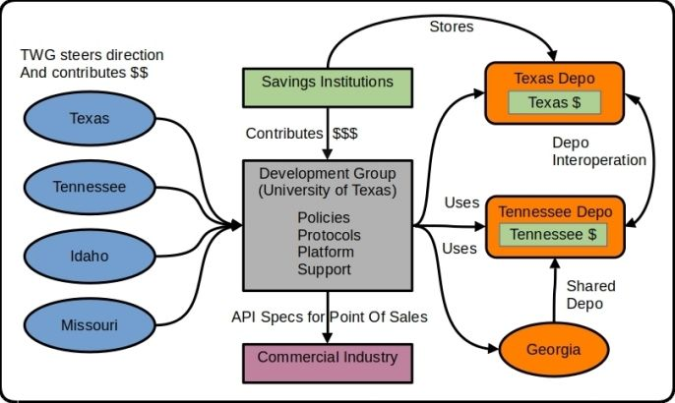

We used this model at Federal Highway from 1994 to 1996 to develop [ASPEN, CDLIS and ISS software](https://broward.ghost.io/2014/05/19/early-mobile-system/) with a permanent staff of five. Ten States contributed 1-2 members each quarter for a three-day design and feedback meeting (about 500 man hours annually).

#### ****5 Major Components****

**1) Development Group** - Independent organization which combines input to produce policies, protocols and platform for State depositories.

**2) Technical Working Group** (TWG) - a steering committee of States which contribute funding, feedback and policies from part-time advisors in each State.

**3) Regional Depositories** - State depositories which support digital currencies and interoperate with other depositories.

**4) Savings Institutions** - contribute funding to use the State depositories and currencies as a mechanism of investment and wealth preservation.

**5) Commercial Industry** - retail vendors, 3rd party developers to support digital currencies.

### SXS Proposal (State Exchange System)

The SXS platform has three strategic goals.

* Manage financial transactions between platform members
* Collect information to generate real-time exchange rates
* Adjust foreign reserves pools between platform members

**CENTRALIZED SYSTEM**  
Also known as hub-and-spoke. This is design of the current Federal Reserve and the spokes (realms) represent countries/provinces/states. A centralized system requires rigorous interfaces but it's efficient and scalable. There are over 100 countries with a dollar exchange rate but control is limited to the common hub interface.

**POINT-TO-POINT**  
But the BRICS aren't pursuing a centralized system (yet), they're creating a point-to-point system. PTP systems are less scalable but there's only a few BRIC countries. PTP is also more complex, less efficient but more flexible. We can manage exchanges between **Realm 1/Realm 2** differently than **Realm 2/Realm 3 or Realm 1/Realm 3**.

This is the critical design difference.

### Author

Thirty-five years of eclectic software development, including seven startups, IT staff at a major university, several USDOT grants and fifteen years of corporate consulting. Three DEFCON presentations on predictive analytics.

#### **State governments**

From 1991-1996, I was the original architect in several Federal Highway Administration grants developing the [first handheld and wireless systems (ASPEN, CDLIS, ISS) for State-level motor carrier inspections](https://www.ugpti.org/research/details.php?id=93). I led a quarterly design conference with representatives from ten States to define features and recommendations and worked directly with State managers, IT staff and police officers, often on-site. We achieved a 40-State adoption of this software.

#### **Digital Currencies**

Hands-on work with three currencies - the Digital Money Trust in 1994 (a precursor to Bitcoin), an IoT token prototype in 2014 and [Sila stablecoin in 2018](https://docs.silamoney.com/docs) which received $21 million in venture capital. I developed the MVP (minimum viable product) in 100 days and we used it in 50 demonstrations for funding. I designed and wrote about 75% of the original beta release code, API, security.

#### **Contracting**

Significant projects at Boeing (call center), Avnet (e-commerce), Aetna (case management), Amdocs (payment system), DLVR.com (video analytics), Verizon (ring tone sales), Staples (e-commerce). Many run one million+ transactions per day and had requirements for internal integrations, adapters and legacy limitations, etc.

#### **DEFCON**

Three DEFCON convention presentations in 2005-2007 on predictive analytics and memetic manipulations such as election hacking.

### **Related Materal By Me**

GOLDDIGR White Paper, 2023 (<https://broward.ghost.io/golddigr/>)

Texas Depository, 2023 (<https://broward.ghost.io/texas_depo>)

Stablecoin Hack, 2022 (<https://broward.ghost.io/stablecoin_hack>)

Miner Bankruptcy, 2022 (<https://broward.ghost.io/miner_bankruptcy>)

Polymorphic API, 2022 (<https://broward.ghost.io/polymorphic_api/>)

Bitcoin Death, 2022 (<https://broward.ghost.io/bitcoin_death>)

Crypto Platform, 2020 (<https://broward.ghost.io/crypto_platform>)

Pandemic and Gold, 2020 (<https://broward.ghost.io/pandemic_and_gold>)

Payment System, 2015 (<https://broward.ghost.io/payment_system>)

Bitcoin Scalability, 2015 (<https://broward.ghost.io/bitcoin_scalability>)

Digital Money Trust, 2015 (<https://broward.ghost.io/digital_money_trust>)

Jing Currency on IoT, 2014 (<https://broward.ghost.io/digital_on_IoT>)