A new buzzword, Cognition-As-A-Service, could be applied to this proposal.

http://gigaom.com/2013/12/07/why-cognition-as-a-service-is-the-next-operating-system-battlefield/

We could add a “rehab relationship model” to the differentiated models (page 3). My wild guesstimate is that the minimum data would be several hundred words of text/voice per month over a period of at least six months.

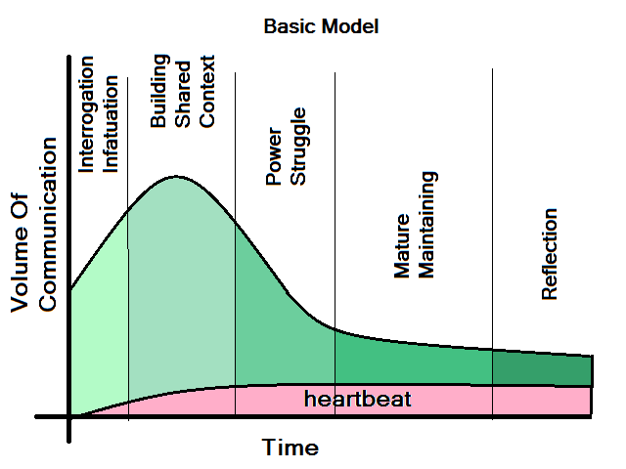

Relationships go through phases, and each phase change can be characterized by a major theme.

- Interrogation/Infatuation – higher-than-average incidence of “who/what/why” words, questions and positivity (flattering comments), higher-than-average incidence of future tense (“we will”).
- Building Shared Context – increasing communication, higher-than-average diversity in nouns as a variety of subjects and viewpoints are shared.
- Power Struggle – decreasing rate-of-increase in communication frequency or possible decline. Higher-than-average conflict keywords - “blame”, “fault”, lower relative positivity, possible increase in asymmetry of communication.
- Mature/Maintaining – less communication frequency, less diversity in topics, a focus on the here-and-now, more present tense conjugation (“we can”), greater increase in words related to shared experience/burdens (“house”, “children”).
- Reflection – Greater increase in past tense (“we did”), greater increase in recall of shared experiences.

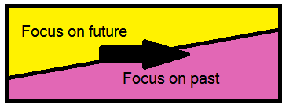
Throughout a relationship, there should be a measurable “heartbeat”, a reference to/reflection upon shared values and goals. The frequency of the heartbeat should be small at first, grow during the first phase or two, and maintain some level of consistency over time. At first, a relationship is forward-thinking but as it matures, it will become increasingly reflective on the past.

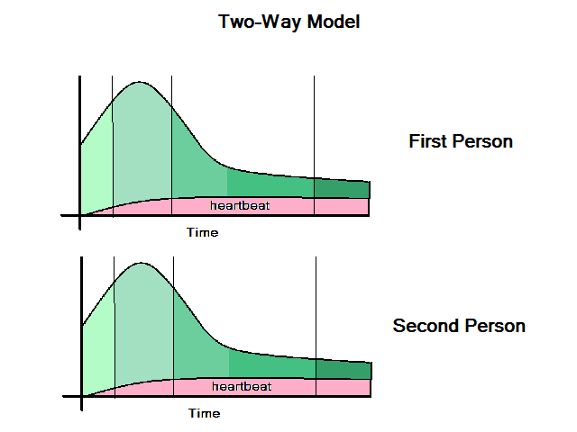
Our original communication model can be refined into a two-way model (communication to and from an individual to a partner). We can then measure asymmetry (i.e. changes in symmetry). We can measure greater or lesser immersion in the current phase by each partner. Individuals who are “out-of-phase” probably have greater stress and potential for relationship breakdown. For instance, one person may move into the “mature/maintaining” phase while the other is still in the “building shared context” phase.

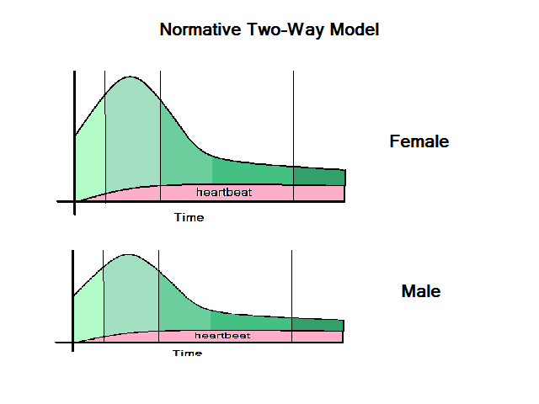
There are two categories of metrics:

1) The first is “relative change”. We should be able to detect in increase or decrease in certain metrics over time, in relation to each other. For instance, imagine a ratio of single pronouns to plural pronouns. Over time, the frequency of “I”, “me”, “mine”, “you” and “yours” should decrease in relation to frequency of “ours”, “we”, and “us”. I would expect this ratio to show a relatively constant rate of change from initial meeting into the “mature/maintaining” phase.

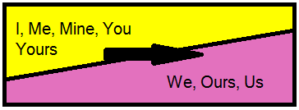

2) The second is “absolute value”. With enough empirical data, we could compare that pronoun ratio to the average ratio for a representative population. This could give a more accurate assessment of the current phase of the relationship, or point out abnormalities.

With enough empirical data, we should be able to refine the original “communication model” to a “normative” model, i.e. a model that compares individual characteristics to an average.
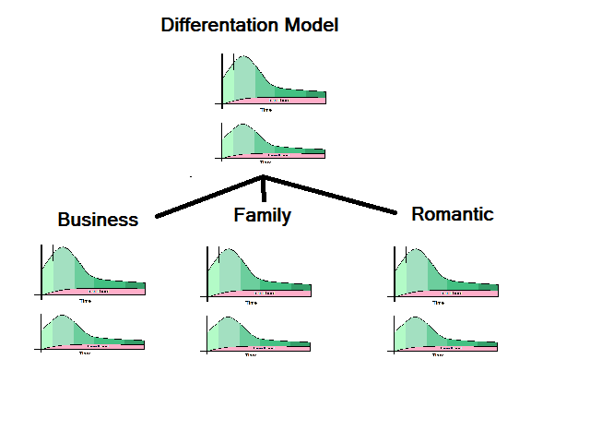
Now that we have a normative model, we should be able to subclass it further by type. I would expect different types of relationships to have minor but measurable differences in their characteristics. For instance, a romantic relationship would probably have more “flattering comments” than a business relationship, a business relationship may enter the “reflection” phase earlier than a family relationship, etc.

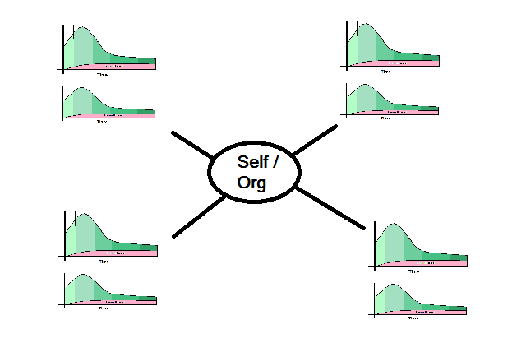
In theory, we can measure frequency and duration of phone calls, emails, text messages and calendar appointments, so we could create an “input/output” model for each person. That model could expose many metrics. For instance, there should be an average net I/O for a person of a certain age and sex, location, culture, etc. A greater or lesser I/O would indicate something, have to figure out exactly what.

We could look for asymmetry in I/O (too much input, not enough output or vice versa), distribution of relationship types (too much business, not enough family) and change in I/O over time.

We could probably prototype this model in working code within three months or so. A larger problem is finding real data to verify the model, increase its accuracy and expose other potential metrics. It occurs to me that we could enter into some kind of partnership with the keepers of this essential data, ie. Facebook, LinkedIn, Twitter, etc, to obtain test data, verify and refine the model and then resell the relationship extrapolation back to their end users. Individually, each of those companies has a skewed view of different relationships and one thing we could provide, as a neutral third-party, is a more balanced model based on a larger dataset. To that end, the HIPAA compliance may enhance our reputation as a trusted third party.

Simple Metrics -

- Pronoun ratio (# of “I”, “me”, mine”, etc) / (# of “we”, “our”, “us)
- Future Tense ratio (# of future tense words) / (Total words)
- Past Tense ratio (# of past tense words) / (Total words)
- Present Tense ratio (# of present tense words) / (Total words)
- Frequency of communication
- Ratio of types of communication (# of emails) / (Total communication), etc.
- Duration of communication (phone call in minutes, length of text message)

Harder Metrics -

- Positivity Ratio (increase in positive or flattering words) , needs a dictionary of the right words
- Diversity Ratio (# of subjects) / (Total words), need definition of good nouns
- Conflict Ratio needs a dictionary defined
- Reflection Ratio needs a dictionary defined
- Mature Ratio dictionary of common subjects / words in a mature relationship, but probably subsetted by type of relationship.
- Shared Context ratio – have to figure out how to tell when people are recalling and reinforcing a shared past experience.

