SCRY LLC - EIN: 39-3578261, VA-certified
Registered Vendor in FL, AL, SC, LA, GA
35+ years software engineering — semantics, predictive analytics, stable token systems
Website: https://www.scry.llc Email: broward@scry.llc Phone: 850-518-5878

I’ve sent out mailers since early 2023 about the Gold Token Platform, a State-owned token platform backed by a State gold depository similar to Texas House Bill 1056. It adapts to regional conditions, supports cash-equivalency and can serve as a fallback system.

https://www.scry.llc/token – Gold Token technical design
https://www.scry.llc/https://www.scry.llc/primer - Gold Token Primer, non-technical info
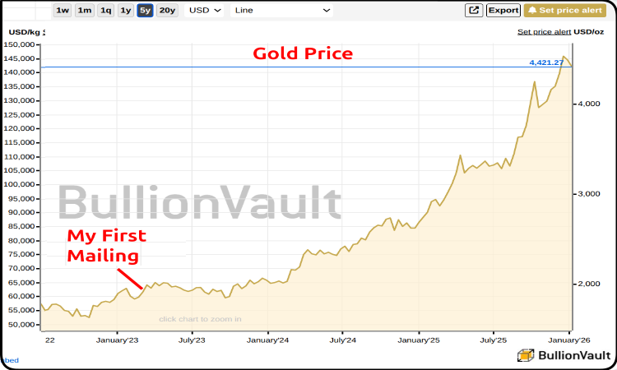
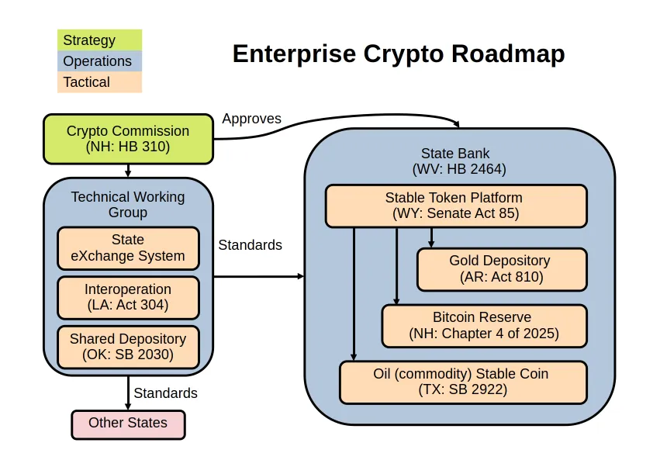
https://www.scry.llc/2025/06/29/token-roadmap/
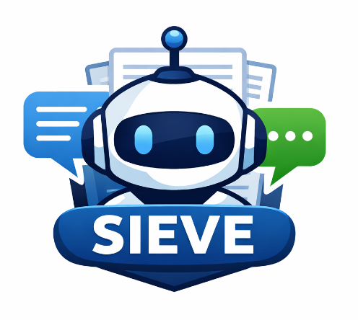
I’m now working on SIEVE, an AI tester which measures bias and accuracy in response to Senator Blackburn’s experience with Google’s AI, fabricated allegations as well as the new Federal AI guidelines which restrict State legislation. SIEVE is written specifically for OMB M-26-04 specs.

It’s a working prototype which I can demo, although it might be rather boring.

https://www.scry.llc/sieve

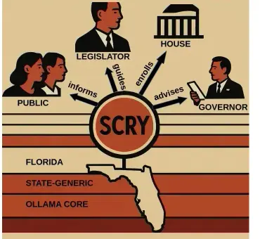
“we can't allow woke Silicon Valley oligarchs to control the information we access.“ – Florida DOGE, Oct 23, 2025

SCRY AI: “is a small, sovereign system free of direct influence from major IT vendors, other nations, Federal agencies, NGOs or billionaires which ingests most information from local sources” – Me, Aug, 2025
https://www.scry.llc/scry

SCRY creates a semantic fingerprint for your State based on Open States data and compares it to new legislation for State compatibility, provides legislative insight and advises leaders using predictive analysis.

I’m a software developer with 35 years of experience across many knowledge domains including extensive work in semantics, predictive analytics, seven startups and Federal / State systems. I'm seeking a sponsor to turn these proposals into real-life projects or consulting/contract work on something similar.

Broward Horne
Scry, LLC
https://www.scry.llc/resume

SCRY LLC - EIN: 39-3578261
Registered Vendor in FL, AL, SC, LA, GA
35+ years software engineering — semantics, predictive analytics, stable token systems
Website: https://www.scry.llc Email: broward@scry.llc Phone: 850-518-5878

