Broward Horne
4019 Apalachee Pkwy
Tallahassee, FL 32311
browardhorne@gmail.com

You previously received a printed copy of the “Gold Token paper” which proposes a crypto-token system and gold depository. Most likely it was thrown away after a few minutes but four associated bills passed this year so far:

Utah HB 306, Precious metals amendments, vetoed by the governor
Arkansas Act 810 establishes a depository and digital payment system
Texas HB 1056 establishes a transactional currency for current depository
Louisiana HB 695, acceptance of gold-backed tokens from other States

You may notice that Texas, Arkansas and Louisiana could be in the early formation of a regional State-based payment system, as implied in my original paper.
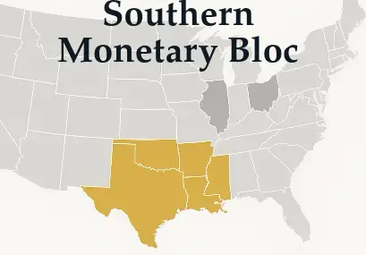

I’ve re-written and expanded this proposal online for a non-technical audience at https://broward.ghost.io/primer, a 12-page “token primer” covering some US history, technical concepts, current legislation status, a State-wide crypto architecture derived from numerous bills filed in several States, etc. The latest version of the Gold Token paper is at https://broward.ghost.io/current-gold-paper
