### GOLD DIGR White Paper – 2024, Ver 7

## Broward Horne, Tallahassee, FL

## browardhorne@gmail.com

## [https://broward.ghost.io/token/](https://broward.ghost.io/tag/gold-token/)

Download current version at <https://broward.ghost.io/current-gold-paper>

### **Abstract**:

This paper contains three complementary proposals to create a **State Depository Token (SDT)** backed by a State-regulated depository similar to Texas [House Bill 1056](https://legiscan.com/TX/bill/HB1056/2025) and [House Bill 1049](https://legiscan.com/TX/bill/HB1049/2025)

1) [**GOLD DIGR**](https://broward.ghost.io/2023/04/25/go-dig-strategic-design/) is an overview of historical and political forces‚ current legislation and strategic design.

2) [**TWG** proposes a multi-State task force](https://broward.ghost.io/2023/05/26/technical-working-group/) to develop a SDT framework for several States and partners.

3) [**SXS** is an interstate exchange system](https://broward.ghost.io/2023/09/01/brics-currency-platform/) like the evolving BRICS currency proposal.

My goal is to create a real system via State funding‚ grants‚ consulting, sponsorship. etc. I have the skills to do it, m[y background is eclectic](https://broward.ghost.io/2014/03/09/about/) and spans startups‚ corporations‚ State and Federal systems for 35 years.

#### **Parasocial Relationship**

Parasocial relationships are one-sided, where one party extends energy and time with the other party unaware of the other’s existence. The dollar is an increasingly parasocial relationship which transfers value from citizens to an elite minority, just as a celebrity profits from fans with no knowledge or concern for them.

### SDT Overview

Imagine a monetary system which conforms to the reality of economic transactions. Transactions are a mirror of relationships. Relationships are largely a function of location. For many years, the US monetary system was a rough approximation of this. Call it an “impedance-matched currency” or SDT.

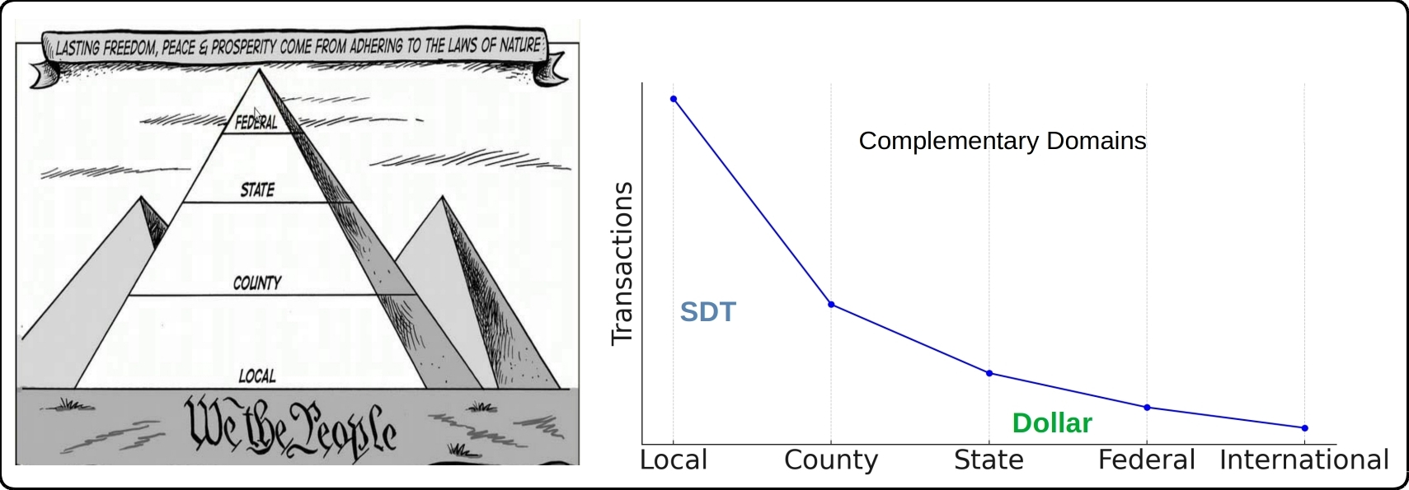

#### **Impedance-Matched Token**

The Euro is somewhat like harnessing a horse, a mule, a dog and a turtle to pull a wagon. A "one size fits all" strategy creates stresses because regions have different resources, skills, goals. Most economic transactions are local and an SDT would be controlled regionally to meet regional conditions.

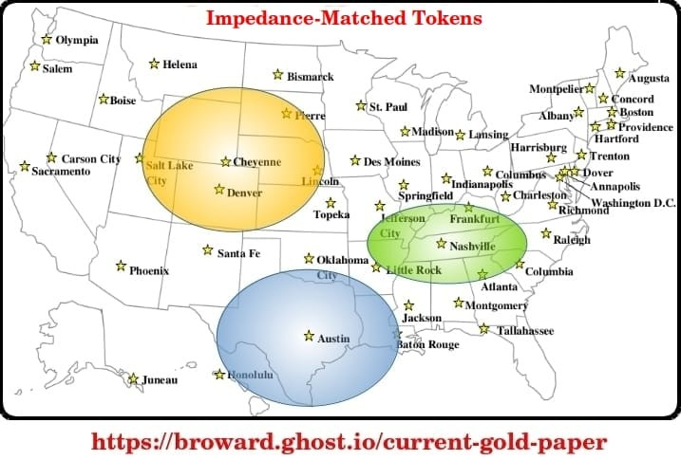

An impedance-matched token adapts to regional conditions, supports multiple depositories and provides multiple coin types such as dollar-backed, gold-backed or bitcoin-backed.

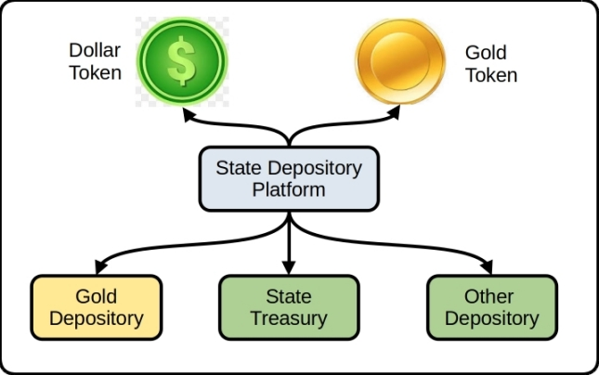

### Historical Background

This current period of fiat currency has already lasted longer than previous fiats of the past several hundred years and contrary forces are aligning against it. Russia and China have planned to end the fiat dollar for fifteen years, the US dollar is ripe for replacement as the world reserve currency, and the current Federal debt is unsustainable.

### **Gold Standard**

The longest period in modern history without a gold standard is now; from 1971 to 2024 or 53 years. The last major gold standard system was the Bretton Woods system, which operated from 1944 to 1971. The United States has briefly abandoned its gold standard in unusual situations (Civil war, World War 1, etc). Russia's central bank has steadily increased gold reserves since 2009 to over 2,330 metric tons. China has consistently increased gold reserves since 2009 to over 2,264 metric tons.

### **Hegemony**

Western hegemonic empires since 1400 A.D. had an average lifespan of 95 years and the United States has already exceeded that. The world reserve token is usually a function of the current hegemony.

### **Interest Payments**

The current rate of increase in [Federal debt interest payments](https://fred.stlouisfed.org/series/A091RC1Q027SBEA) is unsustainable.

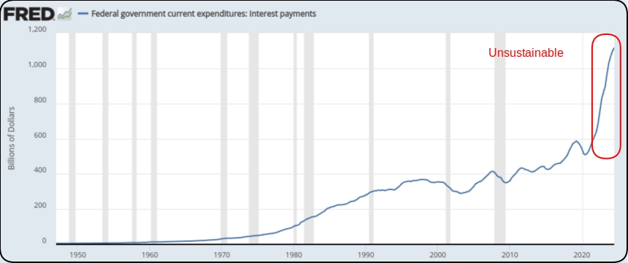

### **Interest Rates**

As debt increases, rates must fall to maintain equilibrium. Interest rates during the credit upcycle (1980 to 2020) have fallen as far as investors will tolerate. A trend reversal to higher rates will be disastrous for the current debt.

### **De-dollarization**

The BRICS coalition will use their oligopoly power to control commodity prices and bypass the US Dollar. BRICS control 50% of the world's food supply, 70% of the microchip supply (China + Taiwan) and almost 50% of world oil reserves. As of Oct, 2024, 13 more countries joined BRICS as limited partners.

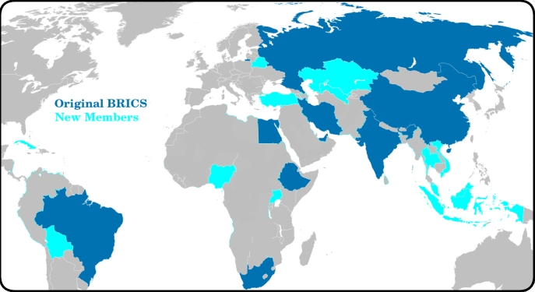

### USA Legislation

The **Sound Money Movement** is a [political and economic movement](https://www.soundmoneydefense.org/) that advocates for a stable, reliable currency and believes central banks should not manipulate currency for political gain and that a gold or silver standard would provide greater stability. The movement supports precious metal legislation in the United States.

### **Three-Step Legislative Strategy**

1. Pass legislation to legalize gold and silver
2. Create a State-controlled depository
3. Create a SDT token backed by the depository

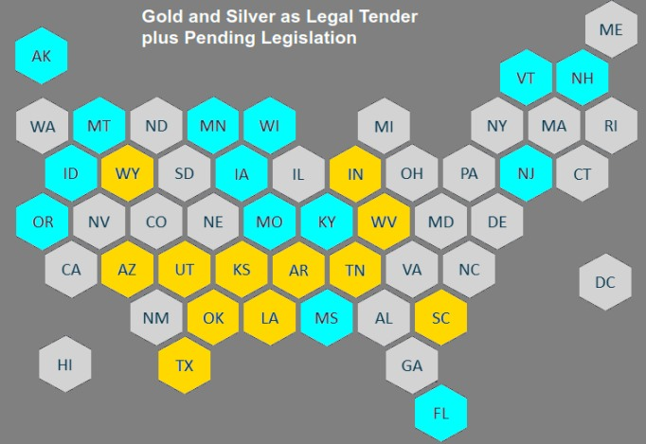

### **Depository Legislation:**

[**Texas Bullion Depository Bill**](https://comptroller.texas.gov/economy/fiscal-notes/2017/september/bullion-depository.php) - Signed into law in 2015 to create a State bullion depository.

[**2023: Tennessee Bullion Depository Act**](https://wapp.capitol.tn.gov/apps/BillInfo/default.aspx?BillNumber=SB0150&amp;GA=113) **SB 150** - Establish a precious metals depository.

[**2023: Mississippi SB 2966**](https://www.billtrack50.com/billdetail/1569891) - Establish the Mississippi bullion depository

[**2023: Missouri HB 718**](https://legiscan.com/MO/bill/HB718/2023) - Create the “Missouri Bullion Depository.”

[**2023: North Carolina H 721**](https://www.ncleg.gov/BillLookUp/2023/H721) - State Precious Metals Depository Study

[**2023: Idaho H 0180**](https://legiscan.com/ID/rollcall/H0180/id/1267687) - Invest in precious metals held in a secure depository

[**2023: Oklahoma SB 816**](https://legiscan.com/OK/bill/SB816/2023) - Establish a State Treasury Depository

[**2023: Montana HB 0884**](https://leg.mt.gov/bills/2023/billhtml/HB0884.htm) - Department of Revenue authorizes a media of exchange using gold

[**2024: Florida H 697**](https://www.flsenate.gov/Session/Bill/2024/697) - State Legal Tender and Bullion Depository

[**2024: Louisiana SB 485**](https://www.billtrack50.com/billdetail/1728658)- Management of the Louisiana Gold and Silver token Platform

[**2024: West Virginia SB 749**](https://www.wvlegislature.gov/Bill_Status/bills_text.cfm?billdoc=sb749%20intr.htm&yr=2024&sesstype=RS&i=749) - Establish the West Virginia Bullion Depository

[**2024: Arizona SB 1633**](https://blog.tenthamendmentcenter.com/2024/02/arizona-senate-committee-passes-bill-to-establish-bullion-depository-and-transactional-gold-backed-currency/?ref=broward.ghost.io) - Establish Bullion Depository and Gold-Backed token

[**2024: Kansas HB 2729**](https://kslegislature.org/li/b2023_24/measures/documents/hb2729_00_0000.pdf) - Enacting the Kansas bullion depository act;

[**2024: Iowa HF 2228**](https://www.legis.iowa.gov/docs/publications/LGI/90/HF2228.pdf)- Establishment of a token based on gold and held in a bullion depository

[**2024: New Hampshire H 1674**](https://fastdemocracy.com/bill-search/nh/2024/bills/NHB00011738/) - Establishes a state depository

[**2024: Utah HB 348**](https://mises.org/power-market/utah-formally-empowers-state-treasurer-protect-state-funds-gold-and-silver) - Protect state funds with physical gold and silver

### Digital Token Legislation:

[**2023: Wyoming SF 0127**](https://wyoleg.gov/Legislation/2023/SF0127) - Wyoming Stable Token Act.

[**2024: New Jersey AB 385**](https://pub.njleg.gov/bills/2022/A0500/385_I1.HTM) - Review/approve a blockchain digital payment platform

[**2024: Rhode Island H7817**](https://legiscan.com/RI/bill/H7817/2024) - Commission To Study Blockchain And Cryptocurrency

#### GOLD DIGR Proposal

This is a high-level overview of how the SDT platform works.

[Github source code](https://github.com/broward/token) is at <https://github.com/broward/token>

DEPOSITORY: stores value such as gold / currency / other

API CODE: receives and executes logins, transactions, etc

BLOCKCHAIN MODULE: contains the Quorum blockchain and MPC library

BLOCKCHAIN: equivalent to an accounting ledger

MPC library: equivalent to safety deposit keys, stores key shards in three locations

DOLLAR CLIENT: customer with funds in the State treasury

CASH CLIENT: customer in a separate domain with funds in gold / other depository

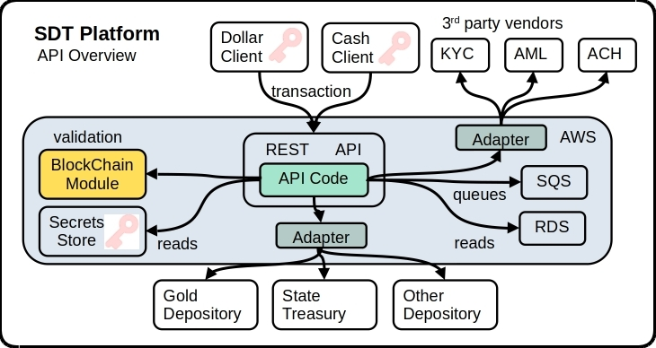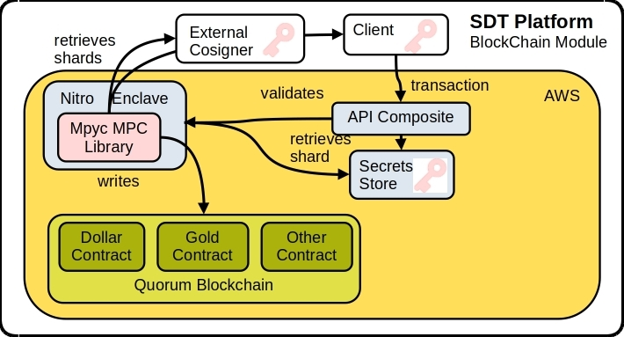

#### TWG Proposal (Technical Working Group)

[Recent legislation](https://broward.ghost.io/golddigr/legal/) shows significant interest in Texas-style precious metal depositories. This proposal is for a Technical Working Group (TWG) of interested parties to fund joint development of regional depositories with common procedures and a SDT platform. Here's an example.

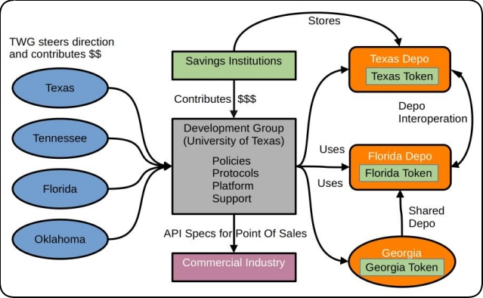

We used this model at Federal Highway from 1994 to 1996 to develop [ASPEN, CDLIS and ISS software](https://broward.ghost.io/2014/05/19/early-mobile-system/) with a permanent staff of five. Ten States contributed 1-2 members each quarter for a three-day design and feedback meeting (about 500 man hours annually).

#### ****5 Major Components****

**1) Development Group** - Independent organization which combines input to produce policies, protocols and platform for State depositories.

**2) Technical Working Group** (TWG) - a steering committee of States which contribute funding, feedback and policies from part-time advisors in each State.

**3) Regional Depositories** - State depositories which support SDTs and interoperate with other depositories.

**4) Savings Institutions** - provide funding to use SDTs as a mechanism of investment and wealth preservation.

**5) Commercial Industry** - retail vendors, 3rd party developers to support SDTs and arbitraging by investors.

Last year I researched [gold-backed crypto issued by private corporations](https://broward.ghost.io/2023/04/25/consider/). Most have failed and I suspect it's because of the pure profit motive. It's too much about instant money and not enough about long-term outcomes. I'm excited about State-based tokens partly because of the mentality of State employees and institutional stability.

#### SXS Proposal (State Exchange System)

The SXS platform has three functions.

* Manage financial transactions between platform members
* Collect information to calculate real-time exchange rates
* Adjust foreign reserves pools between platform members

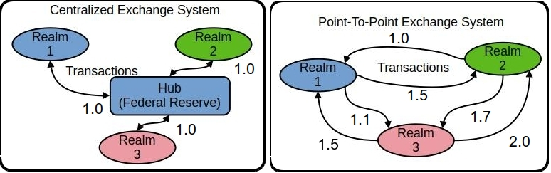

**CENTRALIZED**   
This is the design of the Federal Reserve and the realms represent countries and States. It’s inflexible but efficient and scalable with a single point of control and authority (hub). Over 100 countries use it.

**POINT-TO-POINT (PTP)**  
The BRICS countries are creating a point-to-point system which is less efficient but has more flexibility and freedom. Different rates are possible between Realm1 to Realm2 and Realm1 to Realm3, etc.

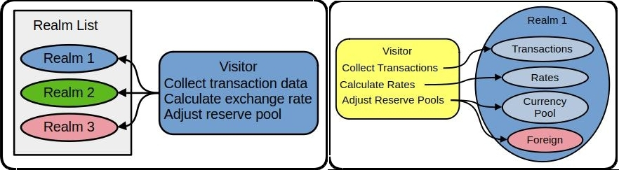

In the PTP system, a visitor regularly converses with all realms and executes a common set of functions. Within each realm are pending transactions, current exchange rates, foreign reserve pools. The visitor executes transactions, recalculates exchange rates and balances foreign reserve pools. Exchange rates are determined by the relationship between two realms instead of a central authority and each country (State) has some control in the exchange rate for each trading partner.

Here is a [small working software model of SXS](https://github.com/broward/BRICS) (<https://github.com/broward/BRICS>)

[More detailed model](https://broward.ghost.io/2023/09/01/brics-currency-platform/)  (https://broward.ghost.io/BRICS)

### Author

Thirty-five years of eclectic software development, including 7 startups, IT staff at a major university, several USDOT grants and 15 years of corporate consulting. [Three DEFCON presentations](https://broward.ghost.io/2014/01/09/defcon/) on predictive analytics.

#### **State governments**

From 1991-1996, I was the original architect of five Federal Highway Administration grants developing the [first handheld & wireless systems (ASPEN, CDLIS, ISS) for State-level motor carrier inspections](https://www.ugpti.org/research/details.php?id=93&ref=broward.ghost.io). I led a quarterly design conference with many State representatives, achieved a 40-State adoption and received a commendation from the US Secretary of Transportation. I was named [Boise State University employee of the year](https://broward.ghost.io/content/images/2022/01/nampa_article-1.jpg) in 1994.

#### **Startups**

* [Federal Highway 1992-96](https://broward.ghost.io/2014/05/19/early-mobile-system/) - R&D on early mobile systems
* [Saleslogix 1998-2000](https://broward.ghost.io/2021/03/01/saleslogix/) - CRM startup, SDK and Salesforce competitor
* [Sunhill Software 2004](https://broward.ghost.io/2023/11/14/sunhill-software/) - supply chain logistics and KPI
* [Gloo 2013](https://broward.ghost.io/2014/05/20/node-postgres-and-highcharts-app/) - health & wellness analytics
* [DLVR 2016-17](https://dlvr.com/how-it-works/video-multi-cdn-optimization/?ref=broward.ghost.io) - video analytics
* [Sila 2018](https://broward.ghost.io/2020/08/14/revision-2/) - stablecoin SDK and toolkit
* [Ensomata 2022](https://broward.ghost.io/2023/04/02/sonoma/) - health care analytics

#### **Digital Currencies**

Hands-on work with three digital currencies – the [Digital Money Trust in 1994](https://broward.ghost.io/2015/09/26/bitcoin-blockchains-and-banking-busts/) (a precursor to Bitcoin), an [IoT token prototype in 2014](https://broward.ghost.io/2021/03/01/digital-currency-on-iot/) and [Sila stablecoin in 2018](https://docs.silamoney.com/docs?ref=broward.ghost.io) which received $21 million in venture capital. I developed the MVP (minimum viable product) in 100 days and we used it in 50 demonstrations for funding. I designed and wrote about 75% of the original beta release code, API, security.

#### **Contracting**

Significant projects at [Boeing](https://broward.ghost.io/2022/11/18/boeing-revisited/) (call center), [Avnet](https://broward.ghost.io/2021/02/28/e-commerce-systems/) (e-commerce), [Aetna](https://broward.ghost.io/aetna)) (case management), [Amdocs](https://broward.ghost.io/2015/05/17/simple-kafka-monitor-using-opendmk-jmx-2-0/) (payment system), [DLVR.com](https://raw.githubusercontent.com/broward/images/master/Architecture/CrossSignFlow.jpg?ref=broward.ghost.io) (video analytics), Verizon (ring tone sales), [Staples](https://broward.ghost.io/2023/01/13/skittles-autopsy/) (e-commerce).

#### **DEFCON**

[Three DEFCON convention presentations in 2005-2007](https://broward.ghost.io/2014/01/09/defcon/) on predictive analytics and memetic manipulations.

### **Related Materal By Me**

[Cost Of Information 2024](https://broward.ghost.io/2024/05/19/cost-of-information/)

[BRICS Currency System 2023](https://broward.ghost.io/BRICS)

[AWS App Design, 2023](https://broward.ghost.io/aws_app_1)

[Stablecoin Hack, 2022](https://broward.ghost.io/stablecoin_hack)

[Miner Bankruptcy, 2022](https://broward.ghost.io/miner_bankruptcy)

[Polymorphic API, 2022](https://broward.ghost.io/polymorphic_api/)

[Crypto Platform, 2020](https://broward.ghost.io/crypto_platform)

[Payment System, 2015](https://broward.ghost.io/payment_system)

[Bitcoin Scalability, 2015](https://broward.ghost.io/bitcoin_scalability)

[Digital Money Trust, 2015](https://broward.ghost.io/digital_money_trust)

[Jing Currency on IoT, 2014](https://broward.ghost.io/digital_on_IoT)

[Aetna Migration, 2011](https://broward.ghost.io/aetna)

[Avnet E-commerce, 2000](https://broward.ghost.io/avnet)

[Multi-Tenant Systems, 1996-2018](https://broward.ghost.io/multi-tenant)

[Federal Highway System, 1992-1996](https://broward.ghost.io/FHWA/)

[Hacking the Planet, 1988](https://broward.ghost.io/hack_the_planet)