### GOLD TOKEN Paper – 2025, Ver 8

## Broward Horne, Tallahassee, FL

## [browardhorne@gmail.com](mailto:browardhorne@gmail.com?subject=Gold%20Token%20paper,%20ver%208)

## <https://broward.ghost.io/token/>

**”Control crypto before crypto controls you”**

### **Abstract**:

This paper contains a proposal for a **State Token Platform (STP)** backed by a State-regulated depository similar to [Arkansas Act 810](https://open.pluralpolicy.com/ar/bills/2025/HB1918/) and Texas [House Bill 1056](https://legiscan.com/TX/bill/HB1056/2025) , including an overview of historical forces, strategic roadmap and system design. My goal is to create a production system via State funding, grants, etc. With today’s AI, three people could build this in three months. [My_background is eclectic](https://broward.ghost.io/2014/03/09/about/) and spans startups, corporations‚ State and Federal systems for 35 years.

Design and code for [a prototype system](https://github.com/broward/token) is at <https://github.com/broward/token>.

#### Law Of Demeter is a systems design principle to reduce complexity and optimize efficiency. It states “An object should have minimal knowledge (dependencies) of other objects; paraphrased it says that "closer is better".

#### Buddhist Economics is a similar design paradigm which states “production from local resources for local needs is the most rational way of economic life... imports from afar.. are uneconomical... exceptional cases". You design successful systems around commonality, not exceptions.

Parasocial relationships are one-sided, where one party extends energy and time with the other party unaware of the other’s existence. The dollar is an increasingly parasocial relationship which transfers value from citizens to an elite minority, just as a celebrity profits from fans with no knowledge or concern for them.

### STP Overview

Imagine a monetary system which conforms to the reality of economic transactions. Transactions are a mirror of relationships. Relationships are largely a function of location. For many years, the US monetary system was a rough approximation of this. Call it an “impedance-matched currency” or STP.

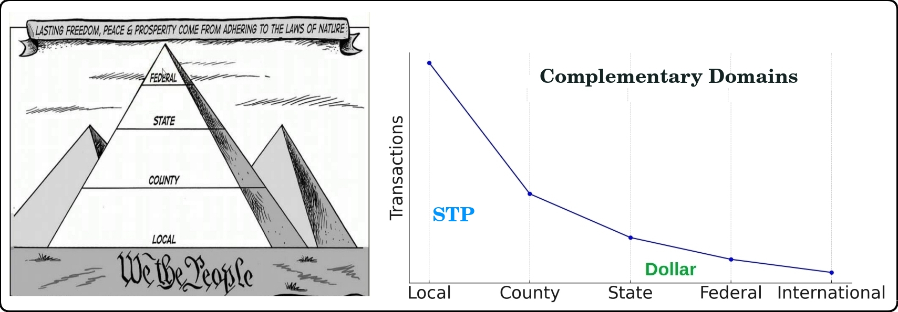

#### **Impedance-Matched Token**

The Euro is somewhat like harnessing a horse, a mule, a dog and a turtle to pull a wagon. A "one size fits all" strategy creates stresses because regions have different resources, skills, goals. Most economic transactions are local and an STP would be controlled locally.

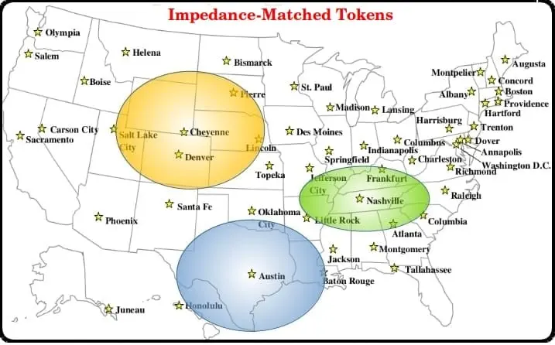

An STP platform can adapt to regional conditions, support cash-equivalent or US dollar tokens and use multiple value depositories to guarantee token value. Unlike Bitcoin, tokens have no intrinsic value and can be replaced if they are lost or stolen. Their value resides in the asset they represent, which can be gold, dollars, cattle, oil, real estate or even Bitcoin itself.

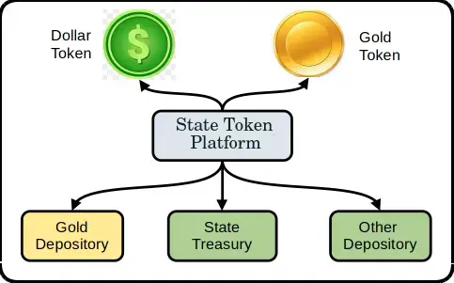

[Link to Regional Development Strategy](https://broward.ghost.io/2023/05/26/technical-working-group/)

[Link to State Exchange System](https://broward.ghost.io/2023/09/02/brics-model-1/)

[Link to Nationwide Pending Legislation for 2025](https://broward.ghost.io/current-alt-bills)

### Historical Background

This current period of fiat currency has already lasted longer than previous fiats of the past several hundred years and contrary forces are aligning against it. Russia and China have planned to end the fiat dollar for fifteen years, the US dollar is ripe for replacement as the world reserve currency, and the current Federal debt is unsustainable.

### **Gold Standard**

The longest period in modern history without a gold standard is now; from 1971 to 2025 or 54 years. The last major gold standard system was the Bretton Woods system, which operated from 1944 to 1971. The United States briefly abandoned its gold standard in unusual situations (Civil war, World War 1, etc). Russia's and China’s central banks has steadily increased gold reserves since 2009 to over 5,000 metric tons.

### **Hegemony**

Western hegemonic empires since 1400 A.D. had an average lifespan of 95 years and the United States has already exceeded that. The world reserve currency is usually a function of the current hegemony.

### 

### **Interest Payments**

The current rate of increase in [Federal debt interest payments](https://fred.stlouisfed.org/series/A091RC1Q027SBEA) is unsustainable.

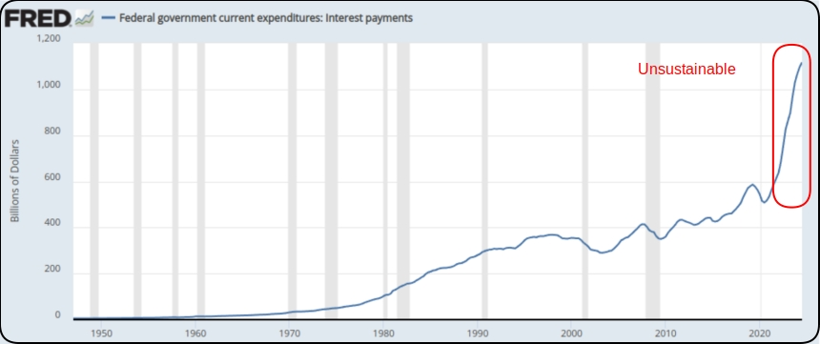

**“Debtors never believe debt matters… until they’re dangling over a vat of acid”**

### **Interest Rates**

Interest rates during the credit upcycle (1980 to 2020) have fallen as far as investors will tolerate. A trend reversal to higher rates will be disastrous for the current debt.

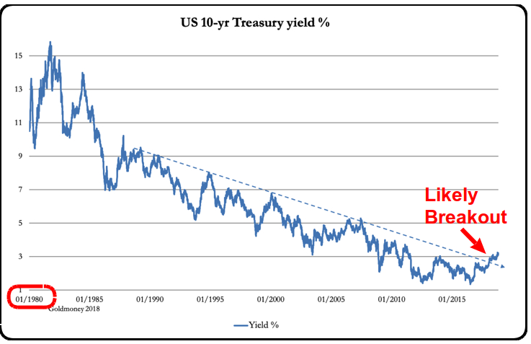

### **De-dollarization**

The BRICS coalition will use their oligopoly power to control commodity prices and bypass the US Dollar. The State Token Platform is a competitive response to the [new BRICS exchange system being announced in Rio](https://www.zerohedge.com/news/2025-05-24/brics-2025-gold-dedollarization-endgame) in July, 2025. Both systems use blockchains, tokens, distributed depositories and physical metal backing.

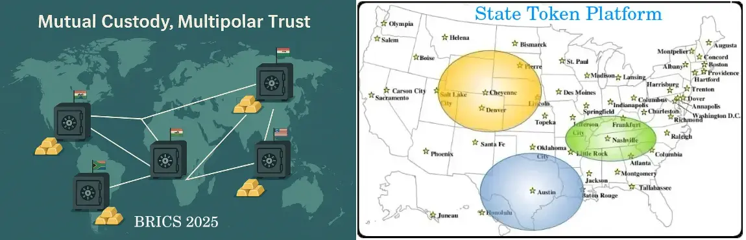

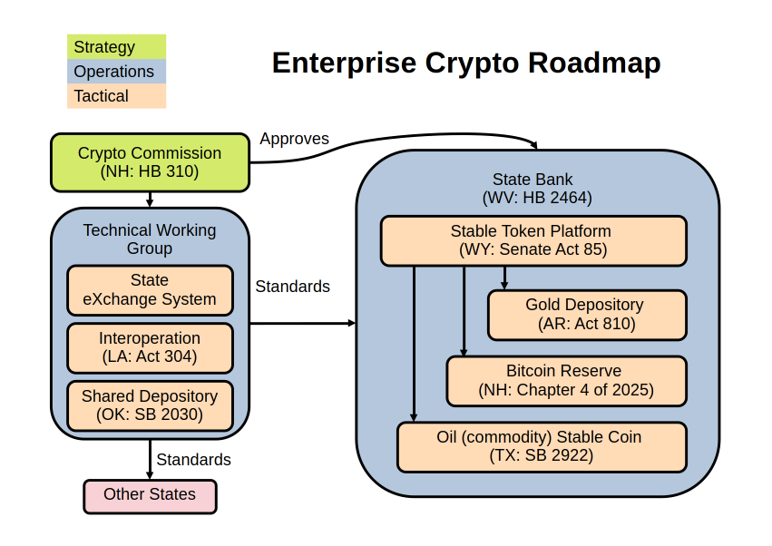

This is an example roadmap of legislative acts and pending bills organized into a comprehensive structure.

[New Hampshire Crypto Commission, HB 310](https://open.pluralpolicy.com/nh/bills/2025/HB310/)

[West Virginia State Bank, HB 2464](https://open.pluralpolicy.com/wv/bills/2025/HB2464/)

[Wyoming Stable Token, Senate Act 85](https://open.pluralpolicy.com/wy/bills/2023/SF127/)

[Arkansas Bullion Depository, Act 810](https://open.pluralpolicy.com/ar/bills/2025/HB1918/)

[New Hampshire Digital Asset Act, Chapter 4, Laws of 2025](https://open.pluralpolicy.com/nh/bills/2025/HB302/)

[Texas Oil-based Stablecoin, SB 2922](https://open.pluralpolicy.com/tx/bills/89R/SB2922/)

[Technical Working Group](https://broward.ghost.io/2023/05/26/technical-working-group/)

[State Exchange System](https://broward.ghost.io/2023/09/01/brics-currency-platform/)

[Louisiana Interoperation,](https://open.pluralpolicy.com/la/bills/2025/HB695/) Act 304

Oklahoma [Shared Depository, SB 2030](https://open.pluralpolicy.com/ok/bills/2024/SB2030/)

After reading proposed State legislation for six months, I realized that most crypto-related bills are singular and self-contained, which is also how I envisioned this STP project. But a roadmap is better for most situations because it’s a strategic approach which reduces complexity and duplication. You probably don't want a bunch of point-to-point systems running in parallel.

**“Hubris is the most dangerous sin because it often masquerades as virtue”**

#### State Token Platform (STP)

This is a high-level overview of how the STP platform works.

[Github source code](https://github.com/broward/token) is at <https://github.com/broward/token>

DEPOSITORY: stores value such as gold / currency / other

API CODE: receives and executes logins, transactions, etc

BLOCKCHAIN MODULE: contains the Quorum blockchain and MPC library

BLOCKCHAIN: equivalent to an accounting ledger

MPC library: equivalent to safety deposit keys, stores key shards in three locations

DOLLAR CLIENT: customer with funds in the State treasury

CASH CLIENT: customer in a separate domain with funds in gold / other depository

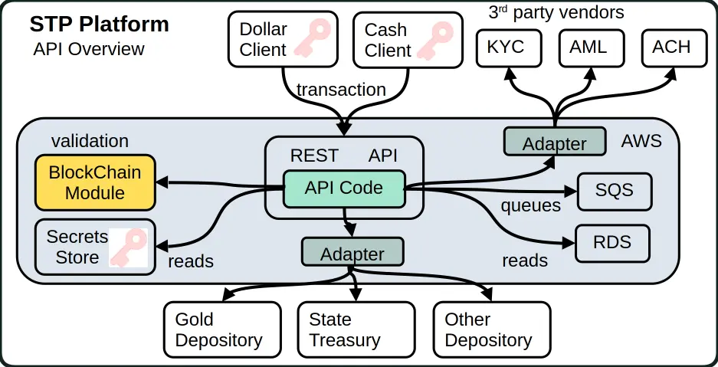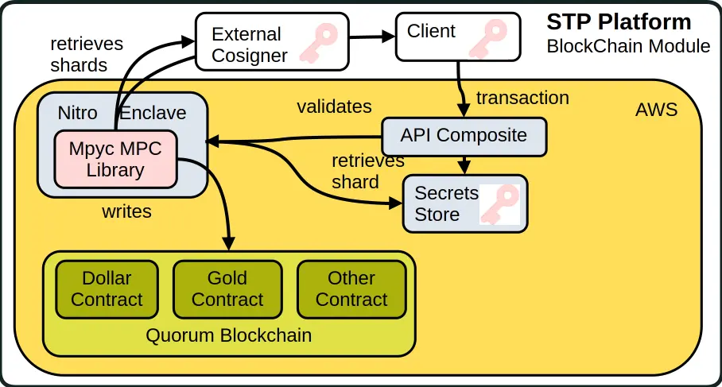

### Author

Thirty-five years of eclectic software development, including 7 startups, IT staff at a major university, several USDOT grants and 15 years of corporate consulting. [Three DEFCON presentations](https://broward.ghost.io/2014/01/09/defcon/) on predictive analytics.

#### **State governments**

From 1991-1996, I was the original architect of five Federal Highway Administration grants developing the [first handheld & wireless systems (ASPEN, CDLIS, ISS) for State-level motor carrier inspections](https://www.ugpti.org/research/details.php?id=93&ref=broward.ghost.io). I led a quarterly design conference with many State representatives, achieved a 40-State adoption and received a commendation from the US Secretary of Transportation. I was named [Boise State University employee of the year](https://broward.ghost.io/content/images/2022/01/nampa_article-1.jpg) in 1994.

#### **Startups**

* [Federal Highway 1992-96](https://broward.ghost.io/2014/05/19/early-mobile-system/) - R&D on early mobile systems
* [Saleslogix 1998-2000](https://broward.ghost.io/2021/03/01/saleslogix/) - CRM startup, SDK and Salesforce competitor
* [Sunhill Software 2004](https://broward.ghost.io/2023/11/14/sunhill-software/) - supply chain logistics and KPI
* [Gloo 2013](https://broward.ghost.io/2014/05/20/node-postgres-and-highcharts-app/) - health & wellness analytics
* [DLVR 2016-17](https://dlvr.com/how-it-works/video-multi-cdn-optimization/?ref=broward.ghost.io) - video analytics
* [Sila 2018](https://broward.ghost.io/2020/08/14/revision-2/) - stablecoin platform and SDK
* [Ensomata 2022](https://broward.ghost.io/2023/04/02/sonoma/) - health care analytics

#### **Digital Currencies**

Hands-on work with three digital currencies – the [Digital Money Trust in 1994](https://broward.ghost.io/2015/09/26/bitcoin-blockchains-and-banking-busts/) (a precursor to Bitcoin), an [IoT token prototype in 2014](https://broward.ghost.io/2021/03/01/digital-currency-on-iot/) and [Sila stablecoin in 2018](https://docs.silamoney.com/docs?ref=broward.ghost.io) which received $21 million in venture capital. I developed the MVP (minimum viable product) in 100 days and we used it in 50 demonstrations for funding. I designed and wrote about 75% of the original beta release code, API, security.

#### **Contracting**

Significant projects at [Boeing](https://broward.ghost.io/2022/11/18/boeing-revisited/) (call center), [Avnet](https://broward.ghost.io/2021/02/28/e-commerce-systems/) (e-commerce), [Aetna](https://broward.ghost.io/aetna)) (case management), [Amdocs](https://broward.ghost.io/2015/05/17/simple-kafka-monitor-using-opendmk-jmx-2-0/) (payment system), [DLVR.com](https://raw.githubusercontent.com/broward/images/master/Architecture/CrossSignFlow.jpg?ref=broward.ghost.io) (video analytics), Verizon (ring tone sales), [Staples](https://broward.ghost.io/2023/01/13/skittles-autopsy/) (e-commerce).

#### **DEFCON**

[Three DEFCON convention presentations in 2005-2007](https://broward.ghost.io/2014/01/09/defcon/) on predictive analytics and memetic manipulations.

### **Related Materal By Me**

[Workweek Equilibirum 2025](https://broward.ghost.io/2025/01/27/equilibrium/)

[Cost Of Information 2024](https://broward.ghost.io/2024/05/19/cost-of-information/)

[BRICS Currency System 2023](https://broward.ghost.io/BRICS)

[AWS App Design, 2023](https://broward.ghost.io/aws_app_1)

[Stablecoin Hack, 2022](https://broward.ghost.io/stablecoin_hack)

[Polymorphic API, 2022](https://broward.ghost.io/polymorphic_api/)

[Crypto Platform, 2020](https://broward.ghost.io/crypto_platform)

[Payment System, 2015](https://broward.ghost.io/payment_system)

[Bitcoin Scalability, 2015](https://broward.ghost.io/bitcoin_scalability)

[Digital Money Trust, 2015](https://broward.ghost.io/digital_money_trust)

[Jing Currency on IoT, 2014](https://broward.ghost.io/digital_on_IoT)

[Avnet E-commerce, 2000](https://broward.ghost.io/avnet)

[Multi-Tenant Systems, 1996-2018](https://broward.ghost.io/multi-tenant)

[Federal Highway System, 1992-1996](https://broward.ghost.io/FHWA/)

[Hacking the Planet, 1988](https://broward.ghost.io/hack_the_planet)

**“Diversity is always an extra cost. Sometimes it has a net benefit.”**