### GOLD DIGR White Paper – 2025, Ver 8

## Broward Horne, Tallahassee, FL

## browardhorne@gmail.com

## [https://broward.ghost.io/token/](https://broward.ghost.io/tag/gold-token/)

Download current version at <https://broward.ghost.io/current-gold-paper>

### **Abstract**:

This paper contains a proposal for a **State Depository Token (SDT)** backed by a State-regulated depository similar to Texas [House Bill 1056](https://legiscan.com/TX/bill/HB1056/2025) and [House Bill 1049](https://legiscan.com/TX/bill/HB1049/2025), including an overview of historical and political forces‚ current legislation and strategic design. My goal is to create a real system via State funding, grants, consulting, sponsorship. etc. I have the skills to do it, [my_background is eclectic](https://broward.ghost.io/2014/03/09/about/) and spans startups, corporations‚ State and Federal systems for 35 years.

Design and code for [a prototype system](https://github.com/broward/token) is at <https://github.com/broward/token>.

#### Law Of Demeter: "An object should have minimal knowledge (dependencies) of other objects; paraphrased it says that "closer is better".

#### Buddhist Economics: "production from local resources for local needs is the most rational way of economic life... imports from afar.. are uneconomic... exceptional cases"

Parasocial relationships are one-sided, where one party extends energy and time with the other party unaware of the other’s existence. The dollar is an increasingly parasocial relationship which transfers value from citizens to an elite minority, just as a celebrity profits from fans with no knowledge or concern for them.

### SDT Overview

Imagine a monetary system which conforms to the reality of economic transactions. Transactions are a mirror of relationships. Relationships are largely a function of location. For many years, the US monetary system was a rough approximation of this. Call it an “impedance-matched currency” or SDT.

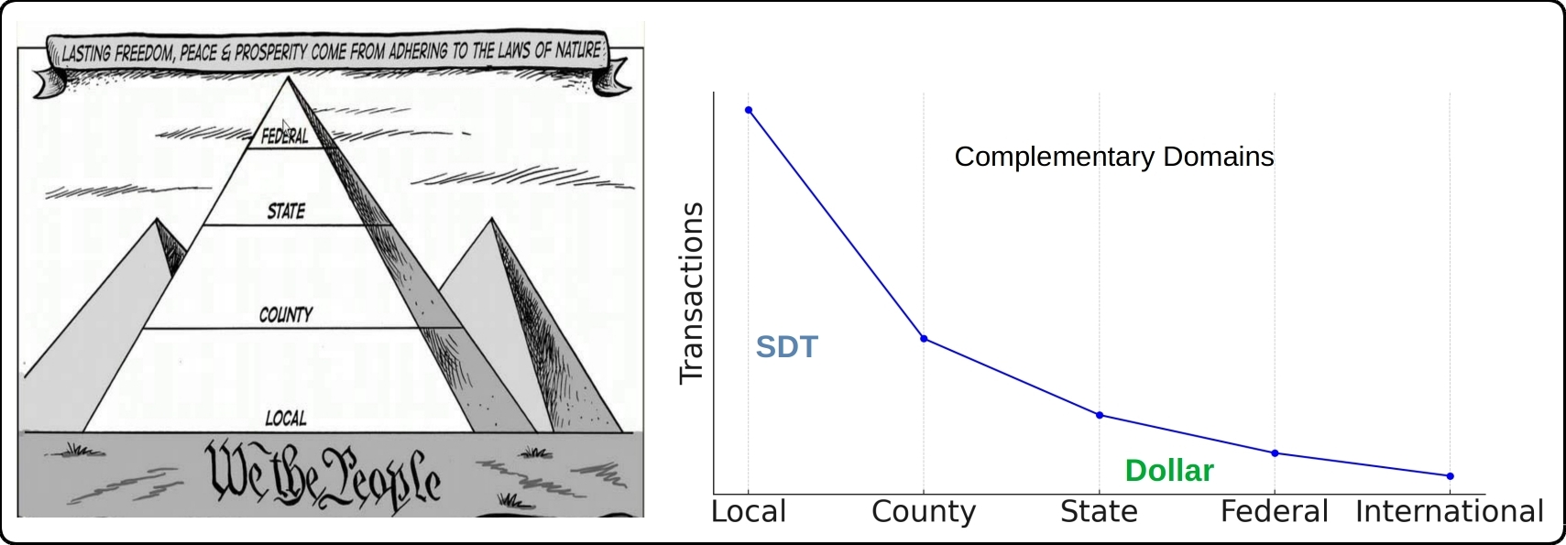

#### **Impedance-Matched Token**

The Euro is somewhat like harnessing a horse, a mule, a dog and a turtle to pull a wagon. A "one size fits all" strategy creates stresses because regions have different resources, skills, goals. Most economic transactions are local and an SDT would be controlled locally.

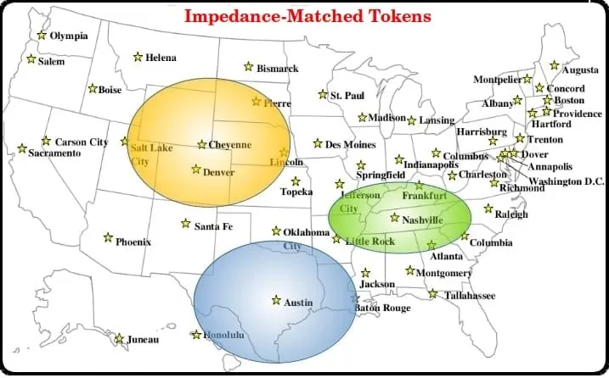

An SDT platform can adapt to regional conditions, support cash-equivalent or US dollar tokens and use multiple value depositories to guarantee token value. Unlike Bitcoin, tokens have no intrinsic value and can be replaced if they are lost or stolen. Their value resides in the asset they represent, which can be gold, dollars, cattle, oil, real estate or even Bitcoin itself.

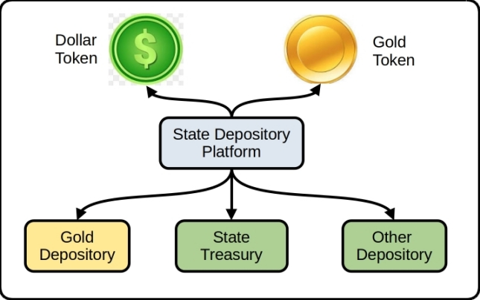

### Historical Background

This current period of fiat currency has already lasted longer than previous fiats of the past several hundred years and contrary forces are aligning against it. Russia and China have planned to end the fiat dollar for fifteen years, the US dollar is ripe for replacement as the world reserve currency, and the current Federal debt is unsustainable.

### **Gold Standard**

The longest period in modern history without a gold standard is now; from 1971 to 2024 or 53 years. The last major gold standard system was the Bretton Woods system, which operated from 1944 to 1971. The United States has briefly abandoned its gold standard in unusual situations (Civil war, World War 1, etc). Russia's central bank has steadily increased gold reserves since 2009 to over 2,330 metric tons. China has consistently increased gold reserves since 2009 to over 2,264 metric tons.

### **Hegemony**

Western hegemonic empires since 1400 A.D. had an average lifespan of 95 years and the United States has already exceeded that. The world reserve token is usually a function of the current hegemony.

### 

### **Interest Payments**

The current rate of increase in [Federal debt interest payments](https://fred.stlouisfed.org/series/A091RC1Q027SBEA) is unsustainable.

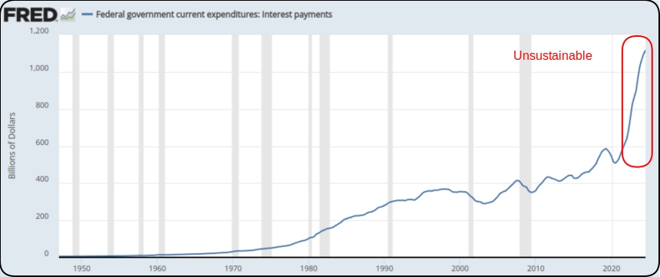

### **Interest Rates**

As debt increases, rates must fall to maintain equilibrium. Interest rates during the credit upcycle (1980 to 2020) have fallen as far as investors will tolerate. A trend reversal to higher rates will be disastrous for the current debt.

### **De-dollarization**

The BRICS coalition will use their oligopoly power to control commodity prices and bypass the US Dollar. BRICS control 50% of the world's food supply, 70% of the microchip supply (China + Taiwan) and almost 50% of world oil reserves. As of Oct, 2024, 13 more countries joined BRICS as limited partners.

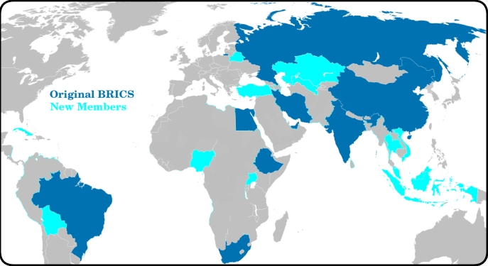

#### GOLD DIGR Proposal

This is a high-level overview of how the SDT platform works.

[Github source code](https://github.com/broward/token) is at <https://github.com/broward/token>

DEPOSITORY: stores value such as gold / currency / other

API CODE: receives and executes logins, transactions, etc

BLOCKCHAIN MODULE: contains the Quorum blockchain and MPC library

BLOCKCHAIN: equivalent to an accounting ledger

MPC library: equivalent to safety deposit keys, stores key shards in three locations

DOLLAR CLIENT: customer with funds in the State treasury

CASH CLIENT: customer in a separate domain with funds in gold / other depository

#### 

### Author

Thirty-five years of eclectic software development, including 7 startups, IT staff at a major university, several USDOT grants and 15 years of corporate consulting. [Three DEFCON presentations](https://broward.ghost.io/2014/01/09/defcon/) on predictive analytics.

#### **State governments**

From 1991-1996, I was the original architect of five Federal Highway Administration grants developing the [first handheld & wireless systems (ASPEN, CDLIS, ISS) for State-level motor carrier inspections](https://www.ugpti.org/research/details.php?id=93&ref=broward.ghost.io). I led a quarterly design conference with many State representatives, achieved a 40-State adoption and received a commendation from the US Secretary of Transportation. I was named [Boise State University employee of the year](https://broward.ghost.io/content/images/2022/01/nampa_article-1.jpg) in 1994.

#### **Startups**

* [Federal Highway 1992-96](https://broward.ghost.io/2014/05/19/early-mobile-system/) - R&D on early mobile systems
* [Saleslogix 1998-2000](https://broward.ghost.io/2021/03/01/saleslogix/) - CRM startup, SDK and Salesforce competitor
* [Sunhill Software 2004](https://broward.ghost.io/2023/11/14/sunhill-software/) - supply chain logistics and KPI
* [Gloo 2013](https://broward.ghost.io/2014/05/20/node-postgres-and-highcharts-app/) - health & wellness analytics
* [DLVR 2016-17](https://dlvr.com/how-it-works/video-multi-cdn-optimization/?ref=broward.ghost.io) - video analytics
* [Sila 2018](https://broward.ghost.io/2020/08/14/revision-2/) - stablecoin SDK and toolkit
* [Ensomata 2022](https://broward.ghost.io/2023/04/02/sonoma/) - health care analytics

#### **Digital Currencies**

Hands-on work with three digital currencies – the [Digital Money Trust in 1994](https://broward.ghost.io/2015/09/26/bitcoin-blockchains-and-banking-busts/) (a precursor to Bitcoin), an [IoT token prototype in 2014](https://broward.ghost.io/2021/03/01/digital-currency-on-iot/) and [Sila stablecoin in 2018](https://docs.silamoney.com/docs?ref=broward.ghost.io) which received $21 million in venture capital. I developed the MVP (minimum viable product) in 100 days and we used it in 50 demonstrations for funding. I designed and wrote about 75% of the original beta release code, API, security.

#### **Contracting**

Significant projects at [Boeing](https://broward.ghost.io/2022/11/18/boeing-revisited/) (call center), [Avnet](https://broward.ghost.io/2021/02/28/e-commerce-systems/) (e-commerce), [Aetna](https://broward.ghost.io/aetna)) (case management), [Amdocs](https://broward.ghost.io/2015/05/17/simple-kafka-monitor-using-opendmk-jmx-2-0/) (payment system), [DLVR.com](https://raw.githubusercontent.com/broward/images/master/Architecture/CrossSignFlow.jpg?ref=broward.ghost.io) (video analytics), Verizon (ring tone sales), [Staples](https://broward.ghost.io/2023/01/13/skittles-autopsy/) (e-commerce).

#### **DEFCON**

[Three DEFCON convention presentations in 2005-2007](https://broward.ghost.io/2014/01/09/defcon/) on predictive analytics and memetic manipulations.

### **Related Materal By Me**

[Cost Of Information 2024](https://broward.ghost.io/2024/05/19/cost-of-information/)

[BRICS Currency System 2023](https://broward.ghost.io/BRICS)

[AWS App Design, 2023](https://broward.ghost.io/aws_app_1)

[Stablecoin Hack, 2022](https://broward.ghost.io/stablecoin_hack)

[Miner Bankruptcy, 2022](https://broward.ghost.io/miner_bankruptcy)

[Polymorphic API, 2022](https://broward.ghost.io/polymorphic_api/)

[Crypto Platform, 2020](https://broward.ghost.io/crypto_platform)

[Payment System, 2015](https://broward.ghost.io/payment_system)

[Bitcoin Scalability, 2015](https://broward.ghost.io/bitcoin_scalability)

[Digital Money Trust, 2015](https://broward.ghost.io/digital_money_trust)

[Jing Currency on IoT, 2014](https://broward.ghost.io/digital_on_IoT)

[Aetna Migration, 2011](https://broward.ghost.io/aetna)

[Avnet E-commerce, 2000](https://broward.ghost.io/avnet)

[Multi-Tenant Systems, 1996-2018](https://broward.ghost.io/multi-tenant)

[Federal Highway System, 1992-1996](https://broward.ghost.io/FHWA/)

[Hacking the Planet, 1988](https://broward.ghost.io/hack_the_planet)