Training Curriculum App

# Screens

## Main Screens

### Login

This will be the first screen users will see when they open the site. The user will be prompted to enter a user name and password which will be verified against user name, password combinations in the database. If a matching user name, password combination exists the user will be logged in, otherwise they will be prompted to retry. When a user is initially created the “password_reset” column in the database is set to “1” which will prompt the application to redirect the user to the *Password Reset* page after logging in with the temporary password given to them. This will also be the case if the user ever has to reset their password in the future. After successfully logging in (and resetting their password if necessary) they will be redirected to the initial page they attempted to load, which will default to the home page.

### Password Reset

This is the screen a user will see when they login either for the first time after their account has been created, or after their password has been reset. It will prompt the user for their temporary password—which will be randomly generated and then emailed to them—as well as a new password which they will come up with—which will be specified in a “New Password” and a “Confirm New Password” field.

### Home

The home page is the default first page users will see after being logged in. This page will include quick views of information that is pertinent to the user. Information that may be useful include:

* List of incomplete trainings that the user needs to be scheduled to take.
* List of upcoming trainings that the user is scheduled to take.
* List of completed trainings.

The trainings may be split into “curriculums” which will define within how many days after starting work the user needs to take a particular training.

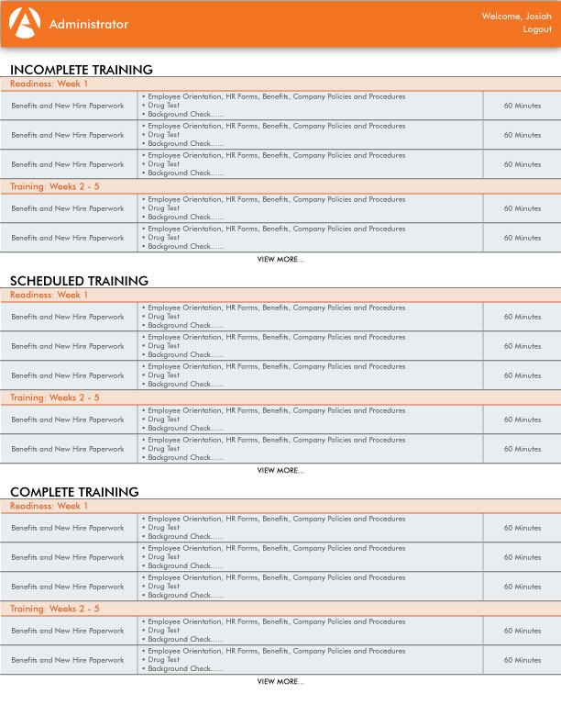

### Administrator

The administrator page is where users—with **Administrative** privileges (the “admin” column for the user in the database is set to “1”)—will go to add/remove/modify content. Features that may be useful include:

#### Employees

* Add new Employees
* Remove (archive) Employees
* Modify Employees (this would take you to the *Employee Modification* screen)

#### Trainings

* Add new Trainings
* Remove (archive) Trainings
* Modify Trainings (this would take you to the *Training Modification* screen)

#### Curriculums

* Add new Curriculum
* Remove (archive) Curriculum
* Modify Curriculum (this would take you to the *Curriculum Modification* screen)

## Modification Screens

### Employee Modification

This is the screen an **Administrative** user will see when they click to “modify” an employees information from the *Administrator* 🡪 *Employees* screen. Content that may be useful to edit would be:

* Username
* Reset user password
  + Administrator would click a “Reset Password” button.
  + “password_reset” column for the user in the database would be set to “1”
  + A random password will be generated, which will be set as the value for the “password” field for the user in the database.
  + The random password will be sent to the users email address.
* First Name/Last Name
* Employee Number
* Phone Extension
* Administrator Privileges
* Groups (will open an instance of a *User Groups* tool)

### Training Modification

This is the screen an **Administrative** user will see when they click to “modify” a trainings information from the *Administrator* 🡪 *Trainings* screen. Content that may be useful to edit would be:

* Topic
* Description
* Duration
* Time Frame
* Facilitators
* Groups (will open an instance of a *Training Groups* tool)
* Dates
  + Recurrences
* Materials

### Curriculum Modification

This is the screen an **Administrative** user will see when they click to “modify” a curriculums information from the *Administrator* 🡪 *Curriculums*screen. Content that may be useful to edit would be:

* Name
* Start (defined in number of days)
* End (defined in number of days)
* Outcome (the desired outcome of this curriculum)
* Description

# Tools

## Groups

### User Groups

This tool will allow an **Administrative** user to add/remove employees from user groups defined in the “user_groups” table. Required information will be:

* User ID
* Group ID (will open an instance of a *Groups* tool)

### Training Groups

This tool will allow an **Administrative** user to add/remove trainings from training groups defined in the “training_groups” table. Required information will be:

* Training ID
* Group ID (will open an instance of a *Groups* tool)

### Groups

This tool will allow an **Administrative** user to select a group, and create new groups for the “groups” table. This table will contain unique ID’s and descriptions (names) for both user and trainings groups. Required information will be:

* Name
* Description

## Privileges

### Facilitators

This tool will allow an **Administrative** user to add/remove users to/from the “facilitators” table. Required information will be:

* User ID
* Group (will open an instance of a *Training Groups* tool)
* Sponsor
* Administrator