Drawing Study Instructions

This is a study to compare several techniques for 3D drawing in the air.

During this virtual reality study, you'll be asked to trace some 3D curves that appear as dotted lines floating in the air in front of you. You will be using various 3D drawing techniques that we have developed here at Brown: "Freehand in Sand Drawing", "Freehand Drawing", "Directional Drag Drawing", and "Two-handed drawing".

Instructions:

1. Tracing: Trace all the lines from right to left. Look for the side marked "Start" and begin there. The start and the end points on the line will also be marked with a bullseye. Try to start and end your lines right in the center of those bullseyes.

2. Timing: You will have up to 30 seconds to start tracing once you are prompted with an example line to trace and then up to another 30 seconds to finish drawing each line. You probably will not need all this time. You should work as quickly as you can without rushing and still working carefully. Your scores on accuracy in tracing are much more important than how quickly you can trace the lines.

3. Scoring: You will be scored on how close the line you draw is to the example using two measures: "Position" and "Direction".

"Position" measures how close the line you draw is to the example line.

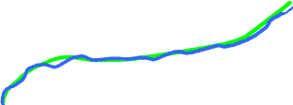 | 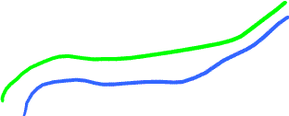
If you drew the blue line above while tracing the green line, you would get a good position score because it is almost right on top of the green line. | This blue line would get a pretty bad position score because it is so far away from the green line.

“Direction” measures whether your line is going in the same direction as the example.

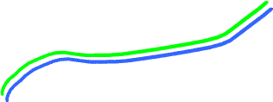 | 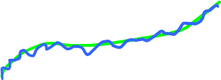
If you drew this blue line, you would get a good direction score. At each point along them, the two lines are almost parallel. Notice, however, that the position score would not be very good here, it would be better if the blue line were closer to the green one. | This blue line would have a bad direction score. Overall it follows along the same path as the green line, but it is very wobbly and rarely goes in the same direction as the green line. Avoiding a wobbly line is a key to getting a good direction score.

Please ask the person running the study if you have any questions about the difference between the position score and the direction score.

Your goal is to try to get as high a score as you can on both “Position” and “Direction”. Sometimes it is hard to get good scores on both of these, and you will have to do some balancing. Think of the lines that you draw as being part of a real drawing, like a medical illustration, that you are creating. You want to try to produce a line that follows the exact path of the example (Position), but at the same time, it is not good if the shape you are trying to convey is smooth and you produce something wobbly (this would produce a bad Direction score), so your job as the artist is to try to balance these two goals.

4. Training: For the first 20 lines you draw, we will show you your position and direction scores after you trace each line. This will help you get a better sense of what it means to have a good score. You will also see a whole set of bullseyes placed along the line you are tracing. If you do a really good job, the line you draw should pass right through the center of each of these bullseyes. Once you get the hang of it, we will stop showing you your scores and the bullseyes along the line will disappear leaving only one to mark the start of the line and one to mark the end.

5. Switching Drawing Techniques: After a while we will switch the drawing technique that you use. The program will tell you the new drawing technique in big red letters whenever this happens and you will have a little break before starting the next section.

