Get paid to try out..
3D Drawing in Virtual Reality
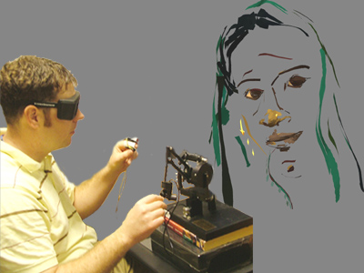

Brown University researchers are running a study to compare artistic computer interfaces for drawing 3D lines in the air using virtual reality technology. Come be a part of it and get paid to try out a futuristic artistic tool. Find out what it means to use a force feedback pen to draw in 3D!

Contact Dan Keefe at dfk@cs.brown.edu for more information.

3D Drawing Study  dfk@cs.brown.edu | 3D Drawing Study  dfk@cs.brown.edu | 3D Drawing Study  dfk@cs.brown.edu | 3D Drawing Study  dfk@cs.brown.edu | 3D Drawing Study  dfk@cs.brown.edu | 3D Drawing Study  dfk@cs.brown.edu | 3D Drawing Study  dfk@cs.brown.edu | 3D Drawing Study  dfk@cs.brown.edu | 3D Drawing Study  dfk@cs.brown.edu | 3D Drawing Study  dfk@cs.brown.edu

