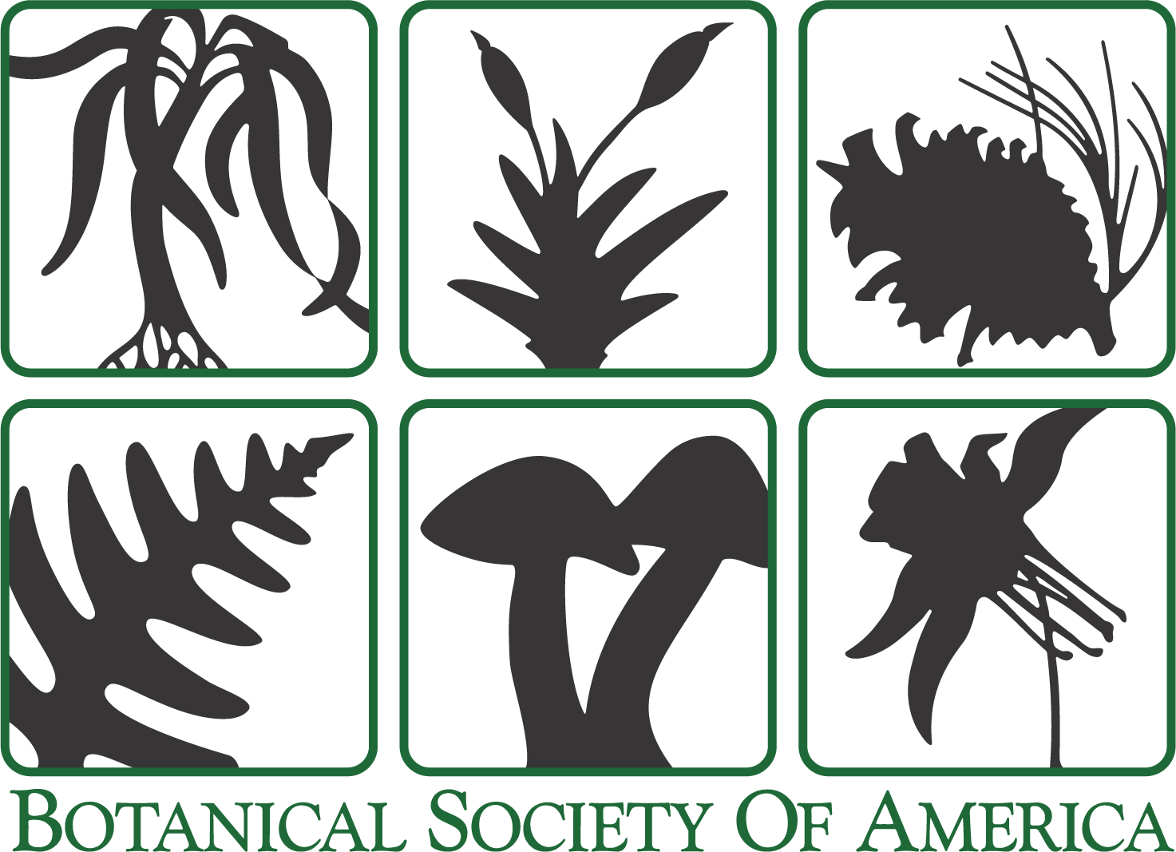***Applications in Plant Sciences* Author Agreement Form**

Click on the first gray box and start typing. You may use the Tab to get to the next field.

**Corresponding Author’s Name:** Andras Zsom

**Date:** July, 17th, 2019

**Respond to ALL the statements below either by typing your initials or checking the appropriate box. After you have completed this form, save it to your desktop as a Word document, and upload it with your manuscript submission on the “Attach Files” page in Editorial Manager (**[**http://www.edmgr.com/apps**](http://www.edmgr.com/apps)**).**

1. All Contributing Authors know of and concur with the submission of this manuscript. Single authors please also initial.

Initials: AZ

2. All authors of this research paper have directly participated in the planning, execution, or analysis of the study;

AND

All authors of this paper have read and approved the final version submitted.

Initials: AZ

3. The contents of this manuscript have not been copyrighted or published previously and are not now under consideration for publication elsewhere. The contents of this manuscript will not be copyrighted, submitted, or published elsewhere while acceptance by the Journal is under consideration.

Initials: AZ

4. *APPS* operates under a Creative Commons Attribution 3.0 license. Please specify which license should be applied to publication of this article:

**CC-BY-NC-SA:** This is the default license under which articles are published in *APPS*. Under the terms of this license, authors retain ownership of the copyright of their articles. Users are allowed to download, print out, extract, reuse, archive, and distribute the article for noncommercial use; this use is contingent upon appropriate credit being given to the authors and the source of the work and upon the new creation being licensed under the same terms.

**CC-BY:** This license should be selected if mandated by article funding sources. CC-BY permits use, distribution, and reproduction in any medium, provided the original work is properly cited. There is no distinction between reuse for commercial or noncommercial purposes.

**CC0:** This is the Creative Commons public domain license. Papers authored by one or more US government employees should use this license, which allows unlimited distribution and reuse of the article for any lawful purpose.

Each of these licenses ensure wide availability of the article and that the article can be included in any scientific archive. No permission is required from the author or the Botanical Society of America. If a CC-BY-NC-SA license is used, those wishing to use material for commercial purposes should contact the author.

Please select the license that should be applied to this article:

**CC-BY-NC-SA**

**CC-BY**

**CC0**

4a. If you select the CC0 license, please confirm the following: One or more authors of this manuscript are US government employees, and this work was prepared as part of the author’s official duties as a US government employee. Note: If this work was not prepared as part of the author’s official duties as a US government employee, it should be published under a CC-BY-NC-SA or CC-BY Creative Commons license.   
Initials:

5. Authors are responsible for recognizing and disclosing any duality of interest that could be perceived to bias their work, acknowledging all financial support and any other personal connections.

**No**, there is no duality of interest that I should disclose, having read the above statement.

**Yes**, having read the above statement, there is potential duality of interest. This has been fully detailed in my cover letter.

6. Have the results/data/figures in this manuscript been published or are they under consideration for publication elsewhere?

**No**, the results/data/figures in this manuscript have not been published elsewhere, nor are they under consideration (from you or one of your Contributing Authors) by another publisher.

**Yes**, some portion of the results/data/figures in this manuscript has been published or is under consideration for publication elsewhere.

6a. If you select Yes, please identify results/data/figures taken from other published/pending manuscripts in the textbox below and explain why this does not constitute dual publication. (Note: The existence of pending or previously published articles that use or have used any of the same results presented in the submitted manuscript does not generally prejudice review and acceptance.)

7. All *APPS* papers are published as Open Access articles. Article Processing Charges (APCs) are as follows:

Non-BSA members: $1400 per article  
BSA members: $800 per article  
BSA members with an active membership for longer than two years: $450 per article

This policy applies to all articles accepted, except for invited articles for which the Editorial Board has agreed to waive fees at the time of article submission. **Authors will be invoiced and payment must be received before online publication.**

**No,** No authors of this manuscript are members of the BSA.

**Yes,** I confirm that at least one author is a BSA member

Please note here the name(s) of author(s) who are BSA members. Membership status will be verified by the editorial office.

Erika Edwards and Michael Donoghue

8. Authors are responsible for covering charges for author-initiated changes made in proof. Authors will be charged when more than 10 changes are requested per article, as well as for figure replacements in proof ($25.00 per figure). This policy applies to BSA members and nonmembers. I have read and understand this policy.

AZ

9. *APPS* requires that genetic information, such as DNA, RNA, or protein sequences, be submitted to an appropriate data bank (i.e., GenBank or EMBL). Alignments used to produce phylogenies must be submitted to TreeBase or to *APPS* to be published with the paper as supplementary material. Authors are encouraged to archive all sequences generated from next-generation sequencing techniques in a suitable public depository (e.g., the Sequence Read Archive of NCBI, the Sequence Read Archive of ENA, or Dryad). I have read and understand this policy.

AZ

[last revised 21 June 2017]