APPLICATION DEPLOYMENT GUILDLINE DOCUMENT
Employee Information
Employee Name | Ha (Huck) H.K. NGUYEN
Department | Engineering
Date | 09-OCT-2015

Table of Contents

1.BUILD APPLICATION 4
1.1Build with Eclipse IDE 4
1.2Build by Maven 6
1.3Build with Jenkins 8
2.DEPLOY APPLICATION 9
2.1Deploy with Jboss (Jboss AS 7) 9
2.2Deploy with Tomcat Apache 10

BUILD APPLICATION

Build with Eclipse IDE
On Menu Bar in Eclipse, click File → Export.
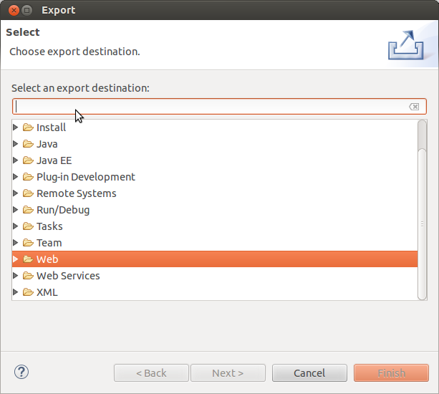
Type “war” to Field → Next.
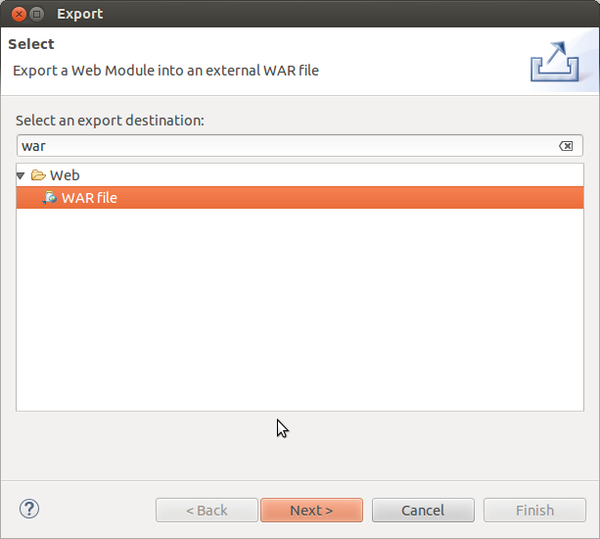

Name for file and browse to destination (for example: /home/user/Desktop/Jenkins.war).
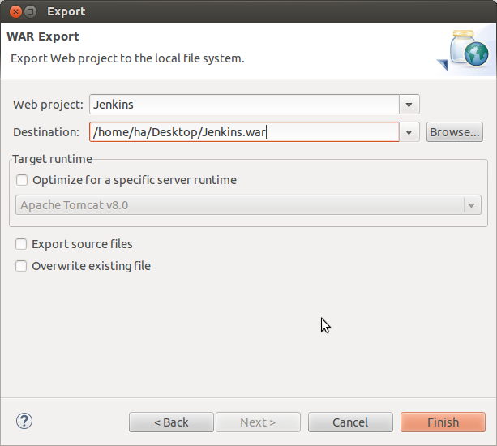
Finish.

Build by Maven
Open Terminal → move to project directory.
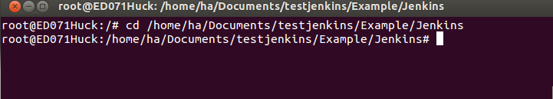
Type to Terminal:
mvn clear
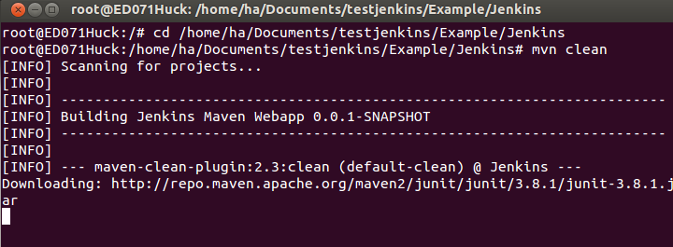
This command remove old builds, then, type to Terminal:
mvn install
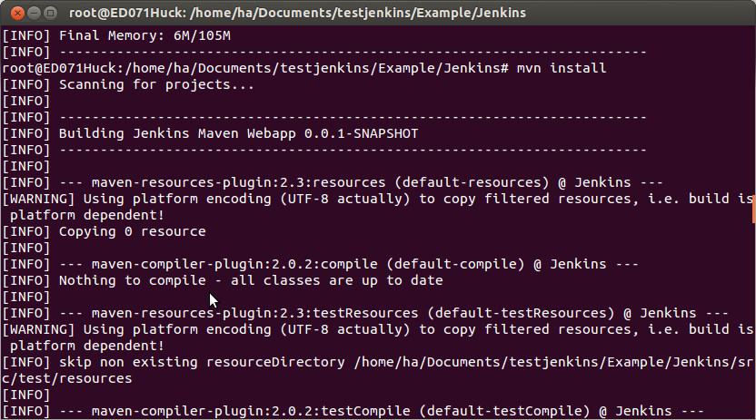
Your build locates on <Your project>/target/<project nam>.war

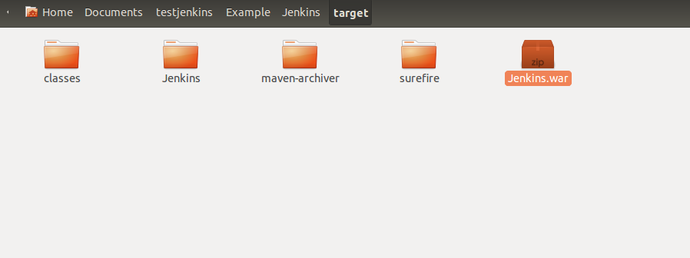
Build with Jenkins
You can read guild line of building in Jenkins, take a look at Jenkins References Document.

DEPLOY APPLICATION

Deploy with Jboss (Jboss AS 7)
Download Jboss AS 7 from: http://jbossas.jboss.org/downloads
Create stand-alone folder (for example: /home/../Desktop/standalone/)
Go to <jboss directory>/standalone/configuration.
Open standalone.xml, then find these lines:
<subsystem xmlns="urn:jboss:domain:deployment-scanner:1.1">
...
</subsystem>
Add your stand alone directory:
<deployment-scanner name="<name>" path="<path>" scan-interval="5000"/>
It looks like:
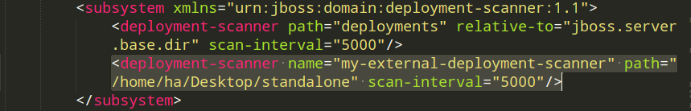
Copy your built file (WAR file) into your folder(/home/../Desktop/standalone/)
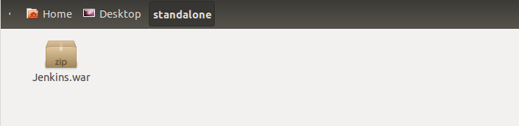
Go to <jboss directory>/bin in Terminal, start jboss:
./standalone.sh
Open Browser, go to localhost:8080/<Project name>

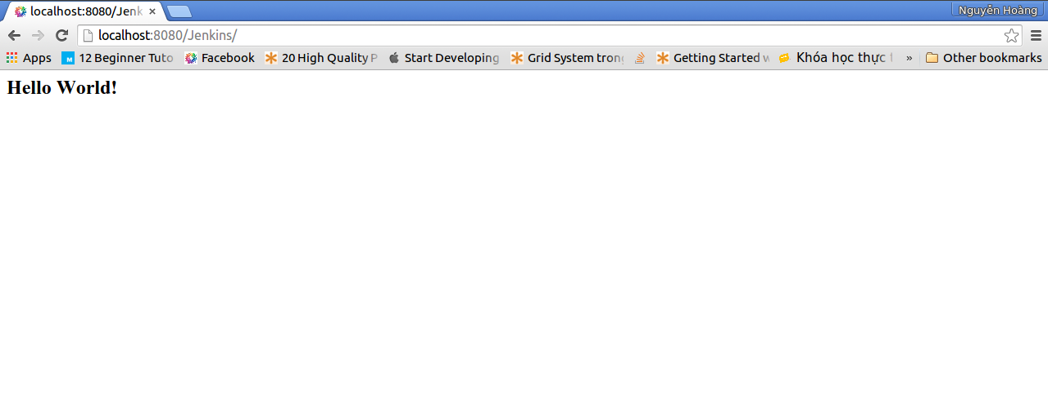
Deploy with Tomcat Apache
Download Tomcat here: http://tomcat.apache.org/
Copy war file into <Tomcat directory>/webapps.
Move to <Tomcat directory>/bin in Terminal, then give permission for bash files:
sudo chmod +x startup.sh
sudo chmod +x shutdown.sh
Run server:
sudo ./startup.sh
Open web browser, then go to localhost:8080/<Project name>
To stop Tomcat service go to <Tomcat directory>/bin:
sudo ./shutdown.sh

