JENKINS INSTALLATION AND CONFIGURATION REFERENCE DOCUMENT
Employee Information
Employee Name | Ha (Huck) H.K. NGUYEN
Department | Engineering
Date | 06-OCT-2015

Table of Contents

1. Jenkins installation 4
1.1 Environment setting 4
1.1.1 JDK Installation 4
1.1.2 Change default version of Java 4
1.1.3 Maven Installation 4
2. Jenkins Installation (Debian-based distributions installation) 5
2.1.1 Installation 5
2.1.2 Upgrade 5
2.1.3 Remove service 5
2.1.4 Configuration 5
2.1.5 Remote service 6
3. Jenkins configuration 8
3.1 Overview 8
3.2 Jenkins general configuration 10
3.3 Plugin management 15
3.3.1 Install Git plug-in 17
3.4 Security in Jenkins 19
3.5 Project management 23
3.5.1 Freestyle project 24
3.5.2 Build Project 29
4. Summary 31

Jenkins installation

Environment setting

JDK Installation
For Jenkins environment setting, openjdk-7-jre and openjdk-7-jdk are suggested.
For Ubuntu 12.04 LTS, you can install JDK from Terminal.
- Open Terminal (Alt + Shift + T)
- Type commend below:
sudo apt-get update
- Check if Java environment has been installed or not:
java -version
- If Java hasn't been installed on your system, you can use the command below to install jre-7:
sudo apt-get install openjdk-7-jre
- If you need jdk-7 for your project, follow the command below:
sudo apt-get install openjdk-7-jdk
- To check if Java environment :
java -version

Change default version of Java
Follow the command below to change Java version:
sudo update-alternatives –config java
Press the number too choose the default version.

Maven Installation
To install Maven from Terminal:
sudo apt-get install maven
Check if installation is successful or not:
mvn –version
The Terminal should show you:
Apache Maven 3.0.4
Maven home: /usr/share/maven
Java version: 1.7.0_80, vendor: Oracle Corporation
Java home: /usr/lib/jvm/java-7-oracle/jre
Default locale: en_US, platform encoding: UTF-8
OS name: "linux", version: "3.11.0-26-generic", arch: "amd64", family: "unix"

Jenkins Installation (Debian-based distributions installation)

Installation
- Open Terminal
- Paste these commands to Terminal:
- wget -q -O - https://jenkins-ci.org/debian/jenkins-ci.org.key | sudo apt-key add -
- sudo sh -c 'echo deb http://pkg.jenkins-ci.org/debian binary/ >/etc/apt/sources.list.d/jenkins.list'
- sudo apt-get update
- sudo apt-get install jenkins
- Press Enter

Upgrade
Once installed like this, you can update to the later version of Jenkins (when it comes out) by running the following commands:
- Open Terminal
- Paste these commands to Terminal:
sudo apt-get update
sudo apt-get install jenkins
- Press Enter

Remove service
To remove Jenkins, you just need to type below command into Terminal:
sudo apt-get remove jenkins

Configuration
- By default, Jenkins listen on port 8080.
- If your /etc/init.d/jenkins file fails to start jenkins, edit the /etc/default/jenkins to replace the line
HTTP_PORT=8080
by: HTTP_PORT=<your port>
For more further information for configuring Jenkins on Ubuntu, please visit site: https://wiki.jenkins-ci.org/display/JENKINS/Installing+Jenkins+on+Ubuntu

Remote service
- To start Jenkins, you can use this command:
service jenkins start
or
service jenkins restart
While processing, the Jenkins page should be like:
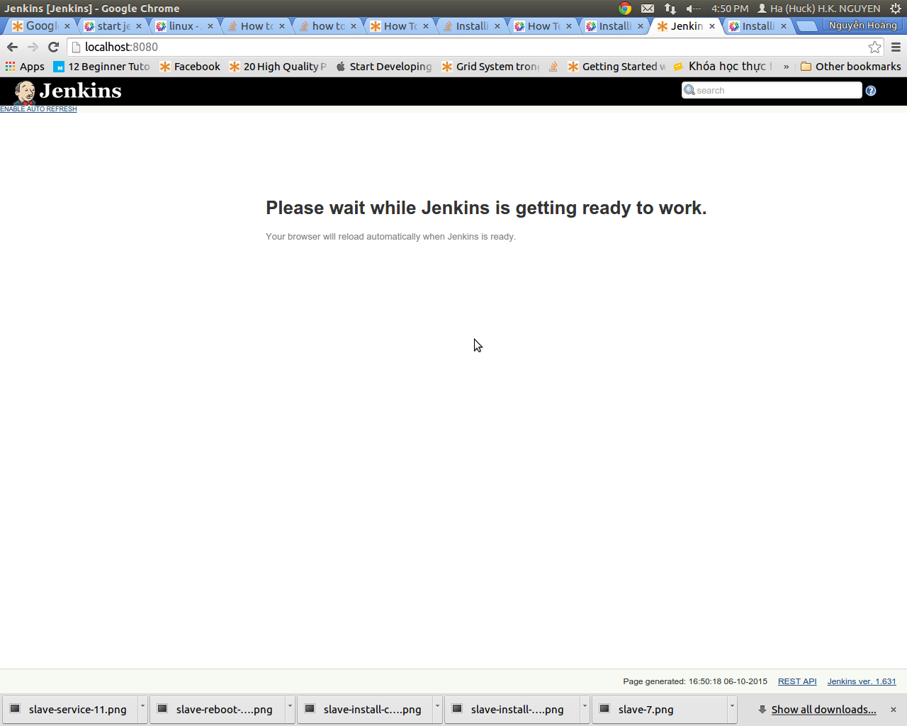
- To stop Jenkins, you can use the command below:
service jenkins stop
- To start/restart Jenkins, you can use these commands:
service jenkins start
or
service jenkins restart
- You can check jenkins service status by using the command below:
service jenkins status
And it could show you port id of Jenkins service.

Jenkins configuration

Overview
After start service, you can access to jenkins local web-page by local address: http://localhost:8080/
It should be like the picture below:
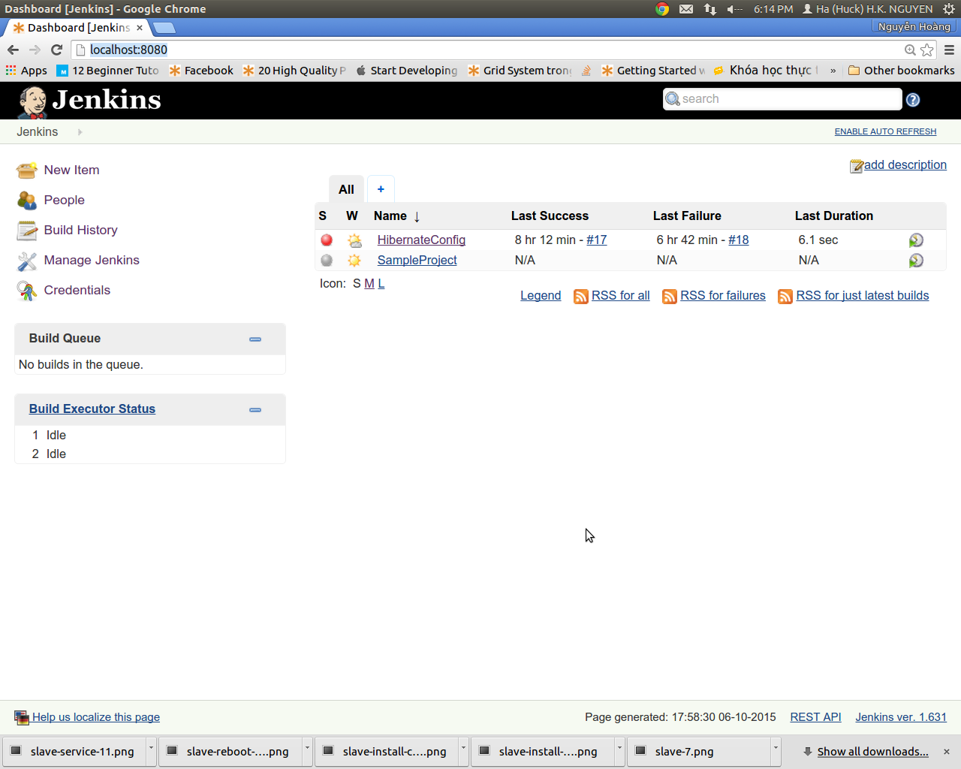
This page has two main-component:
- The sidebar on the left

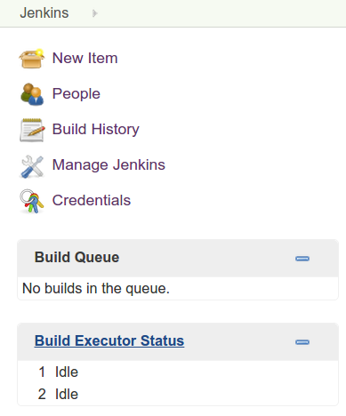

This sidebar shows options could be used to configure Jenkins's functionalities. As default, it has 3 part:
- General Configurations
- Build Queue
- Build Executor Status
- The main-content
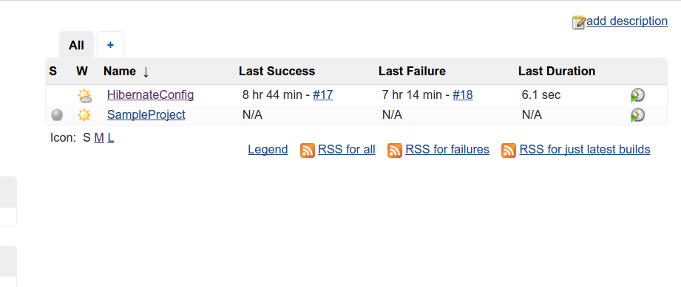

The Main-content shows the overview about projects using Jenkins every first time you visit this site, including Status (S), Weather report (W: showing aggregated status of recent build), Name, Last Success, Last Failure, Last Duration.
As default, this content is blank.

Jenkins general configuration
Go to Jenkins – local page, click on the Manage Jenkins on the left sidebar
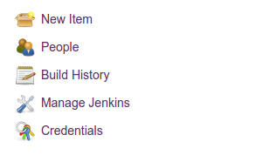

It should change your main-content in the right to the interface of Manage Jenkins functionality.
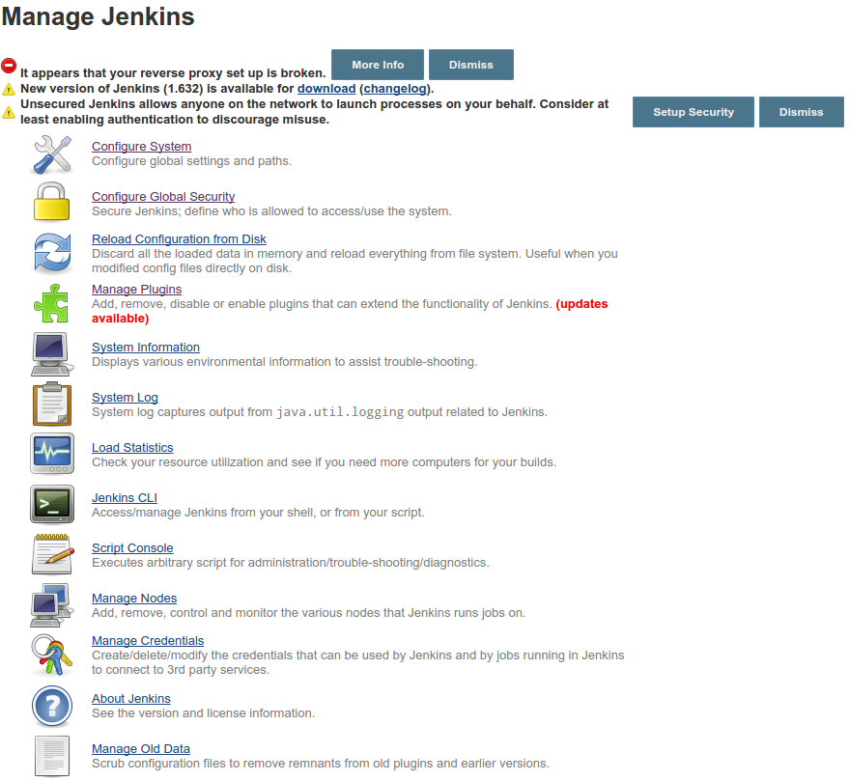
Click Configure System to go to Configuration functionalities.
The site will change to show you system configuration functionality.
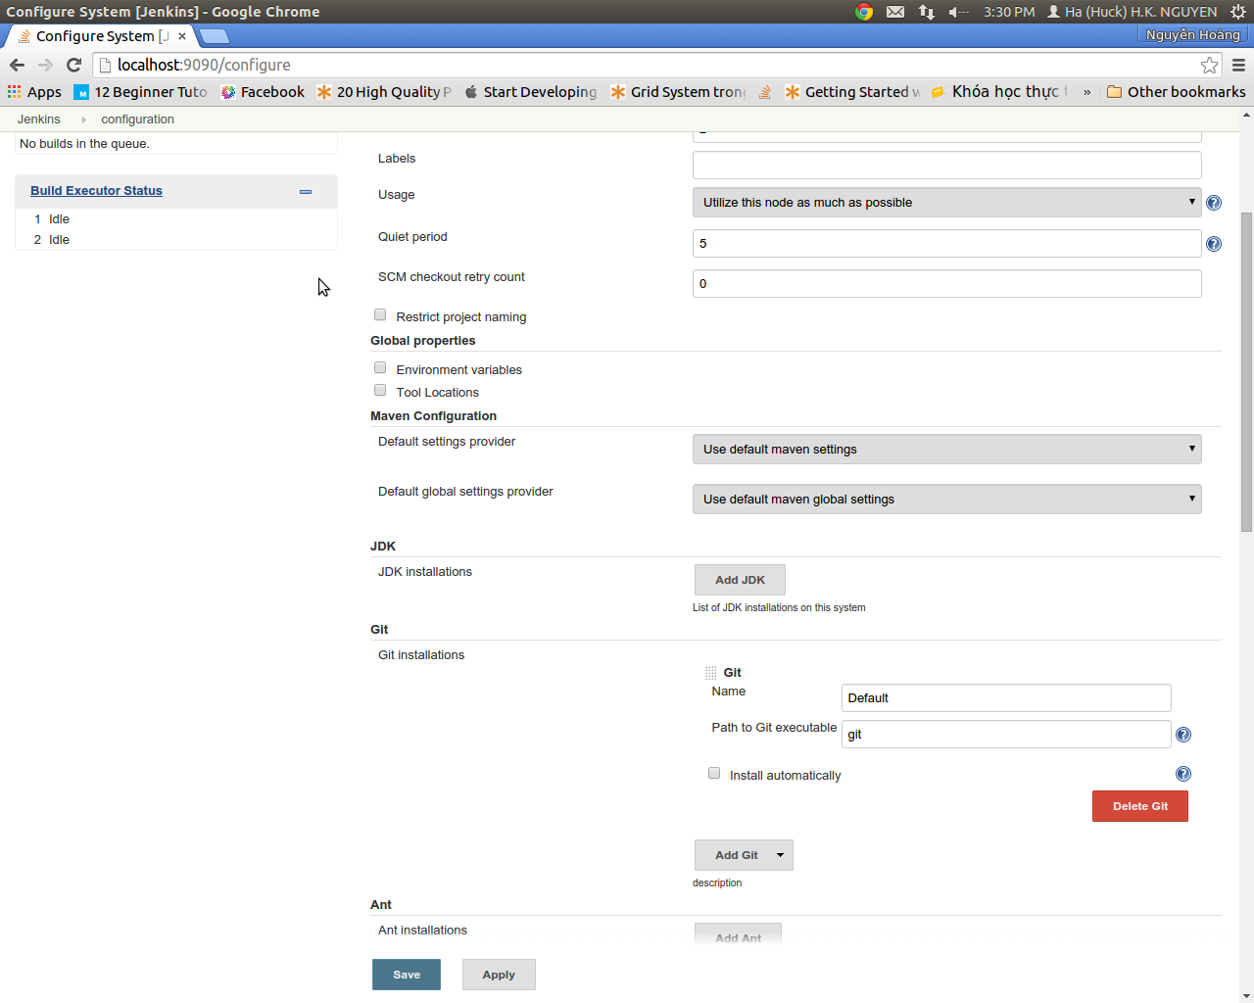
By default, Jenkins let you some fill are not blank, but you can customize them as long as you want.
- Maven configuration:
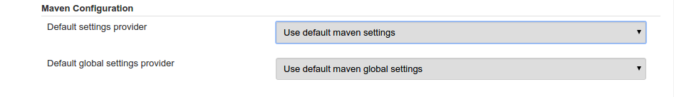
You can define where is setting.xml file located, by relative path of every project or relative to system. By default, it's depend on project setting.
- JDK configuration:
By default, Jenkins uses current Java version.
By clicking on add JDK, it should show you the form.
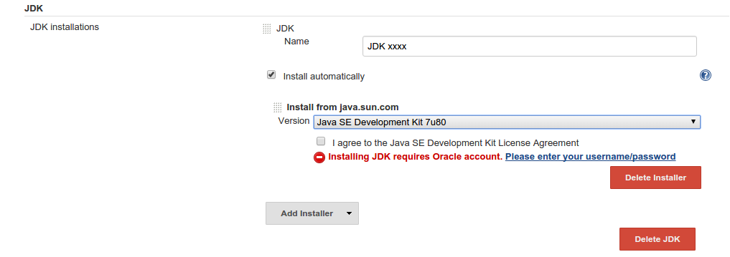
You can install JDK from your local machine by Add Installer, or tchoose the version of Java from Oracle and install. Which the second option, click on the blue line (Please enter your username/password) below the option of version and check I agree to the Java SE Development Kit License Agreement.
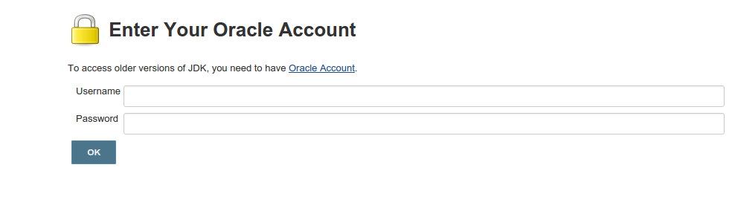
- Git installation (After you installing Git plug-in package)
Figure where git-executable file is. You can figure it out by completed path or just fill “git” as default.
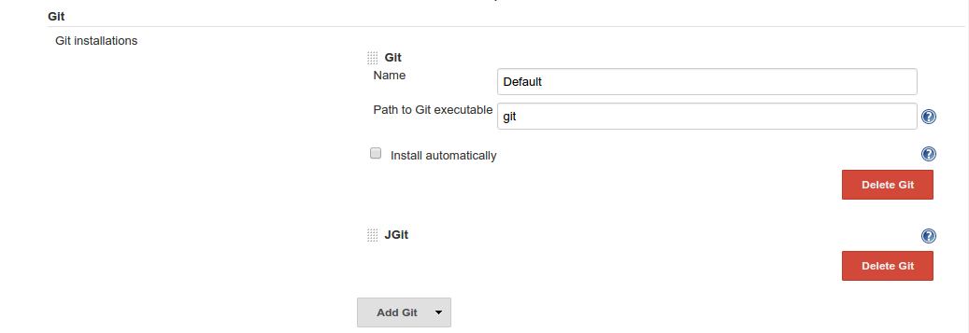
If you have demand to use JGit, just click on select tag “Add Git” and choose Jgit.
- Jenkins Location Configuration
To other people can access from another machine, you'd like to deploy it on your host.
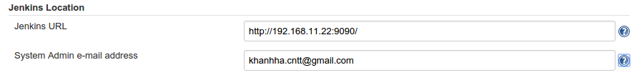
You can use your host by pattern: http://<your host>:<port>/
Fill in the System Admin e-mail address to figure out the email of project owner.
- Git - plug-in configuration
In order to use Git plug-in you need to define your account by completing these fields below
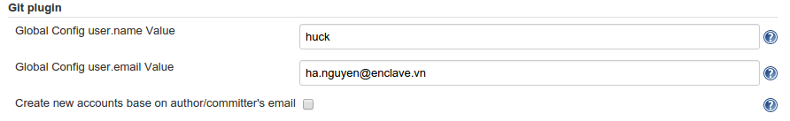
You can add your Git user name and email stand for your Git account
- Email Notification
Go to Email notification.
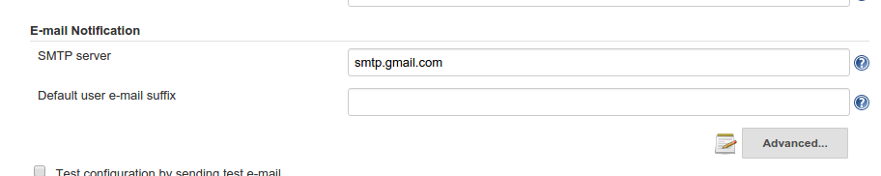
Define mail server, for specific definition, click on Advanced tag.

Click-on Use SMTP Authentication to validate your account and password to send mail. (Account and Password field are below check box).
Click-on Use SSL to use SSL protocol on mail.
Define port of mail server (for example: Gmail uses port 465 for SSL mail-service).
Checking on Test configuration by sending test email to test function.

Plugin management
Go to Jenkins – local page, click on the Manage Jenkins on the left sidebar

Click on Manage Jenkins functionality.
Click on Manage Plugin to go to Plugin - management site

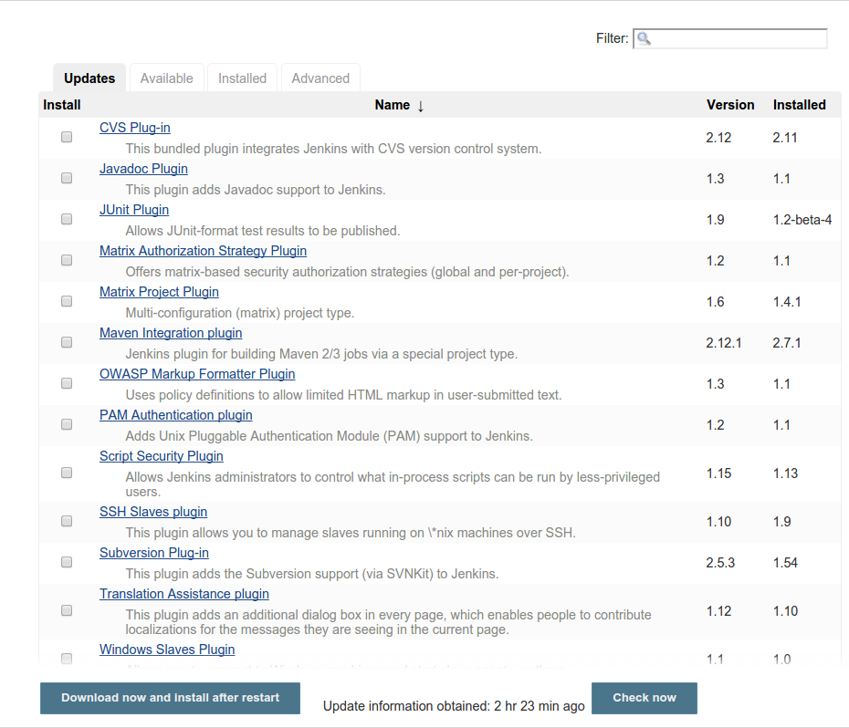
At the main content, you have the list of Jenkins Plugin which you installed, available on market place, can be updated, or something you want to add specifically at Advanced tag.

Install Git plug-in
Go to Plugin – management-site to check if Git Plug-in was installed or not.
Go to Available tag to find out the plug in
Put name of plug in to Filter
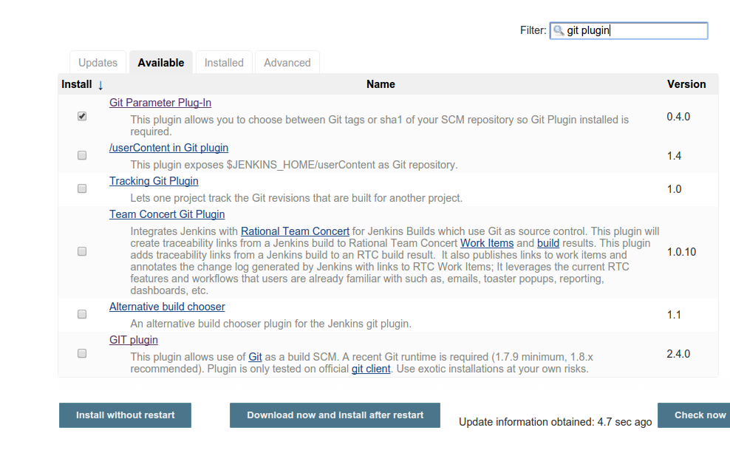
Checking the plug-in and hitting at “Install without restart”.
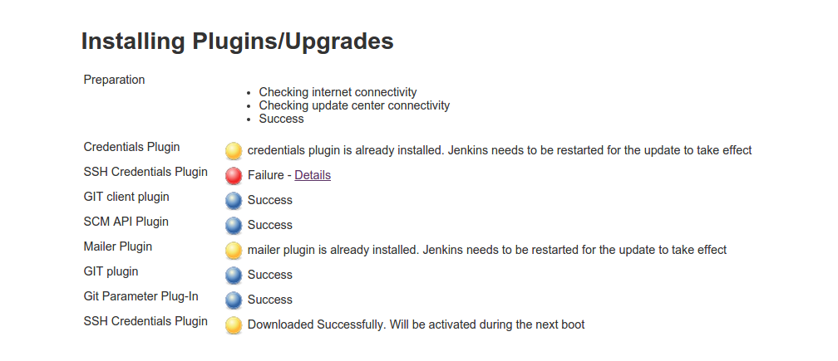

Balls show the status processes, the blue is success, the red one is failure and the yellow is waiting for restart service or reboot system. The gray one shows that element is in processing.
Note: if any failure element, you just need to copy name of that one and find again in list of plug-ins, don't need to install the whole plug-in.
You can check if the plug – in is installed successfully or not by taking a look at Installed tag in list of Plugin.
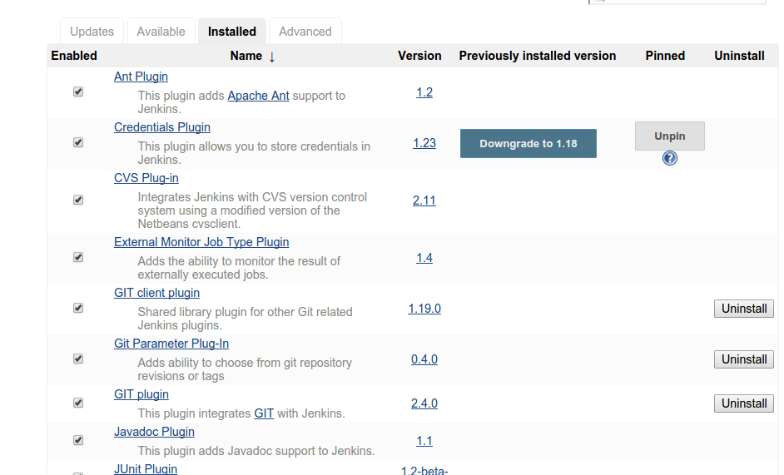
To remove plug in, Click on Uninstall button and wait for the end of process.
Note: To update plug-in, you just need to do the same thing when installing, but with Updates tag

Security in Jenkins
Take a look at Configure Global Security at Manage Jenkins functionality, then, you can see the content is like:
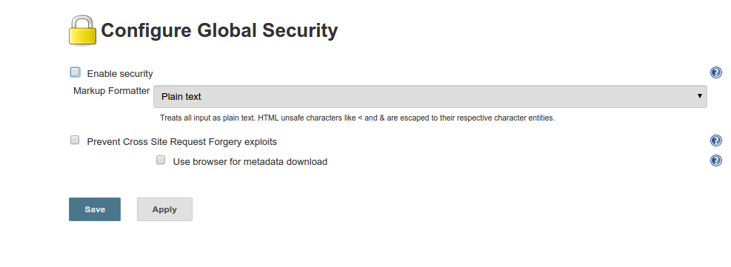
Checking at Enable security:
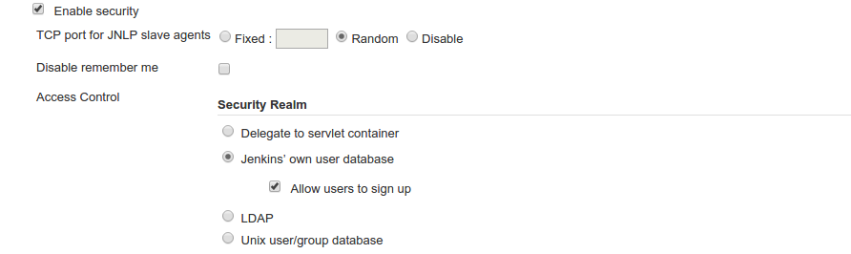
Choose Jenkins' own user database (automatically checking at Allow users to sign up).
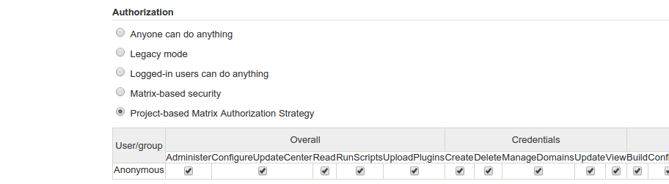
Checking at Project-based Matrix Authorization Strategy, then, enable all permissions for this Anonymous. Save.
Back to Manage Jenkins, you should take a new functionality “Manage User”.

Click on this one to go to Manage-User functionality.
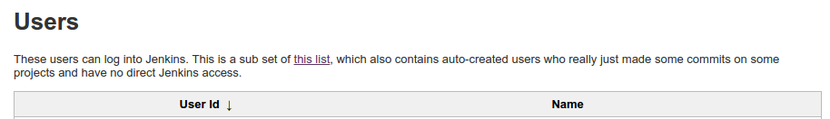

Click on “Create User” at the left sidebar, it will show you the form to create new user.
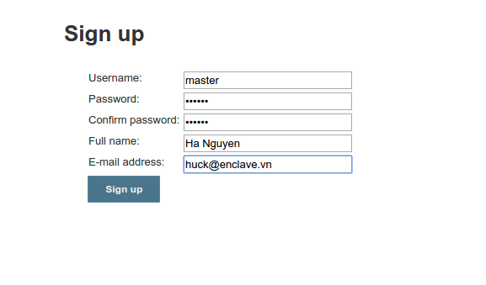

Fill in all fields and click Sign up. Back to Configure Global Security .
Below the table of user/group, Enter user-name of the account you've just created.
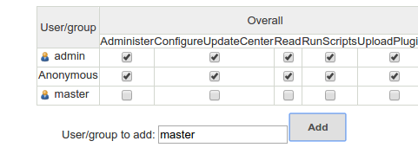
Provide permissions for that account.
Note: In order to start User management, we gave anonymous account all permissions. Remember to remove permissions of anonymous account
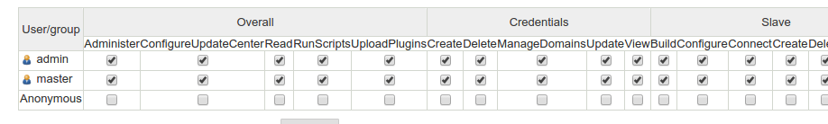
Click Save.

Note: In case you forget to set permissions for anonymous, go to:
/var/lib/jenkins/config.xml
then set:
<useSecurity>true</useSecurity>
to
<useSecurity>false</useSecurity>

Project management
Click at New Item int left sidebar from Jenkins' Dashboard (Homepage).
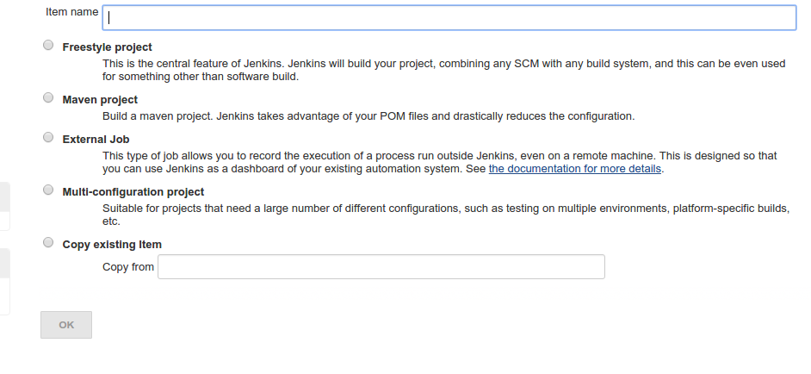
Fill in the name of project, then, choose one of options below the name field (As default, you have 4 options).
Choose Freestyle project
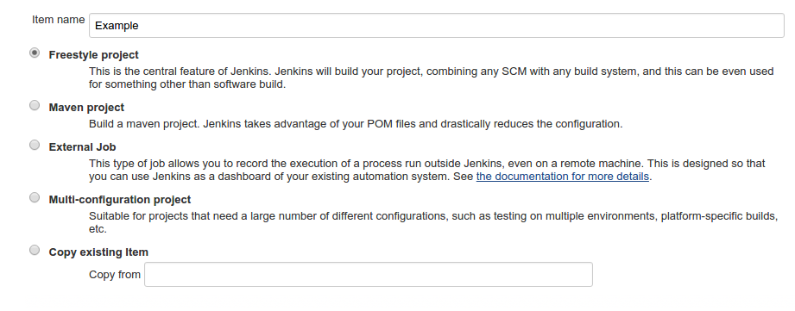
Click OK.

Freestyle project
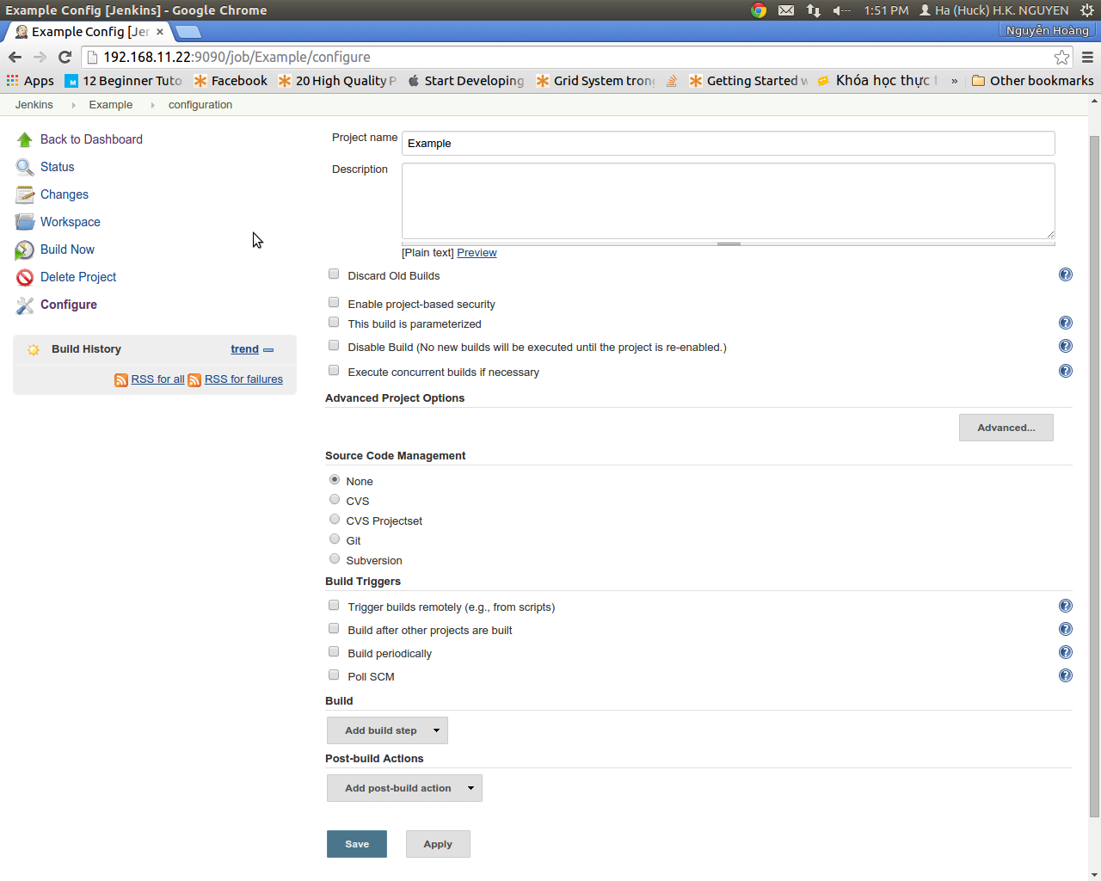

Check at Discard Old Builds, then fill in Max # of builds to keep by the max number of build-process you want to keep.
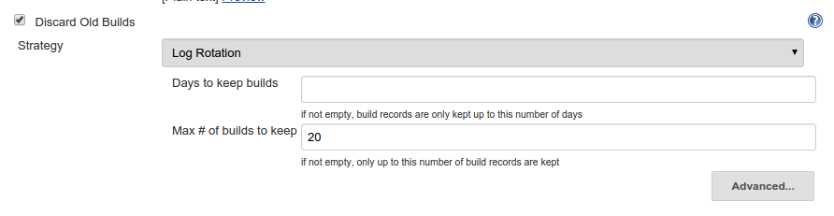
After adding Git plug-in (shown above), you can use git-repository to save your source. Checking at Git.
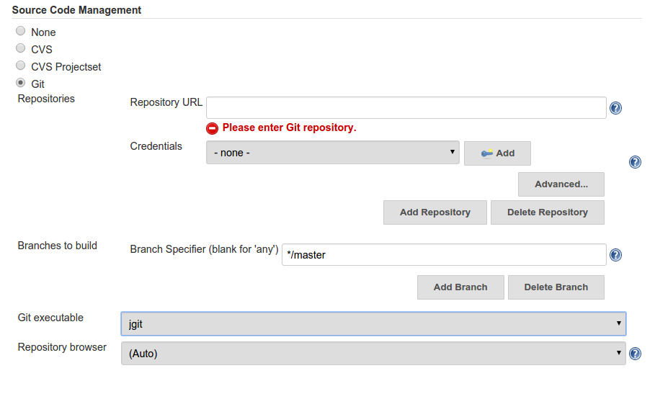
Please fill in Repository URL by your Git repository address. If you're familiar with Jgit, please choose jgit at Git executable ( make sure that you did choose Jgit at Jenkins' Configure System).
Click on Add button at Credentials field.
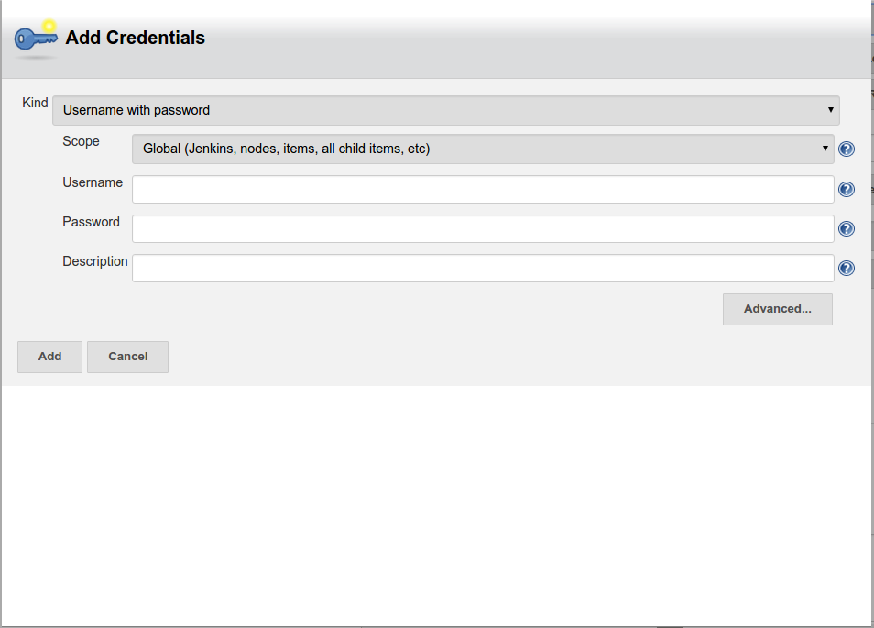
Fill the form with your Git Username/Password, click Add.
Note: you can use ssh protocol by changing Kind.
Choose your Credentials bypass.
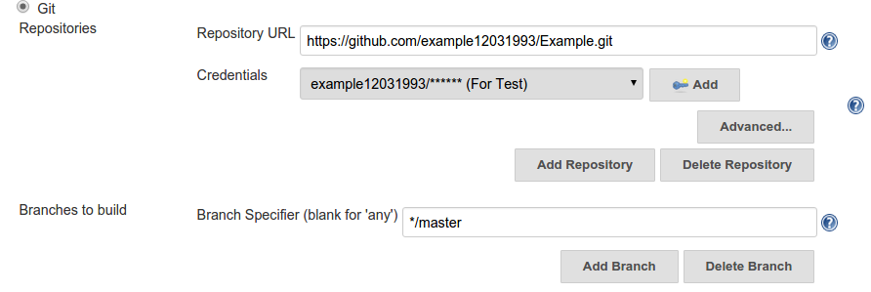
Note: in case you'd have many branches in your Git, please specify your need-to-build branch. If you let that field free, Jenkins would build whole branches from your git.

Check at Poll SCM to build by your schedule. You can find out the syntax to define schedule by clicking onto the question mark (?) on the right of the field.
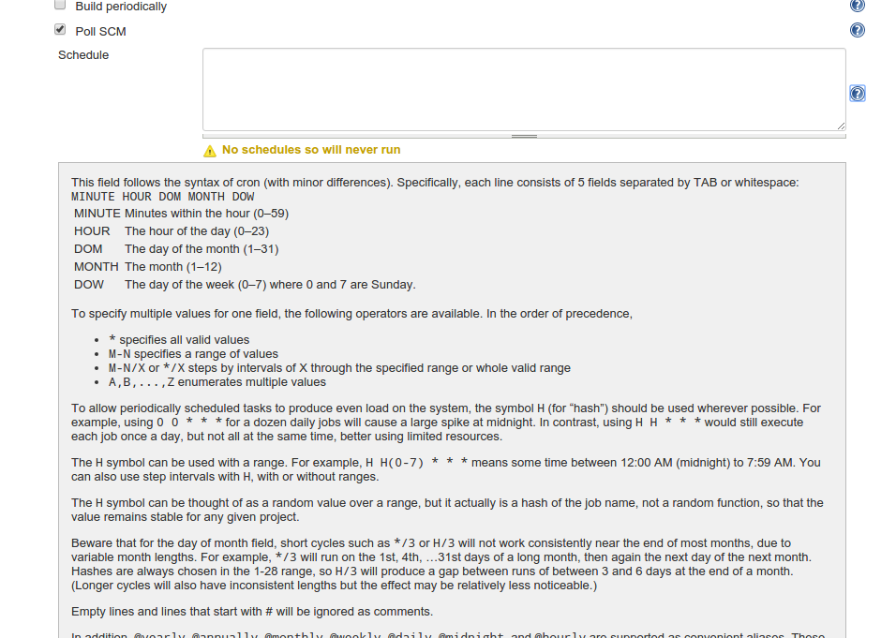
Click on Add Build Step to define the steps to build.
For Maven project only, choose Invoke top-level Maven install, then click on Advanced button to show all functions.
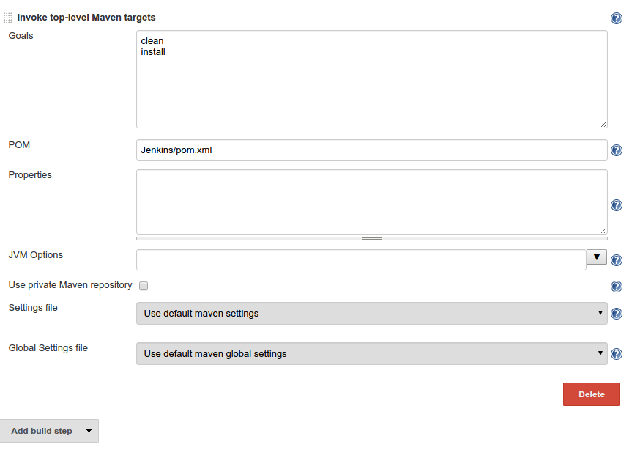
You need to define some fields.
- Goals: The maven command you need to run when Jenkins build your project.
- POM: you can define relative link to POM.xml file in Jenkins project (for example, in my case is: /var/lib/jenkins/jobs/Example/workspace/Jenkins/pom.xml).
Look at Post-build Action, click at Add post-build action and choose Email notification
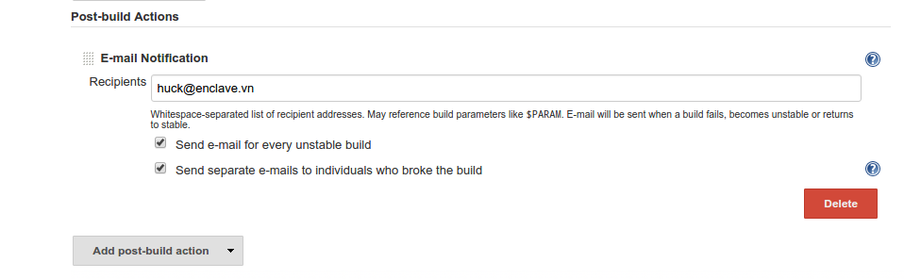
- Fill in the Recipients by the emails of people who you want to send to.
- Check in Send email for every unstable build: to send mail every unstable version of project was build.
- Check in Send separate e-mails to individuals who broke the build: to send email to send mail to the guy who broke the system.

Build Project
There are many place to build your project. One of them, click on your own from Project table in Jenkins homepage.
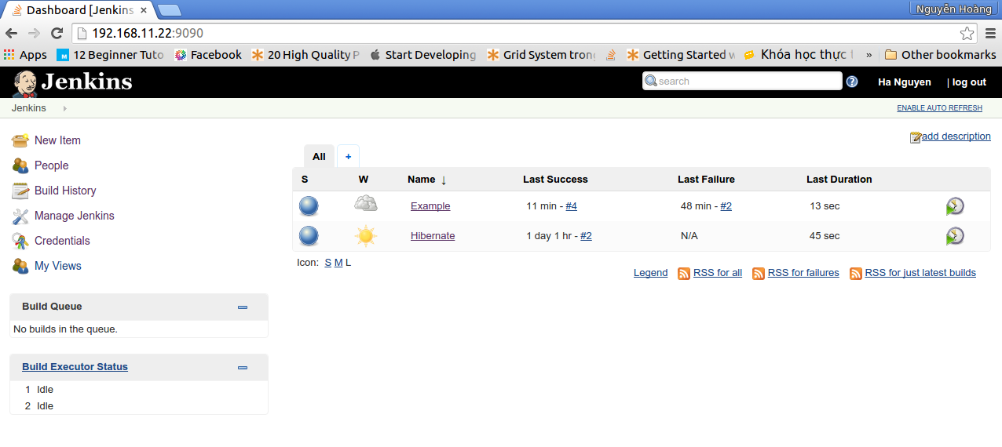
Go to Project page.
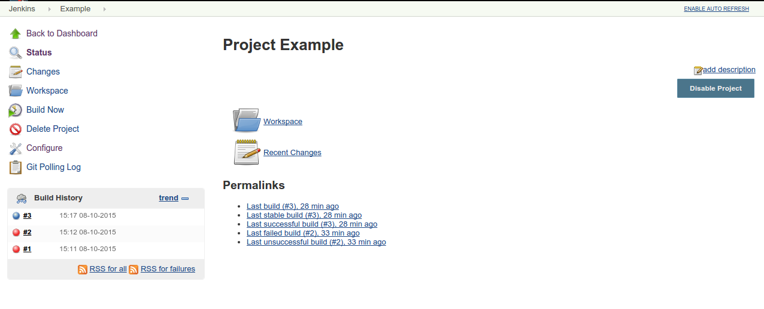
Click on Build Now, then look at the Build History on the left sidebar to track process.
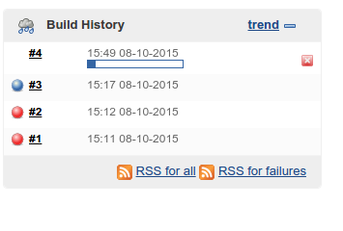

You can click at the colorful ball at Build History to follow build-processing.
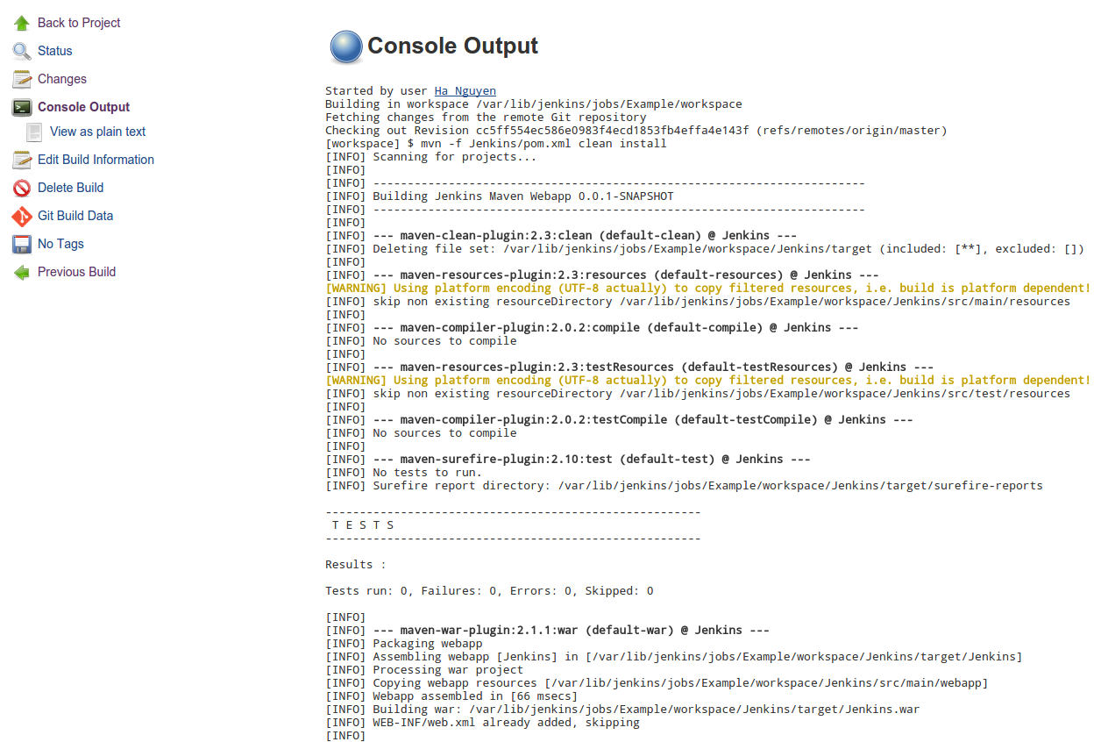
Click on Console Output on the left sidebar to show the console of that build.

Summary

