Sean McGlincy

HW 5

Tensorflow: CNN

Due to the fact that I've never used tensor flow before, I chose to follow this Tensorflow tutorial, which uses the MNIST data set on a convolutional neural network.

https://www.tensorflow.org/tutorials/layers

The MNIST data set from HW 4 and contains 1,000 samples that contain numbers ranging from 0-9. The convolutional neural network uses two convolutional layer which are each followed by a pooling layer. The constitutional layer scans the 28x28 pixel image with a 5x5 array and is then pooled using a 2x2 array with a stride size of two. The convolution layers use a Tensorflow function, “conv2d”, which uses a relu activation function. After the second convolutional layer and pooling, there are 64 filters.

The layers are then mapped to a dense layer that contains 3,136 features and again uses relu as an activation function. The model then re-enforces training by using drop out, before calculating the logits or probability values. This is the final layer and contains 10 nodes. The final activation function is softmax function, which is applied to logits layer. Because we are using softmax as our output function, the loss function is a softmax cross entropy function. This is applied to before gradient decent!

The rest of the function are Tensorflow functions for evaluating and logging data while the program compiles. The one interesting function is the estimator function which ties variables into Tensorboard and can be used to model the neural network. In this assignment, I've taken as screen capture of the loss and accuracy functions from tensorboard.

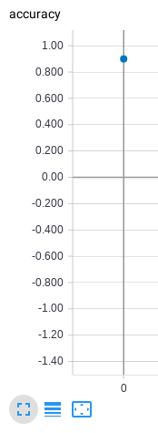

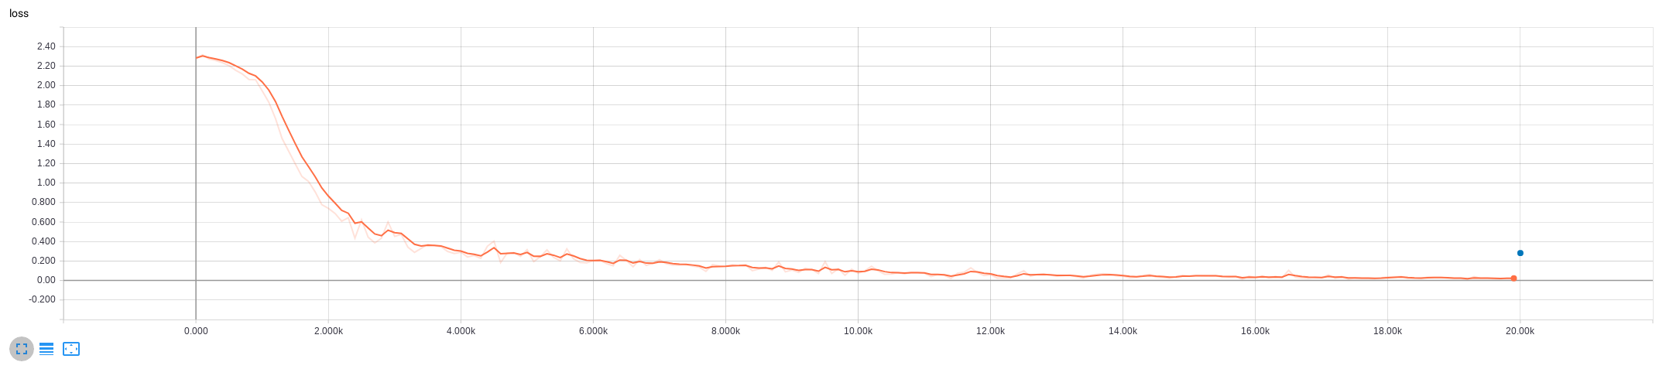

{'accuracy': 0.9, 'loss': 0.28168038, 'global_step': 20000}

INFO:tensorflow:Saving checkpoints for 20000 into ./cnn_tensorboard_model/model.ckpt.

INFO:tensorflow:Loss for final step: 0.02612660825252533.

INFO:tensorflow:Calling model_fn.

INFO:tensorflow:Done calling model_fn.

INFO:tensorflow:Starting evaluation at 2018-05-02-04:57:20

INFO:tensorflow:Graph was finalized.

INFO:tensorflow:Restoring parameters from ./cnn_tensorboard_model/model.ckpt-20000

INFO:tensorflow:Running local_init_op.

INFO:tensorflow:Done running local_init_op.

INFO:tensorflow:Finished evaluation at 2018-05-02-04:57:20

INFO:tensorflow:Saving dict for global step 20000: accuracy = 0.9, global_step = 20000, loss = 0.28168038