**Deploy your Website Cloud 9 Website with GitHub**

1. Sign in to your GitHub account. Or create one at [github.com](https://github.com/)

2. Click Start A Project  or 

And now you should see this screen

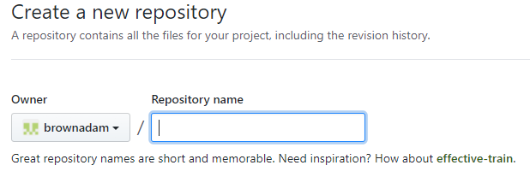

3. Give your Repository the name “*portfolio*”

4. Be careful you **must NOT** check the box 

5. Now click . Once you have created your repository you will see a page like the following:



6. Log-in to Cloud 9 and go to the workspace that has all of your Online Portfolio Code!

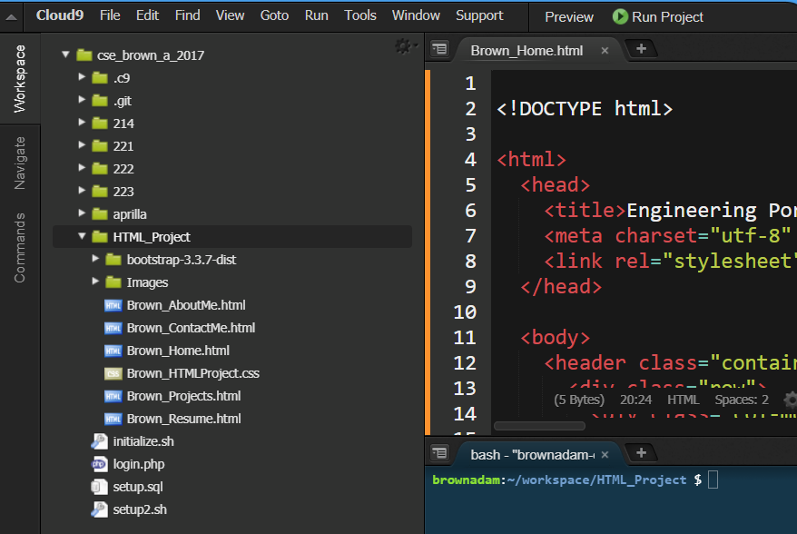

Note: In order for Git Pages to work you must have a file title index.html. Please change your Last_Home.html to index.html (note, you will also have to change links in your code as well to make your navigation work ).



7. Change your directory so you are located where all of your Online Portfolio documents are

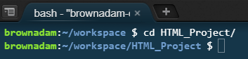

8. Initialize git in your bash shell to create an empty git repository in cloud 9. If done correctly you will now see a .git folder in your Online Portfolio directory.

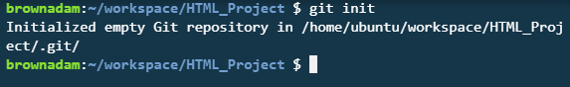 

9. Now we need to add the remote access to Github from cloud 9. To see the remote access link go back to github and you will see it in the code tab of the repository you just created. Should be something like:

git remote add origin https://github.com/YOUR_USER_NAME/online_portfolio.git



Once you have connected remotely you can check the connection by using git remote -v

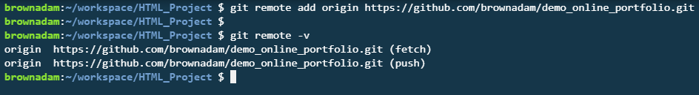

10. Now we are going to add all of our files to github, commit our work and push it to github. To do that we will use the following commands: git add . , git commit -m "My first commit" and git push -u origin master

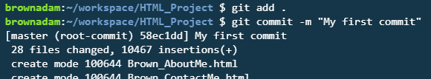

All of your files will now add to github. Please wait until this process is done. Once it is complete please run the git push (git push -u origin master), which will ask for your username and password.

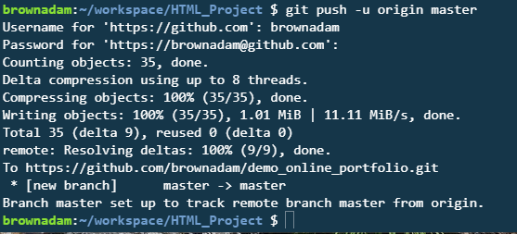

11. Click on setting

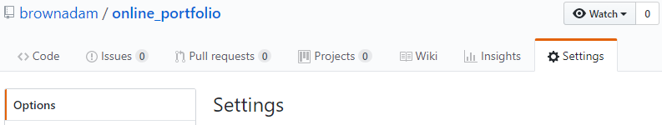

And scroll down to GitHub Pages. If you do not see a URL for your published site, then Change the Source from None to master branch

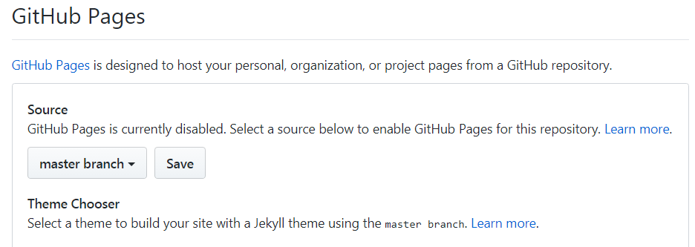

And then click Save and you will now see the site.

Now scroll back down to see your new online portfolio URL.

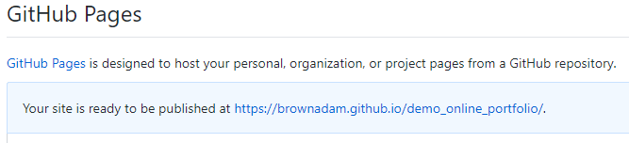

And you should see your website's address, click on it to see your live website.

**Note**: *github will sometimes take some time to load your live site for the first time, or when major changes have been made! If you get a 404 page error give it some time, if after a couple minutes and reload your repository page. If it has still not loaded go reread through all of the prior directions to make sure you have done everything correctly!*

12. To update your website make the changes in cloud9 and then redo step 10.