**HTML Project**

**Introduction**

|  |  |
| --- | --- |
| In this project you will be doing one of two things. You will be creating an Online Engineering Portfolio, or a website to promote a business (Real or Fake). If it is a real business, make sure you do not break any copyright laws, and that you clearly state this is an HTML project and not connected with the real business. If it is a fake business, make sure it is school appropriate, and clearly states that it is a fake business. ***For those of you making the Engineering portfolio page, reference all of the documents in the Online Portfolio Drive Folder.*** | |

**Part I: Setting-up Cloud 9**

1. Log in to Cloud9 at [**https://c9.io**](https://c9.io) . Each partner should do this.
2. From your dashboard, open your **cse#-last-firstinitial** workspace.
3. Make sure this workspace is **Shared** with your teacher.

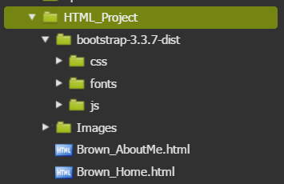

1. In the Cloud9 workspace, create a directory named HTML\_Project. Inside that directory please create an Images directory, two HTML documents (Last\_Home.html & Last\_AboutMe.html), and then upload the bootstrap folder (first you need to download the zip file from google classroom, extract the files and then upload them to Cloud 9). When you are done your directory structure should look like the image to the right. Note: We are using an older version of Bootstrap, version 4.0.0 was recently released and has major changes, so for the sake of this assignment we will be using version 3.3.7.

**Part II: How to use Bootstrap in Cloud 9**

|  |  |
| --- | --- |
| Before you start coding your website you are first going to create a basic starting point using Bootstrap in Cloud 9. To do this you will need to study the images of the two pages below and reference the table of required material. After you have studied the two images below you will attempt to recreate those pages using information and images about yourself.   1. In your first step you will need to link to the proper Bootstrap CSS document. To accomplish this, please link to the selected file shown in the image to the right in both your Last\_Home.html & Last\_AboutMe.html pages. | Expanded_File_Layout2.PNG |

**Home Page**

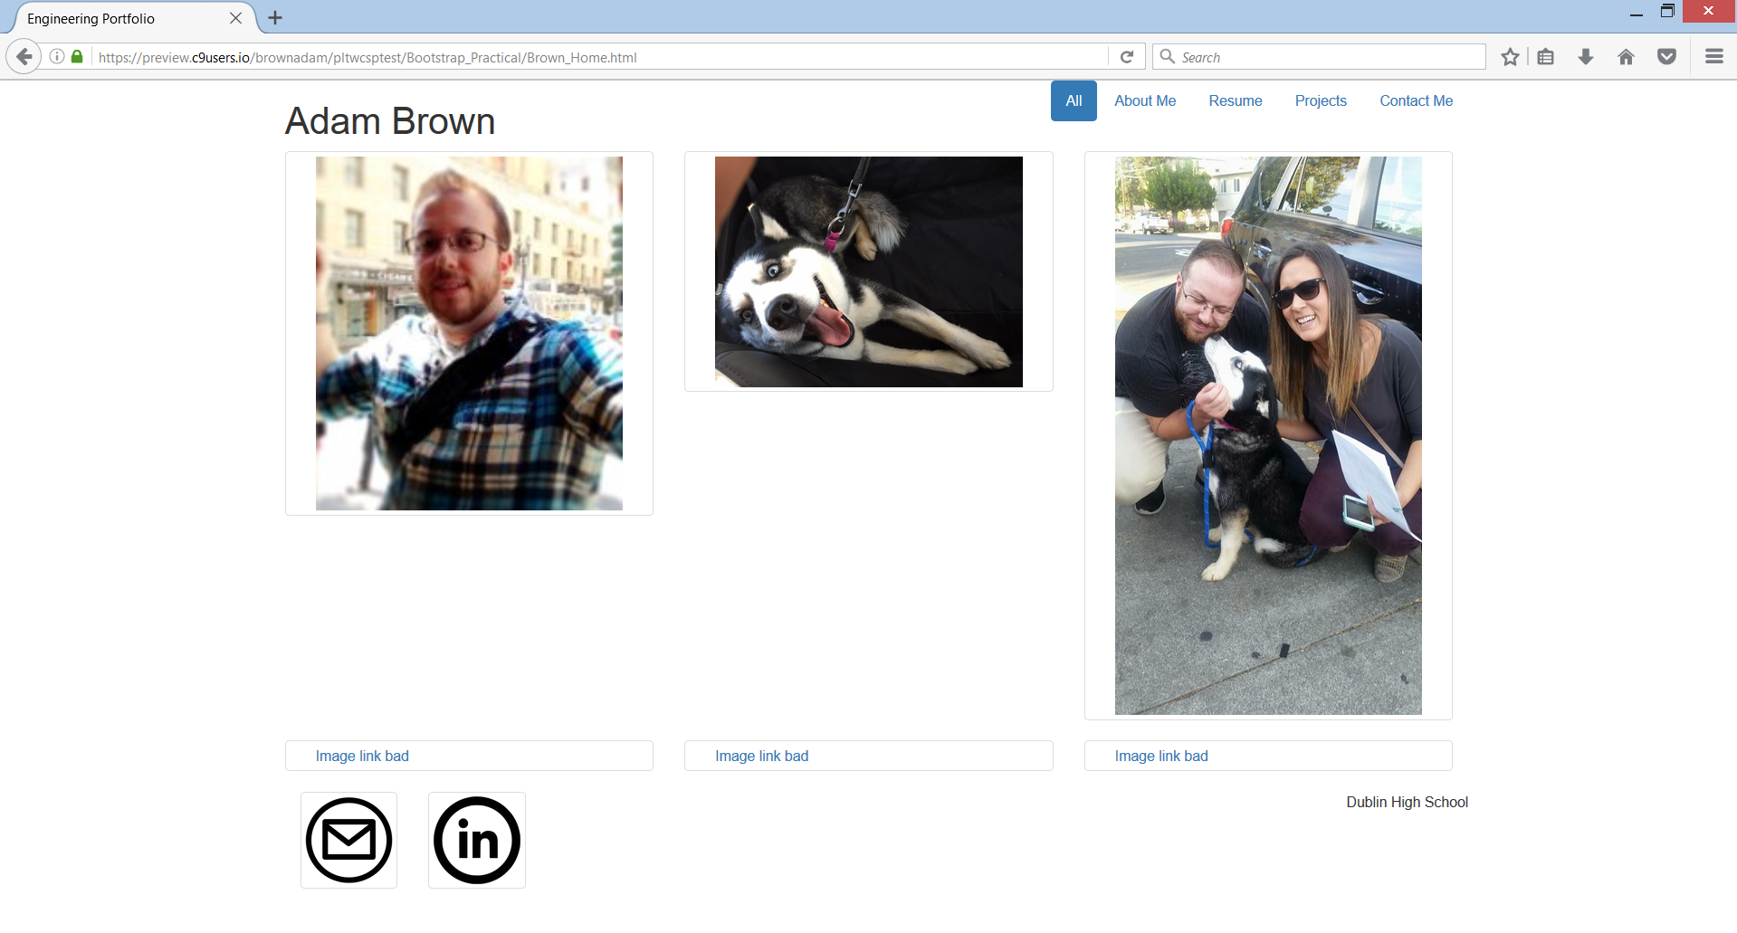

**About Me Page**

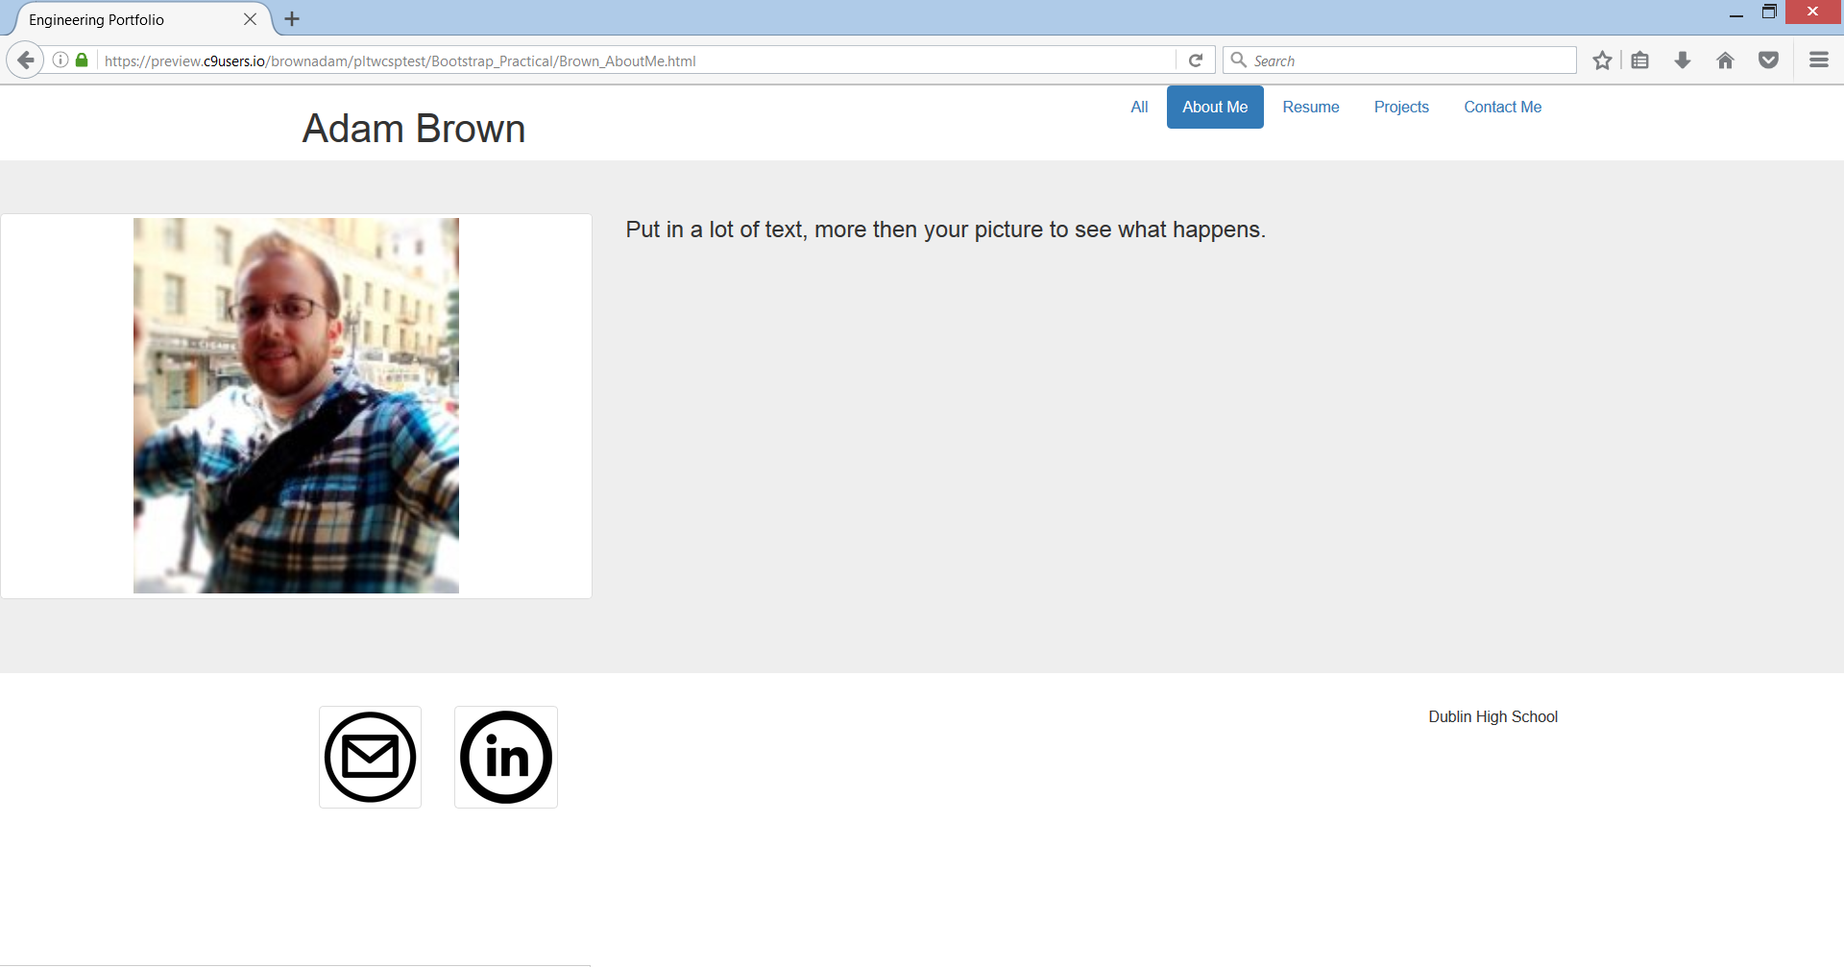

|  |  |  |
| --- | --- | --- |
| **Required Features** | | |
| **Section** | **Elements & Tags** | **Bootstrap Classes** |
| Header | Heading with your name and the following navigation options: All, About Me, Resume, Projects, & Contact Me  <header>, <div>, <h1>, <ul>, <li>, & <a> | container, row, col-\_\_-#, pull-right, nav nav-pills, & active |
| Footer | Icon that links to sending you an email, an icon that links to a professional social networking site of your choosing, and some form of stating Dublin High School  <footer>, <div>, <a>, & <img> | container, row, col-\_\_-#, thumbnail, & pull-right |
| Home Page Main Content | A 3 by 2 grid of images that have three successfully linked images of your choosing and three that have alternative text displayed  <section>, <div>, & <img> | main, container, row, col-\_\_-#, & thumbnail |
| About Me Page Main Content | An image of yourself on the right or left hand side with enough text written on the opposite side of our image that is larger than the height of your image  <section>, <div>, <a>, <img>, & <p> | main, jumbotron, row, col-\_\_-#, & thumbnail |

1. Once you believe you have completed the two demo pages call over your teacher for final approval before moving on.

**Part III: Your Turn**

Now it is your turn! You will create an Online Engineering Portfolio, ***please reference all of the documents in the Online Portfolio Drive Folder***, to create a fully functioning multi-page website. If you already have an online engineering portfolio from another PLTW class then you have the option to create a website to promote a business (Real or Fake). If it is a real business, make sure you do not break any copyright laws, and that you clearly state this is an HTML project and not connected with the real business unless you obtain written permission from that company. If it is a fake business, make sure it is school appropriate, and clearly states, on every page, that it is a fake business.