BUXTON / MICROSOFT COLLECTION
home | explore | associated narratives | about | acknowledgments | contact

Casio Mini Electronic Calculator
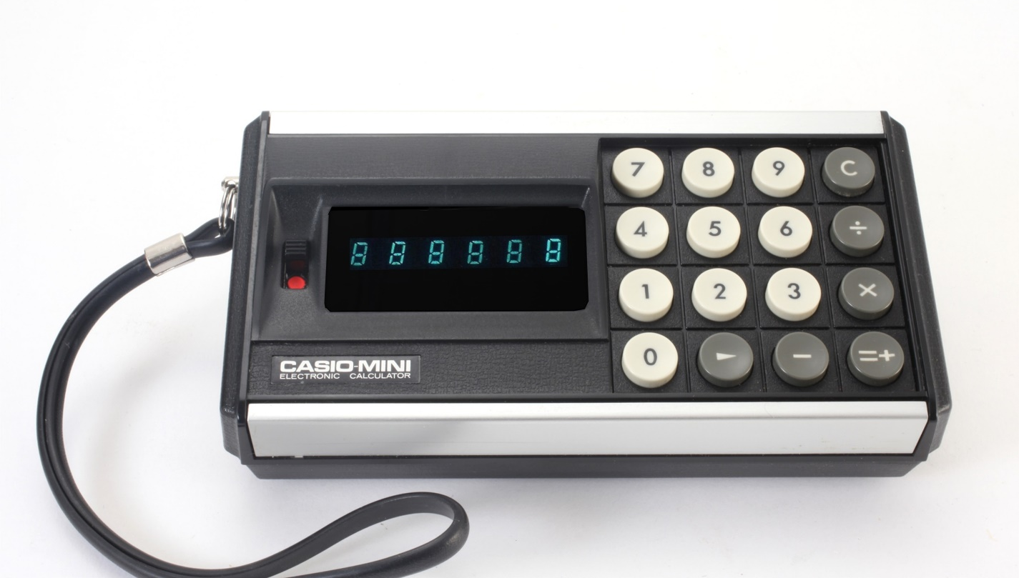
Short Description: The Casio-Mini did not quite match the accuracy or small size of the few pocket-sized calculators on the market in 1972, when it was released. Nevertheless, it still disrupted the market by selling at 20% of the price of the cheapest competitor. By so doing, it made this new kind of gadget affordable to the more general population, rather than just the well-heeled.

Bill Buxton’s Notes
The original Casio-Mini is important because of the disruptive effect it had on the young pocket-sized portable calculator market. When this first version was released in August 1972, its purchase price was just 20% of its nearest priced competitor.
To place this in context, in 1971 a company called Busicom released the first battery-powered pocket-sized electronic calculator. This was the the Busicom LE-120A Handy LE. Its small size was enabled by the recent release of technology capable of placing the functionality of a 4-function calculator on a single chip (integrated circuit), rather than requiring much bulkier discrete components, (logic, transistors, etc.) previously needed to realize the same functionality. The Busicom LE-120A Handy LE was also the first pocket-sized calculator to use an LED display. Its price was $395.00, which was out of reach of all but the very well heeled.
In February 1972, Busicom released a less expensive version, the LE-120S Handy. This was in a plastic, rather than metal, case; however, the reduced price of $295.00 was still high for the average business-person, much less consumer.
This was the situation when, six months later, August 1972, Casio released its Mini Electronic Calculator.
Like the Busicom models, the Casio-Mini was a 4-function calculator. That is, all any of them could do was add, subtract, multiply and divide. However, the Casio-Mini could only give results to the nearest integer. In contrast, the Busicom Handy models, had two significant digits to the right of the decimal. Furthermore, the Casio-Mini was about 1/3 larger than them. Yet, despite these two disadvantages, the Casio-Mini took off and both transformed and dominated the market. What this clearly established was that an 80% price differential was enough to compensate for a few shortcomings of a product.
The impact of the Casio-Mini was dramatic. The only companies who could survive in this emerging market were those who had the efficiencies or long-term funding to match or exceed the price/performance bar set by Casio. The result was that the number of players in the market was significantly reduced, and those who remained had to significantly up both their game in terms of both efficiency and innovation. One of the companies which did not survive the disruption was Busicom.
.

Device Details
Company: Casio | Year: 1972 | Original Price (USD): $59.95
Degrees of Freedom: N/A
Dimensions: (L x W x H): 148 x 75 x 42 (mm)
Key Words
Primary: Calculator
Additional: Handheld, Keyboard
Links
- Vintage Calculators.com entry for Casio-Mini: http://www.vintagecalculators.com/html/casio_mini.html
- $60 Calculator. What’s New Column, Popular Science, November 1972: https://books.google.ca/books?id=8v2VW0V9p8wC&printsec=frontcover&rview=1&lr=&redir_esc=y#v=onepage&q=%2460%20calculator&f=false

- Casio-Mini Operator’s Instruction Manual.
- Casio History Site entry for Casio-Mini (source web site: https://world.casio.com/corporate/history/chapter01/ )

- you tube link

Image | File Name | Caption
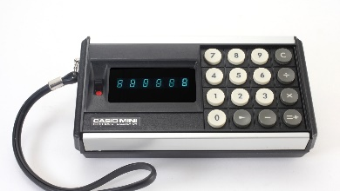 | Casio-Mini.JPG | Casio-Mini handheld pocket-sized calculator
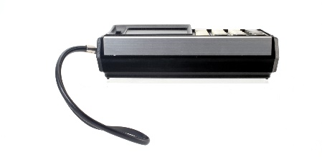 | Casio-Mini_Side.JPG | Side-view of Casio-Mini handheld calculator.
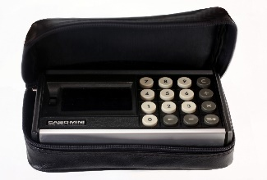 | Casio-Mini_in_case.JPG | Casio-Mini Handheld calculator in carrying case.
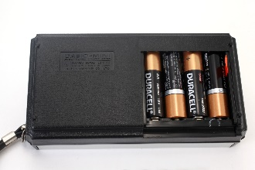 | Casio-Mini_Bottom.JPG | Backside of Casio-Mini handheld calculator showing the 4 AA batteries which power it.
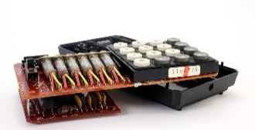 | Casio-Mini_Inside1.JPG | A view of the internal electronics of the Casio-Mini handheld calculator.
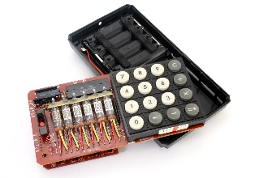 | Casio-Mini_Inside2.JPG | A top-view of the internal electronics of the Casio-Mini handheld calculator. Note the large chip which performs the 4-function calculation.
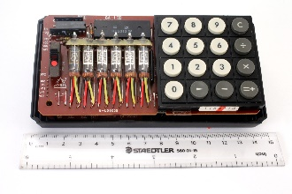 | Casio-Mini_Inside3.JPG | The Casio-Mini electronics seated in the bottom half of the case.
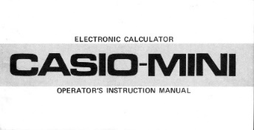 | Casio-Mini_Manual.jpg | Image of the cover of the Casio-Mini Instruction Manual. Click on image to read the manual.
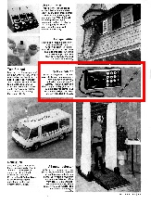 | Casio_Popular_Science_Nov_1972_p107.jpg | Announcement of Casio-Mini Electronic Calculator stressing the breakthrough low price in November 1972 issue of Popular Science, page 107.
 | Casio_History_Site-Casio_Mini.png | Discussion of the Casio-Mini from Casio’s web page on the history of its key products. Click on image to read.

