BUXTON / MICROSOFT COLLECTION
home | explore | associated narratives | about | acknowledgments | contact

FingerWorks MultiTouch Evaluation System
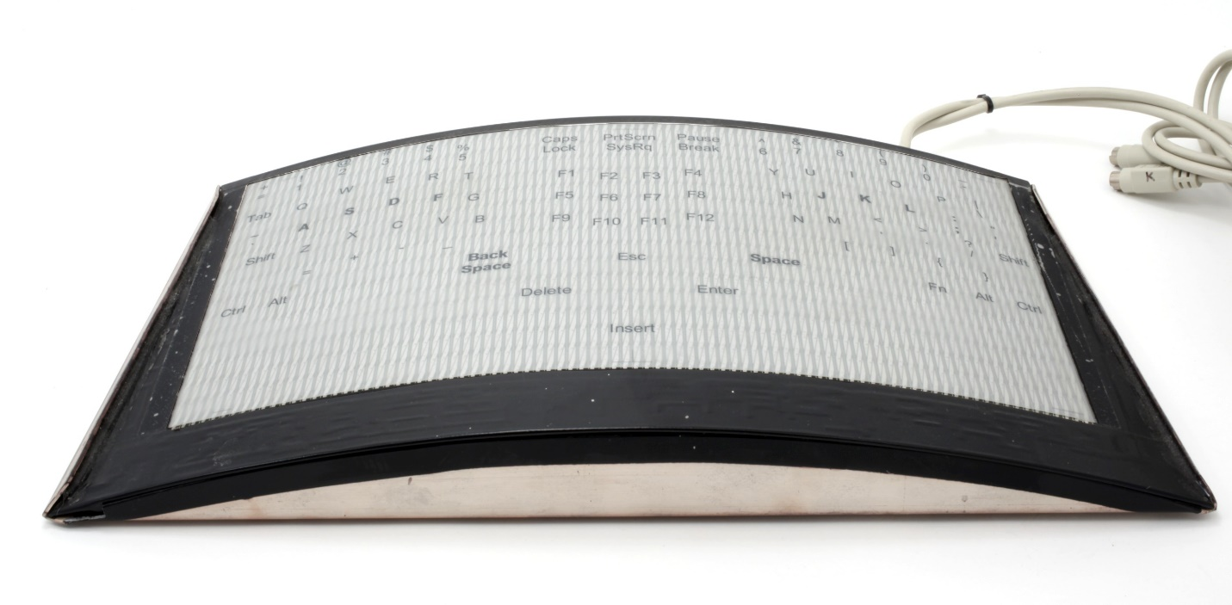
Short Description: The is a prototype built to evaluate what was to become the FingerWorks TouchStream Keyboard. This particular unit was one of three made and was given by the University of Southern California for user studies.

Bill Buxton’s Notes
There is a good chance that the last thought that comes to mind when you first see this device is “Apple iPhone”. However, one you know the history, that may change.
This is a prototype capacitive multi—touch keyboard which was designed as part of an exploration of how such a device might enable the user to both type, use gestures, and perform mouse-type tasks all on the same device. It this was possible, and if it could be accomplished with minimal training and at a reasonable expense, then it may lead to much more efficient input to computer systems – at least in some circumstances and especially for certain people.
However, to test such ideas in practice, one needs to learn from people using the device. One builds such prototypes to test such concepts in the lab with test participants before going to the expense of manufacturing actual product.
The work which lay directly behind this prototype was the 1999 PhD thesis of a student, Wayne Westerman, at the University of Delaware. Based largely on this work, Westerman and his advisor started a company, FingerWorks, to develop some of the core ideas commercially. The development of this prototype was part of their FingerWorks initiative. My understanding is that this is one of three such prototypes built for user studies. This one was given to the Human-Computer Interaction group at the University of California San Diego for testing. Several years later, it was donated to this collection by Prof. Jim Hollan who let the testing work.
So, what about the iPhone? How does that fit in? Well, it turns out that the prototype worked well, and the product went into production. The commercial version is also in the collection, the FingerWorks TouchStream keyboard, and a photograph of it beside the prototype accompanies this note. The device developed a highly dedicated community of users, one of whom seems to have worked at Apple. And, during the early discussions around designs for a new smartphone at Apple – what evolved into the iPhone – the idea of incorporating the multi-touch expertise of FingerWorks not only came up, they bought the company in order to bring it to fruition.
So, the next time you use a device with a capacitive multi-touch screen, think of this prototype and ask yourself, “If I couldn’t see any connection between this thing and one of the most successful products of the past 50 years, what else am I missing? How can I better learn to see the value behind what otherwise appears to be a crude non-descript gadget?”
In terms of the latter question, providing a vehicle to help you down the path to addressing that second question is one of the prime reasons for this collection’s existence.

Device Details
Company: Fingerworks | Year: 2000 | Original Price (USD): NFS
Degrees of Freedom: 2
Dimensions (L x W x H): XXX x XXX x XXX (mm) Note: watch is W x D (Width is the shortest distance across the dial side of the main plate measured through the center.)
Key Words
Primary: Keyboard
Secondary: TouchPad, Multi-Touch, Gesture
Links
- Westerman, Wayne (1999). Hand Tracking,Finger Identification, and Chordic Manipulation on a Multi-Touch Surface. U of Delaware PhD Dissertation: https://www.scribd.com/document/233784848/HAND-TRACKING-FINGER-IDENTIFICATION-AND-CHORDIC-MANIPULATION-ON-A-MULTI-TOUCH-SURFACE

Image | File Name | Caption
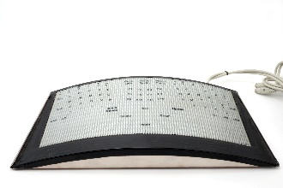 | FingerWorks_Proto_Front_Angle.jpg | Top-front quarter view of the Fingerworks prototype for what would become the TouchStream keyboard.
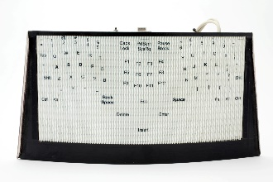 | FingerWorks_Proto_Top.jpg | Top view of the Fingerworks TouchStream prototype.
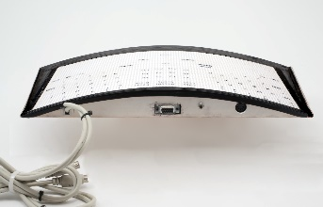 | FingerWorks_Proto_Backside.jpg | Back view of the Fingerworks TouchStream prototype.
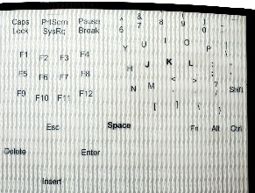 | FingerWorks_Proto_Right_Top.jpg | Detail of the top right of the Fingerworks TouchStream prototype.
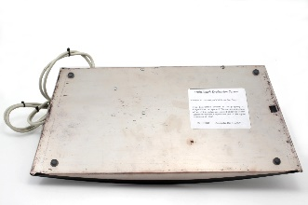 | FingerWorks_Proto_Bottom.jpg | Bottom view of the Fingerworks TouchStream prototype.
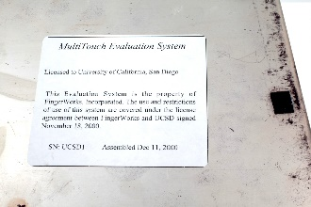 | FingerWorks_Proto_Bottom_Label.jpg | Detail of the bottom of the Fingerworks TouchStream prototype, showing the identification label.
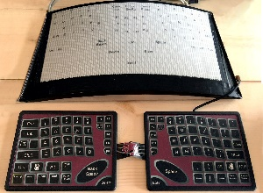 | TouchStream+Prototype.JPG | TouchStream prototype shown adjacent to the TouchStream product.
 | WestermanThesis.jpg | Cover page of Wayne Westerman’s 1999 PhD thesis from the University of Delaware which described his multi-touch research. Click on image to access the thesis.

