BUXTON / MICROSOFT COLLECTION
home | explore | associated narratives | about | acknowledgments | contact

Frog Pad Inc. FrogPad
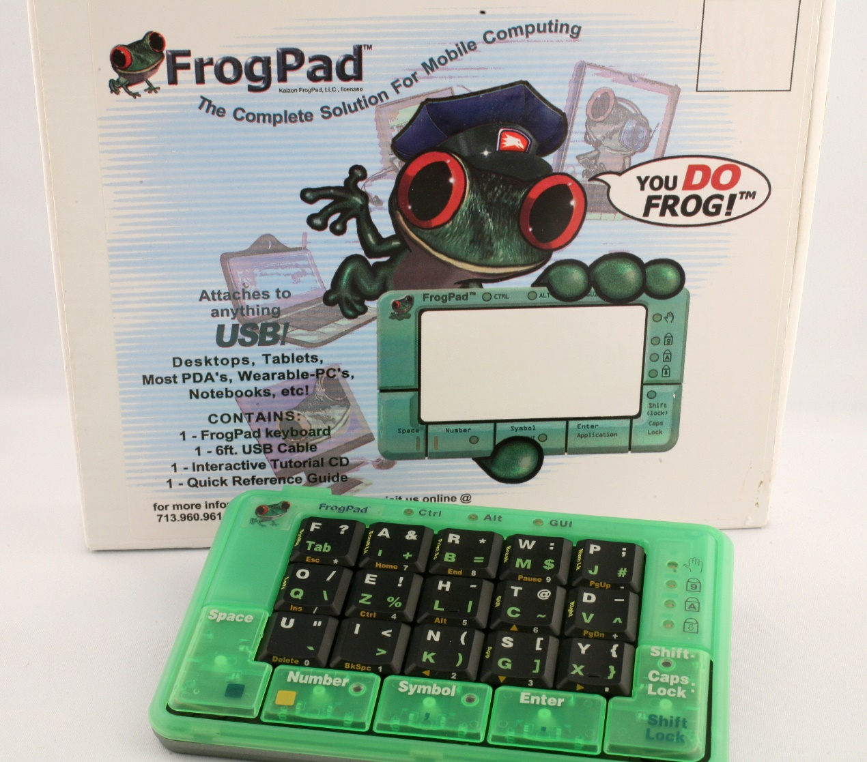
Short Description: The FrogPad is a one-hand chord keyboard, which is available for the left or right hand. The left and right keyboard versions are mirror images of each other.

Bill Buxton’s Notes
While early 19-key versions were released in Japan and Europe in 2001, this first North American version was released in 2002, and had 20 keys. While only having 20 keys, the FrogPad provided access to the full character set normally available on a full-sized QWERTY keyboard. That way one can get the full alphabet in upper and lower case, as well as all the numbers, punctuation, and special characters is not relying on one-key-per-character. Hence, the FrogPad is a chord keyboard – but one that has more keys than the 5 – 8 seen on most. The result is that at most, entering a character requires only 2 keys to be pressed. The higher number of 1-key characters and the restriction to two key chords means that higher typing speeds are more likely on this device than chord keyboards with fewer keys but more complex, and fewer 1-key codes – all things being equal (such as quality of design of the key mappings).
There are two layouts available for the device: one for typing with the left hand, the other for typing with the right. Each is a mirror image of the other, which reflects the mirror image layout of the hands.
The interesting question that this provokes is this: should a right-handed person use the right or the left-hand version of the device? As always, the correct answer is, “It depends.” In this case, one of the prime factors is this: do you want to use it in conjunction with a mouse? If so, then generally, you would likely be best to adopt a FrogPad that is designed for use by your non-mouse hand (most typically, your non-dominant hand). The good news is, due to the mirror image mapping of the keys on the left- and right-hand keyboards, moving from one to the other should require only little adjustment.
Of course, each instance of “likely”, “typically”, “generally” and “should” indicates something that could be tested and quantified, which is my way of providing a concrete illustration of when formal user studies can help shed light on design questions.
Designed by IDEO

Device Details
Company: Frog Pad, Inc. | Year: 2002 | Original Price (USD): $229.00
Degrees of Freedom: NA
Dimensions (L x W x H): 142 x 94 x 13 (mm)

Key Words
Primary: Chord Keyboard
Secondary: Keyboard, One-Handed Keyboard
Links
- Archived Page (March 6, 2001): https://web.archive.org/web/20010306120119/http://www.frogpad.com:80/fphome.htm
- Frogpad 1998 Patent US5793312: http://pdfpiw.uspto.gov/.piw?PageNum=0&docid=05793312&IDKey=EF6E929C240F%0D%0A&HomeUrl=http%3A%2F%2Fpatft.uspto.gov%2Fnetacgi%2Fnph-Parser%3FSect2%3DPTO1%2526Sect2%3DHITOFF%2526p%3D1%2526u%3D%25252Fnetahtml%25252FPTO%25252Fsearch-bool.html%2526r%3D1%2526f%3DG%2526l%3D50%2526d%3DPALL%2526S1%3D5793312.PN.%2526OS%3DPN%2F5793312%2526RS%3DPN%2F5793312
- FrogPad 2002 Patent US6,348,878: http://pdfpiw.uspto.gov/.piw?PageNum=0&docid=06348878&IDKey=7E86EC98E9F5%0D%0A&HomeUrl=http%3A%2F%2Fpatft.uspto.gov%2Fnetacgi%2Fnph-Parser%3FSect2%3DPTO1%2526Sect2%3DHITOFF%2526p%3D1%2526u%3D%25252Fnetahtml%25252FPTO%25252Fsearch-bool.html%2526r%3D1%2526f%3DG%2526l%3D50%2526d%3DPALL%2526S1%3D6348878.PN.%2526OS%3DPN%2F6348878%2526RS%3DPN%2F6348878
- FrogPad Press Release, CeBit,March 13, 2002: https://web.archive.org/web/20021206162300/http://www.frogpad.com:80/news_events.html
- FrogPad Press Release, COMDEX, Las Vegas, Nov 17 – 20, 2002: https://web.archive.org/web/20030207145040/http://frogpad.com:80/comdex.html
- FrogPad About Us Web Page, Dec. 6, 2002: https://web.archive.org/web/20021206151641/http://www.frogpad.com:80/about_us.html
- FrogPad Buy Now Web Page, Nov. 24, 2002: https://web.archive.org/web/20021124224620/http://www.kaizenfrogpad.com:80/online_store.html
- Kanellos, Michael (2003). FrogPad aims to cut keyboard size. C|net, Nov. 17, 2003.: https://www.cnet.com/news/frogpad-aims-to-cut-keyboard-size/
- FrogPad USB Instruction Manual
- FrogPad Quick Reference Chart
- FrogPad on the iPad (2011): https://www.youtube.com/watch?v=7EL91fT_pzs&feature=youtu.be
Image | File Name | Caption
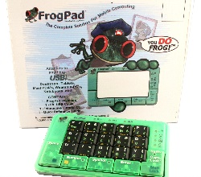 | Frog_0_plus_box.JPG | A view of the FrogPad in front of the box in which it came.
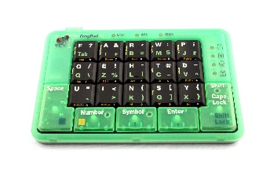 | Frog_1_Top_Angle.JPG | A 2002 FrogPad from the collection, the first version released in North America. Unlike the earlier Japanese and European versions, it had 20, rather than 19 keys.
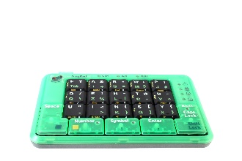 | Frog_2_Top_Angle.JPG
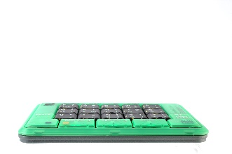 | Frog_3_Front.JPG
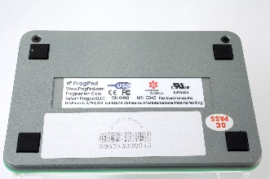 | Frog_4_Back.JPG
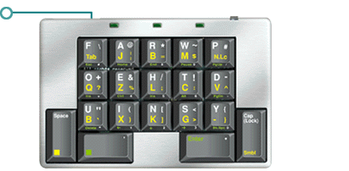 | FrogPad_2000.gif | An image of the earlier 19-key version of the FrogPad released in Japan & Europe only. It dates from 2000.
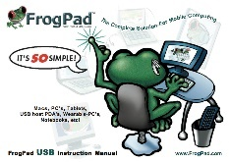 | Frog_Froggy-Manual-USB.jpg | The cover of the FrogPad User’s manual. Click on image to access manual.
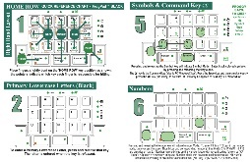 | Frog_PadQR-righty.jpg

