BUXTON / MICROSOFT COLLECTION
home | explore | associated narratives | about | acknowledgments | contact

Tap Systems The Tap
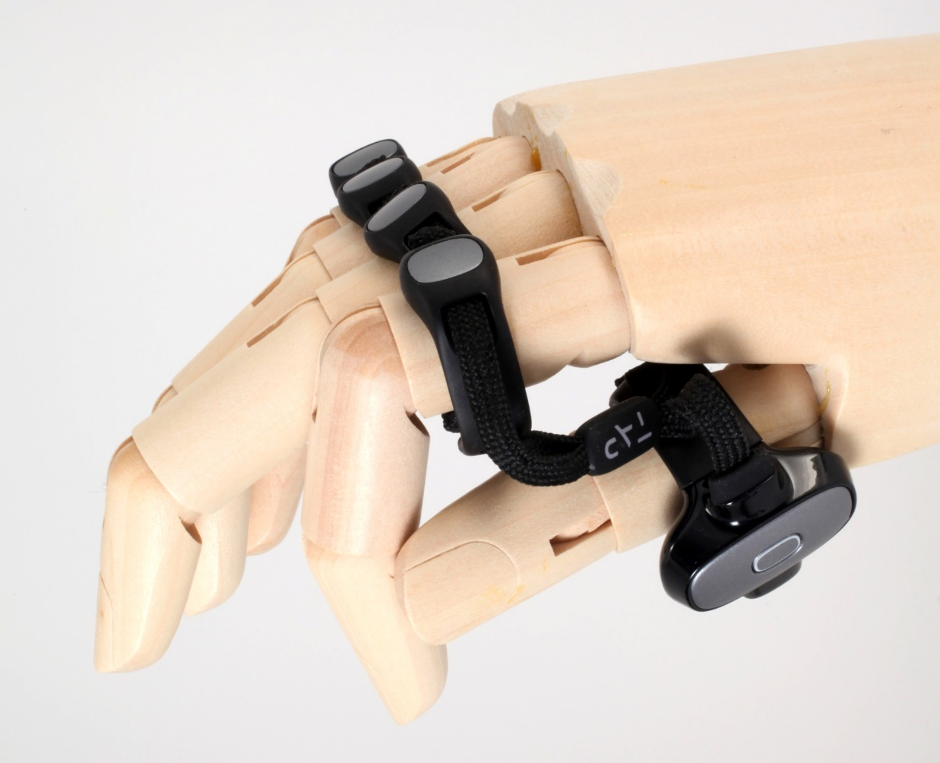
Short Description: The Tap is a wearable device which enables any surface to become a chord keyboard and a mouse alternative. It does so by instrumenting the hand rather than the tapped surface. This is accomplished by the user wearing a sensor ring on each digit of one hand. Thus, enables one to type into any Bluetooth device, such as a slate or mobile that one could with a regular QWERTY keyboard into a computer, and point/select in a way comparable to using a touch pad on a laptop..

Bill Buxton’s Notes
To come.

Device Details
Company: Tap Systems | Year: 2018 | Original Price (USD): $179.00
Degrees of Freedom: 2
Key Words
Primary: Chord Keyboard
Additional: Keyboard, Glove, Wearable, Mouse
{Advertisment, Book, Button, Camera, Chord Keyboard, Cursor, Dial, e-Reader, Foot Control, Game Controller, Game Machine, Gesture, Glove, Magazine, Mouse, Handheld, Head Control, Joystick, Keyboard, Magazine, Miscellaneous, MP3 Player, Multi-Touch , Music Player, PDA, Pedal, Pen Computer, Phone, Puck, Reference Object, Remote Control, Roller, Reskin, Slider, Sound Recorder, Stylus, Tablet, Touch Pad, Theme, Touch Screen, Touch Tablet, Toy, Trackball, VR, Virtual Reality, Watch, Wearable, Wheel}
Links
- https://www.tapwithus.com/

Image | File Name | Caption
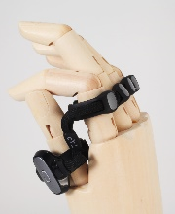 | Tap_00_Finger-tap.jpg | Tap device worn on right hand. Flipped over, it can also fit left hand.
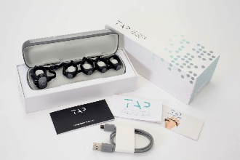 | Tap_01_Contents.jpg | Tap device in charging case, along with box, documentation and charging cable.
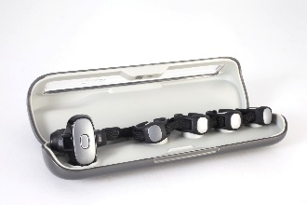 | Tap_02_in_Charger.jpg | Close up of Tap device in charging case.
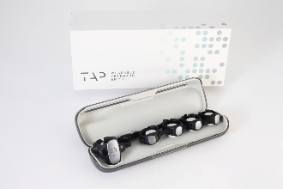 | Tap_02_in_Charger+Box | Tap device in charging case in front of box.
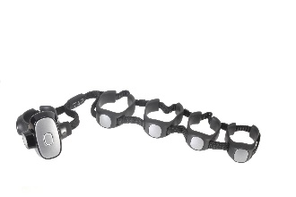 | Tap_03_Alone.jpg | Tap device by itself.
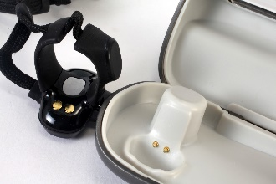 | Tap_04_Charge_Points.jpg | Close-up showing charging points to back of thumb ring beside those in charging case.
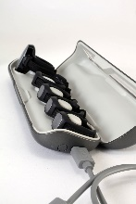 | Tap_05_Charging.JPG | Tap device in charging case with charging cable connected.
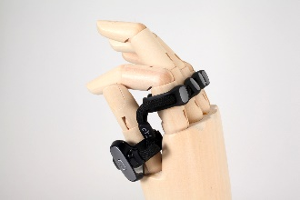 | Tap_06_Hand.jpg | Right hand wearing Tap device. The Tap comes in 3 sizes to ensure proper fit to hand.
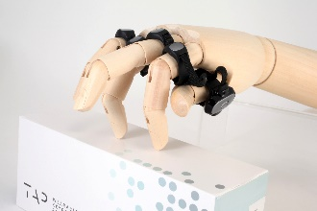 | Tap_07_Hand-Tap.jpg | Illustration of entering information by tapping on a surface. Any surface can be used, including your body.
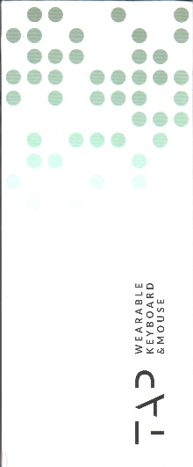 | Tap_Box_Top.jpg | Tap Box Top
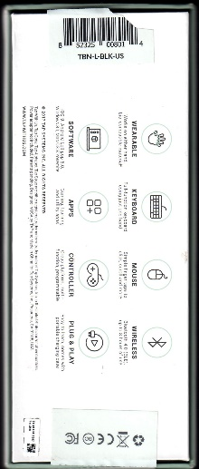 | Tap_Box_Bottom.jpg | Tap Box Bottom
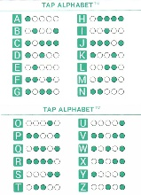 | Tap_Alphabet.jpg | Tap Alphabet Chord Codes
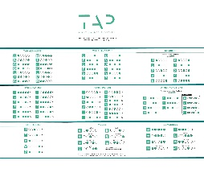 | Tap_RH_Glossary.jpg | Tap Chord Codes
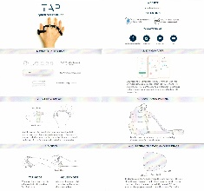 | Tap_Quick_Start.jpg | Tap Quick Start Guide
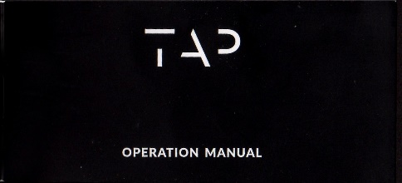 | Tap_Operation_Manual.jpg | Tap Operation Manual Cover. Click on image to access manual.

