[BUXTON / MICROSOFT COLLECTION](http://research.microsoft.com/en-us/um/people/bibuxton/buxtoncollection/default.aspx)

[home](http://research.microsoft.com/en-us/um/people/bibuxton/buxtoncollection/default.aspx) | [explore](http://research.microsoft.com/en-us/um/people/bibuxton/buxtoncollection/browse.aspx) | associated narratives | [about | acknowledgments](http://research.microsoft.com/en-us/um/people/bibuxton/buxtoncollection/acknowledgements.aspx) | [contact](http://research.microsoft.com/en-us/um/people/bibuxton/buxtoncollection/contact.aspx)

**Amazon Kindle Keyboard (Model D00901)**

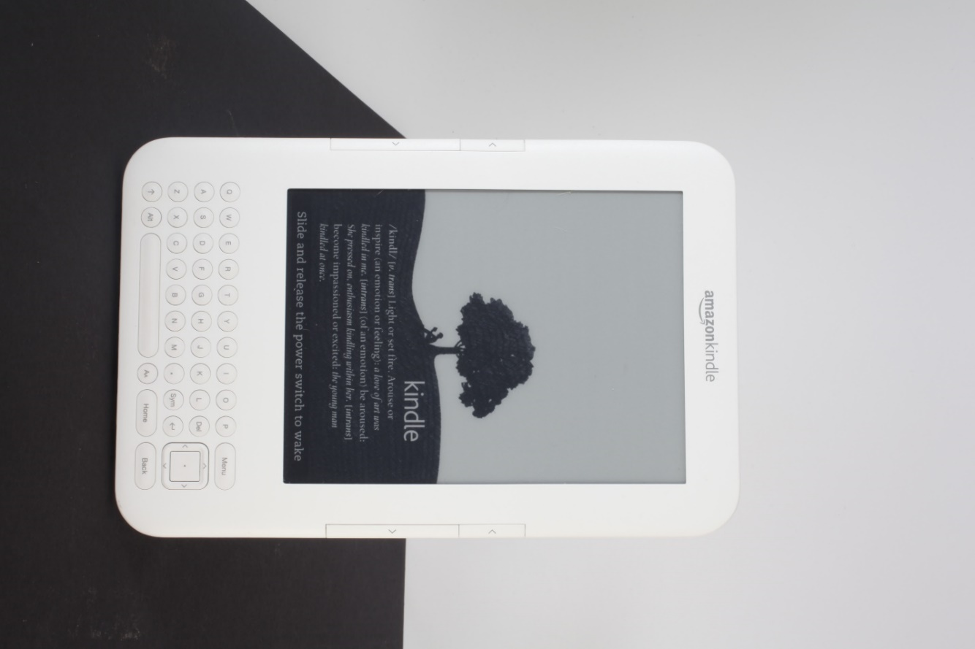

Short Description: This is the 3rd generation of the Amazon Kindle e-reader. It incorporates a keyboard which enables annotations, searches, etc. The main reason for its inclusion in the collection is how it integrates with its companion Amazon Kindle Lighted Leather Cover.

Bill Buxton’s Notes

This is the 3rd generation of the Amazon Kindle e-reader. It incorporates a keyboard which enables annotations, searches, etc. The main reason for its inclusion in the collection is how it integrates with its companion Amazon Kindle Lighted Leather Cover.

Like all previous kindles, the Kindle Keyboard had an e-ink display. This is a display technology which reflects light like paper, rather than emits light like most TVs and laptop displays. Hence, without light shining on it, one cannot read what is on the display. On the other hand, the screen is much sharper than a typical laptop screen at the time. However, in bright sun, such as on the beach, the e-ink is far superior for reading.

To address the reading in the dark issue, the Amazon Book has 2 slots on the left side into which its optional Lighted Leather Cover binding can snap into. These not only lock the Kindle Book to its cover’s binding, they also provide an electrical connection between book and cover, which enables electricity from the Kindle’s battery to power a reading light integrated into the cover to illuminate the Kindle’s screen when the light is extended from the cover.

Device Details

Company: Amazon | Year: 2010 | Original Price (USD): $139.00 (w/o 3G) / $189.00 (with 3G)

Design: XXX

Degrees of Freedom: 2

Dimensions (L x W x H): XXX x XXX x XXX (mm) / 7.5” x 4.8” x 0.335”

Key Words

Primary: e-Reader

Secondary: Handheld, Keyboard

Links

* Amazon Product Announcement, July 30th, 2010: <https://web.archive.org/web/20100730012342/http://www.amazon.com:80/>
* Amazon Product Page, July 31st, 2010: <https://web.archive.org/web/20100731020907/http://www.amazon.com/Kindle-Wireless-Reading-Display-Graphite/dp/B002Y27P3M>
* pdf file
* powerpoint
* Vimeo video link
* XXX

|  |  |  |
| --- | --- | --- |
| **Image** | **File Name** | **Caption** |
|  | Amazon3_01.JPG | Amazon Kindle Keyboard front view. |
|  | Amazon3_02.JPG | Amazon Kindle Keyboard view from upper left. |
|  | Amazon3_03.JPG | Amazon Kindle Keyboard view from left diagonal. |
|  | Amazon3_04.JPG | Looking across the surface of the Amazon Kindle Keyboard from bottom end. |
|  | Amazon3_05.JPG | View across the surface of the Amazon Kindle Keyboard from right side. |
|  | Amazon3_06.JPG | Lower view across surface of Amazon Kindle Keyboard from right diagonal. |
|  | Amazon3_07.JPG | Amazon Kindle Keyboard with back removed, revealing the inner workings. |
|  | Kindle3_Cover_06_Light_on.jpg | The Amazon Kindle Keyboard e-reader, in the dark, with its leather cover’s integrated reading light illuminating its display. See the Amazon Kindle Lighted Leather Cover for details. |
|  | Kindle_Keyboard_Announcement.jpg | Amazon.com Product Announcement for the Kindle Keyboard, July 30th, 2010 |
|  | Kindle_Keyboard_Product_Page.jpg | Amazon.com Product Page for the Kindle Keyboard, July 31st, 2010. Click on image to access full document. |