[BUXTON / MICROSOFT COLLECTION](http://research.microsoft.com/en-us/um/people/bibuxton/buxtoncollection/default.aspx)

[home](http://research.microsoft.com/en-us/um/people/bibuxton/buxtoncollection/default.aspx) | [explore](http://research.microsoft.com/en-us/um/people/bibuxton/buxtoncollection/browse.aspx) | associated narratives | [about | acknowledgments](http://research.microsoft.com/en-us/um/people/bibuxton/buxtoncollection/acknowledgements.aspx) | [contact](http://research.microsoft.com/en-us/um/people/bibuxton/buxtoncollection/contact.aspx)

**Apple Inc. Macintosh Portable**

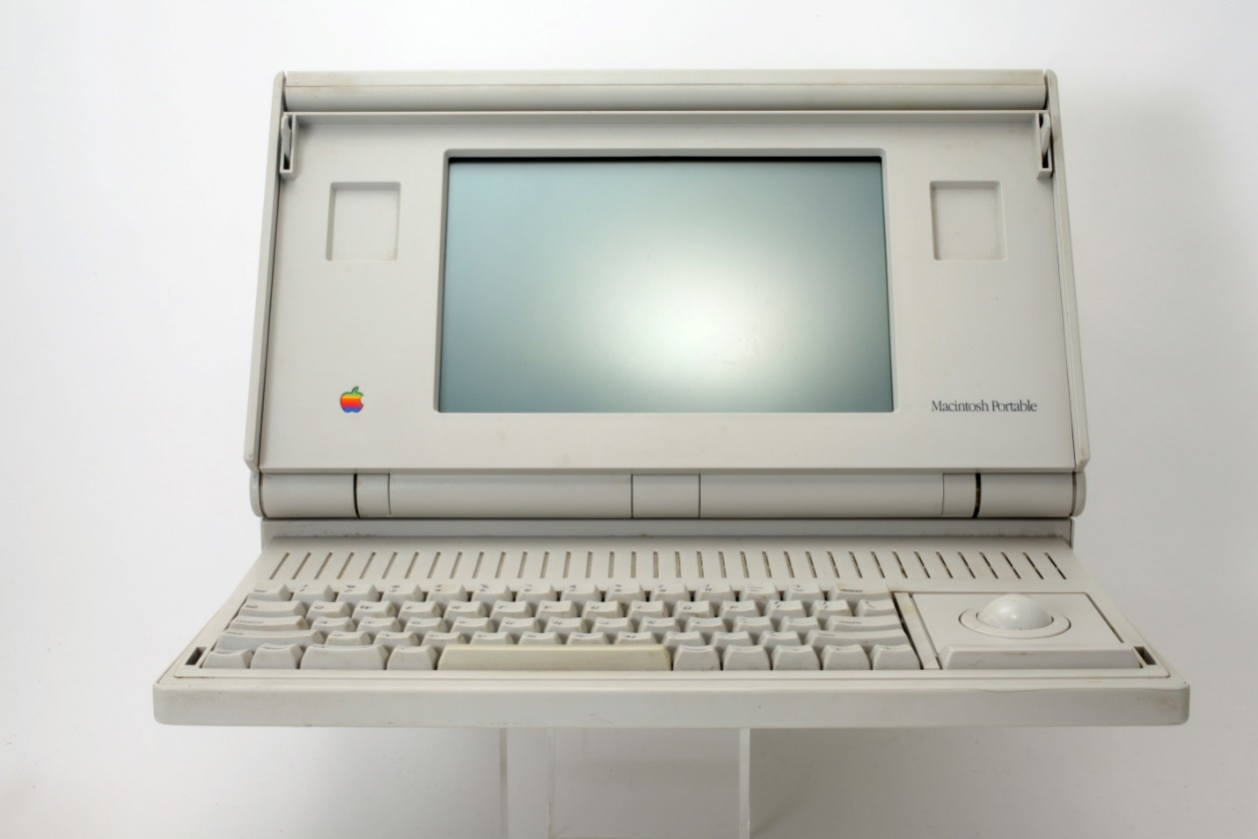

Short Description: This was the first portable Macintosh, and the first Mac which could be powered by an internal battery. It was also the first clam-shell laptop with an integrated trackball which could serve as a mouse alternative. The trackball could be placed to either the left or right of the keyboard to accommodate handedness. It also supported the Apple Desktop Bus (a predecessor to USB), which enabled other input devices, such as mice to be easily connected. Likewise, it has an AppleTalk port, which enabled it to easily connect to one’s local area network. This was my go-to machine for a few years and I loved it.

Bill Buxton’s Notes

This was the first battery-powered Macintosh. It was the first clam-shell laptop with an integrated trackball as a mouse alternative. The trackball could be placed to either the left or right of the keyboard to accommodate handedness. The very first models, of which this is one, had an active matrix display, which was wonderful for its time in terms of responsiveness and sharpness. However, it did not have back lighting. That is, like paper and e-ink displays, to be read, an external light source such as the sun or lamp was required. On the positive side, the battery life was extended due to the reduced power consumption.

While, at the time, one could get away calling this a portable. In today’s lingo however, weighing in at 7.26 kg / 16 lbs., this machine would now be deemed a “luggable.” Fact is, I knew that at the time that it came out. But at the time that I got it, I was working with Mark Weiser’s Ubiquitous Computing team, and understood Moore’s law. That is, I knew that the weight and size were going to rapidly drop, and that change was going to be significant in terms of how computers – namely portable computers – were used. Hence, despite appearances (and reality) I treated this machine as if it was a modern lightweight portable and carried it with me everywhere for at least a year. Office-to-office, up-and-down the PARC hallways, etc. There is a reason that I have really long arms for my body size!

My use of this machine was a great example of one of my maxims, namely:

*The only way to engineer the future tomorrow is to have lived in it yesterday.*

The more I carried it, the more used to doing so I got, so the size and weight disappeared. And given that wifi was not commonplace at the time, having my digital stuff always with me on my own machined produced a valuable visceral sense of knowing in advance many implications of what was inevitably to come.

That is the kind of attitude which drove most a PARC. It was part of the culture. And it goes a long way – coupled with encouraging management and brilliant determined people – to explaining why so much of what came in the next 25 years had roots in that lab.

.

Device Details

Company: Apple | Year: 1989 | Original Price (USD): $5,300.00

Degrees of Freedom: 2

Dimensions (L x W x H): 102.87 x 387.35 x 366.5 (mm) / 4.05” x 15.25” x 14.43”

Design: Apple Design / Frog Design

Key Words

Primary: Portable Computer

Secondary: Trackball

Links

* <https://en.wikipedia.org/wiki/Macintosh_Portable>
* Macintosh Portable Service Manual: <http://tim.id.au/laptops/apple/legacy/macintosh_portable.pdf>
* Macintosh Portable Technical Manual: <https://www.brutaldeluxe.fr/documentation/manual/atp_macintoshportable.pdf>
* Excellent photos of components: <https://www.oldcomputr.com/apple-macintosh-portable-backlit-1991/>
* pdf file
* powerpoint
* Vimeo video link
* XXX

|  |  |  |
| --- | --- | --- |
| **Image** | **File Name** | **Caption** |
|  | Mac_Portable_01.jpg | Front view of the Apple Macintosh Portable with screen open. |
|  | Mac_Portable_02.jpg | Close up of the integrated trackball and the right side of the keyboard of the Apple Macintosh Portable. The trackball could be placed on either the left or right side of the keyboard, according to preference/handedness. |
|  | Mac_Portable_03.jpg | Front view of the Apple Macintosh Portable with screen closed. |
|  | Mac_Portable_04.jpg | The left side of the Apple Macintosh Portable with screen open. |
|  | Mac_Portable_05.jpg | The left side of the Apple Macintosh Portable with screen closed. |
|  | Mac_Portable_06.jpg | The right side of the Apple Macintosh Portable with screen open. The slot for inserting 3.5” floppy disks can be seen. |
|  | Mac_Portable_07.jpg | The right side of the Apple Macintosh Portable with screen closed. |
|  | Mac_Portable_08.jpg | The back side of the Apple Portable Macintosh is shown with the screen open. |
|  | Mac_Portable_09.jpg | The back side of the Apple Portable Macintosh is shown with the screen closed. All of the I/O ports can be seen, including Apple Desk Top Bus, SCSI, serial, and an RJ45 telephone jack which enabled a standard telephone cable to plug it in order for you to dial in to the Internet via a built-in 9600 baud modem. |
|  | Mac_Portable_10.jpg | A view of the bottom side of the Apple Macintosh Portable computer. Besides the Apple serial number, etc., the Xerox Property tag remains – my having acquired it while working at Xerox PARC. |
|  | Mac_Portable_11.jpg | A view of the Apple Macintosh Portable’s innards. |
|  | Mac_Portable_12.jpg | A view of the Apple Macintosh Portable’s innards from a slightly different angle. |
|  | Mac_Portable_13.jpg | The Apple Macintosh Portable’s trackball removed from the computer |
|  | Mac_Portable_14.jpg | Disassembling the Macintosh Portable’s trackball: the trackball retaining ring. (1 of 5). |
|  | Mac_Portable_15 | Disassembling the Macintosh Portable’s trackball: the trackball. (2 of 5). |
|  | Mac_Portable_16 | Disassembling the Macintosh Portable’s trackball: the trackball cover plate. (3 of 5). |
|  | Mac_Portable_17.jpg | Disassembling the Macintosh Portable’s trackball: frame. (4 of 5). |
|  | Mac_Portable_18.jpg | Disassembling the Macintosh Portable’s trackball: the chassis housing the 2 spring-loaded shaft encoders and the 2 supporting rollers. (5 of 5). |
|  | Mac_Portable_19.jpg | The Macintosh Portable’s trackball, assembled, but without the cover plate and the trackball retaining ring. |
|  | Mac_Portable_20 | The chassis housing the 2 spring-loaded shaft encoders and the 2 supporting rollers of the Apple Macintosh Portable, with the trackball in place. |
|  | Mac_Portable_21 | The chassis housing the 2 spring-loaded shaft encoders and the 2 supporting rollers of the Apple Macintosh Portable, with the trackball removed. |
|  | Mac_Portable_22_-LH_edited.jpg | The left-side of the 2-page advertisment for Apple’s new Macintosh Portable Computer. |
|  | Mac_Portable_23_Ad-RH_edited.jpg | The right-side of the 2-page advertisment for Apple’s new Macintosh Portable Computer. |
|  | Mac_Portable_Service_Manual.jpg | Cover of an on-line version of the Apple Macintosh Service Manual. Click on the image to access the full document. |
|  | Mac_Portable_Technical_Manual.jpg | Cover of an on-line version of the Apple Macintosh Technical Manual. Click on the image to access the full document. |