[BUXTON / MICROSOFT COLLECTION](http://research.microsoft.com/en-us/um/people/bibuxton/buxtoncollection/default.aspx)

[home](http://research.microsoft.com/en-us/um/people/bibuxton/buxtoncollection/default.aspx) | [explore](http://research.microsoft.com/en-us/um/people/bibuxton/buxtoncollection/browse.aspx) | associated narratives | [about | acknowledgments](http://research.microsoft.com/en-us/um/people/bibuxton/buxtoncollection/acknowledgements.aspx) | [contact](http://research.microsoft.com/en-us/um/people/bibuxton/buxtoncollection/contact.aspx)

**Infogrip BAT**

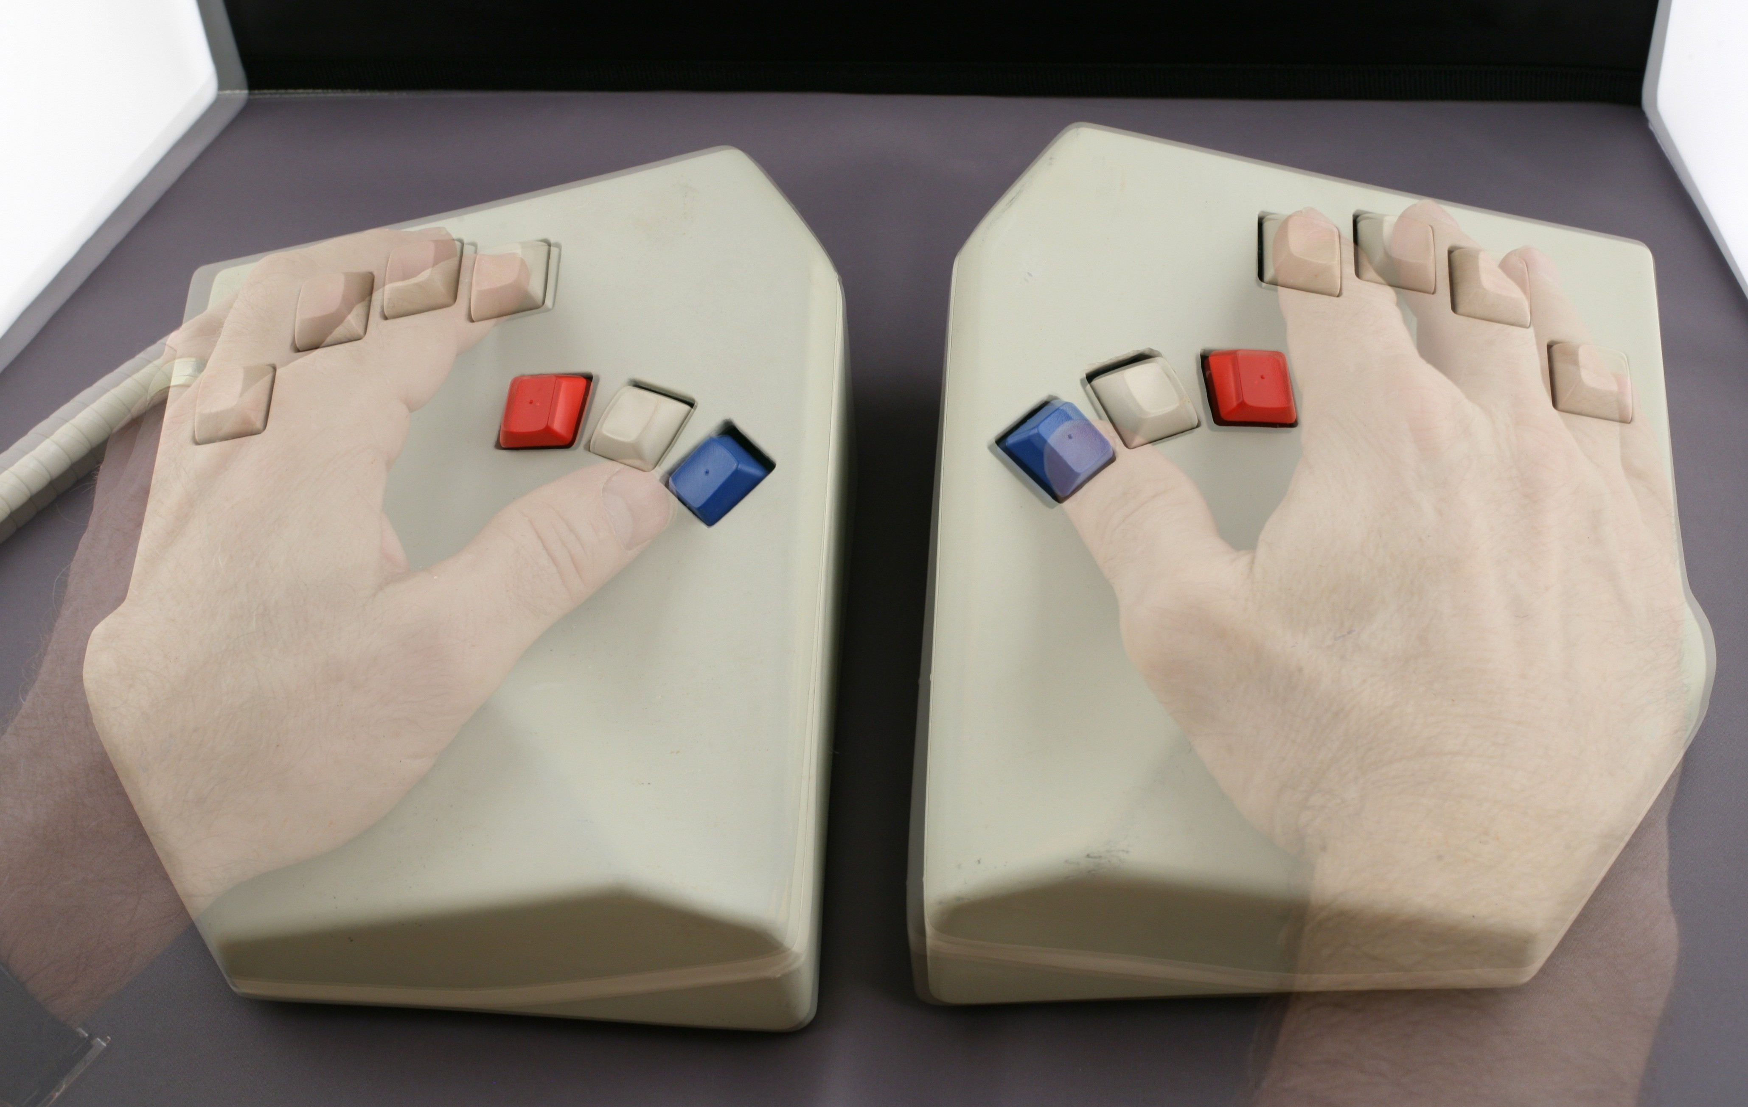

Short Description: The BAT includes two one-handed keyboards. Each keyboard can be used alone, or they can be used together to speed up data entry by alternating from one to the other. The left and right keyboards are mirror images of each other, with one button under each of the five fingers and two additional modifier keys for each thumb..

Bill Buxton’s Notes

……..

Device Details

Company: InfoGrip | Year: 1991 | Original Price (USD): $379.00

Degrees of Freedom: NA

Dimensions (L x W x H): 210 x170 x75 (mm) / (2 ¾” x 6 ½” x 7 ¾”)

Key Words

Primary: Chord Keyboard

Additional: Keyboard

Links

* [BAT Brochure](https://microsoft-my.sharepoint.com/personal/bibuxton_microsoft_com/Documents/Buxton%20Collection/Collection/Shot/Infogrip%20BAT/BAT_brochure.pdf)
* [BAT Newsletter](https://microsoft-my.sharepoint.com/personal/bibuxton_microsoft_com/Documents/Buxton%20Collection/Collection/Shot/Infogrip%20BAT/BAT_newsletter.pdf)
* [BAT Quick Reference Guide](https://microsoft-my.sharepoint.com/personal/bibuxton_microsoft_com/Documents/Buxton%20Collection/Collection/Shot/Infogrip%20BAT/BAT_Quick_Reference_Guide.pdf)
* [BAT SMN Review](https://microsoft-my.sharepoint.com/personal/bibuxton_microsoft_com/Documents/Buxton%20Collection/Collection/Shot/Infogrip%20BAT/BAT_SMN_Review.pdf)
* [BAT Tandy Review](https://microsoft-my.sharepoint.com/personal/bibuxton_microsoft_com/Documents/Buxton%20Collection/Collection/Shot/Infogrip%20BAT/BAT_Tandy_Review.pdf)
* [BAT Chord Keyboard Reference Guide 1992](https://microsoft-my.sharepoint.com/personal/bibuxton_microsoft_com/Documents/Buxton%20Collection/Collection/Shot/Infogrip%20BAT/Bill/Katy%20copy%20Buxton%20Collection/Working/Infogrip%20BAT/BAT_1992_Kbd_Ref_Guide.pdf)
* [BAT Personal Keyboard Brochure 1993](https://microsoft-my.sharepoint.com/personal/bibuxton_microsoft_com/Documents/Buxton%20Collection/Collection/Shot/Infogrip%20BAT/Bill/Katy%20copy%20Buxton%20Collection/Working/Infogrip%20BAT/BAT_1993_Brochure.pdf)
* [BAT 1994 Letter](https://microsoft-my.sharepoint.com/personal/bibuxton_microsoft_com/Documents/Buxton%20Collection/Collection/Shot/Infogrip%20BAT/Bill/Katy%20copy%20Buxton%20Collection/Working/Infogrip%20BAT/BAT_1994_letter.pdf)
* [BAT 1994 PC Today](https://microsoft-my.sharepoint.com/personal/bibuxton_microsoft_com/Documents/Buxton%20Collection/Collection/Shot/Infogrip%20BAT/Bill/Katy%20copy%20Buxton%20Collection/Working/Infogrip%20BAT/BAT_1994_PC_Today.pdf)
* [BAT 1994 Price List](https://microsoft-my.sharepoint.com/personal/bibuxton_microsoft_com/Documents/Buxton%20Collection/Collection/Shot/Infogrip%20BAT/Bill/Katy%20copy%20Buxton%20Collection/Working/Infogrip%20BAT/BAT_1994_Price_List.pdf)
* [BAT 1994 Smart Electronics](https://microsoft-my.sharepoint.com/personal/bibuxton_microsoft_com/Documents/Buxton%20Collection/Collection/Shot/Infogrip%20BAT/Bill/Katy%20copy%20Buxton%20Collection/Working/Infogrip%20BAT/BAT_1994_Smart_Electronics.pdf)
* [BAT Description](https://microsoft-my.sharepoint.com/personal/bibuxton_microsoft_com/Documents/Buxton%20Collection/Collection/Shot/Infogrip%20BAT/Bill/Katy%20copy%20Buxton%20Collection/Working/Infogrip%20BAT/BAT_Description.pdf)
* [BAT Press Release circa 1994](https://microsoft-my.sharepoint.com/personal/bibuxton_microsoft_com/Documents/Buxton%20Collection/Collection/Shot/Infogrip%20BAT/Bill/Katy%20copy%20Buxton%20Collection/Working/Infogrip%20BAT/BAT_Press_release_circa_1994.pdf)
* [BAT User's Manual](https://microsoft-my.sharepoint.com/personal/bibuxton_microsoft_com/Documents/Buxton%20Collection/Collection/Shot/Infogrip%20BAT/Bill/Katy%20copy%20Buxton%20Collection/Working/Infogrip%20BAT/BAT_User's_Manual.pdf)
* powerpoint
* you tube link

|  |  |  |
| --- | --- | --- |
| **Image** | **File Name** | **Caption** |
|  | BAT_1016-7.JPG |  |
|  | BAT_1016.JPG |  |
|  | BAT_1018.JPG |  |
|  | BAT_brochure.jpg |  |
|  | BAT_newsletter.jpg |  |
|  | BAT_Quick_Reference_Guide.jpg |  |
|  | BAT_SMN_Review.jpg |  |
|  | BAT_Tandy_Review.jpg |  |
|  | BAT_1992_Kbd_Ref_Guide.jpg |  |
|  | BAT_1993_Brochure.jpg |  |
|  | BAT_1994_letter.jpg |  |
|  | BAT_1994_PC_Today.jpg |  |
|  | BAT_1994_Price_List.jpg |  |
|  | BAT_1994_Smart_Electronics.jpg |  |
|  | BAT_Description.jpg |  |
|  | BAT_Press_release_circa_1994.jpg |  |
|  | BAT_User's_Manual.jpg |  |

**KATY’S NOTES:**

* DOF? The word ‘Bat’ should be all in caps, including on Bill’s Microsoft Research site
* <http://youtu.be/JhqeGRhhoFc>